Experimental procedures:

(1) Questionnaire completion

First, doctors judge the Parkinson's level of patients, record the level, lead the subjects into the test venue, and fill in the HAMD-23 questionnaire.

*HAMD-23:*

1) The HAMD-23 is derived from the HAMD-24, and sexual desire issues are deleted in consideration of the actual situation of elderly people.

2) Since the subjects are mainly elderly people, we read the content of the scale to the patients, and filled in the questionnaire according to their descriptions.

3) For ethical reasons, suicide and other issues are not asked, and we fill in the questions based on the patients' answers to other questions.

(2) Motion information

Uniformly wear the device on the right ankle, ask the subject to walk naturally, and walk along a straight line, first advancing to the end point and then turning around to return to the starting point.

(3) Audio information and facial information

Four negative emotional questions are asked during the interview process, and the positive video of the subject is recorded during the process. Later, the video and audio are separated from the video. All the questions and responses in the survey were conducted in Chinese.

The questions are as follows:

1. Is there anything that makes you feel sad or angry? Please tell me about it.

2. What worries or troubles do you have in your life? Please tell me about it.

3. Please tell me the impact of the disease on your life.

4. Please tell me your psychological feelings or thoughts after getting sick.

The experimental flowchart is shown as Figure 1.

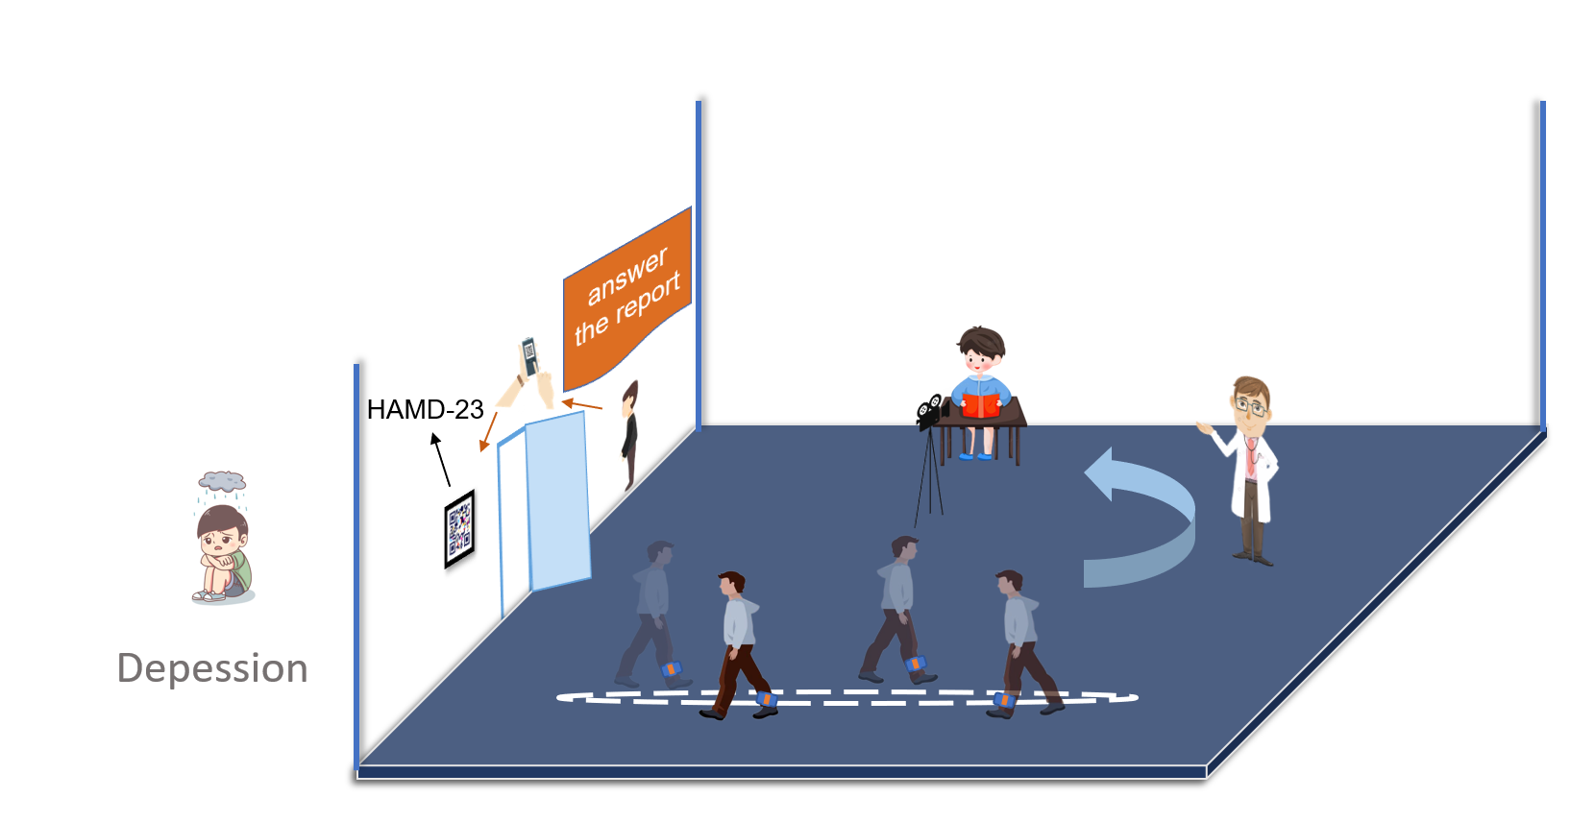Figure 1: Experimental procedure diagram.