1. Users can have many Roles
2. Roles can have many Users
3. Roles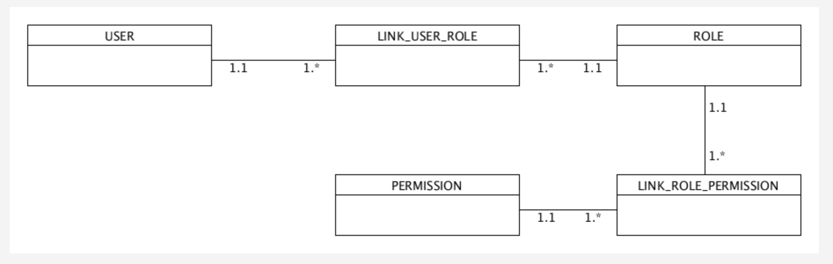 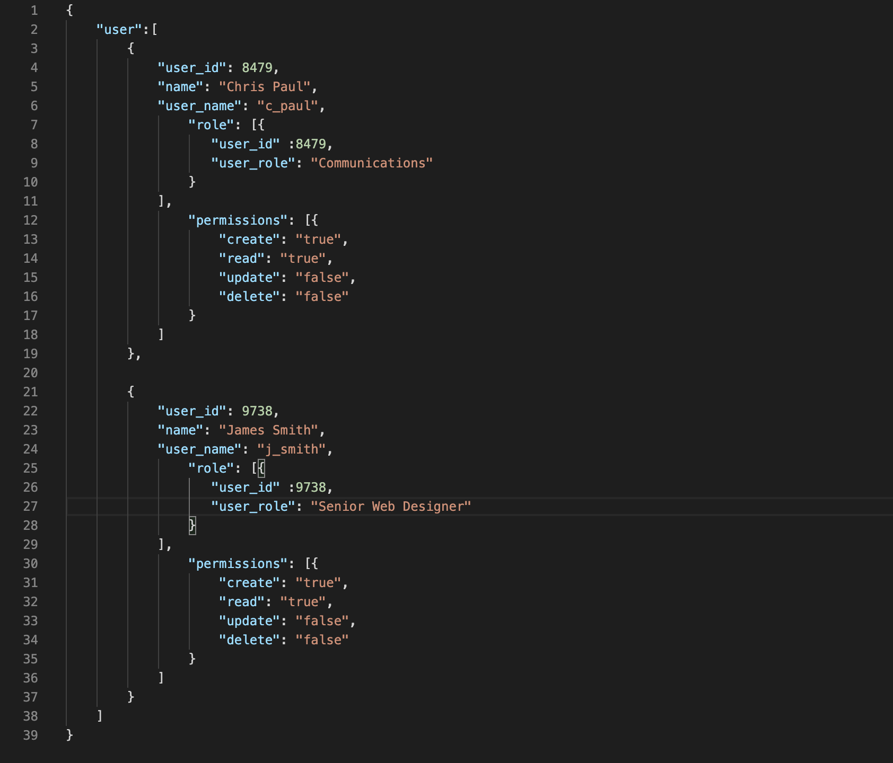can have many Permissions
4. Permissions can have many Roles