1. Author can have many Books
2. Books can have many Authors
3. Boo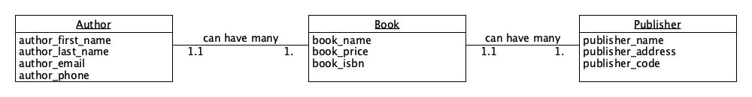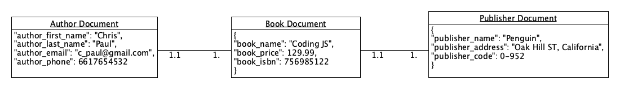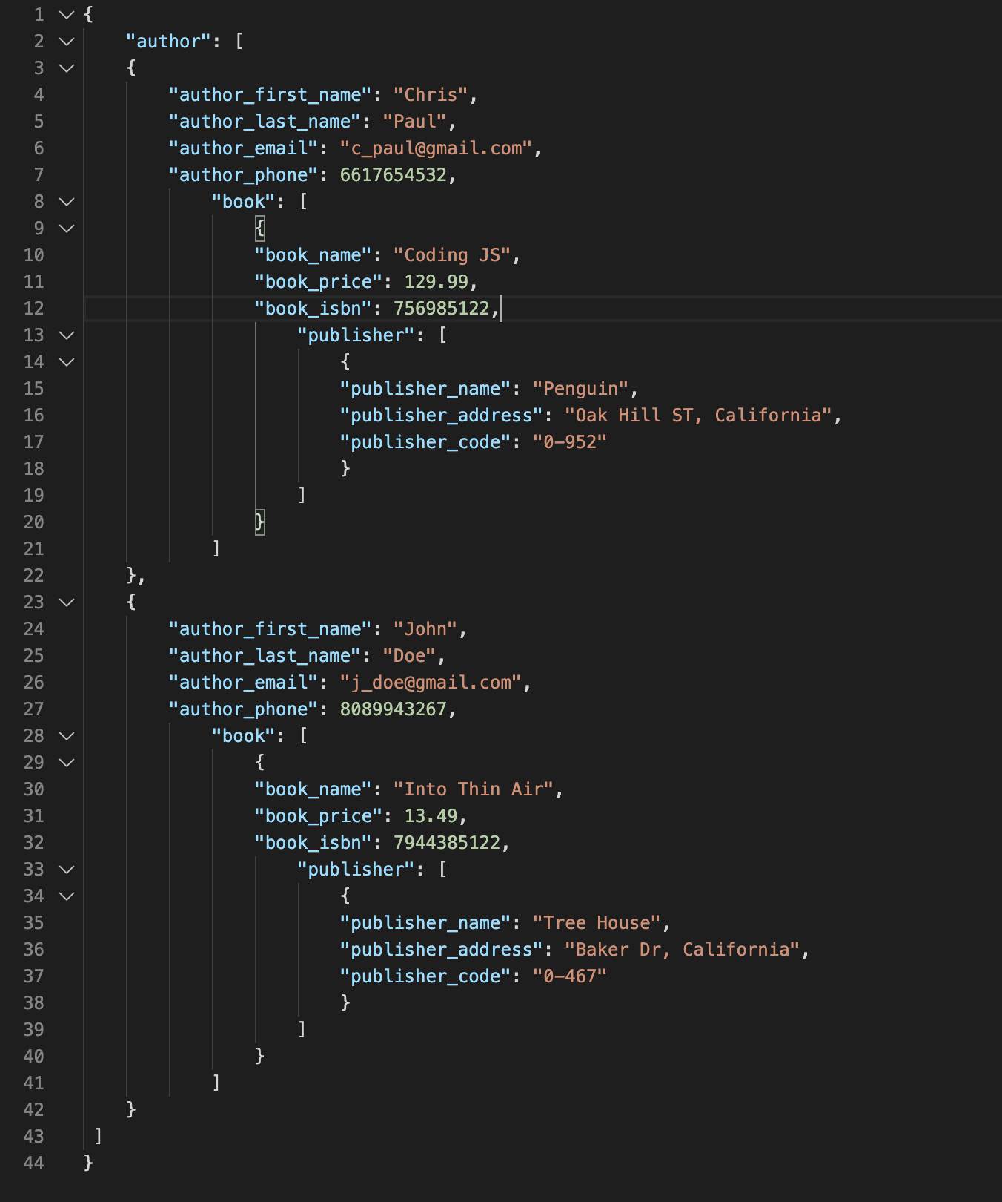ks can have many Publishers
4. Publishers can have many Books