URBAN ATLAS – production / metadata
LUZ | Utrecht_NL

LUZKOSICE_SK
GENERAL INFORMATION
Area of product | 389,64 km ²
Format (shapefile + prj) | Ok
SOIL SEALING cover and projection | Ok
COTS validation | Ok

Coordinate system reference
Projection: UTM 31
Central Meridian: 3°
Latitude of Origin: 0°
False Easting: 500000,00
False Northing: 0,00
Ellipsoid: WGS84

IMAGE data used
Satellite &  Sensor | Image name | Date (y/m/d) | Remark (e.g. clouds)
Spot 5 2,50 m | 00183538004 (PS) | 2005/06/23 | Pan-sharpening Images created by SPOT IMAGE
 | 00183538024 (PS) | 2005/10/15

Ancillary data used (thematic data, satellite images, aerial photos, city maps)
Id. | Data source/type | Title  (if relevant) | Date de production  (y/m/d) | Scale  (spatial detail) | Remark
Google earth
city map | falk | Utrecht | 2006 | 1: 13 000 | Scan + georef

CAPI/ DIGITAL CLASSIFICATION

Photointerpreter(s)
Name/surname | interpretation
Name/surname | start (y/m/d) | end (y/m/d) | Remark
Dupré Adelaïde | 09/06/09 | 09/06/17

Internal quality control
Internal quality check | Date of control  (y/m/d) | Result | Remark (errors, corrections, etc.)
Crépin Anne | 09/06/19 | ok

Quality assesment
Internal quality check | Date of control  (y/m/d) | Result | Remark (errors, corrections, etc.)
IGNFI | 09/08/07 | ok

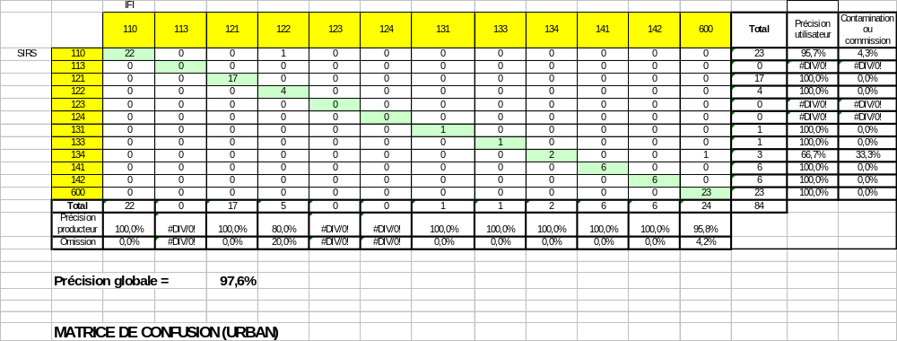

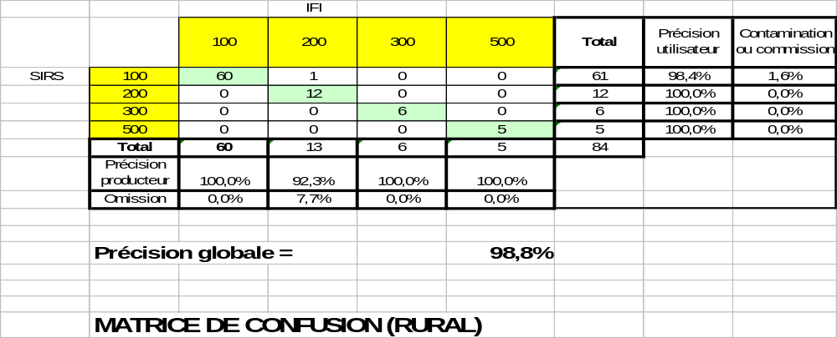

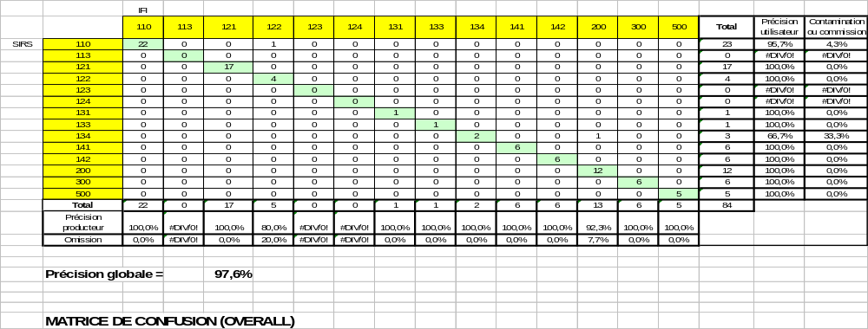

TOPOLOGICAL QUALITY CHECK

The topological quality check of all the LUZ was based on the same rules ( cf diagram).
- Thematic QC on the CAPI phase,
- Creation of Arcinfo’s Topology,
- Geometric check and validation of Geodatabase’s Topology.
However, in some cases, especially in huge LUZ, the geometric check and arcgis’s topology failed.
The main cause was the size and shape of a very large and complex polygon composed of roads (code 12220).
So, to avoid this problem, SIRS creates on those LUZ a 10 km size grid which splits this huge polygon in smaller ones.
Only the 12220 code roads are split using this method.
After this operation, the geometric and topology check passed successfully.

Internal quality check | Date of control  (y/m/d) | Result | Remark (errors, corrections, etc.)
SIRS | 09/12/04 | ok

