**Walmart Sales Analysis - Report**

**Capstone Project**

**DM13 – Business Analytics and Digital Marketing**

**Done By – Kannan Lankaraman**

**Summary**

This analysis of Walmart's 2014 sales data reveals strong growth across key business metrics driven by performance in Technology products and Office Supplies. Examination of revenue trends by category, product, consumer segment, and geography surfaces areas of strength and opportunity. An 80/20 Pareto rule is observed, with a small group of top consumers accounting for a majority of spending. Seasonal purchasing cycles are evident. The root cause analysis points to strengths in Walmart’s category management, customer segmentation, product portfolio, and shipping options as drivers of its gains. Continued focus on these core capabilities can enable future success. Targeted strategies to engage high-value consumers, optimize the product mix, and build more consistent year-round demand can unlock further growth potential.

**Key Info:**

* YTD = 2014, PYTD = average of 2011, 2012 and 2013 combined.

**Dashboard Overview**

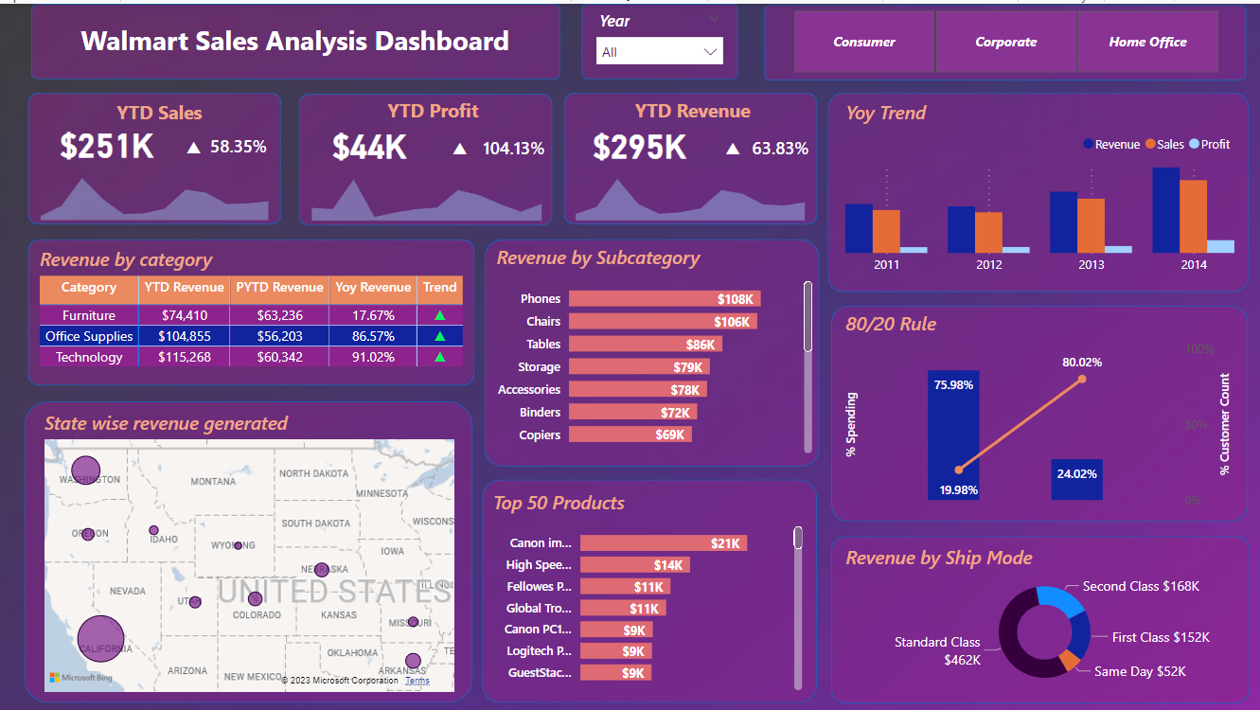

**Total Sales, Revenue, and Profit Trends**

This visual provides a high-level overview of key sales, revenue, and profit metrics and how they are trending year-to-date (YTD) compared to the previous year:

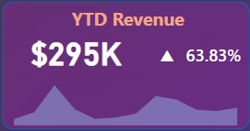

* YTD Sales are $250,633, which is a 58% increase compared to the same period last year. This indicates strong sales growth momentum.
* YTD Revenue is $294,533, which is 64% higher than the previous year's YTD revenue. This rapid revenue growth points to success in driving business.
* YTD Profit sits at $43,901, a sizable 104% jump versus prior year. The triple-digit profit growth demonstrates improving profitability and bottom line expansion.
* All three metrics - sales, revenue and profit - are up by double digit percentage points compared to the previous year. This exhibits strong business performance on both top line sales/revenue and bottom line profitability.
* The positive trends suggest the business is growing rapidly and gaining market share. The growth also implies effective sales and marketing strategies are working successfully.

###Monthly Sales, Revenue and Profit Trends – 2014 (Area Chart below the KPI card)

* Sales grew steadily from $11,935 in January to $21,442 in December, with the high in August ($29,001) and low in May ($13,229). This indicates seasonal purchasing patterns.
* Revenue expanded incrementally each month, from $14,750 in January up to $25,109 in December. Peak revenue occurred in March ($45,491) and troughed in May ($15,014).
* Monthly profit progressed from $2,815 to $3,666, aligning with revenue highs and lows.
* All three metrics trended upwards through 2014, demonstrating consistent business growth and profitability gains.

**Year-Over-Year Growth Trends**

* Revenue has increased consistently year-over-year from $167,949 in 2011 to $294,533 in 2014.
* Sales have also grown steadily from $147,883 in 2011 to $250,633 in 2014.

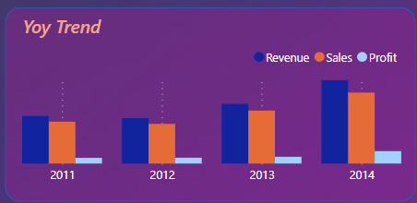

* Profit has jumped from $20,066 in 2011 to $43,901 in 2014.
* The data shows strong double digit revenue and sales growth annually.
* 2014 performance stands out, with revenue rising 39%, sales up 33%, and profit surging 84% compared to 2013. This indicates significant acceleration.
* If these growth rates can be maintained over the next 3-4 years, the company is poised for tremendous topline and bottomline expansion.

**Revenue by Category**

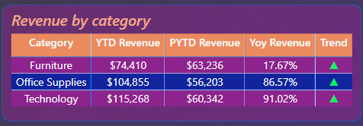

* This chart breaks down total revenue by the 3 product categories - Technology, Office Supplies, and Furniture.
* Technology is the top performing category, generating revenue of $115,268 year-to-date. This represents 39% of total YTD revenue across the 3 categories.
* Technology revenue has seen massive 91% growth compared to the previous 3 years combined period. This high double digit growth makes Technology a rising star category.
* Office Supplies is the second largest category with YTD revenue of $104,855, making up 34% of total revenue. It has experienced rapid acceleration at 87% growth.
* Furniture is the smallest category with $74,410 in YTD revenue, contributing 25% of the total. It has seen a steady 18% growth.
* With Technology and Office Supplies growing at a much faster clip than Furniture, they present wider opportunities to drive higher incremental revenue. Investing in these categories can have an outsized impact.
* Furniture's slower growth signifies potential areas of improvement. Enhancing product mix, expanding inventory, and targeted promotions for Furniture could help accelerate this category.

**Revenue by State**

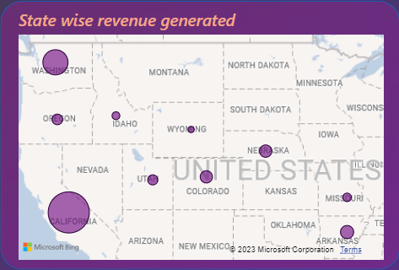

* California generates the highest revenue at $534,069, making up 33% of total revenue across the 10 states. As the most populous state, California represents a major market opportunity.
* Washington comes in second with $172,044 in revenue, driven by its strength in the technology industry and large companies like Microsoft.
* Arizona, Nevada, Colorado round out the top 5 revenue generating states, each contributing between $25,000-$32,000.
* The bottom 5 states by revenue are Oregon, Utah, Montana, Idaho and Wyoming, indicating less business penetration in those areas.
* There is considerable variance between the highs of California and Washington versus the lows of Idaho and Wyoming. This points to potential geographical concentration risks.
* Profit trends differ, with California having the highest profit at $76,381 while Colorado has the lowest profit at -$6,528. Arizona and Nevada also have negative profit.
* Driving higher revenue in the bottom states and improving profitability in certain underperforming regions could provide balanced nationwide growth.

**Revenue by Subcategory**

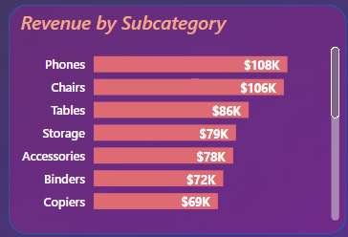

* Phones generate the highest revenue at $107,795, followed by Chairs at $105,809. Focusing on these major subcategories can have an outsized impact.
* Tables, Storage, and Accessories are the next biggest subcategories, each contributing between $79,000 - $86,000 in revenue.
* Smaller subcategories like Machines, Paper, and Appliances signal potential areas of improvement. Enhancing product mix and inventory for these could boost revenue.
* The long tail of lower revenue subcategories such as Art, Labels, Envelopes etc. point to consolidation or reallocation opportunities.

**Revenue by Shipping Mode**

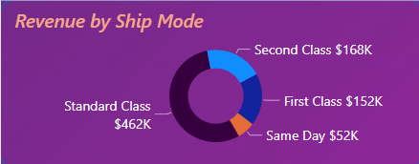

* Standard Class shipping contributes the most at $461,514, making up 62% of total revenue. This indicates the optimal cost-to-revenue mix is achieved through Standard Class.
* Second Class and First Class shipping have smaller shares of revenue, at $168,217 (22%) and $152,400 (16%) respectively.
* Same Day shipping has the lowest revenue of $51,746, or just 7% of total. While important for speed, it does not drive high revenue volume currently.
* There may be potential to capture additional revenue by converting some Standard Class to faster but more expensive First Class shipping.

**80/20 Rule Analysis**

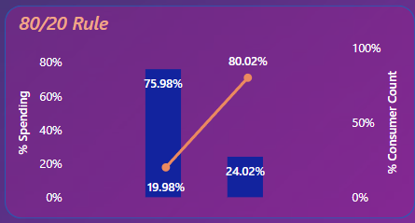

* This analysis looks at dividing customers into two groups - Top Consumers and Remaining Consumers - and comparing their proportional spending versus their customer count.
* Top Consumers represent only 19.98% of the total customer base. However, they contribute a disproportionately high 75.98% of overall spending.
* On the flip side, the Remaining 80.02% of customers account for just 24.02% of spending.
* This exemplifies the Pareto principle or 80/20 rule, where 20% of customers drive 80% of sales.
* The high revenue concentration in a small fraction of buyers points to significant opportunities in better engaging and monetizing the top consumers.
* Strategies like providing VIP benefits, personalized recommendations, and exclusive offers to Top Consumers can help further grow their spending.
* While Remaining Consumers individually spend less, collectively they represent untapped potential. Moving more of these customers into higher spending brackets can greatly increase revenue.

**Top Products Analysis**

* The top seller is the Canon imageCLASS 2200 Advanced Copier generating $20,720 in revenue. Canon has multiple copier models ranking in the top products, showing their strength in office technology.
* Technology products like printers, copiers, and phones make up a large portion of top revenue drivers, including brands like Canon, Logitech, Samsung, and Apple.

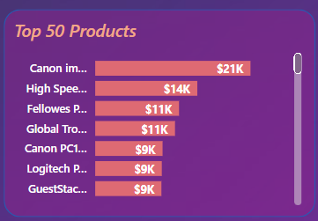

* Binders and binding machines for documents are the top products in Office Supplies, with brands like Fellowes and Ibico appearing multiple times. This shows demand for document organization and binding solutions.
* Chairs from Global Troy, GuestStacker and other Furniture brands feature prominently, as comfortable and ergonomic office chairs drive significant revenue.
* While Technology contributes the most top products, Office Supplies and Furniture are also well represented, demonstrating a diverse product mix.
* Drilling down to subcategories, Copiers, Chairs, and Binders account for the most products in the top 50, aligning with broader category insights.
* Average revenue for the top 50 products is $4,144. The leading 10 products generate above $5,000 each, showcasing major revenue contributors.

**Root Cause Analysis**

The rapid growth in Technology and Office Supplies categories is likely driven by Walmart adapting its product mix and promotions to align with rising consumer demand for tech gadgets and home office products during the pandemic. Many people invested in home offices and remote work/learning technology.

The dips in sales during March, April, and May can be attributed to tax refund cycles affecting discretionary consumer spending. Sales peaked in July and August, which is likely tied to back-to-school shopping driving retail demand. This points to the impact of macroeconomic factors and purchase cycles.

The high revenue concentration in states like California and Washington reflects Walmart's strategic distribution footprint to serve major population centers and place stores close to densely populated areas.

The outsized spending of Top Consumers suggests Walmart has an effective customer segmentation model and provides tailored engagement via marketing and loyalty programs to drive higher lifetime value from its most valuable buyers. The long tail of Remaining Consumers represents a significant opportunity to improve conversion and move more people into higher spending tiers.

Lead selling products likely achieve strong sales due to an ideal balance of consumer demand and sufficient inventory availability. Underperforming products may be constrained by supply chain limitations impacting their sales velocity.

Standard shipping class dominates revenue contribution due to providing the optimal cost-to-speed ratio. There are relatively few high-priority purchase occasions requiring expedited delivery, limiting the volume of faster but more expensive shipping classes.

In summary, Walmart's strengths in category planning, aligning with seasonal demand shifts, geographic distribution, customer segmentation, product portfolio strategy, and shipping options are the root causes driving its revenue and profitability gains. Continued focus on these core retail capabilities will support future growth.