Kinetic study of functionalized HABIs and their applications

Graduation Thesis

Masters of Macromolecular Science and Engineering
DDan Li¹
¹ Macromolecular Science and Engineering, University of Michigan, 2300 Hayward St, Ann Arbor, MI 48109

Correspondence to: Timothy F. Scott, E-mail: tfscott@umich.edu
ABSTRACT
Dynamic covalent chemistry provides accessibility to incorporate the error-correction capability in robust covalently bonded polymeric systems. Among reported approaches, light-induced dynamic covalent networks attract more and more attention as a green synthetic approach, since its responses can be finely controlled under irradiation and through remote localized activation and delivery of energy to the polymeric system. To deepen the understanding in photo-induced dynamic covalent system, this study focus on synthesized Hexaarylbiimidazoles (HABIs) to utilize their radical forming capability as a method of photochemical radical-mediated addition-fragmentation. This study broads the library of photo-induced dynamic covalent chemistry and efficiently provides new approaches to self-healing and shape-memory materials for medical applications.
KEYWORDS: Dynamic covalent chemistry, Photoresponsive, Hexaarylbiimidazoles, Radical forming capability, self-healing, shape- memory.

INTRODUCTION
Dynamic covalent chemistry attracts enormous attention since it allows access to complex assemblies such as designed polymer networks, molecular knots and covalent organic frameworks. Common types of stimuli such as thermal, chemical, mechanical and radiant signals can induce reversibility assemble and disassemble in such dynamic covalent systems. Although thermal-induced reversible covalent systems are proved to be reliable and convenient to be incorporated into further functional compounds, it suffers from heat treatment corresponded mechanical properties changing. However, photo-induced reversible networks can be 3D remotely triggered by controlled light without sacrificing mechanical and thermal properties. These features can be utilized to fabricate materials with crack-healing and shape-memory capabilities for applications in pharmaceutical, chemical and biological fields. To deepen the understanding in photo-responsive dynamic covalent chemistry, in particularly Hexaarylbiimidazoles (HABIs) chemistry as a method of photochemical radical-mediated addition-fragmentation, it is necessary to compare synthesized Hexaarylbiimidazoles (HABIs) and commercial HABI, and their radical forming capability. This study broads and integrates the library of photo-induced dynamic covalent chemistry which efficiently provides new possibilities in self-healing materials and shape-memory materials for medical applications.
All biomolecular reactions are, to some extents, reversible as indicated by their chemistry nature and controlled by the temperature-depending equilibrium. However, most reactions can substantially be considered as irreversible since their temperature constraints exclude the majority of reactions from being thermal-reversible, including requirements such as practical temperature range, chemical decomposition temperature and high-temperature induced side effects. Additionally, bond rearrangement on an appropriate time scale that are desired in many applications is not in accordance with the great majority of the forward and reverse reaction rates. The irreversible nature of these reactions guarantees that once the expected product is formed it is not possible to reform to the starting materials or convert to other products, as least under the conditions of the reactions. Indeed, historically, chemists have designed synthesis routes of both natural and unnatural products based on irreversible reactions. [1]
However, on the other hand, there are a rising number of interests in where the covalent bonds can potentially to be formed and broken, and for sure, reformed reversibly under a certain condition.[2] If the equilibrium process is adequately fast, this so-called dynamic covalent chemistry leads to the formation of products under thermodynamic control. [3] Dynamic covalent chemistry has been integrated into distinguished research fields, and enabled many important applications in biotechnology, drug delivery, molecular separation, light harvesting, etc. Dynamic covalent chemistry utilizes the reversibility of rather strong covalent bonds within molecules to incorporate error-correction capability like supramolecular chemistry along with the robust bonding of covalent bonds [4]. As a comparison, supramolecular chemistry which depends on noncovalent interactions between ions and molecules contained in the complexes, also allows access to a tremendous numbers of noncovalent structures assemblies [5]. Nevertheless, as many of these supramolecular structures are not sufficiently stable, especially in solution, they are often difficult to be investigated and further applied to polymeric networks. Therefore, the possibility of reversible structural elements with higher stability is extraordinary precious.
Thermal-reversible Polymer Networks
Types of dynamic covalent reactions include thermo-, chemo-, mechano-, and photo-responsive dynamic polymers which are formed by polycondensation of components through dynamic imine, disulfide, and other bonds. [6] Among them, thermal-responsive polymers are first typically reported as dynamic covalent systems. Several previously reported thermos-reversible cross-linking reactions that have been used to assemble thermos-reversible polymer networks are shown in Fig 1. [7]
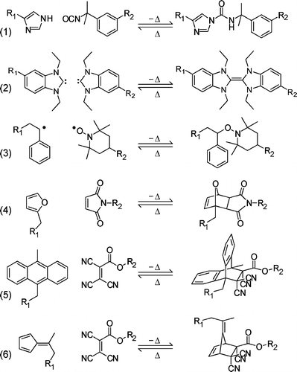
FIGURE 1. A selection of thermo-reversible cross-linking addition reactions: (1) nucleophilic addition between isocyanate and imidazole, [39] (2) carbene dimerization[40], (3) reversible radical coupling between TEMPO and a styryl radical[41]and the Diels Alder cycloaddition between (4) furan and maleimide, (5) anthracene and tricyanoacrylate[42] and (6) fulvene and tricyanoacrylate[43].
However, practical limitations exist in most of these thermos-reversible reactions, such as insufficient reversibility resulting from side reactions and low reaction rates without using catalysts. For example, nucleophilic addition, as a kind of well-known thermos-reversible reactions, has strong dependency to a good leaving group in the nucleophile in order to be reversible in a reasonable temperature range. [8]
Diels-Alder (DA) chemistry has been investigated extensively with various cross-linked polymer networks based on dienes and dienophiles [4+2] cyloaddition. The reason is that DA reaction attributes to typically click-type reaction which is reasonably tolerant to water and oxygen and can be tuned to be responsive over a wide range of temperatures through reactions. Discovered and developed by Otto Diels and Kurt Alder who received the Nobel Prize in 1950 for their discovery [9], DA reactions are widely used to fabricate thermos-reversible polymer networks between a conjugated diene and an electronically activated double bond, also called dienophile, ever since. [10] Several researchers conducted the method to synthesize polymeric networks by crosslinking linear polymers with pendant furan moieties and bismaleimide or trismaleimide moieties via DA reaction. [11-15] However, this strategy obviously reduced the ability of gel-to-sol transition of the polymeric network, since the commonly used fuctionalized linear chains acted as a macromonomer with a high degree of functionality. Therefore, researchers have utilized low functionality and low molecular weight diene and dienophile monomers to increase the gel-point conversion to introduce the ability of reverting to liquids at certain temperatures to these systems. [16-20] However, many reversible networks utilizing diene and dienophile pairs require excessive heating to undergo the retro-DA reaction, which might also trigger irreversible side reactions. Despite the attention that furan−maleimide networks have received, there is still a need to characterize these novel materials.
A recently popular candidate for thermal reversible systems is thiol-based addition reactions, including thiol-Michael, thiol-ene, and thiol-yne reactions, which are advantaged by their compatibility with most functional groups and facile implementation conditions. [21] Although commonly being more used in post-polymerization modification and network synthesis rather than being used as dynamic covalent components, recent study revealed the advantages of thiol-Michael reactions (SCHEME 1) as a new approach to thermal reversibility, showing that the covalent bonds formed under ambient temperature exhibited long-term stability against mechanical deformation in the absence of thermal stimulus
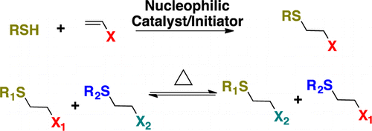
SCHEME 1. Thiol–Michael Adduct Forming Reaction (Top) and Thermally Induced Dynamic Equilibrium (Bottom).
Photoreversible Polymer Networks
Although thermal reversible reactions are capable of great reversibility and can be effectively being controlled by temperature, some obvious disadvantages restrict their use in medical application, such as inherent poor spatial and temporal reaction limitations. Comparing to thermal-reversible networks, photo-reversible networks can be finely adjusted to response only under irradiation, otherwise exhibiting ignorable creep or adaptation. Furthermore, photo-responsive mechanism allows remote localized activation and deactivation as well as the capability of ambient temperature reactions in the solid-state. Also, photo-chemical reactions are considered to be green synthetic approaches because of no side products generated during reaction. [22] Several approaches to photo–responsive reversible polymer networks, including photo induced cyclization reactions and photochemical radical-mediated addition-fragmentation, have been developed and utilized in further applications. The cyclization reactions suffer from limited response rate, since only a single cross-link can be converted for each absorbed photon. Comparatively, the addition-fragmentation reactions can generate multiple reversible bond cleaving and reforming processes when one photon was absorbed during a network rearrangement. However, one dilemma for addition-fragmentation reactions is that having a large fraction of bonds cleaved at a given time is not allowed, which limiting these materials from applications where need gel-to-sol transition. [23], [24]
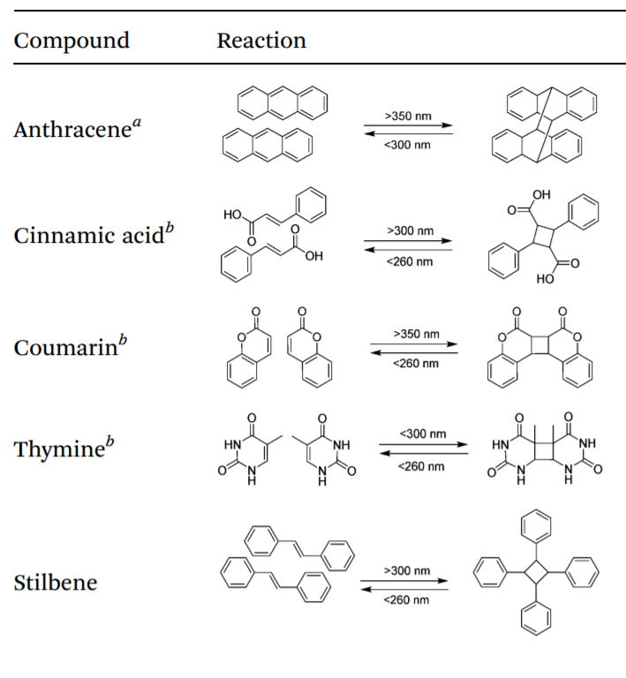
Some of the moieties capable of photo-reversible dimerization are used in polymeric systems to exhibit photo dynamic behavior. Commonly used dimerization reactions in photo-reversible systems are proceeded by either a [4 + 4] or [2 + 2] cycloaddition mechanism that can be reversed upon application of an appropriate wavelength of light, such as the reactions of anthracene, cinnamic acid and stilbene, as shown in Table 1. [25] Depending on the conditions of irradiation, photo-dimerization can result in the formation of one or more cyclobutane isomers. Additionally, by monitoring changes in the UV absorbance at a wavelength, one may conveniently evaluate the extent of dimerization and reversion that occurs during irradiation. The electron conjugation of photo-sensitive molecules lead to strong UV absorption at a certain wavelength typically around 260-300 nm. However, during dimerization of the molecules, conjugation is disturbed and the absorbance of the irradiated sample reduced greatly in the mentioned range of wavelength. When the retro-cycloaddition occurs, conjugation is restored in the molecule and absorption increases again. In these cases, these reactions are analogous to the thermal-reversible DA reactions, where light intensity controls the rates of the forward and retro reactions, and the wavelength of light controls the equilibrium extent of the cyclization and reverse reactions. Though, the photoinduced cyclization systems are capable of reverting to a liquid state when sufficient light given to the system, broaden its applications such as self-healing materials.
TABLE 1. Moieties capable of undergoing photo-reversible dimerization by UV irradiation
- Undergoes [4 + 4]-cycloaddition. b. Undergoes [2 + 2]- cycloaddition.

Another recently found approach is inducing photo-mediated reversible cleavage in polymer backbones, which allows chain rearrangement during rapid stress relief at ambient conditions without mechanical property degradation by integrating addition-fragmentation chain transfers. This technique exhibits great advantages of photoinduced reactions whereby the networks stays in a permanent nonadaptable state without light and the adaptation process can be easily ceased on demand. Furthermore, addition-fragmentation chain transfer functional groups are easy to be incorporated into the backbone of polymer networks and convenient for subsequent applications, in contrast to cycloaddition reactions which usually suffer from choosing the perfect materials for polymer network to exhibit the function of photo-reversibility. [26] Scott et al. [27] firstly reported polymer networks using allyl sulfide as efficient addition-fragmentation chain transfer agents. The addition-fragmentation process changes the topography of the networks while the chemical structures and network crosslinkages remain unchanged. When absent of radical termination events, the number of allyl sulfide groups remains unchanged and relaxation of the bond stresses is facilitated by alternating cleavage and reformation reactions. Unlike photoinduced dimerization reactions, the overall cross-link density remains essentially constant throughout irradiation since an equilibrium is reached between bonds cleavage and reformation.
Hexaarylbiimidazoles – Photo-chemically and Mechanically Reversible Moieties
Hexaarylbiimidazoles (HABIs), 2,4,5-triaryl-substituted imidazole dimers were first synthesized by Hayashi and Maeda in 1960 [28] and has been well known as thermo- and photo-chromic materials and widely used as photoinitiators in photoimaging and photoresists for decades. [29] The photochromic behavior of HABI derivatives can be attributed to the photoinduced homolytic reversible cleavage of the C−N bond between the imidazole rings to generate colored 2,4,5-triarylimidazolyl (i.e., lophyl) radicals which can be thermally recombined to reproduce imidazole dimer. Unlike other organic radicals that recombine at diffusion-controlled rates, the lophyl radicals originated from HABIs are insensitive to atmospheric oxygen and show uncommonly slow recombination rates, due to their chemical structure affording stabilization by steric hindrance and electron delocalization. [30]
Specifically, HABI photoinitiators show no initiation activity in methacrylate formulations without the presence of any hydrogen-donating coinitiator such as a thiol [31] where hydrogen abstraction by the HABI-derived lophyl radicals yields initiating thiyl radicals. Advantaged by low inter-imidazole bond energy (17 kcal/mol), absence of parasitic side reactions, and unusually low reactivity and long lifetime of the lophyl radicals originating from HABI cleavage, cross-linked polymers composed of HABI-incorporating network strands offer extraordinary mechanochromic properties that are unattainable in conventional materials and useful for further applications.

FIGURE 2. Reversible photo- or mechano-mediated homolysis of HABIs into lophyl radicals. The spontaneous recombination reaction proceeds over tens of seconds to minutes in solution. In the presence of thiol, a lophyl radical can abstract a thiol hydrogen, generating a thiyl radical capable of initiating polymerization.
The facile synthetic accessibility of HABIs enables their ready modification to provide particular properties. The solubility of these usually solid materials has been dramatically increased by affixing alkyl substituents. [29, 32] The lophyl radical recombination rate can be decreased with a corresponding bathochromic shift in its absorption spectrum by incorporating extended π-conjugated moieties. [33] The recombination rates of lophyl radical can also be greatly increased by attaching both units of the imidazole dimer to a rigid bridge. [34] Additionally, the synthetic adaptability enables the investigation of radical forming capability of HABIs with different substituents that affects the conjugation structures. Understanding these make it easier to fabricate HABIs with specific properties to fit in different applications.

EXPERIMENTAL
Synthesis of functionalized HABI compunds

Three HABI compounds are used for comparison throughout this study: (2,2'-(((((((4,4',5,5'-tetraphenyl-2'H-[1,2'-biimidazole]-2,2'-diyl)bis(4,1-phenylene))bis(oxy))bis(ethane-2,1-diyl))bis(oxy))bis(ethane-2,1-diyl))bis(oxy))bis(ethan-1-ol)) also called dihydroxy no-HABI, (2,2'-(((((((4,4',5,5'-tetraphenyl-2'H-[1,2'-biimidazole]-2,2'-diyl)bis(3-methoxy-4,1-phenylene))bis(oxy))bis(ethane-2,1-diyl))bis(oxy))bis(ethane-2,1-diyl))bis(oxy))bis(ethan-1-ol)) also called dihydroxy o-me-HABI and ((((((((4,4',5,5'-tetraphenyl-2'H-[1,2'-biimidazole]-2,2'-diyl)bis(3-chloro-4,1-phenylene))bis(oxy))bis(ethane-2,1-diyl))bis(oxy))bis(ethane-2,1-diyl))bis(oxy))bis(ethane-2,1-diyl) diacrylate) also called diacrylate Cl-HABI. The synthesis procedure for them are listed below, using diacrylate Cl-HABI as an example as showed in Fig 3. 2,2′-Bis(2-chlorophenyl)-4,4′,5,5′-tetraphenyl-1,2′-biimidazole (o-Cl-HABI, TCI America) was used as the starting material and was used as received.
FIGURE 3. Synthetic Route to Functionalized HABIs. Reaction conditions: (a) 2-[2-(2-Chloroethoxy)ethoxy]ethanol, K₂CO₃, DMF, 120°C; (b) benzil, NH₄OAc, AcOH, reflux; (c) sodium hydroxide, H₂O/THF, reflux; (d) K₃[Fe(CN)₆], sodium hydroxide, H₂O/DCM, reflux; (e) acyl chloride, triethylamine, DCM. Here, DMF is dimethylformamide, THF is tetrahydrofuran, and DCM is dichloromethane. Using different starting materials, no-HABI, o-me-HABI and Cl-HABI can be synthesized separately. And no-HABI and o-me-HABI skipped the last step of reaction for easier incorporating into polymer networks.
- A typical synthetic procedure of HABI compounds is shown as below (Use Cl-HABI as an example):Synthesis of 2-chloro-4-(2-(2-(2-hydroxyethoxy)ethoxy)ethoxy)benzaldehyde (2).
2-Chloro-4-hydroxybenzaldehyde (10.0 g, 63.9 mmol) and potassium carbonate (26.5 g, 192 mmol) were added to 150 mL of dimethylformamide (DMF) with stirring. 2-[2-(2-Chloroethoxy)ethoxy] ethanol (12.1 mL, 83.0 mmol) was then added to the mixture. The mixture was heated at 120°C and stirred for 16 hours under nitrogen. After that, the mixture was cooled to room temperature and filtered to remove potassium carbonate. The filtrate was then evaporated under reduced pressure to remove DMF and the residue was carefully distilled to remove the excess 2-[2-(2-Chloroethoxy)ethoxy]ethanol.
To synthesize no-HABI, 4-hydroxybenzaldehyde (10.0 g, 81.9 mmol) was used as starting material instead of 2-Chloro-4-hydroxybenzaldehyde; while to synthesize o-me-HABI, 4-hydroxy-2-methoxybenzaldehyde (10.0 g, 65.7 mmol) was used as starting material instead. The mass of other materials is calculated stoichiometrically and reacted under same condition.
- 2-(2-(2-(3-chloro-4-(4,5-diphenyl-1H-imidazol-2-yl)phenoxy)ethoxy)ethoxy)ethyl acetate (3).
A mixture of 2 (10.0 g, 39.0 mmol), benzil (8.19 g, 39.0 mmol), ammonium acetate (25.4 g, 330 mmol), and acetic acid (150 mL) was refluxed for 16 hours under nitrogen. After cooling to room temperature, the solvent was partially removed under reduced pressure. The mixture was then poured into 10-fold volume of water to generate brown-yellow precipitates. The precipitate was filtered, washed with water, dried and then purified through column chromatography.
- 2-(2-(2-(3-chloro-4-(4,5-diphenyl-1H-imidazol-2-yl)phenoxy)ethoxy)ethoxy)ethan-1-o (4).
A solution of 3 (3.00 g, 6.13 mmol) in tetrahydrofuran (THF) (10 mL) was mixed with 3 M NaOH aqueous solution (100 mL) and refluxed at 75°C for 12 hours. After cooling to room temperature, the mixture was evaporated under reduced pressure to partially remove the solvent and then extracted with dichloromethane. The organic layer was collected, washed with brine, and dried by anhydrous magnesium sulfate. The organic solvents were removed under reduced pressure to afford a yellow powder.
- 2,2'-(((((((4,4',5,5'-tetraphenyl-2'H-[1,2'-biimidazole]-2,2'-diyl)bis(3-chloro-4,1-phenylene))bis(oxy))bis(ethane-2,1-diyl))bis(oxy))bis(ethane-2,1-diyl))bis(oxy))bis(ethan-1-ol) (p-HOH-HABI) (5).
A solution of 4 (1.00 g, 2.24 mmol) in dichloromethane (50 mL) was added dropwisely to a vigorously stirred solution of potassium ferricyanide (3.29 g, 10.0 mmol) and potassium hydroxide (12.0 g, 214 mmol) in water (100 mL) under nitrogen protection. The mixture was refluxed at 45°C for 16 hours. After cooling to room temperature, the organic layer was collected, washed with water, dried over anhydrous magnesium sulfate, filtered, and evaporated under reduced pressure to remove solvent. The residue solid was collected and recrystallized in diethyl ether/hexane.
- (((((((4,4',5,5'-tetraphenyl-2'H-[1,2'-biimidazole]-2,2'-diyl)bis(3-chloro-4,1-phenylene))bis(oxy))bis(ethane-2,1-diyl))bis(oxy))bis(ethane-2,1-diyl))bis(oxy))bis(ethane-2,1-diyl) diacrylate.
A solution of 5 (0.8 g 0.838 mmol), Triethylamine (1.12 mL, 8 mmol) and THF (50 mL) was cooled in ice-water bath. After cooled down to 0ºC, acrylate chloride (0.64 mL, 8 mmol) was added dropwisely. The mixture was stirred at room temperature for 16 hours. After stirring, the solution was distilled, washed with water, dried and evaporated under pressure to remove solvent.
Supplementary, this procedure was only applied to Cl-HABI, not to no-HABI and o-me-HABI, and the product of each routes are showed in Fig 4.
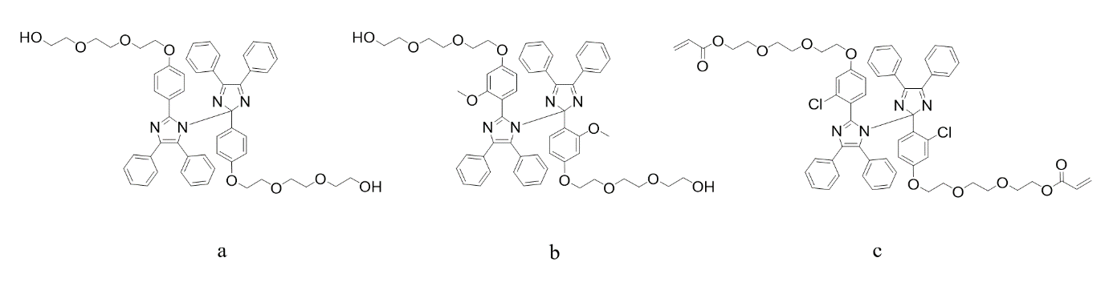
FIGURE 4. Chemical Structures for (a) dihydroxy no-HABI. (b) dihydroxy o-me-HABI. (c) diacrylate Cl-HABI.

Electrospray Ionization Mass Spectrometry (ESI-MS) spectra were obtained to show the synthesis results in Fig 5. For (a), M: 445.2116 (radical+H); 887.4012 (M+H). For (b), M: 533.1790 (radical +H); 1063.3439 (M+H). For (c) M: 473.2075 (radical +H); 947.4228 (M+H).
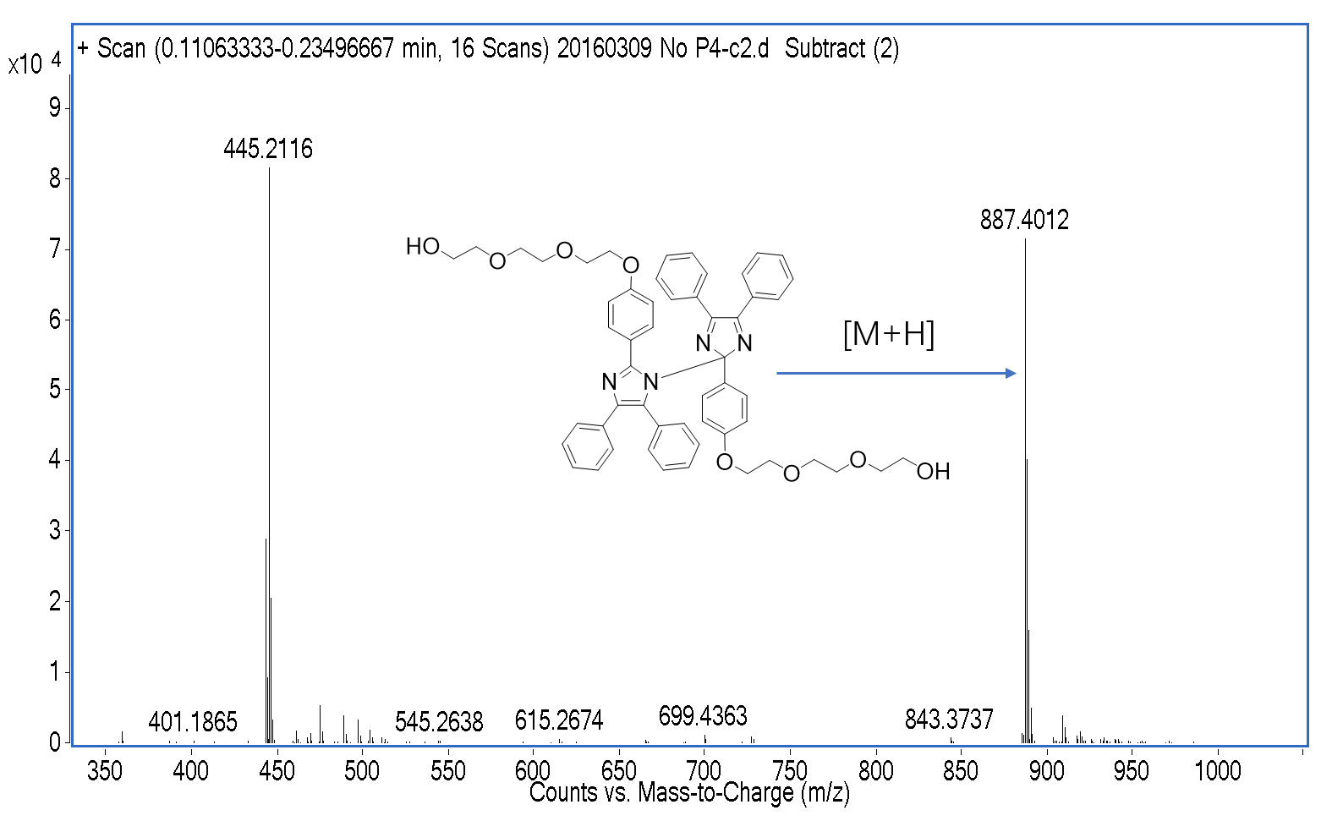
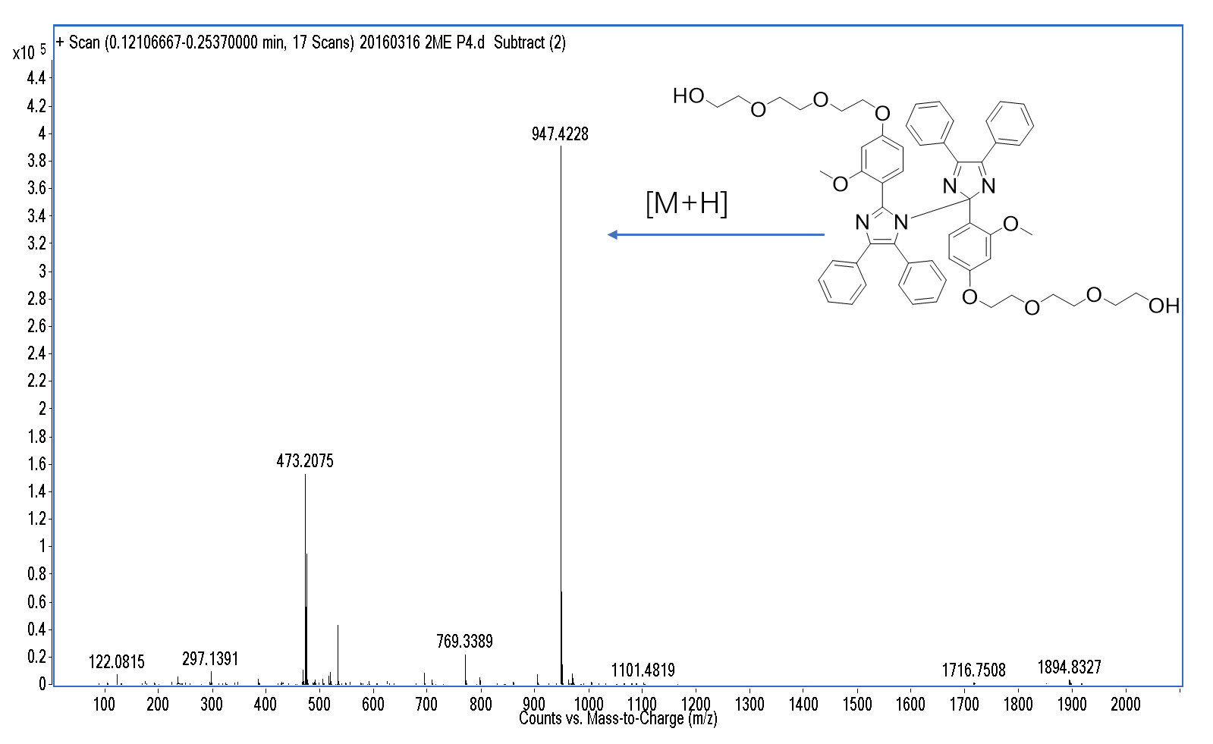
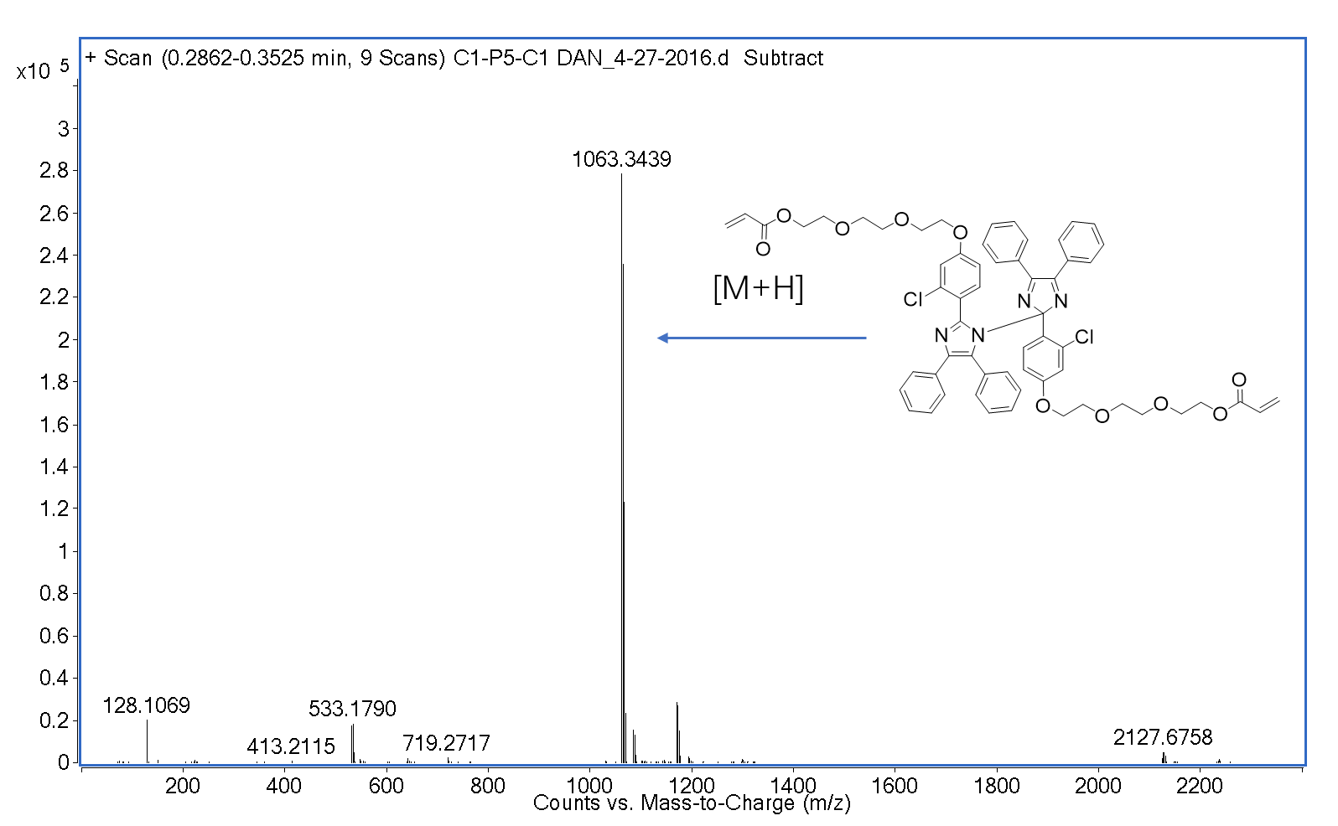
FIGURE 5. ESI-MS for (b) dihydroxy no-HABI. (c) dihydroxy o-me-HABI. (d) diacrylate Cl-HABI

Polyurethane Containing Cl-HABI.
Polycaprolactone diol (PCL diol, Sigma-Aldrich, Inc., US) and Desmodur® N 3390 BA/SN (HDI trimer, equivalent weight approx. 214, Bayer, DE) was used as received. The polyurethane containing dihydroxy Cl-HABI was formulated as a mixture containing 50 % (hydroxyl groups percentage) dihydroxy Cl-HABI and 50 % PCL diol for the hydroxyl groups such that the hydrogen and isocyanate functional groups were present at a 1:1.12 stoichiometric ratio, and used as a polyurethane resin. For convenience, dihydroxy Cl-HABI which was the product of the last but one step reaction, but not the final product of the synthesis procedure of diacrylate Cl-HABI, was used to prepare polymer network. The hydroxyl and isocyanate functional groups were not present at a 1:1 stoichiometric ratio to prevent slight consumption of isocyanate group caused by water exposure. During the polymerization process, nitrogen protection was applied in case of degradation since isocyanate is extremely sensitive to water. After monomers were mixed and stirred to be evenly blended, the mixture was casted on glass slides by blading and then samples were kept at room temperature for overnight.

Light Sources and Intensity Measurement
Blue light was provided by an LED-based dental lamp (GLight, GC America) through a longpass filter (435nm cut-on wavelength) to yield a single emittance curve peak centered at 469nm (full width at half maximum (FWHM) 29nm), while violet light was provided by a collimated, LED-based illumination source (Thorlabs M405L2-C) with an emittance centered at 405nm (FWHM 13nm) controlled by a current-adjustable LED driver (Thorlabs LEDD1B) for intensity adjustment. UV light was provided by a high-pressure mercury vapor lamp (EXFO Acticure 4000) with a filter to isolate the 365nm spectral line (FWHM 10nm). Irradiation intensities were measured by an International Light IL1400A radiometer equipped with a broadband silicon detector (model SEL033), a 10× attenuation neutral density filter (model QNDS1), and a quartz diffuser (model W).
UV–vis Spectrophotometry
UV–vis spectrophotometry was performed on an Agilent Technologies Cary 60 UV–vis spectrophotometer. Samples were dissolved in DMF with a weight fraction of 1% and the spectra were collected from 200 to 800nm on the solutions using a 1mm pathlength quartz cuvette both in the dark and under irradiation once the radical concentration reached equilibrium. HABI photodissociation and subsequent recombination was examined by monitoring the absorption wavelengths for dihydroxy no-HABI, dihydroxy o-me-HABI and diacrylate Cl-HABI, respectively, while the sample solutions in the cuvette were irradiated with 455 nm light by the Thorlabs LED light source positioned approximately 20 cm from the sample for 2 min to ensure radical concentration equilibration, then for a further 2 min after the light was turned off.

RESULTS AND DISCUSSION
Dissolution of HABI compounds are typically yellow indicating that they exhibit decent absorbance in the blue region of the spectrum. However, these solutions undergo greatly color-change ranging from indigo to teal via irradiation corresponding to dissociation of HABIs and generation of lophyl radical species [35]. This transition suggests that UV-vis spectrophotometry is a convenient way to detect and monitor the photo-dissociation of HABIs and subsequently the recombination process of lophyl radicals in dark condition.
The evolution of ultraviolet/visible light absorbance of HABI photoinitiators in darkness and upon irradiation with 455 nm light at 10 mW·cm⁻² until reactions attain steady state are shown in FUGURE 6. The unirradiated samples and irradiated samples of the all four compounds displayed similar low absorbance at 455 nm. Thus, 455 nm light was used as the irradiation wavelength to exhibit HABIs’ photodissociation to avoid excessive light attenuation and concomitant concentration inhomogeneity in different samples. The peak absorbance wavelengths (i.e., λ_{max}) of the dihydroxy no-HABI, dihydroxy o-me-HABI, diacrylate Cl-HABI and o-Cl-HABI solutions while under irradiation (612 nm, 702 nm, 606 nm and 556 nm respectively) are not overlapped by the absorbance spectra of the respective parent HABI solutions. Thus the lophyl radical concentration curves can be determined by simply monitoring λ_{max} conveniently without deconvoluting the radical absorbance from an underlying absorbance of the parent compound. Notably, the absorbance attained from UV-vis spectroscopy is qualitative and not provide a direct measure of the radical concentration, thus Electron paramagnetic resonance (EPR) spectroscopy, which allowing the direct measurement of radical concentration should be done in future work for further investigation. [36]
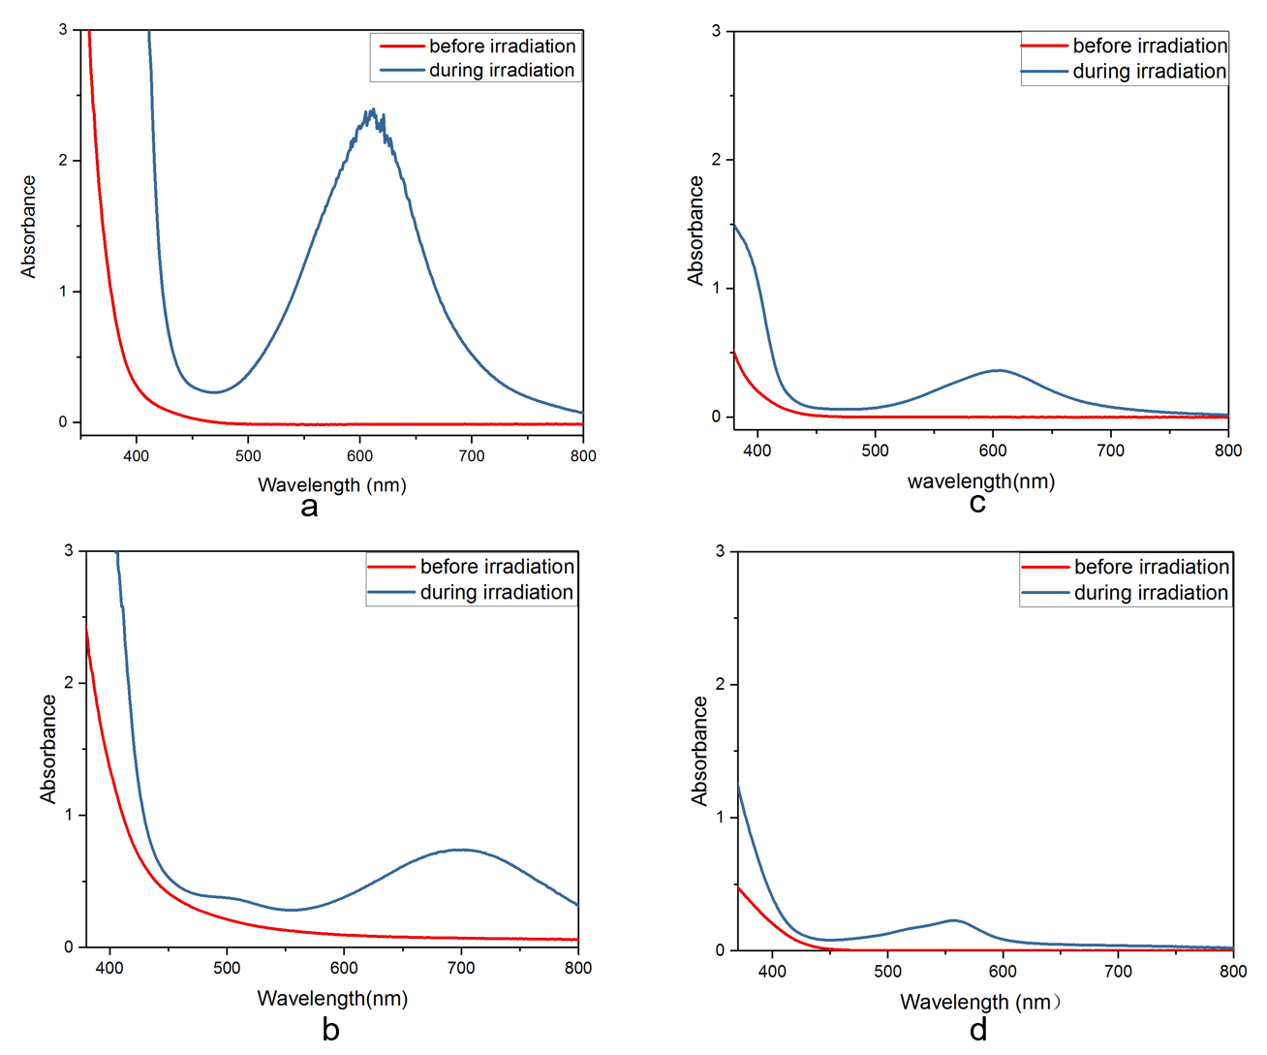
FIGURE 6. UV–vis absorbance spectra for (a) dihydroxy no-HABI (b) dihydroxy o-me-HABI (c) diacrylate Cl-HABI (d) o-Cl-HABI and prior to (red line) and during (blue line) irradiation with 405nm at 10 mW·cm⁻².

As shown in FIGURE 6, all four HABIs display extended absorption tailing into the visible region of spectra, but o-Cl-HABI displays lowest absorbance at short wavelengths, while o-me-HABI displays highest absorbance at the same region. During irradiation, these HABI photoinnitiator solutions turn to indigo, absorbing strongly throughout the visible spectrum with absorbance peaks at 612 nm, 702 nm, 606 nm and 556 nm respectively for dihydroxy no-HABI, dihydroxy o-me-HABI, diacrylate Cl-HABI and o-Cl-HABI. Among them, dihydroxy no-HABI has the highest absorbance indicating its excellent dynamic properties and radical forming capability.
Commercially available HABI photoinitiators such as o-Cl-HABI typically exhibit low absorbance throughout UV-vis spectra, as shown in FIGURE 6 (d). Additionally, they usually exhibit poor solubility in common solvents and resins [37], which adds difficulty to the characterization and photopolymerization of these commercial chemicals as applied to common applications. Fortunately, the synthetic accessibility of HABIs makes it possible to improve their properties through chemical modifications. Generally, there are two methods to modify HABI compounds. One is affixing long alkoxy or alkyl substituents at the para-position of the phenyl rings[29, 32]which induces a corresponding bathochromic shift in the absorption spectrum by incorporating extended π-conjugation moieties [33]. The other method is affixing electron donating or electron withdrawing groups attached to the ortha or meta positons to affect the homogeneous dissociation of HABIs. In this study, both the method of affixing long alkoxy substituents at para-position (i.e., ethoxyethoxyethnol tails of dihydroxy no-HABI, dihydroxy o-me-HABI, diacrylate Cl-HABI) and the method of affixing substituents to ortha and meta positions (dihydroxy o-me-HABI, diacrylate Cl-HABI) have been investigated. The UV-vis spectra results showed that all synthetic HABIs have a higher absorbance under irradiation, indicating higher activity upon irradiation and better performance in homogeneous formation of lophyl radicals. A good radical-forming capability effectively equips these synthetic HABIs with better crack-healing ability or shape-changing ability in the future applications such as self-healing materials and shape-memory materials. The spectra show that dihydroxy no-HABI has the best intensity during irradiation among three synthetic HABIs. However, the mechanism behind this high absorbance hasn’t been confirmed in this study. A possible explanation is that flexible hydroxyhexyl pendant groups enhance their driving force to generate lophyl radicals, which are the joint characteristic for three synthetic HABIs. Surely, the affixed hydroxyhenxyl pendant groups increase the solubility of synthetic HABIs in allyl solvent and polar organic solvents comparing to unfunctionalized o-Cl-HABI, which is confirmed in following experiments. This enhanced solubility indicates that the synthetic HABIs are more suitable for photopolymerization.
Moreover, HABI photolysis is highly efficient with quantum yields approaching two, which means that approximately two lophyl radicals are generated for each absorbed photon [31, 38]. At the same time, lophyl radicals generated during irradiation are unexpectedly stable and will not initiate vinyl polymerization in the absence of a hydrogen donating thiol coinitiator [31]. The stability of the generated lophyl radicals results in slow recombination rates where the recombination happens over several minutes. Thus, the capability of generating long-lived lophyl radicals provide the potential to be used as self-healing or shape-changing materials with splendid performance.
Applications for Functionalized HABIs
SCHEME 3. Formulation for polyurethane networks which containing dihydroxy Cl-HABI. PCL diol is used as hydrogen component with dihydroxy Cl-HABI together to react with isocyanate component which is HDI trimer here.
The mechanism of polyurethane networks which containing dihydroxy Cl-HABI is showed in SCHEME 3. However, the requirement to prohibit the existence of water during polyurethane polymerization is extremely harsh and hardly reached. The presence of water in the polymer network will largely affect the accuracy of thermal properties analysis in following experiments. In this study, it is believed that there was water in the polymer materials owning to the changes of rigidity before and after Dynamic Mechanical Analysis; thus the inaccurate results of thermal properties are not shown in this paper. Future investigations in water-proof synthesis and polymerization procedures is needed to achieve better thermal and mechanical properties of HABI-polymer networks.
Potential Applications for Polyurethane Containing Cl-HABI Shape Memory Networks
After the preparation of HABI-containing polymer network, shape-memory behavior was studied as shown in FIGURE 7, to testify the potential of HABI dynamic covalent networks as shape-memory materials.
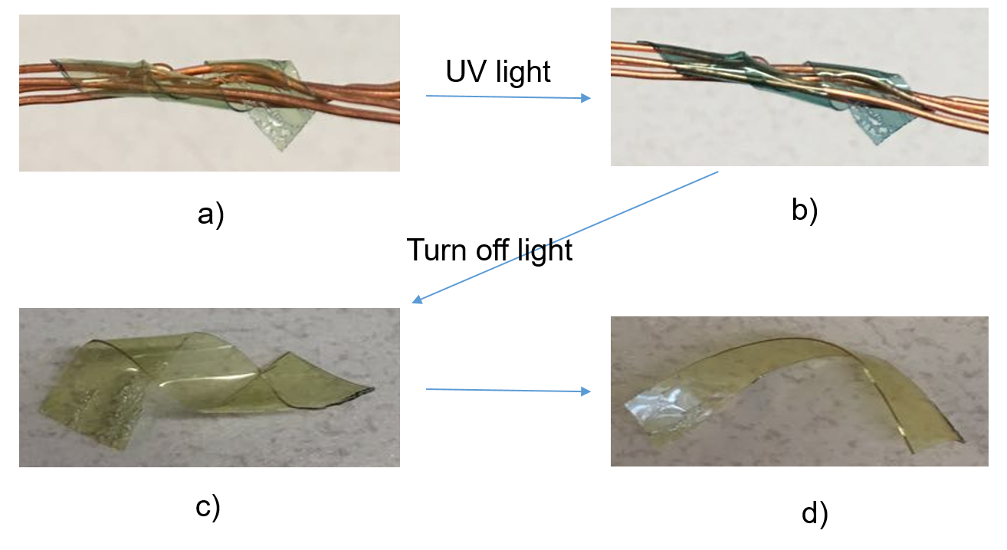
FIGURE 7. Tests for photo-induced shape memory effects in polyurethane which containing Cl-HABI moieties. a) Twined polymer film on wires to give it deformation. b) While the film still twining on wires, 455 nm light was applied and polymer film turn from yellow to indigo colored. c) Remove the sample from wires and kept in ambient condition. d) After fifteen minutes, the sample shape changed to the condition as shown in d).
The polymer film which containing dihydroxy Cl-HABI was twined on cooper wires to a temporary shape. During the deformation process, 455 nm light was used to provide luminous energy to this system until the film was stabilized at indigo-colored condition. Later, the film was carefully removed from wires without exerting anymore external force and was kept at ambient condition. Fifteen minutes later, the film was still partially kept in the given shape which means the memorial behavior was not entirely exhibited.
This test of shape memory polymer networks was a not complete success but indicated the possibility of shape-memory behavior in HABI-containing polymer networks. One important reason for the failure is the chosen polymer network did not exhibit appropriate thermal behavior which should have shown rubbery properties at room temperature. The next step should be selecting another polymer network for the designed polymer film to be used as elastomer at room temperature. Although the design of HABI-containing polymer networks failed to exert benign functions, there are great number of replacing formula to incorporate HABI into polymer networks which can potentially exhibit better performance using HABI as a switch responding to external stimuli.
CONCLUSIONS
Upon irradiation with UV or short wavelength visible light, HABIs dissociate and generate lophyl radicals which are uncommonly stable and long-lived, able to thermally recombine over several minutes to produce HABI moieties again. Notably, lophyl radicals show uncommonly slow recombination rates and during both process there is no parasitic product and mechanical properties sacrifice. These features make HABIs promising as healing materials and shape-changing materials. To address the shortcomings of o-Cl-HABI, one of commercially-available HABI photoinitiators with limit visible light absorptivity, several novel functionalized HABI (dihydroxy no-HABI, dihydroxy o-me-HABI, and diacrylate Cl-HABI) were successfully synthesized and demonstrated increased light absorbance in yellow to red range after affixing hydroxyhenxyl pendant group and ortha, meta position substituents. Surprisingly, dihydroxy no-HABI exhibits the best absorptive ability throughout UV-vis spectrum, suggesting larger potentials in fabrication of self-healing and shape-changing materials.
OUTLOOK AND FUTURE
Given the stable and long lifetime of the lophyl radicals generating from HABI photodissociation, the good radical-forming capability of HABI brings extraordinary properties unattainable in traditionally consistently materials. For example, the relative stable HABI-derived lophyl radicals yield a substantially reversibility, where the hemolytic cleaved covalent C-N bond spontaneously reforms without parasitic side reactions, imparting autonomous healing characteristics. Because of the longevity, these lophyl radicals can compensate the reduced chain mobility within glassy resins and provide sufficient time for healing. Additionally, owing to the low binding energy of inter-imidazole bonds, HABI-based functionalities can act as mechanophores if incorporated into crosslinked polymer networks, where mechanical forces can selectively break the incorporated HABI groups and generate indigo-colored lophyl radicals.
Another possible application for HABIs incorporated polymer networks is as shape memory materials. The reversibility of HABI photocleavage will be exploited to afford photoinduced, elastomeric shape memory effects with no concomitant modulus loss. During irradiation, lophyl radicals generate from HABI compound and polymer networks will be kept in a specific designed shape when applying mechanical force. When the irradiation was removed, the polymer networks with HABI-derived lophyl radicals are maintained in the temporary shape owing to the inherent reversibility lophyl radicals recombining with each other. Afterwards, mechanical force subtracting from the networks, the polymer networks retain a pre-designed shape. Conversely, crosslinked polymer network can reverse to its originally shape when apply irradiation again, where the strain change during deformation process can be memorized and stable temporary shape can be reversed. Moreover, HABIs are sensitive to photo stimuli in a wide range of wavelength, thus the required triggered wavelength is wide to induce configuration change. Besides, comparing to traditional thermal phase transition in thermal-induced shape memory polymer which sacrifices their mechanical properties, photo-mediated dissociation of HABI moieties in the backbone of cross-linked elastomers has no sacrifice of mechanical properties.

ACKNOWLEDGEMENTS
The authors gratefully acknowledge the support for this work by the Rackham Research Grant and kindly guidance from Dr. Timothy F. Scott and Mr. Dowon Ahn.
REFERERENCES
[1] E. J. Corey, “The Logic of Chemical Synthesis: Multistep Synthesis of Complex Carbogenic Molecules(Nobel Lecture),” Angew. Chemie Int. Ed. English, vol. 30, no. 5, pp. 455–465, May 1991.
[2] J.-M. Lehn, “Dynamic Combinatorial Chemistry and Virtual Combinatorial Libraries,” Chem. - A Eur. J., vol. 5, no. 9, pp. 2455–2463, Sep. 1999.
[3] S. J. Rowan, S. J. Cantrill, G. R. L. Cousins, J. K. M. Sanders, and J. F. Stoddart, “Dynamic covalent chemistry.,” Angew. Chem. Int. Ed. Engl., vol. 41, no. 6, pp. 898–952, Mar. 2002.
[4] Y. Jin, C. Yu, R. J. Denman, and W. Zhang, “Recent advances in dynamic covalent chemistry,” Chem. Soc. Rev., vol. 42, no. 16, p. 6634, Aug. 2013.
[5] R. Wyler, J. de Mendoza, and J. Rebek, “A Synthetic Cavity Assembles Through Self-Complementary Hydrogen Bonds,” Angew. Chemie Int. Ed. English, vol. 32, no. 12, pp. 1699–1701, Dec. 1993.
[6] J.-F. Xu, Y.-Z. Chen, L.-Z. Wu, C.-H. Tung, and Q.-Z. Yang, “Dynamic Covalent Bond Based on Reversible Photo [4 + 4] Cycloaddition of Anthracene for Construction of Double-Dynamic Polymers,” Org. Lett., vol. 15, no. 24, pp. 6148–6151, Dec. 2013.
[7] L. P. Engle and K. B. Wagener, “A Review of Thermally Controlled Covalent Bond Formation in Polymer Chemistry,” J. Macromol. Sci. Part C Polym. Rev., vol. 33, no. 3, pp. 239–257, Aug. 1993.
[8] C. J. Kloxin, T. F. Scott, B. J. Adzima, and C. N. Bowman, “Covalent Adaptable Networks (CANs): A Unique Paradigm in Cross-Linked Polymers,” Macromolecules, vol. 43, no. 6, pp. 2643–2653, Mar. 2010.
[9] O. Diels and K. Alder, “Synthesen in der hydroaromatischen Reihe,” Justus Liebig’s Ann. der Chemie, vol. 460, no. 1, pp. 98–122, 1928.
[10] M. A. Tasdelen, “Diels–Alder ‘click’ reactions: recent applications in polymer and material science,” Polym. Chem., vol. 2, no. 10, p. 2133, 2011.
[11] H. Laita, S. Boufi, and A. Gandini, “The application of the Diels-Alder reaction to polymers bearing furan moieties. 1. Reactions with maleimides,” Eur. Polym. J., vol. 33, no. 8, pp. 1203–1211, Aug. 1997.
[12] † Cécile Goussé, *,† and Alessandro Gandini, and ‡ Philip Hodge*, “Application of the Diels−Alder Reaction to Polymers Bearing Furan Moieties. 2. Diels−Alder and Retro-Diels−Alder Reactions Involving Furan Rings in Some Styrene Copolymers,” 1998.
[13] Rana Gheneim, and Catalina Perez-Berumen, and A. Gandini*, “Diels−Alder Reactions with Novel Polymeric Dienes and Dienophiles: Synthesis of Reversibly Cross-Linked Elastomers,” 2002.
[14] E. Goiti, F. Heatley, M. B. Huglin, and J. M. Rego, “Kinetic aspects of the Diels–Alder reaction between poly(styrene-co-furfuryl methacrylate) and bismaleimide,” Eur. Polym. J., vol. 40, no. 7, pp. 1451–1460, Jul. 2004.
[15] E. Goiti, M. B. Huglin, and J. M. Rego, “Some properties of networks produced by the Diels–Alder reaction between poly(styrene-co-furfuryl methacrylate) and bismaleimide,” Eur. Polym. J., vol. 40, no. 2, pp. 219–226, 2004.
[16] X. Chen et al., “A Thermally Re-mendable Cross-Linked Polymeric Material,” Science (80-. )., vol. 295, no. 5560, 2002.
[17] M. Watanabe and N. Yoshie, “Synthesis and properties of readily recyclable polymers from bisfuranic terminated poly(ethylene adipate) and multi-maleimide linkers,” Polymer (Guildf)., vol. 47, no. 14, pp. 4946–4952, 2006.
[18] B. Gotsmann, U. Duerig, J. Frommer, and C. J. Hawker, “Exploiting Chemical Switching in a Diels–Alder Polymer for Nanoscale Probe Lithography and Data Storage,” Adv. Funct. Mater., vol. 16, no. 11, pp. 1499–1505, Jul. 2006.
[19] K. Ishida and N. Yoshie, “Synthesis of Readily Recyclable Biobased Plastics by Diels-Alder Reaction,” Macromol. Biosci., vol. 8, no. 10, pp. 916–922, Oct. 2008.
[20] Y.-L. Liu, C.-Y. Hsieh, and Y.-W. Chen, “Thermally reversible cross-linked polyamides and thermo-responsive gels by means of Diels–Alder reaction,” 2006.
[21] C. E. Hoyle, A. B. Lowe, and C. N. Bowman, “Thiol-click chemistry: a multifaceted toolbox for small molecule and polymer synthesis,” Chem. Soc. Rev., vol. 39, no. 4, p. 1355, 2010.
[22] S. R. Trenor, T. E. Long, and B. J. Love, “Photoreversible Chain Extension of Poly(ethylene glycol),” Macromol. Chem. Phys., vol. 205, no. 6, pp. 715–723, Apr. 2004.
[23] C. J. Kloxin, T. F. Scott, B. J. Adzima, and C. N. Bowman, “Covalent Adaptable Networks (CANs): A Unique Paradigm in Cross-Linked Polymers,” Macromolecules, vol. 43, no. 6, pp. 2643–2653, Mar. 2010.
[24] W. J. Tomlinson, E. A. Chandross, R. L. Fork, C. A. Pryde, and A. A. Lamola, “Reversible Photodimerization: a New Type of Photochromism,” Appl. Opt., vol. 11, no. 3, p. 533, Mar. 1972.
[25] G. Kaur, P. Johnston, and K. Saito, “Photo-reversible dimerisation reactions and their applications in polymeric systems,” Polym. Chem., vol. 5, no. 7, pp. 2171–2186, 2014.
[26] T. F. Scott, A. D. Schneider, W. D. Cook, and C. N. Bowman, “Photoinduced Plasticity in Cross-Linked Polymers,” Science (80-. )., vol. 308, no. 5728, 2005.
[27] T. F. Scott, R. B. Draughon, and C. N. Bowman, “Actuation in Crosslinked Polymers via Photoinduced Stress Relaxation,” Adv. Mater., vol. 18, no. 16, pp. 2128–2132, Aug. 2006.
[28] T. Hayashi and K. Maeda, “Preparation of a New Phototropic Substance,” Bull. Chem. Soc. Jpn., vol. 33, no. 4, pp. 565–566, Apr. 1960.
[29] Y. Shi, J. Yin, M. Kaji, and H. Yori, “Synthesis of a novel hexaarylbiimidazole with ether groups and characterization of its photoinitiation properties for acrylate derivatives,” Polym. Eng. Sci., vol. 46, no. 4, pp. 474–479, Apr. 2006.
[30] M. Kawano, T. Sano, J. Abe, and Y. Ohashi, “The First in Situ Direct Observation of the Light-Induced Radical Pair from a Hexaarylbiimidazolyl Derivative by X-ray Crystallography,” J. Am. Chem. Soc., vol. 121, no. 35, pp. 8106–8107, Sep. 1999.
[31] S. Berdzinski, N. Strehmel, H. Lindauer, V. Strehmel, and B. Strehmel, “Extended mechanistic aspects on photoinitiated polymerization of 1,6-hexanediol diacrylate by hexaarylbisimidazoles and heterocyclic mercapto compounds,” Photochem. Photobiol. Sci., vol. 13, no. 5, p. 789, 2014.
[32] Y. Shi, J. Yin, M. Kaji, and H. Yori, “Photopolymerization of acrylate derivatives initiated by hexaarylbiimidazole with ether groups,” Polym. Int., vol. 55, no. 3, pp. 330–339, Mar. 2006.
[33] A. Kikuchi, T. Iyoda, and J. Abe, “Electronic structure of light-induced lophyl radical derived from a novel hexaarylbiimidazole with π-conjugated chromophore,” Chem. Commun., vol. 0, no. 14, pp. 1484–1485, Jul. 2002.
[34] Y. Kishimoto and J. Abe, “A Fast Photochromic Molecule That Colors Only under UV Light,” J. Am. Chem. Soc., vol. 131, no. 12, pp. 4227–4229, Apr. 2009.
[35] T. Hayashi and K. Maeda, “Chemiluminescence of 2,3,4,5-Tetraphenylpyrrole,” Bull. Chem. Soc. Jpn., vol. 35, no. 12, pp. 2058–2059, Dec. 1962.
[36] J. L. Zweier, J. T. Flaherty, and M. L. Weisfeldt, “Direct measurement of free radical generation following reperfusion of ischemic myocardium,” Med. Sci., vol. 84, pp. 1404–1407, 1987.
[37] D. Ahn, S. S. Sathe, B. H. Clarkson, and T. F. Scott, “Hexaarylbiimidazoles as visible light thiol–ene photoinitiators,” Dent. Mater., vol. 31, no. 9, pp. 1075–1089, 2015.
[38] Q. Q. Zhu, M. Fink, F. Seitz, S. Schneider, and W. Schnabel, “On the photolysis of bis[2-(o-chlorophenyl)-4,5-diphenylimidazole] sensitized by 2-isopropylthioxanthone or Michler’s ketone,” J. Photochem. Photobiol. A Chem., vol. 59, no. 2, pp. 255–263, Jul. 1991.
[39] J. Y. Chang, S. K. Do, and M. J. Han, “A sol–gel reaction of vinyl polymers based on thermally reversible urea linkages,” Polymer (Guildf)., vol. 42, no. 18, pp. 7589–7594, 2001.
[40] J. W. Kamplain and C. W. Bielawski, “Dynamic covalent polymers based upon carbene dimerization,” Chem. Commun., no. 16, p. 1727, 2006.
[41] Yuji Higaki, * and Hideyuki Otsuka, and A. Takahara*, “A Thermodynamic Polymer Cross-Linking System Based on Radically Exchangeable Covalent Bonds,” 2006.
[42] P. Reutenauer, P. J. Boul, and J.-M. Lehn, “Dynamic Diels-Alder Reactions of 9,10-Dimethylanthracene: Reversible Adduct Formation, Dynamic Exchange Processes and Thermal Fluorescence Modulation,” European J. Org. Chem., vol. 2009, no. 11, pp. 1691–1697, Apr. 2009.
[43] Peter J. Boul, and Philippe Reutenauer, and J.-M. Lehn*, “Reversible Diels−Alder Reactions for the Generation of Dynamic Combinatorial Libraries,” 2004.

