- Merge sort (Dat Luan Lu)
This function uses the divide and conquers strategy to sort data. Merge sort will split the list in half until the sub-lists are small enough to manage then rebuild the lists in sorted order.
First, the divide phase using recursive call. I have the base case “if len(arr) <= 1” to get the list with 0 or 1 item is already sorted to stop the recursion. The “middle = len(arr) // 2” is used to find the midpoint. “Left” and “right” creates two new sub-lists by slicing the original array. “merge_sort(left, col_idx)” is the function to call itself to sort the left half and “merge_sort(right, col_idx)” is the function to call itself to sort the right half.
Second, the conquers phase using merge loop. I have three pointers is “i” for the left list, “j” for the right list and “k” for the main array. For the comparison, “if left[i][col_idx] < right[j][col_idx]:” will look inside the rows at the specific column then comparing it to decide which column is smaller. Then it will place the smaller element into “arr[k]”.
Finally, the final two “while” loop (“while i < len(left):” and “while j < len(right):”) ensure that if one list runs out of items before the other, the remaining items will be added to the end of the main array.
- Quick sort (Dat Luan Lu)
Quick sort function also uses the divide and conquers strategy by takes more pythonic approach by using list comprehension rather than just swapping elements in place.
Quick sort also has the base case similar to merge sort to check if the list is empty or has one item to return it immediately (“if len(arr) <= 1:”). The difference is quick sort has a pivot selection “pivot = arr[len(arr) // 2]” to select the pivot element as the reference point which is in this case is the middle point of the array.
Come to partitioning (list comprehensions). The function will create three new lists by iterating through the entire array:
- Left will be all rows where the value at “col_idx” smaller than the pivot’s value.
- Right will be all rows where the value at "col_idx” larger than the pivot’s value.
- Middle will be all rows where the value is equal to the pivot's value.
After partitioning step, there is the recursive step to return the result of sorting the left side + the middle value + the result of sorting the right side.
- Insertion Sort (Maxim Orechnikov)

Insertion sort is a sorting algorithm that builds a sorted list one element at a time by inserting each element into its correct position within the newly sorted portion of the list.

How the insertion sort code works:
- The function sorts a subarray defined by left and right, starting from the second element
- For each element at index i, store it in curr.
- Compare curr[col_idx] with elements in the sorted portion (from j-1 down to left).
- Shift elements larger than curr[col_idx] one position to the right.
- Insert curr into the correct position.
- The sorting is performed directly on the input list arr, modifying it without returning a new list.

- Time comparison between quick sort, merge sort and insertion sort
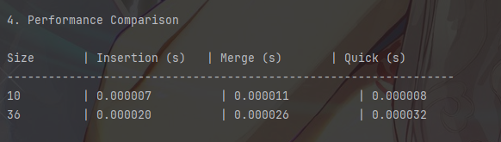
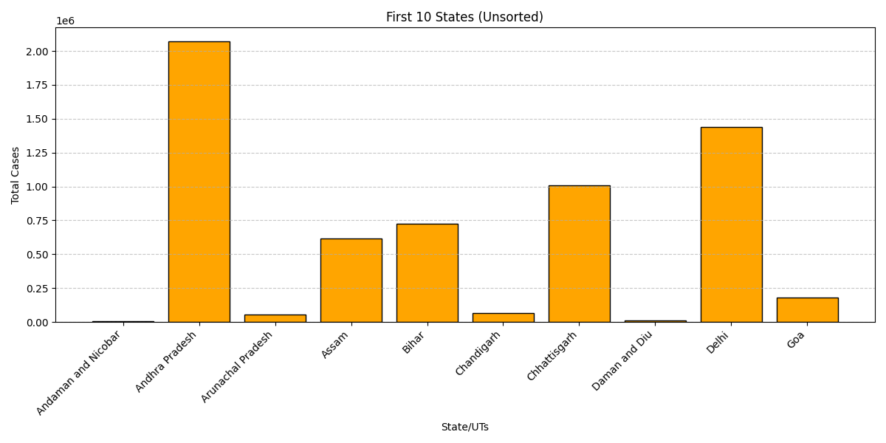

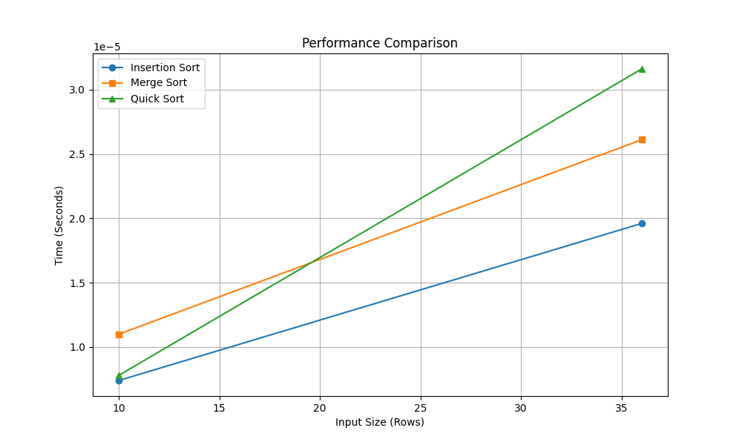
- Binary search (Dat Luan Lu)
Binary search is a search algorithm used to find a find a specific element within a sorted dataset by dividing the search interval in half (O(log N)).
However, unlike the linear search which can work with unsorted array, binary search only works on sorted array because the algorithm needs the chosen col_idx before this function is called otherwise the logic will fail.
How binary search work:
- The function will initial two values: “low = 0” is the point to the beginning of the search range and “high = len(arr) – 1” is the point to the end of search range.
- There is a loop to keep the algorithm continues if the search range is valid (“low <= high”).
- “mid = (low + high) // 2” is used to find the center index.
- Comparison step:
  - “if arr[mid][col_idx] == target:” is the Match found. The function will return the entire row found in that index.
  - “elif arr[mid][col_idx] > target:” means Too high. This means that the target must be in the left halt then the high pointer will be moved to “mid – 1”
  - “else” means Too low (value is smaller than the target). This means that the target must be in the right half then the low pointer will be moved to “mid + 1”
- If the target can not be found, the function will return None.
Example output:
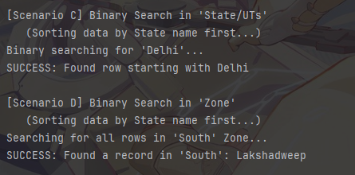
- Linear Search (Maxim Orechnikov)

Linear search is a search algorithm that checks each element in a list, one by one, until it finds the target value or reaches the end of the list. It works on both sorted and unsorted datasets, making it a versatile but less efficient search method for large datasets compared to binary search.

How linear search works:
- The function starts from the first element of the list and compares each element with the target value.
- If a match is found, the function returns the index (or the entire row) of the matching element.
- If the end of the list is reached without finding the target, the function returns “None”.
How the linear search code works:
- The function first finds the index of the search_column by comparing it with the column names stored in columns.
- If the column is not found, it returns -1.
- The function iterates through each row in array.
- For each row, it retrieves the value at col_index.
- It handles None or NaN values by skipping them.
- If the value matches search_value, the row index will be added to matches.
- If matches are found, it returns a list of row indices, If no matches are found, it returns -1.
