**Creating Bibliographies with BibTeX**

It’s easy to create a bibliography using BibTeX. You need a .bib file in the same file structure as your LaTeX document (or, if you’re using Overleaf, uploaded to your Project pane).

You can download citations in a .bib format from most any database by selecting .bib file format or BibTeX as your output. Additionally, you can export citations from citation managers (Mendeley, Zotero, and Endnote) as .bib files.

A citation in a .bib file looks similar to the image below:

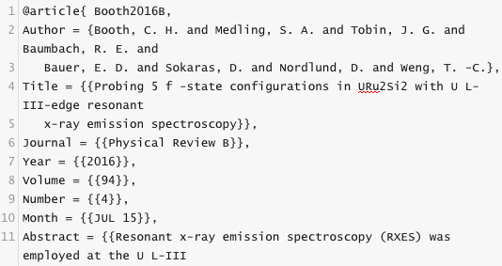

The citation record consists of a key, which will help your LaTeX document identify the correct citation data. Once you have all of your citation keys entered in your document using various commands (\citet{} – t for textual or \citep{} p for parenthesized, etc.), your bibliography will automatically generate in the style you’ve indicated.

In the preamble of your document, you need to pull in a BibTeX package. A commonly used package is Natbib, which works for both author-year and numerical citations. Three citation styles to use with Natbib are: plainnat, abbrvnat, unsrtnat.

Other packages include Harvard, apalike, Chicago, astron, and authordate.

Read more about the Natbib package [here](http://ftp.math.purdue.edu/mirrors/ctan.org/macros/latex/contrib/natbib/natbib.pdf).

Here is another brief guide to using [BibTeX from the University of Toronto](https://www.economics.utoronto.ca/osborne/latex/BIBTEX.HTM).