<Music Streaming Website>

Software Development Plan

Version <1.0>

Revision History

| **Date** | **Version** | **Description** | **Author** |
| --- | --- | --- | --- |
| <26/10/2024> | <1.0> | <Description about project plan, scope, objectives also project organization and management process> | <Nhã Uyên>, <Nhật Minh>, <Hồng Minh> |
|  |  |  |  |
|  |  |  |  |
|  |  |  |  |

Table of Contents

**1.** **Introduction 4**

**2.** **Project Overview 4**

*2.1* *Project Purpose, Scope, and Objectives 4*

*2.2* *Assumptions and Constraints 4*

*2.3* *Project Deliverables 4*

**3.** **Project Organization 4**

*3.1* *Organizational Structure 4*

*3.2* *Roles and Responsibilities 4*

**4.** **Management Process 4**

*4.1* *Project Estimates 4*

*4.2* *Project Plan 4*

4.2.1 Phase and Iteration Plan 5

4.2.2 Releases 5

4.2.3 Project Schedule 5

4.2.4 Project Resourcing 5

*4.3* *Project Monitoring and Control 5*

4.3.1 Reporting 5

4.3.2 Risk Management 5

4.3.3 Configuration Management 6

Software Development Plan

# 

# Introduction

The purpose of this document is to provide an overview of our software development project plan, the purpose and objectives of the project as well as the task assigned to each member in the team

# Project Overview

## Project Purpose, Scope, and Objectives

***Project purpose***: Provide users with a convenient tool for playing and managing their favorite music. This software allows users to search for, organize, and listen to their personal preferences.

***Scope:*** The project includes designing, developing, and testing a music player software, and playlist creation. Additional features may include offline music storage, song recommendations

***Objectives:***

* Understand the steps to complete the software
* Enhance teamwork skills
* Learn how to use various new tools

## Assumptions and Constraints

**Assumptions**

* The project will be completed within a fixed schedule of 10 weeks.
* The project team includes five members (one project manager, one developers, one tester, one UI/UX designer, and one business analyst).
* All team members will work remotely, and using Discord for meeting
* Documents and reports are stored on Google Drive
* Source codes are pushed to Github

**Constraint**

* The project must be completed within 10 weeks without any timeline extensions.
* Meetings will be held once or twice a week.
* Zero-budget project
* Project has 5 people, there will be no more people added during the project
* Each person is assigned a specific role such as tester, business analyst, project manager, developer, and developer
* Each task may be done by multiple members

## Project Deliverables

# 

| <Project Name> | Version <1.0> |
| --- | --- |
| Software Development Plan | Date: <27/10/2024> |
| User Interface (UI/UX) design document | Date: <10/11/2024> |
| Software source code document | Date: <8/12/2024> |
| Software testing document | Date: <18/12/2024> |
| User manual document | Date: <21/12/2024> |

# 

# Project Organization

## Organizational Structure



## Roles and Responsibilities

| **Person** | **Role** |
| --- | --- |
| Đỗ Lương Nhật Minh | **Project manager**   * Oversee the team, allocate resources, and ensure collaboration. * Identify potential risks, create mitigation strategies, and resolve issues. * Define project scope, create a timeline, and establish goals. |
| Võ Thị Hồng Minh | **Business analyst**   * Identify and document project requirements * Break down requirements into detailed specifications for developers and designers. * Analyze and optimize business processes where necessary. |
| Nguyễn Hoàng Như | **Designer**   * Design user interface and user experience * Work with developers to ensure design viability and implementation accuracy. * Create wireframes, prototypes, and high-fidelity UI designs focusing on user experience. |
| Nguyễn Gia Nguyễn | **Developer**   * Write, review, and maintain code according to project specifications. * Debug and fix issues raised during testing and development. * Work closely with designers, testers, and project managers to ensure smooth integration. |
| Nguyễn Lâm Nhã Uyên | **Tester**   * Design test strategies, test cases * Identify issues, work with developers to resolve them, and retest fixes. * Ensure the final product meets the required standards |

# Management Process

## Project Estimates

## Project Plan

### Phase and Iteration Plan

Our project follow RUP process, including three phases (Inception, Elaboration, Construction) and 5 iterations, 1 iteration last 2 weeks

+**Inception phase:** 1 iteration.

+**Elaboration phase:** 1 iteration.

+**Construction phase:** 3 iterations.

Here’s the graph illustrates our project’s phases and milestones:

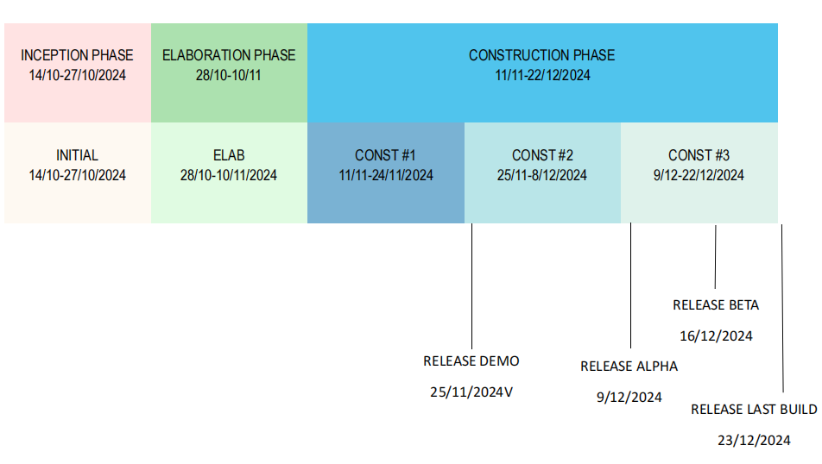

Here’s our objectives for each phase:

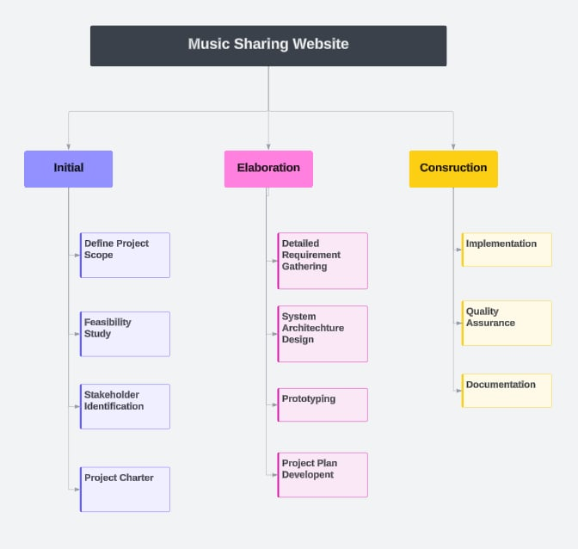

Here’s our plan to propose artifacts:

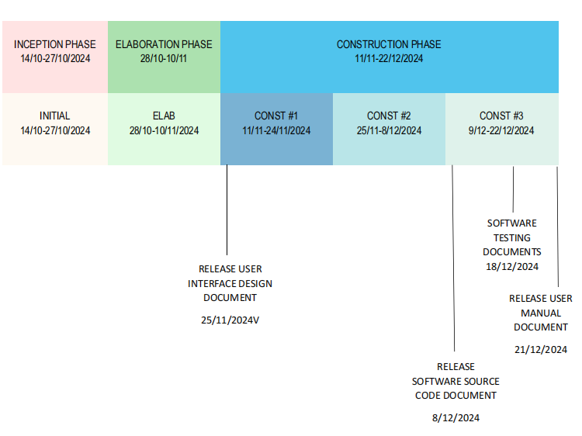

### Releases

Project Schedule

| **Milestone** | **Time** | **Objective** |
| --- | --- | --- |
| Demo Release | 25/11/2024 | Showcase the user interface and some basic functions (LogIn, SignUp) to gather initial feedback from stakeholders or internal teams. |
| Alpha Release | 9/12/2024 | Provide all basic features including registration, login, music player, and search for internal testing and feedback from the development and testing teams. |
| Beta Release | 16/12/2024 | Introduce advanced features like following artists, notifications, creating playlist, recommendation section, artist music upload for a select group of users to test and provide feedback. |
| Final Release | 23/12/2024 | Deliver a nearly complete version with all features tested, ready for final review and approval, and then deploy the fully functional website to the production environment for end users. |

4.2.3 *Project Schedule:*

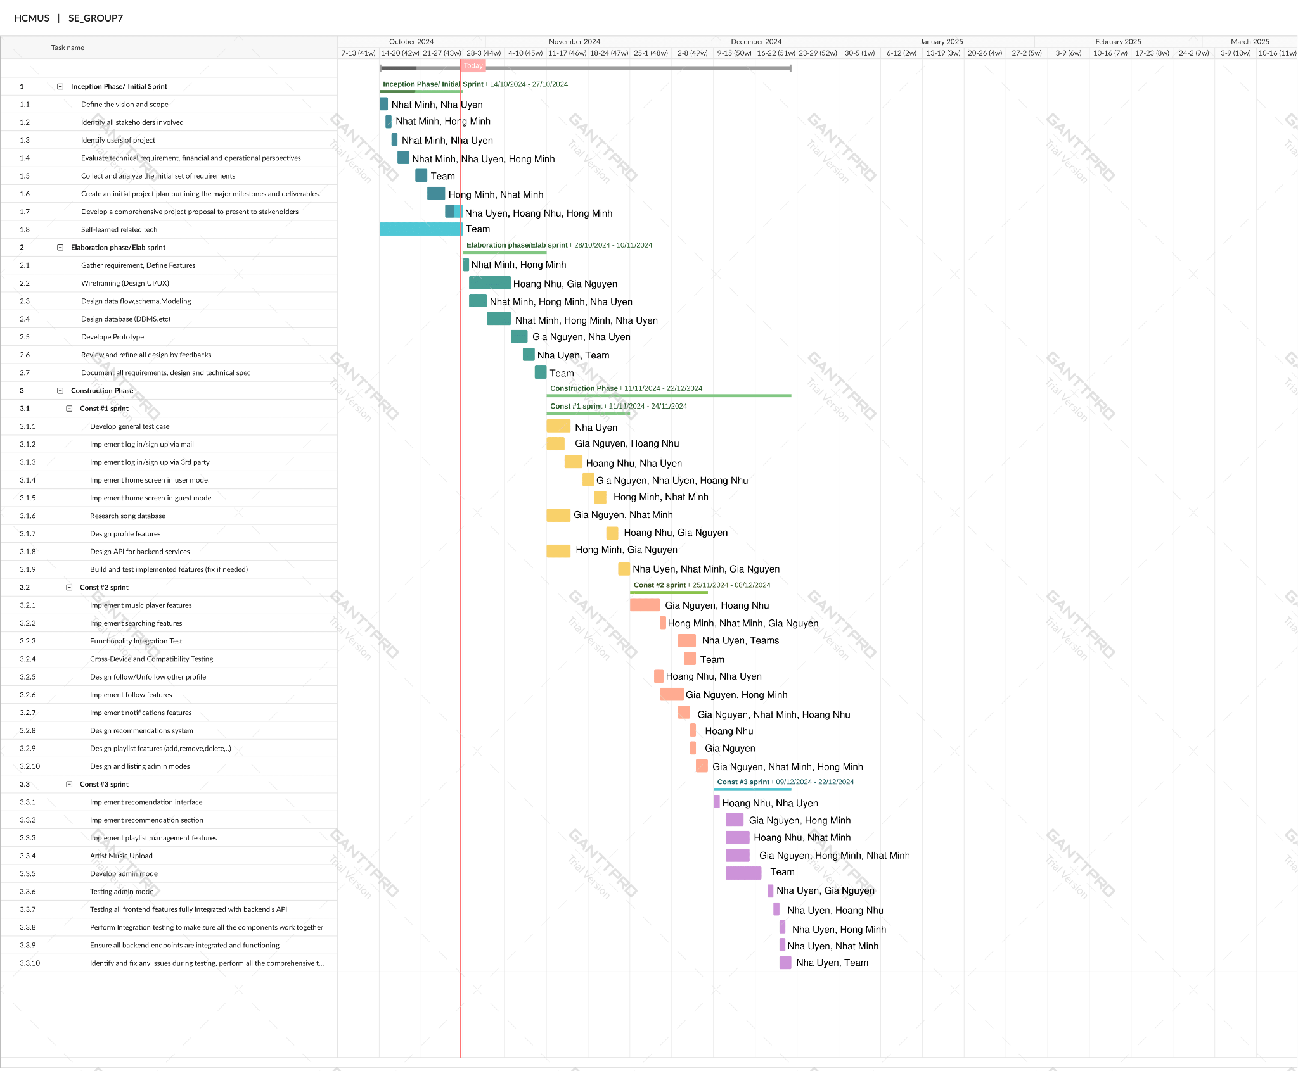

| **Task Name** | **Duration** | **Start** | **Finish** | **Resource Names** |
| --- | --- | --- | --- | --- |
| **Inception Phase** | 14 days | 14/10 | 27/10 |  |
| **Initial** | 14 days |  |  |  |
| Clearly define the vision and scope of the music streaming website | 1 days | 14/10 | 14/10 | Đỗ Lương Nhật Minh.  Nguyễn Lâm Nhã Uyên |
| Identify all stakeholders involved in the project. | 1 days | 15/10 | 15/10 | Đỗ Lương Nhật Minh, Võ Thị Hồng Minh |
| Identify users of project | 1 days | 16/10 | 16/10 | Đỗ Lương Nhật Minh.  Nguyễn Lâm Nhã Uyên |
| Evaluate technical requirement(technology stack, tools, and platform required,...), financial (costs, budgets, operational perspectives (including resource availability and organizational readiness) | 3 days | 17/10 | 19/10 | Đỗ Lương Nhật Minh.  Nguyễn Lâm Nhã Uyên,  Võ Thị Hồng Minh |
| Collect and analyze the initial set of requirements for the project. | 2 days | 20/10 | 21/10 | Team |
| Create an initial project plan outlining the major milestones and deliverables. | 3 days | 22/10 | 24/10 | Đỗ Lương Nhật Minh, Võ Thị Hồng Minh |
| Develop a comprehensive project proposal to present to stakeholders(Executive Summary, Project Objectives, Business Case, Risk Management:, Stakeholder Analysis) | 3 days | 25/10 | 27/10 | Nguyễn Lâm Nhã Uyên  Võ Thị Hồng Minh,  Nguyễn Hoàng Như |
| Get used to technical tools (self learn) (Frontend Framework, Backend services) | 14 days | 14/10 | 27/11 | Team |
| **Elaboration Phase** | 14 days | 28/10 | 10/11 |  |
| **Elab** | 14 days |  |  |  |
| Gather requirement, Define Features (Core features, Prioritize Features) | 1 days | 28/10 | 28/10 | Đỗ Lương Nhật Minh,  Võ Thị Hồng Minh |
| Wireframing (UI/UX design) for key screens (Home, Log in, Profile, Music Player,..) | 7 days | 29/10 | 04/11 | Nguyễn Hoàng Như,  Nguyễn Gia Nguyễn |
| Design data flow schema, Modeling: (User, Music, Playlist,...) | 3 days | 29/10 | 31/10 | Đỗ Lương Nhật Minh,  Võ Thị Hồng Minh,  Nguyễn Lâm Nhã Uyên |
| Design table, column, relations, constraint,rules on DBMS | 4 days | 01/11 | 04/11 | Đỗ Lương Nhật Minh,  Võ Thị Hồng Minh,  Nguyễn Lâm Nhã Uyên |
| Develop Prototypes: Build interactive prototype for key flows, testing within team | 3 days | 05/11 | 07/11 | Nguyễn Lâm Nhã Uyên,  Nguyễn Gia Nguyễn |
| Review and Refine all design base on requirement and feedbacks | 2 days | 07/11 | 08/11 | Nguyễn Lâm Nhã Uyên,Team |
| Documenting all requirements, design and technical specifications. | 2 days | 09/11 | 10/11 | Team |
| **Construction Phase** | 42 days | 11/11 | 22/12 |  |
| **Const #1** | 14 days | 11/11 | 24/11 |  |
| Develop general test case | 4 days | 11/11 | 14/11 | Nguyễn Lâm Nhã Uyên |
| Implement **log in/sign up** form by mail | 3 days | 11/11 | 13/11 | Nguyễn Gia Nguyễn,  Nguyễn Hoàng Như |
| Implement **log in/sign up** features by 3rd party | 3 days | 14/11 | 16/11 | Nguyễn Hoàng Như,  Nguyễn Lâm Nhã Uyên |
| Implement **home** screen in user mode | 2 days | 17/11 | 18/11 | Nguyễn Gia Nguyễn, Nguyễn Lâm Nhã Uyên, Nguyễn Hoàng Như |
| Implement **home** screen in guest mode | 2 days | 19/11 | 20/11 | Võ Thị Hồng Minh,  Đỗ Lương Nhật Minh |
| Research for song database | 4 days | 11/11 | 14/11 | Nguyễn Gia Nguyễn,  Đỗ Lương Nhật Minh |
| Design profile layout | 2 days | 21/11 | 22/11 | Nguyễn Hoàng Như,  Nguyễn Gia Nguyễn |
| Design API for backend services | 4 days | 11/11 | 14/11 | Võ Thị Hồng Minh,  Nguyễn Gia Nguyễn |
| Test for implemented features (built) and fix bug (if needed) | 2 days | 23/11 | 24/11 | Đỗ Lương Nhật Minh,  Nguyễn Lâm Nhã Uyên,  Nguyễn Gia Nguyễn |
| **Const #2** | 14 days | 25/11 | 08/12 |  |
| Implement **music player** (drag and drop music, build API, create table for store song information,...) | 5 days | 25/11 | 29/11 | Nguyễn Hoàng Như,  Nguyễn Gia Nguyễn |
| Implement **search feature** (develop search queries for songs, artists and albums,...) | 4 days | 30/11 | 03/12 | Đỗ Lương Nhật Minh,  Võ Thị Hồng Minh,  Nguyễn Gia Nguyễn |
| Functionality Integration Test (check if data is work well and pass correctly through all functions) | 3 days | 04/12 | 06/12 | Nguyễn Lâm Nhã Uyên, Team |
| Cross-Device and Compatibility Testing: Check if basic functionality work well on different devices and browsers | 2 days | 04/12 | 06/12 | Team |
| UI: Design follow/unfollow buttons on artist pages. | 2 days | 29/11 | 30/11 | Nguyễn Hoàng Như, Nguyễn Lâm Nhã Uyên |
| Implement **artists-following** function for logged-in users | 5 days | 30/11 | 04/12 | Nguyễn Gia Nguyễn, Đỗ Lương Nhật Minh, Võ Thị Hồng Minh |
| UI: design/implement **notification** interface for users. | 2 days | 01/12 | 02/12 | Nguyễn Hoàng Như, Đỗ Lương Nhật Minh |
| Implement a **notification system** to alert users when their favorite artists release new content.  Build APIs to fetch notifications. | 3 days | 03/12 | 05/12 | Nguyễn Gia Nguyễn, Đỗ Lương Nhật Minh, Nguyễn Hoàng Như |
| Design **recommendations function** (UI, algorithm,...) | 2 days | 05/12 | 06/12 | Nguyễn Hoàng Như |
| Design **create playlist function** (UI, algorithm, database...) | 2 days | 05/12 | 06/12 | Nguyễn Gia Nguyễn |
| Design and list **all roles of admin** in the whole system | 3 days | 06/12 | 08/12 | Nguyễn Gia Nguyễn, Đỗ Lương Nhật Minh, Võ Thị Hồng Minh |
| **Const #3** | 14 days | 09/12 | 22/12 |  |
| UI: Implement interface for **song recommendations.** | 2 days | 09/12 | 10/12 | Nguyễn Hoàng Như, Nguyễn Lâm Nhã Uyên |
| Implement **recommendation section** (recommended songs, artists, albums,...) based on user listening history and other factors (new-released, trend,..) | 4 days | 11/12 | 14/12 | Nguyễn Gia Nguyễn, Võ Thị Hồng Minh |
| Implement **creating playlist function** (create/delete playlists, add/remove songs from playlists) | 5 days | 11/12 | 15/12 | Nguyễn Hoàng Như, Đỗ Lương Nhật Minh |
| Develop **Artist Music Upload** function | 5 days | 11/12 | 15/12 | Nha Uyen, Gia Nguyen, Hoang Nhu, |
| Develop **admin role** including view/disable user accounts, review and moderate content, verify artists with blue check marks. | 8 days | 11/12 | 17/12 | Team |
| Testing: Admins can manage user accounts, moderate content, and grant or revoke verified badges to artists, with all changes accurately reflected in the database. | 2 days | 18/12 | 19./12 | Nguyễn Gia Nguyễn, Nguyễn Lâm Nhã Uyên |
| UI: ensure all frontend features are fully integrated with backend APIs | 2 days | 19/12 | 20/12 | Nguyễn Hoàng Như, Nguyễn Lâm Nhã Uyên |
| Data: Perform Integration testing to make sure all the components work together. | 2 day | 20/12 | 21/12 | Nguyễn Lâm Nhã Uyên,Võ Thị Hồng Minh |
| Ensure all backend endpoints are integrated and functioning | 2 days | 20/12 | 21/12 | Nguyễn Lâm Nhã Uyên, Đỗ Lương Nhật Minh |
| Testing:Identify and fix any issues during testing, perform all the comprehensive testing of all features. | 3 days | 20/12 | 22/12 | Nguyễn Lâm Nhã Uyên, Team |

*Detailed table for Project Schedule(Task, time,duration and resource names)*

## Project Monitoring and Control

### Reporting

| **Weekly meeting** | The meeting are held every Wednesday at 12 am |
| --- | --- |
| **Weekly status report** | The report will be done 2 to 3 days after the meeting |
| **Informal chats** | All group members can discuss with each other when they meet problems during working on the project to complete the report project status better |

### Risk Management

| ***Risk ID*** | ***Risk Description*** | ***Probability*** | ***Impact*** | ***Risk Exposure*** | ***Priority*** | ***Mitigation Strategy or Contingency Plan*** |
| --- | --- | --- | --- | --- | --- | --- |
| a | Tasks was not completed on time | Occasional | Moderate | 2500 | 4 | All team members could give a hand to complete the task |
| b | Group members might have heated arguments | Seldom | Serious | 1875 | 1 | Discuss with the team what could be learned from the argument and how to avoid similar situation in the future |
| c | Unequal tasks assign | Seldom | Moderate | 1250 | 5 | Redistribution of tasks based on the discussions. Ensure that everyone has an equitable share of the workload. |
| d | Communication  difficulties | Occasional | Serious | 3750 | 2 | Promote active listening among team members. Encourage them to paraphrase what others have said to ensure understanding. |
| e | Working style differences | Likely | Insignificant | 1875 | 3 | Encourage team members to discuss their preferred working styles openly. This can help everyone understand each other's approaches better.Gi |

### Configuration Management

**Github:** for managing source code and related files.

**Google drive:** for storing and sharing documents, reports and files.

**Jira:** monitor the progress of the project.

**Discord:** for online meeting and assign tasks

**Messenger:** for team members to discuss the project outside the meeting time.