Diana Norgaard

dnorgaard@usgs.gov

Rsam2Disk 1.0 Beta

User Manual

Table of Contents

1 Overview 2

1.1 Download 2

1.2 Software Repository (for software developers) 2

1.2.1 Dependencies: 2

1.2.2 Python Modules 2

1.3 Starting Rsam2Disk 3

2 Configuration 3

2.1 Initial Configuration 3

2.2 Editing Configuration 4

2.2.1 Show Configuration 4

2.2.2 Edit Primary Server 4

2.2.3 Edit Secondary Server 5

2.3 Selecting Stations for RSAM and SSAM Calculations 5

2.4 Advanced Configuration 6

2.4.1 Inventory Filter 7

2.4.2 Log File 7

2.4.3 Primary Port and Server 7

2.4.4 RSAM Directory 8

2.4.5 Secondary Port and Server 8

2.4.6 SSAM Bands 8

2.4.7 SSAM Directory 9

2.4.8 Stations 9

2.5 Print Options 9

2.5.1 Print Stream 10

2.5.2 Print Data 10

3 Outputs 10

3.1 RSAM 10

3.2 SSAM 11

4 Logging 11

# Overview

Rsam2Disk is a stand-alone application that replaces the Glowworm Visual Basic modules Rsam2Disk and Ssam2Disk.  The application 1) obtains wave form data from an Earthworm Wave Server, 2) calculates RSAM and SSAM values, and 3) writes them to file.  The RSAM values can be calculated for 1 minute and 10 minute intervals while the SSAM value can only be calculated for 1 minute intervals.  The application has a user interface to simplify configuration.

RSAM stands for Real-time Seismic-Amplitude Measurement. It is the average signal size over a given period of time. In this application the average over 1 minute and 10 minute intervals can be calculated.

SSAM stands for Seismic Spectral-Amplitude Measurement and shows the relative signal size in different frequency bands. In this application SSAM values are calculated over 1 minute intervals.

## Download

Software is available for download from:

<https://github.com/dnorgaard-usgs/rsam2disk/releases/tag/1.0-beta>

Simply download and unzip the file in a directory of your choice. There is no installation. The site-packages directory must reside alongside the executable.

## Software Repository (for software developers)

For those familiar with Python and GitHub, the Rsam2Disk code can be cloned from:

<https://github.com/dnorgaard-usgs/RsamSsam>

This may be desirable for users who want to avoid having a large executable.

### Dependencies:

* Python 3.6 (recommend using Anaconda - see <http://conda.pydata.org/docs/index.html>)
* obspy (see <https://github.com/obspy/obspy/wiki/Installation-via-Anaconda>)
* PIL (conda install pillow)

### Python Modules

Rsasm2Disk is written in Python and contains the following modules:

|  |  |
| --- | --- |
| Module | Description |
| RsamSsam | This is the point of entry.  Execute this code to start Rsam2Disk. |
| config | Stores software execution configuration. By default it reads a JSON formatted configuration file called 'default-config.json'. Other JSON formatted configurations files can be loaded or created from within the application. |
| ui | This module contains the main GUI generation and functions. |
| controller | This module does bulk of the processing and also stores relevant data not found in config.  It uses [ObsPy](https://docs.obspy.org/) library to simplify data access to Earthworm. |
| rsam | Calculates RSAM and writes to file. DC offset calculated and removed from the RSAM values. |
| ssam | Calculates SSAM and writes to file. |

## Starting Rsam2Disk

For Windows, double click on Rsam2Disk.exe to start the program. For Linux and Mac platforms run Rsam2Disk from command line.

# Configuration

## Initial Configuration

When the program is run for the first time, the user will be prompted for the wave server it wants to read wave data from, as well as the desired output data directories:

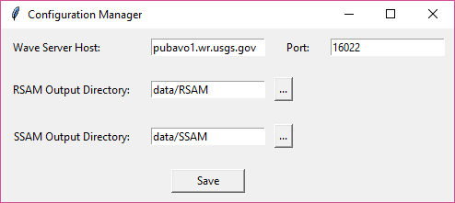

Figure 1 Configuration Manager upon initial execution

* Wave Server Host* – Enter the wave server IP or hostname.
* Port* – Enter the wave server port.
* RSAM Output Directory – Enter the desired RSAM output directory. The default directory is data/RSAM under the same directory the executable resides.
* SSAM Output Directory – Enter the desired SSAM output directory. The default directory is data/SSAM under the same directory the executable resides.

*The Configuration Manager is pre-configured with the Alaska Volcano Observatory’s publicly accessible Winston Wave Server pubavo1.wr.usgs.gov:16022. This is so that the user may test the software against another server if they have difficulty connecting to their own wave server.

## Editing Configuration

Under the Configuration menu there are three options:

* Show Configuration
* Edit Primary Server
* Edit Secondary Server

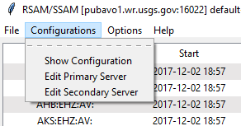

Figure 2 Configuration menu

### Show Configuration

The ‘Show Configuration’ menu item will open a pop-up to show the user the current configuration. Details on these configuration items can be found in the Advanced Configuration section.

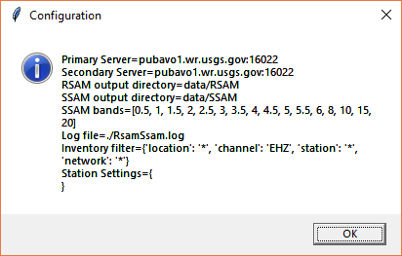

Figure 3 Show Configuration dialog

### Edit Primary Server

Users can edit the primary wave server from the ‘Edit Primary Server’ menu item. Enter a different server and/or port. Then click ‘Set’ to modify without loading (e.g. to save new configuration to file) or ‘Set and Load’ for it to take effect immediately.

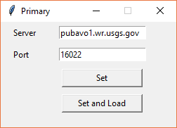

Figure 4 Edit Primary Server dialog

### Edit Secondary Server

Secondary server serves as a backup if the program loses connection to the primary server. By default, the secondary server is set to the primary server specified upon initial configuration. This can be modified through the ‘Edit Secondary Server’ menu item. The dialog works the same as the ‘Edit Primary Server’ dialog.

## Selecting Stations for RSAM and SSAM Calculations

After initial configurations the user will see a dialog window listing the available channels and times in the wave server specified. Users can enable or disable RSAM and SSAM calculations for a channel by clicking on the column of the desired calculations (RSAM 1 Min, RSAM 10 Min, or SSAM 1 Min) for the appropriate row of the channel. When calculations are enabled you will see a check mark in appropriate cell. For RSAM, after the appropriate time period has passed, it will display the latest calculated RSAM value instead of the check mark. To disable calculations, click on the appropriate check mark or RSAM value.

*Be sure to save the updated configurations through the File->Save menu after making changes!*

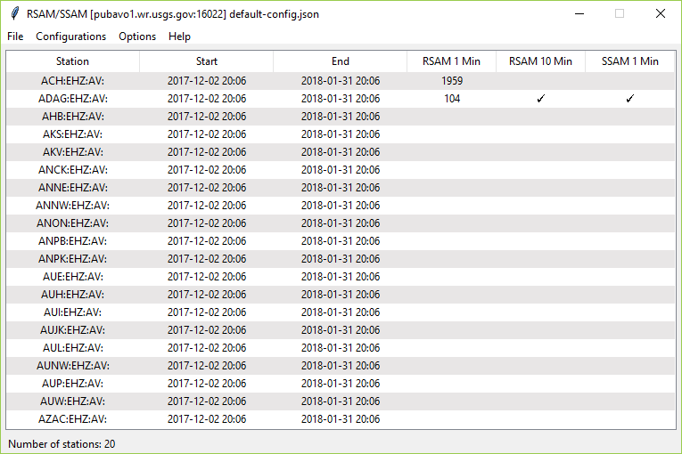

Figure 5 Rsam2Disk main user interface

## Advanced Configuration

The program will create a configuration file called *default-config.json* after hitting the Save button in Configuration Manager that opens for initial execution. This configuration file will be read each the program is restarted. Users may want to further customize their configuration by editing this file or creating a new one. Restart of Rsam2Disk is required after any edits to the configuration file.

Sample *default-config.json*:

{

"inventory_filter": {

"channel": *"EHZ"*,

"location": *"*"*,

"network": *"*"*,

"station": *"*"*

},

"log_file": *"./RsamSsam.log"*,

"primary_port": 16022,

"primary_server": *"pubavo1.wr.usgs.gov"*,

"rsam_directory": *"data/RSAM"*,

"secondary_port": 16022,

"secondary_server": *"pubavo1.wr.usgs.gov"*,

"ssam_bands": [

0.5,

1,

1.5,

2,

2.5,

3,

3.5,

4,

4.5,

5,

5.5,

6,

8,

10,

15,

20

],

"ssam_directory": *"data/SSAM"*,

"stations": {}

}

The configuration fields are listed in alphabetical order. More information on each are below.

### Inventory Filter

"inventory_filter": {

"channel": *"EHZ"*,

"location": *"*"*,

"network": *"*"*,

"station": *"*"*

},

If a wave server contains many channels, a user may want to filter it based on SCNL to optimize program performance. By default, the channel filter is set to ‘EHZ’ so only EHZ channels will show up in the program. “*” denote a wildcard and will pull all values available. You can use regular expressions to limit the number of channels it returns. For example, putting “A*” for station will only return channels whose station names begin with an “A”.

### Log File

"log_file": *"./RsamSsam.log"*,

This specifies the filename where logs will go to. The default is RsamSsam.log in the same directory as the executable. Use full or relative path.

### Primary Port and Server

"primary_port": 16022,

"primary_server": *"pubavo1.wr.usgs.gov"*,

This is the wave server and port entered during the initial configuration or through the Edit Primary Server menu. You can edit it here also.

### RSAM Directory

"rsam_directory": *"data/RSAM"*,

This is the directory where the RSAM data output files are written. It can be edited during initial configuration or here.

### Secondary Port and Server

"secondary_port": 16022,

"secondary_server": *"pubavo1.wr.usgs.gov"*,

This is the wave server and port entered during the initial configuration or through the Edit Secondary Server menu. You can edit it here also. If the program loses connection to the primary server, it will attempt to connect to the secondary server.

### SSAM Bands

"ssam_bands": [

0.5,

1,

1.5,

2,

2.5,

3,

3.5,

4,

4.5,

5,

5.5,

6,

8,

10,

15,

20

],

This is a list, in brackets, of the upper bounds for each channel’s range for purposes of SSAM calculation. In the default setting above, there are 16 frequency bands for which the relative signal size will be calculated. The first band is from 0 to 0.5 (the upper bound is exclusive), second band is from 0.5 to 1.0, third band is from 1.0 to 1.5, and so forth.

Users may modify this configuration to specify any number of upper bounds for the frequency bands to use in SSAM calculation. However, because the frequency band information is not stored in the SSAM outputs, there is no way to tell from the output files alone what the frequency bands are. Users should take caution to document this information. Future versions of the software may support inclusion of band information with the output.

### SSAM Directory

"ssam_directory": *"data/SSAM"*,

This is the directory where the SSAM data output files are written. It can be edited during initial configuration or here.

### Stations

"stations": {}

This is a dictionary list of the stations enabled to write RSAM or SSAM and its corresponding configuration. After initial configuration users must select which stations they would like to write RSAM and/or SSAM for (see section 2.3.). Then this field will look something like this:

"stations": {

"ACH:EHZ:AV:": [

1,

0,

0

],

"ADAG:EHZ:AV:": [

1,

1,

1

]

}

The channel names are in the format <station>:<channel>:<network>:<location>. The value associated with this key is a list of configurations that indicate 0 or 1. If the first configuration is 1, then the one-minute RSAM is enabled. If the second configuration is 1, then the 10-minute RSAM is enabled. If the third configuration is 1, then the one-minute SSAM is enabled. 0 indicates that particular setting is disabled.

This configuration is best done through the user interface. See section 2.3. Don’t forget to save your configurations after any changes through the user interface.

## Print Options

Under the Options menu, there are three menu items that can be used for troubleshooting purposes if necessary: Print Stream, Print Data, and Print Debug. None of the options are enabled by default. You can enable/disable an option by selecting the menu item. An enabled option will be indicated by a checkmark.

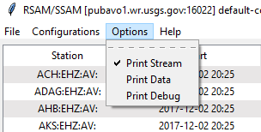

Figure 6 Options menu with Print Stream enabled

### Print Stream

Enabling the Print Stream option will output stream information to the console for channels that queried against the wave server, e.g.:

1 Trace(s) in Stream:

AV.ADAG..EHZ | 2018-01-31T20:23:00.000000Z - 2018-01-31T20:24:00.000000Z | 100.0 Hz, 6001 samples

Typically, a minute’s worth of data is retrieved at a time. The above indicates the channel name, start and end time of the stream, sample rate, and number of samples.

### Print Data

Enabling the Print Data option will output to console the calculated RSAM or SSAM values to the console. This is the same text that is written to the output files.

For RSAM, there values printed are the channel name, period end time, RSAM value, max value of signal in duration, min value of signal in duration, number of samples, and the DC offset. E.g.:

ACH:EHZ:AV: 31-Jan-2018 21:02:00, 001955, 005925, -06301, 6001, 386

For SSAM, the channel name and end time, followed by the calculated SSAM values for each frequency band, are printed. E.g.:

ADAG:EHZ:AV: 31-Jan-2018 21:24 00038 00063 00058 00042 00040 00043 00053 00039 00048 00041 00033 00046 00026 00014 00008 00004

# Outputs

## RSAM

RSAM output filename in *RSAM_<yyyymmdd>_<station>_<channel>_<network>_<location>_<duration in seconds>.csv*

Column 1 is date/time of RSAM calculation. It indicates the end of the period (1 min or 10 min) for which data was calculated.

Column 2 is the RSAM value with DC offset removed

Column 3 is the max amplitude value for duration

Column 4 is the min amplitude value for duration

Column 5 is the number of sample points used.  When the trend changes here it may indicate missing data.

Column 6 is the estimated DC offset.

Example:

15-Feb-2017 00:31:00, 6, 59, -4, 6001, 29

## SSAM

SSAM output file name is *SSAM_<yyyymmdd>_<station>_<channel>_<network>_<location>_<duration in seconds>.dat*

Data is space delimited. First value is the date/time of SSAM calculation. It indicates the end of the period (1 min) for which data was calculated. This is followed by the SSAM values for each frequency band used in configuration.

In example below, 00099 is the SSAM value for the frequency band 0 to 0.5.  00109 is the SSAM value for frequency band 0.5 to 1. And so forth.

16-Feb-2017 00:13 00099 00109 00115 00113 00105 00091 00074 00060 00049 00045 00043 00042 00056 00069 00073 00088 0033

# Logging

Basic output is made to standard output.  This is the console window that opens when running from Window, or in the terminal for Linux.

Some logging is also done to log file specified in the configuration file.