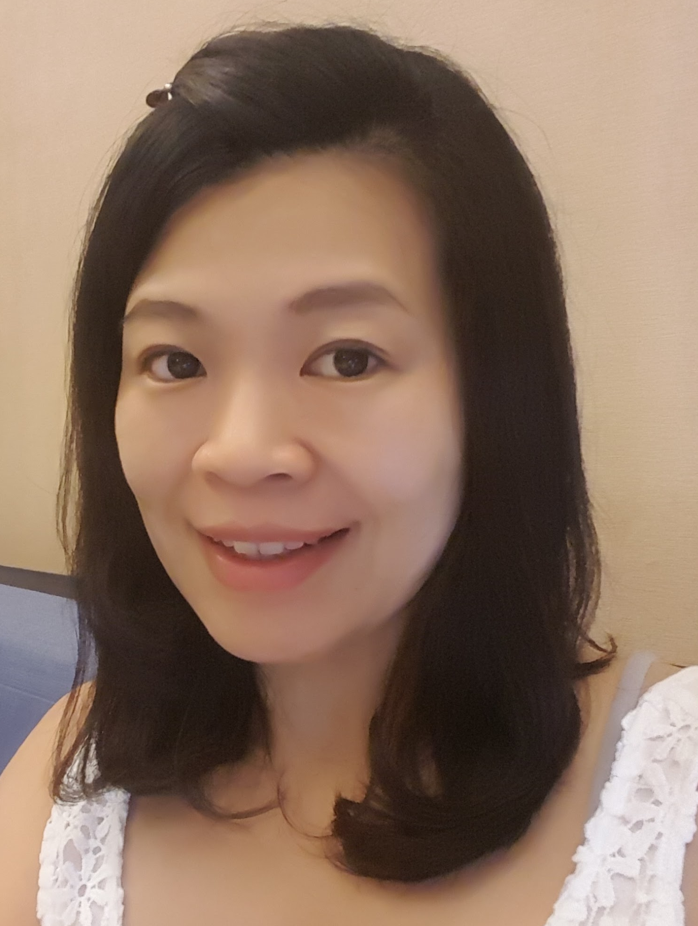
Being an English teacher trainer for many years, I believe everyone can be a great teacher as long as they want to and try to. I always like to share this quote with the teachers-to-be, "The best thing about being a teacher is that it matters. The hardest thing about being a teacher is that it matters EVERY DAY. (from Todd Whitaker) "
Education:
University of National Sun Yat-sen , BA
Employment:
Present:
English Education Center Teacher Trainer Of Kid Castle Educational Corporation
Past:
Over 15 Years Experience in Teaching English & Training English Teachers
Teacher Trainer & Instructor of EFL Chain School
Speaker of ETA(English Teacher's Association)
Editor & Writer of Many ESL/EFL Teaching Books
Camille Chen

