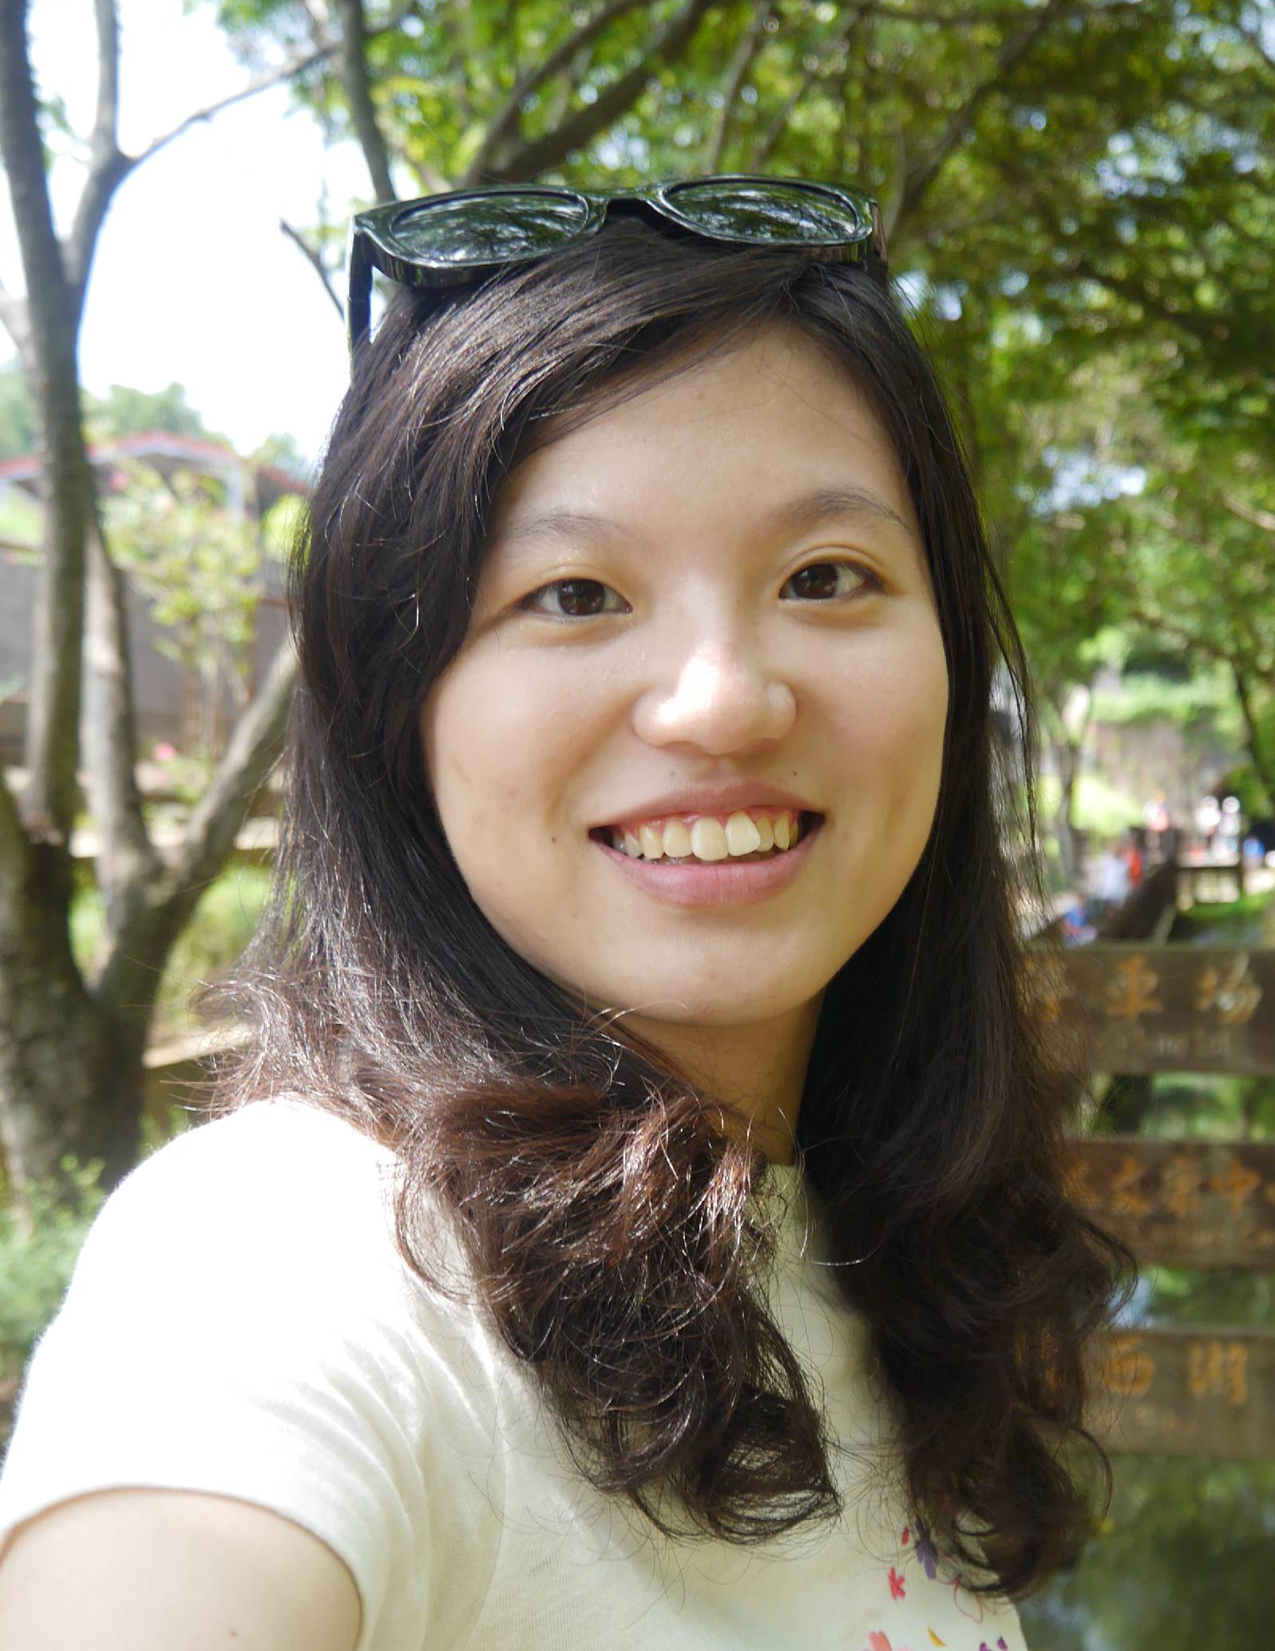
Do what is right, not what is easy.
I’m Christine Chiu. I studied English in university, including one year abroad in the States. When I came back, I taught English in the classroom for 7 years before going to Australia for a year-long working holiday. Now, I work behind the scenes creating educational ESL/EFL content and training teachers. I have filled every role in the English learning process: a student, a friend, an employee, a teacher, a writer, and now a trainer. I believe that anyone can learn English if they're given the right support.

Education Background
Tamkang University
Bachelor of Art, English Literature

Indiana University of Pennsylvania
Exchange Student, English Dept.

Employment
Present Trainer, Kid Castle Educational Corporation
- Train Teachers
- Create educational ESL/EFL content
- Execute school- and country-wide special events including proficiency tests and English summer camp

2009-2014 Area Supervisor, Hess Young Scholars English School
- Plan and execute school- and area-wide special events including English competitions, holiday events, performances and graduation ceremonies
- Train teachers at the branches and Taipei Main Office
- Plan and execute English summer camps
- Teach English at all levels to students ages 7-15

2007-2008 English Teacher, Ming Xin English Tutoring School
- Plan and execute English summer camps
- Teach English at all levels to students ages 7-15
Christine Chiu

