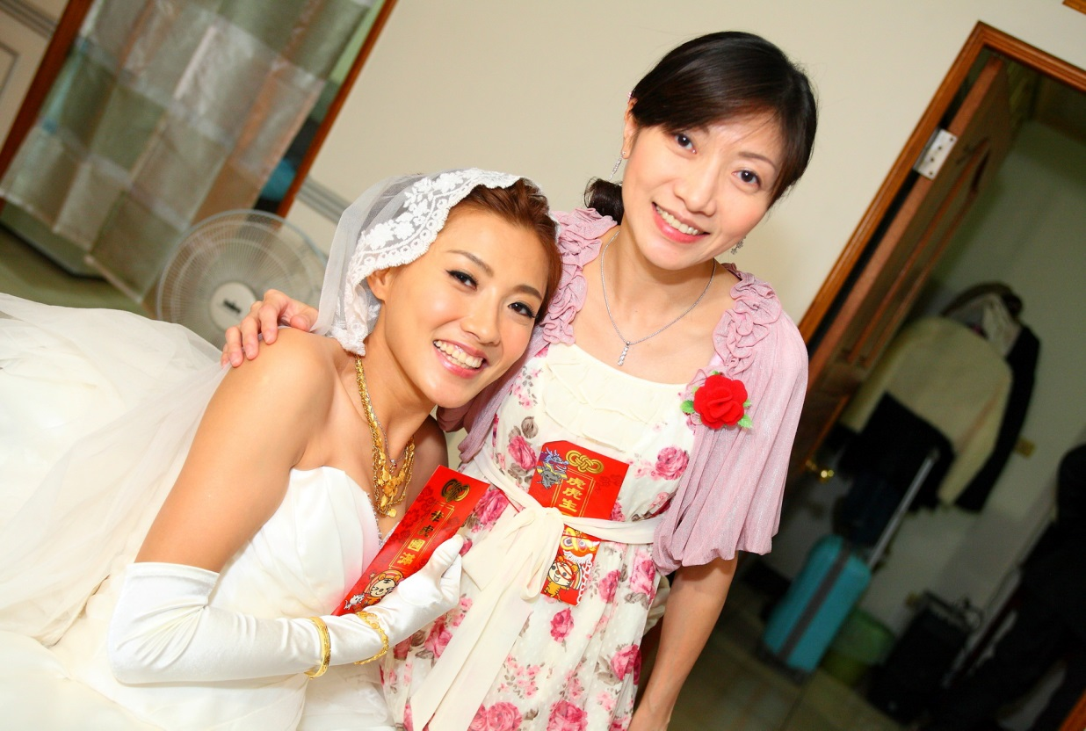

I’m Michelle. Teaching has been my favorite job and I always get more than I give. Now, my job is not teaching kids but teachers, to recruit and train more people to be teachers.

**Education:**

Post-graduate Certificate of English Teaching (CPBAE) University of Tamkang, BA (English)

**Employment:**

Present:

Teacher Training Project Manager

2009~2016:

Academic Affairs Deputy Manager, Headquarter

2006-2008:

School Owner

2004-2006:

Teacher Trainer, Headquarter

1998-2004:

English Teacher and Head Teacher

Michelle Hsieh