Instructions for No Magic Cameo Enterprise Architecture

Shihong Huang  
shihong@fau.edu  
Florida Atlantic University

1. Go to <http://www.nomagic.com/products/cameo-enterprise-architecture.html>
2. Click “Download Trial Version” at the right-hand side of the page.
3. Click “Register me” at the bottom of the page. Enter the required information. Log in with your created credentials. Return to the page in the first step if needed.
4. At the page titled “Download Cameo Enterprise Architecture Demo”, select “**18.0 LTR**” from the “Pick Version” drop-down list. Leave “Pick Edition” as “Enterprise”.  
   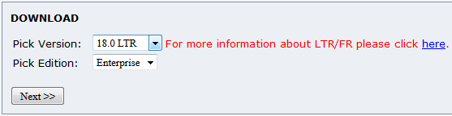
5. Download the appropriate installer for your operating system.  
   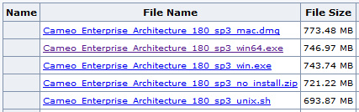
6. Install and run the program with all the default settings.
7. At the “Cameo Enterprise Architecture 18.0 License Manager” dialog box, choose the first option “Select License Key Files”. Point the program to the license file provided to you.  
   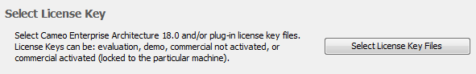
8. At the “License Configuration” dialog box, select “OK”. You are done!  
   