SELFTEST BOARD ASSEMBLY INSTRUCTIONS

This document provides detailed instructions on how to build the Selftest board.
The board has been designed to be assembled by hand or by automatic machine if larger quantities are required. In this document, the instructions are for the hand assembly method.
In the hand assembly method, component sockets will be used for most parts to facilitate component replacement and make repairs easier.
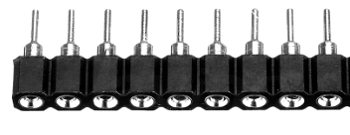

The round hole header type is preferred due to its smaller size, lower contact resistance and versatility. It can be used directly to mount through-hole electronic components, such as relays and integrated circuits. A round hole male header is required to match with the round hole female header when components do not have pins pre-installed. In the case of the Selftest board, the Raspberry Pi Pico controller will be mounted using a round hole male header.

Assembly Strategy
To facilitate hand soldering of components, the suggested strategy is to solder all the round circular sockets first. Achieving straight alignment of the round sockets can be tricky and requires some practical experience.
Once the round sockets are soldered, the other components can be installed, following the rule of soldering smaller components first, then moving on to larger ones.

ASSEMBLY INSTRUCTIONS
Follow these steps to successfully assemble the PCB:

Preparation
- Ensure you have the required components and tools (e.g., soldering iron, flux, multimeter).
- Review the Bill of Materials (BOM) to ensure all parts are available.
- Refer to the document Selftest_assembly.pdf to identify the component values to be installed.
- Do not mount components marked N.A. (Not Assembled).
.
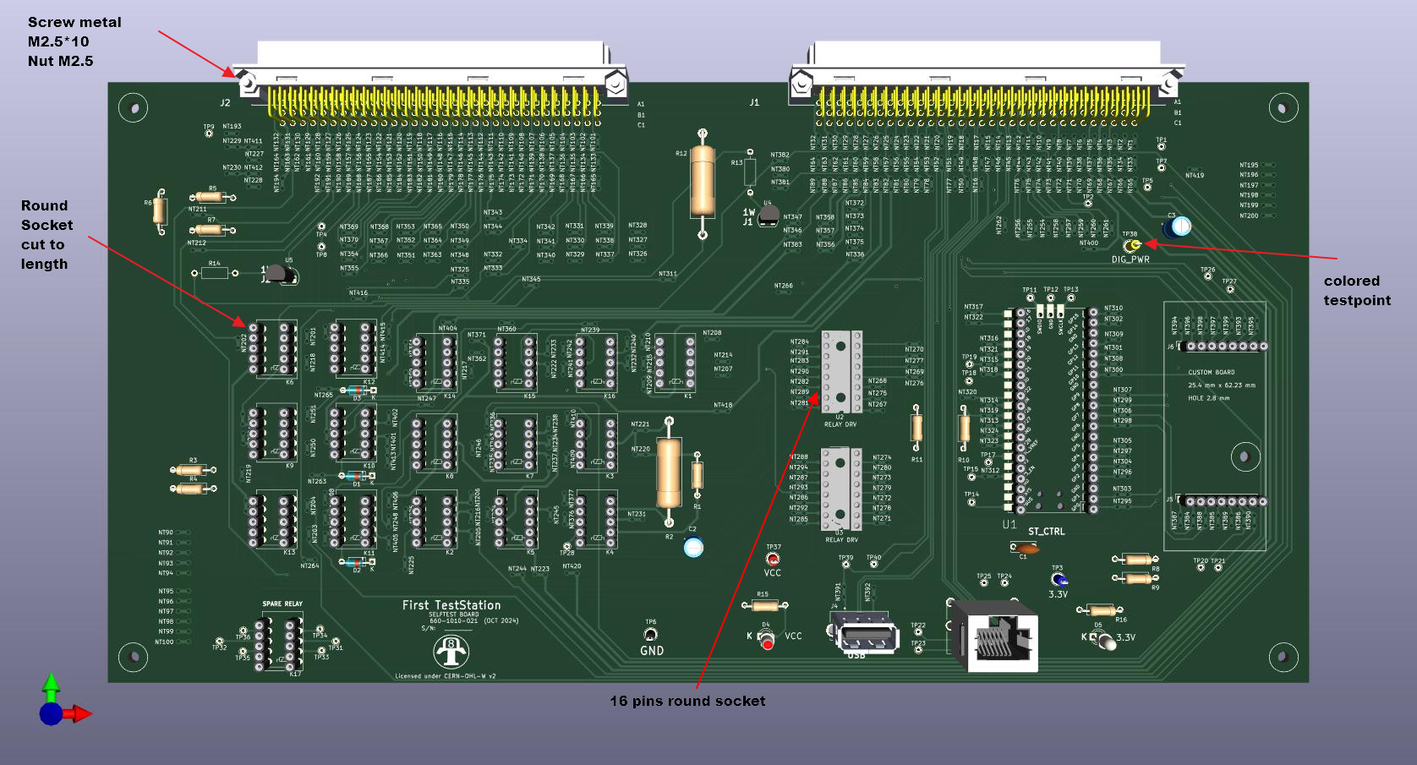
The picture below of the Selftest Board shows all parts to be soldered.

Step-by-Step Soldering Instructions

- Solder Round Pin Sockets: Begin by soldering the round pin sockets (cut to length) for components such as the Microcontroller, ICs, and relays.
- Solder 16-Pin Sockets: Solder the 16-pin sockets to mount integrated circuits. If 16-pin round sockets are unavailable, round socket headers can be used as an alternative.
- Install Large Connectors: Place large connectors J1 and J2 on the PCB. Install the retaining screws before soldering to ensure they are securely mounted.
- Install Smaller Components: Start by soldering the smaller components, such as resistors, capacitors, Leds, transistors and test points, before moving on to larger components.
- Solder Other Connectors: Attach and solder all remaining connectors.
- Solder Pins Header on Pico: Solder 2x20 round pin headers on the bottom of the Pico module. If modifications to the software code are required, solder a 3-pin square header on the top of the module to debug code.
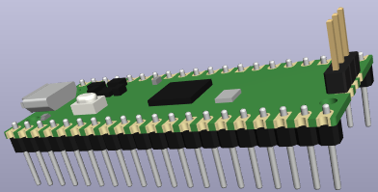

.
A this point, the soldering is complete and only parts on socket need to be installed.

Step-by-Step Mounting Parts Instructions

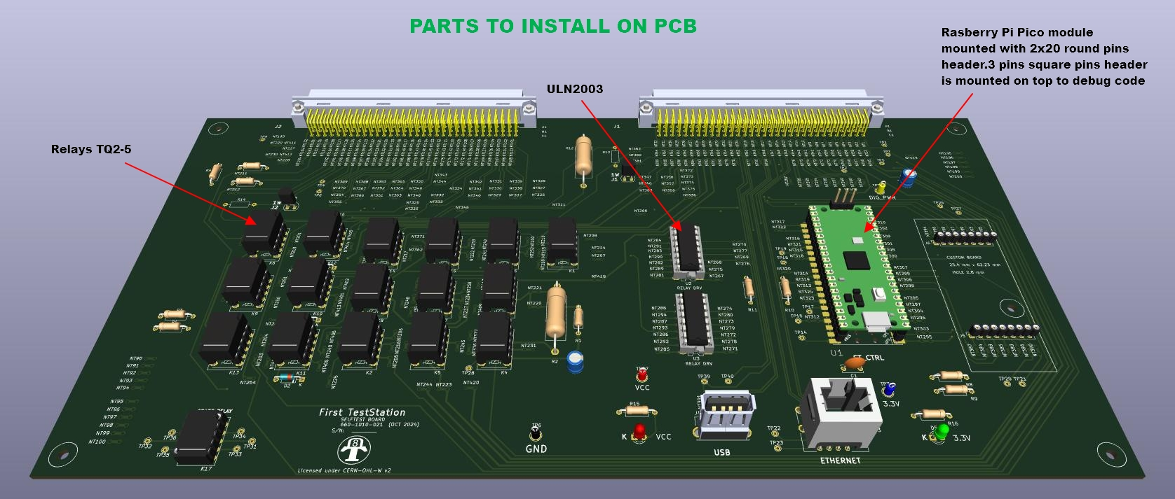
- Mount Relays: Start by installing all the relays. Ensure that each relay is installed with the correct polarity (refer to the picture for guidance).

- Mount Integrated Circuits: Next, install the integrated circuits. Make sure to align pin 1 of each integrated circuit with the pin 1 marking on the board.

- Mount Pico Module: Program one Raspberry Pi Pico with the Selftest software. Follow the instructions from Selftest_code GitHub Repository. Once programmed, install the Pico on the Board at the location marked "ST_CTRL." Ensure the module is installed in the correct orientation.

At this point, the board assembly is complete, and initial testing can be performed.

TESTING
- Shorts Verification: Using a multimeter, verify that there are no shorts present between all the test points: VCC, GND,3V3, and DIG_PWR. If any shorts are detected, make the necessary corrections before applying power to the board.

- First Power On: The Selftest board does not have its own power input and requires power from an external board. However, the power can be supplied through the Raspberry Pi Pico's USB connector.

  - Connect a USB cable between your computer and the Pico board.
    - The red LED (D4) should turn ON, indicating VCC power.
    - The green LED (D5) should turn ON, indicating 3.3V power.
    - The LED on the Pico module should slowly flash, indicating the Pico heartbeat.
  - Using a multimeter, verify the following:
    - 5V between the VCC and GND test points.
    - 3.3V between the 3V3 and GND test points.
Initial testing is complete. Comprehensive testing of the board will require additional hardware and will be included in the First Test Station documentation.

