1.Home Page

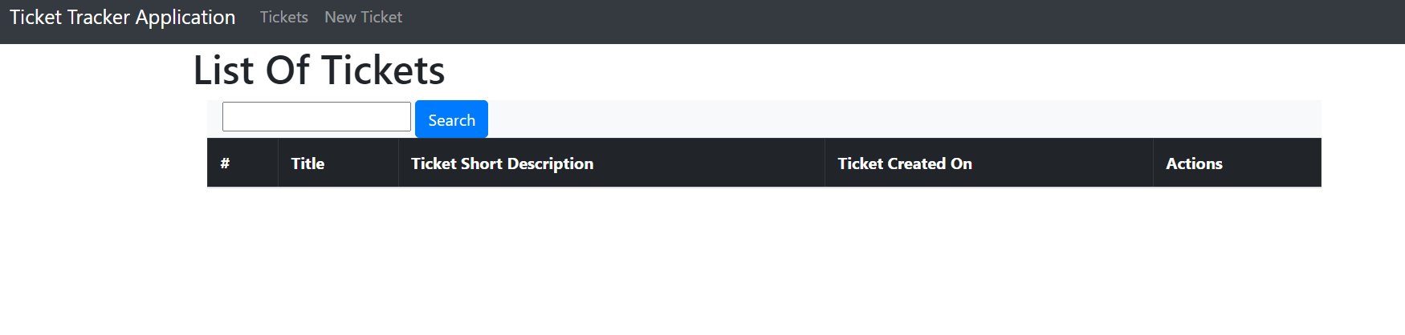

2.Add New Ticket (nav bar option)

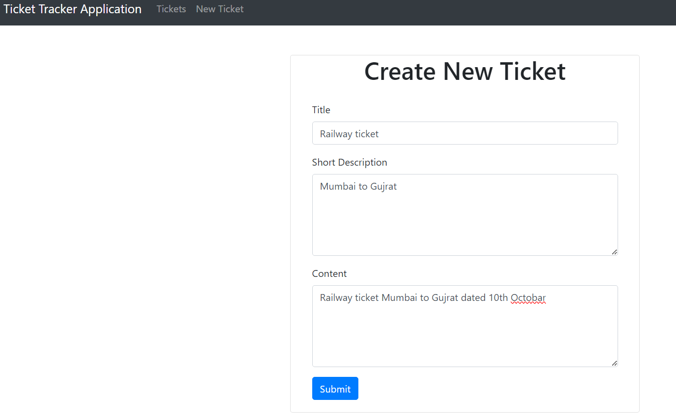

On submit redirected to home page

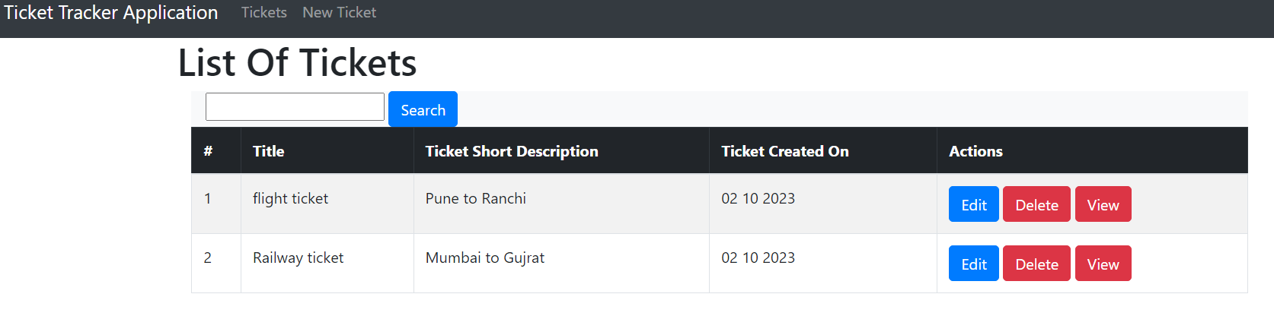

3.Edit 1st tkt description

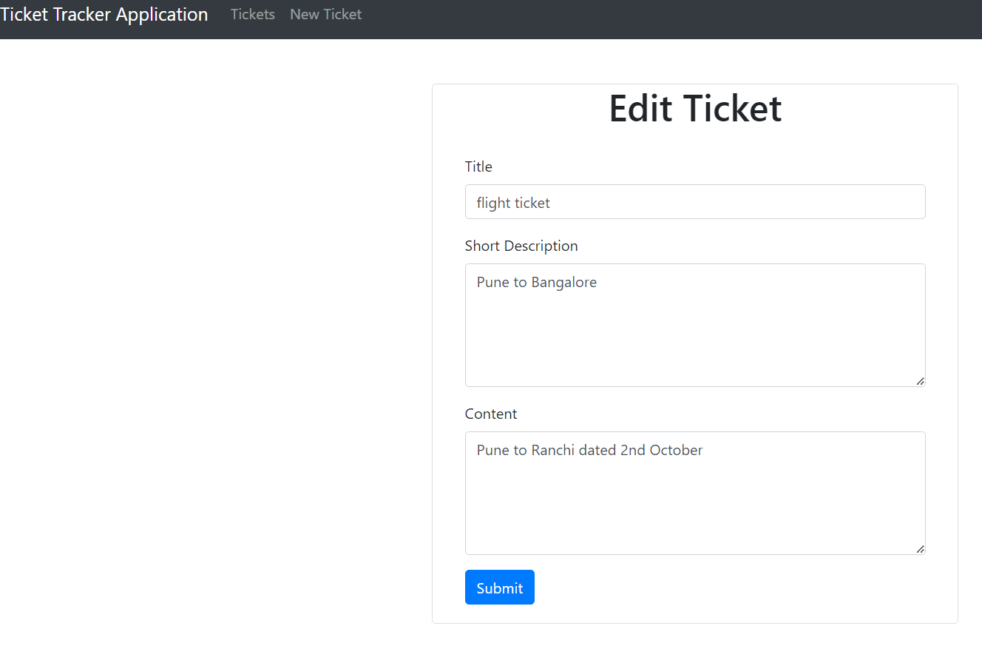

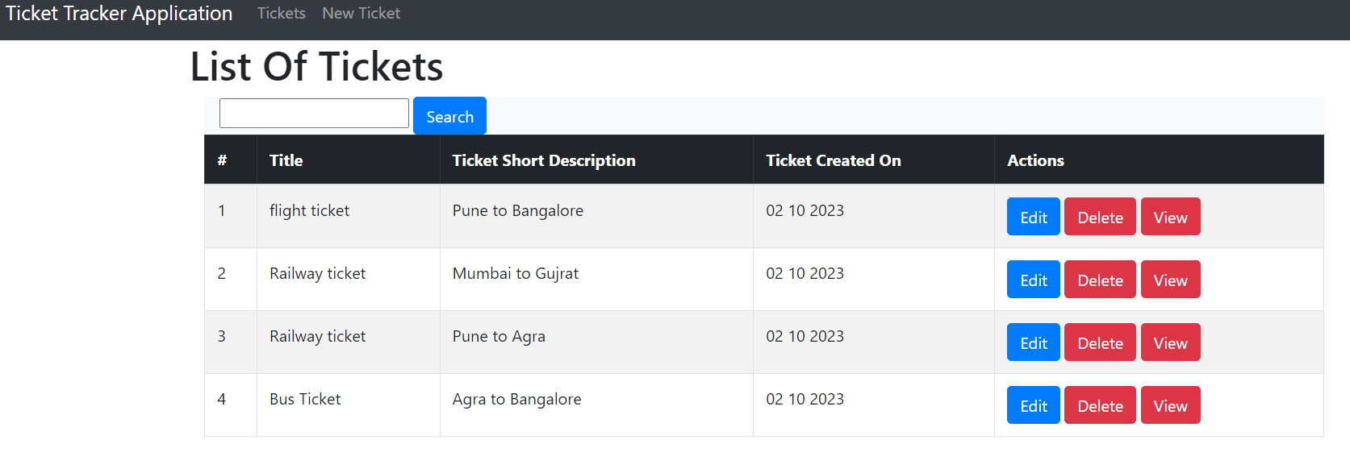

4.Delete (3rd tkt)

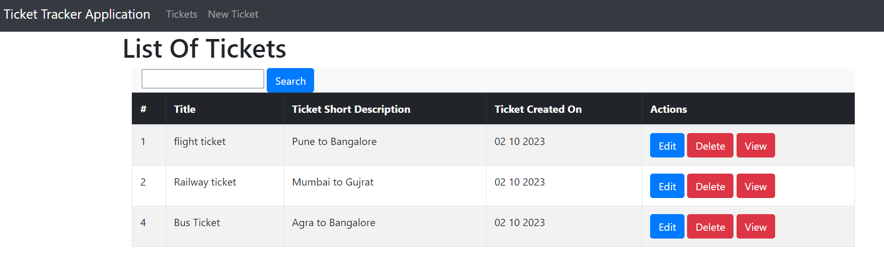

4.view (4th tkt)

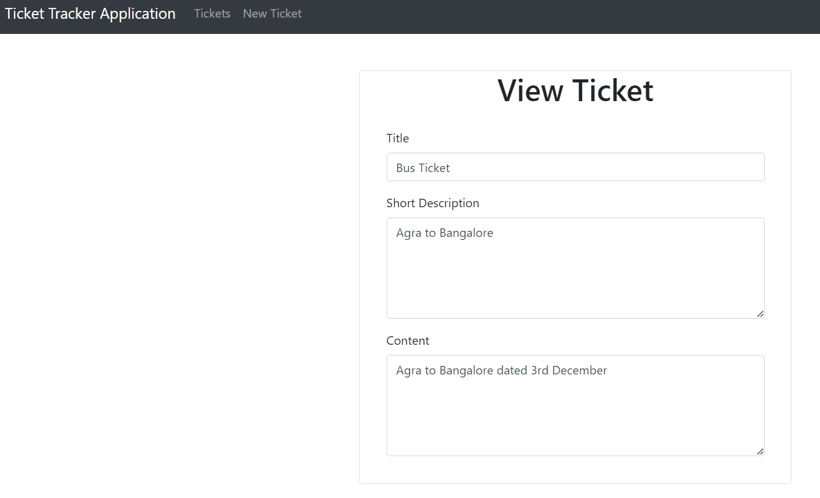

5.Search (eg Bangalore will result in record with title or description containing “Bangalore”)

