1.Role creation

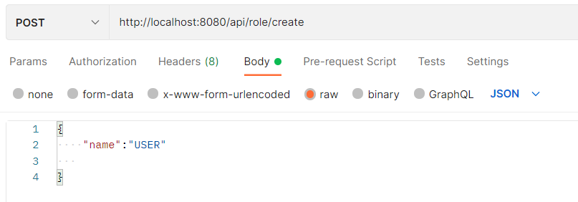

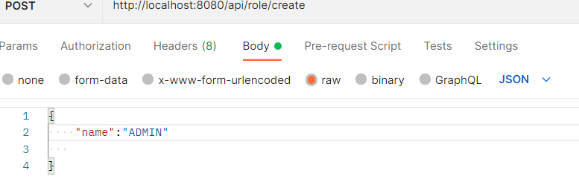

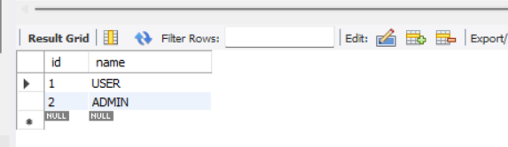

2.User creation

{

    "userName":"Deepshikha",

    "password":"welcome",

    "roles":[{

        "id":1,

        "name":"USER"

    }]

}

{

    "userName":"admin",

    "password":"welcome",

    "roles":[{

        "id":1,

        "name":"USER"

    },

    {

        "id":2,

        "name":"ADMIN"

    }]

}

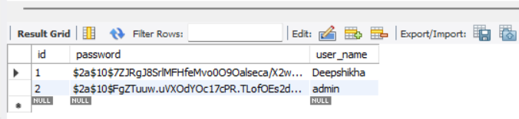

3. Users_Roles table data

INSERT INTO `empdb`.`users_roles` (`role_id`, `user_id`) VALUES ('1', '1');

INSERT INTO `empdb`.`users_roles` (`role_id`, `user_id`) VALUES ('1', '2');

INSERT INTO `empdb`.`users_roles` (`role_id`, `user_id`) VALUES ('2', '2');

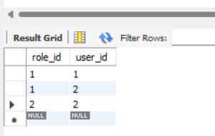

4.Create new employee

-“User” role not able to create

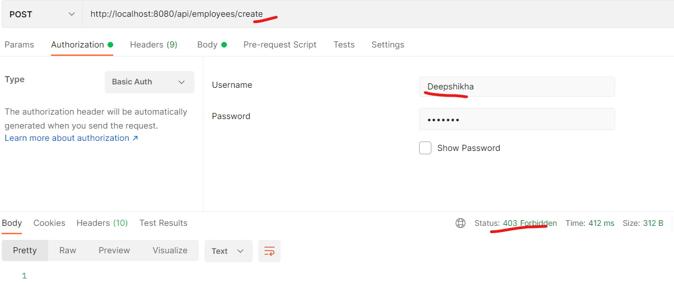

-Only “ADMIN” can create new employee

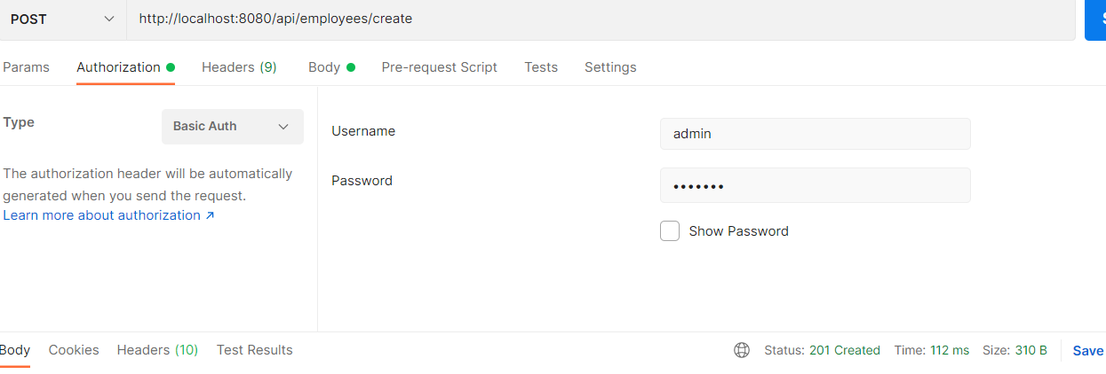

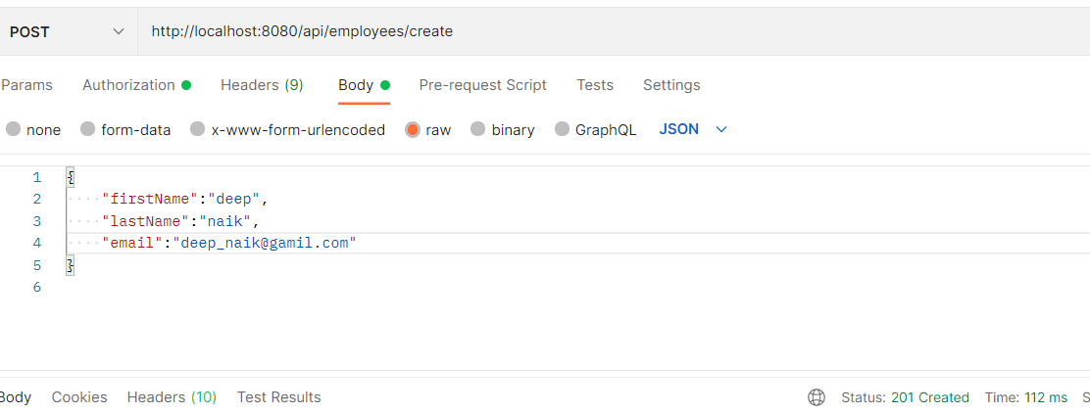

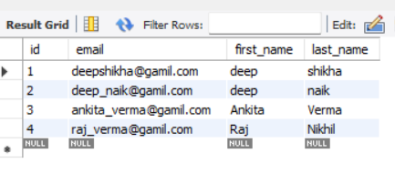

5.List all Employees

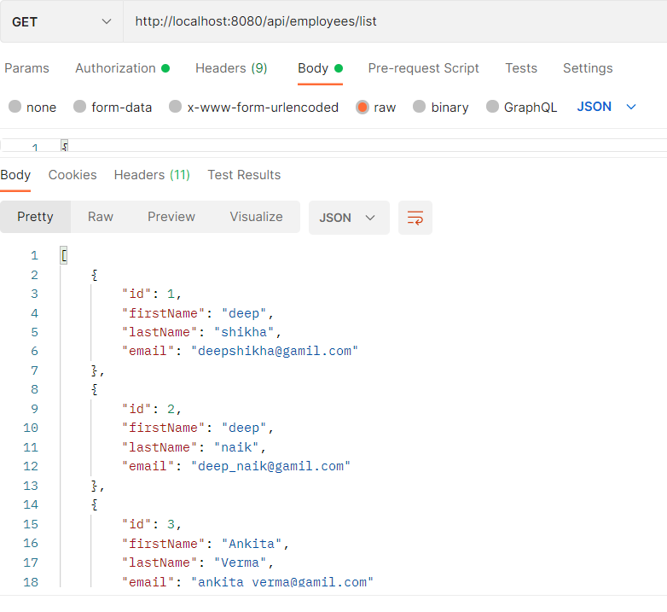

6.Get Employee record based on id

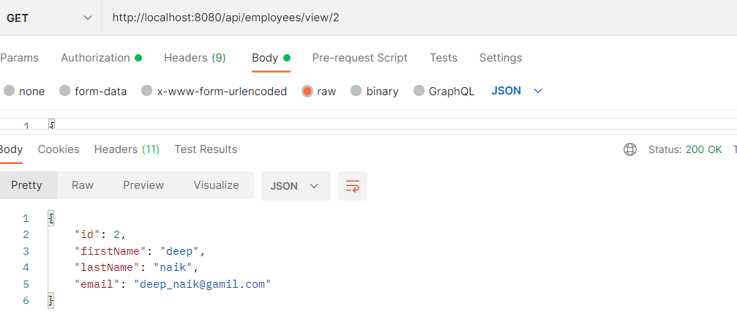

7.Update existing employee (eg id->2)

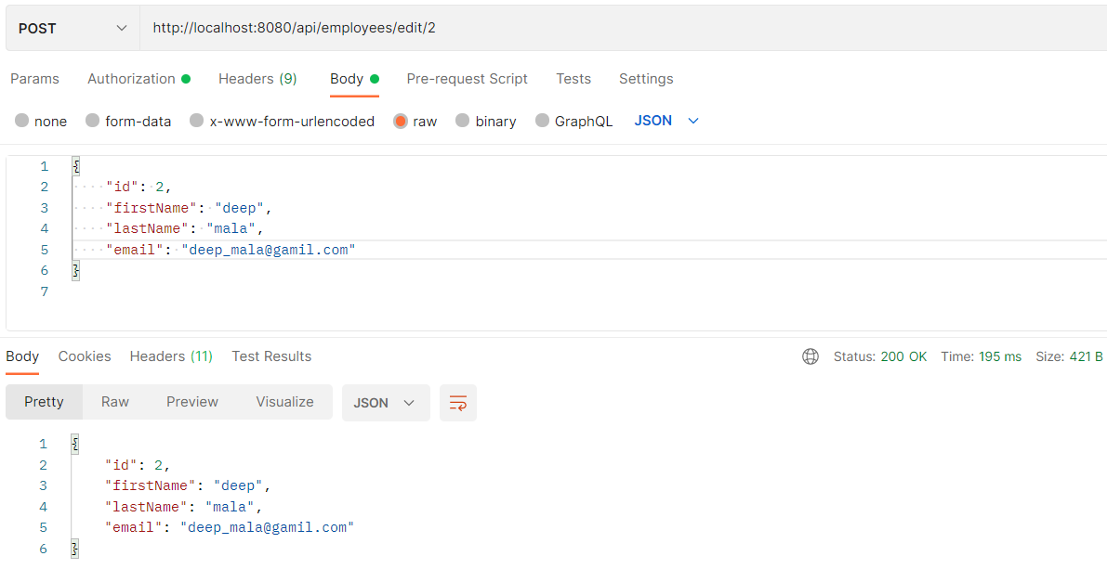

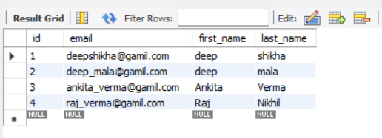

8.delete existing employee

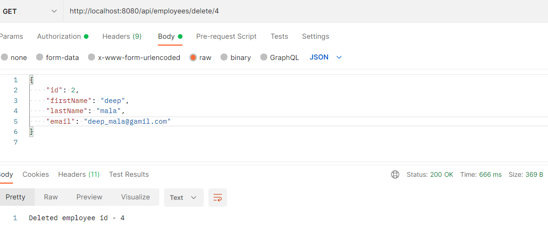

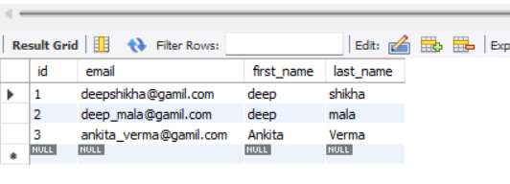

9.search employee based on firstName

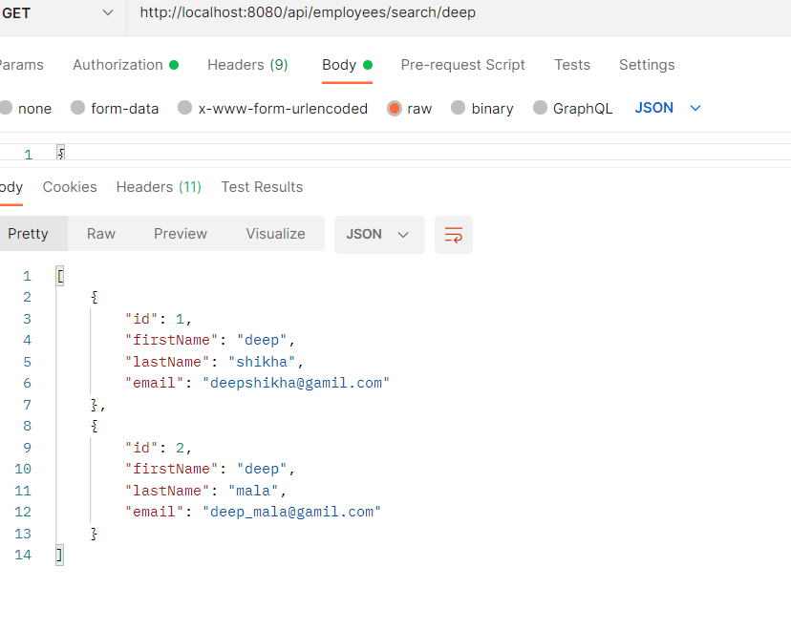

10.Sort employees based on firstName with passing direction(asc or desc)

