Introduction

The mountain goat (Oreamnos americanus) is an alpine dwelling evened towed ungulate in the Bovid family. Despite sharing the same name and belonging in the same subfamily as the domesticated goat, O. americanus is genetically distinct and more closely related to the takin and chamois (Bover et al., 2019). The mountain goat has a herbivorous diet consisting of a wide variety of high alpine plants including graminoids, shrubs, conifers, ferns, forns, and cryptogams (Fox & Smith, 1988). Additionally, they travel to salt licks to obtain salt which is not otherwise present in their diet (Hebert, 1971).
They are endemic to the North American rocky mountains and cascade mountains, being commonly found on peaks as high as 13,000 feet. This is thought to be an avoidance measure against predators including cougars, bears, wolves, and wolverines, who would have difficulty following mountain goats along steep and treacherous cliffs and ledges (Festa-Bianchet & Côté, 2008). Over many years of evolution, the mountain goat has acquired morphological and physiological adaptations to thrive in harsh alpine environments. For example, robust hooves for grip on steep terrain, and woolly coats offer insulation against the biting cold of high altitudes, while also camouflaging them against the rocky backdrop, aiding in evading predators (Côté & Festa-Bianchet, 2003).
For this set of analyses, we use spatial analyses to address three questions. (1) Do mountain goats tend to cluster together in space? (2) Does mountain goat intensity (density) correlate with elevation or tree cover? (3) If mountain goat density does correlate with elevation or tree cover, to what degree would each co-variate contribute to a mountain goat density model? We predict that mountain goat density will be highest in areas of high elevation. Furthermore, since high elevation areas tend to be devoid of trees, we predict that mountain goat intensity will be highest where there is less tree cover. To address these questions, we utilized GBIF mountain goat occurrence data in conjunction with raster image data for the co-variates.

Methods

The steps we used to complete these analyses can be broken down into four parts: (1) downloading and cleaning the occurrence data file, (2) assessing cluster patterns in mountain goats, (3) assessing correlation patterns between mountain goat density and the climatic co-variates, (4) assessing mountain goat density model fit.

Downloading and cleaning the occurrence data file

All filtering and analyses were completed in R v4.3.3, utilizing the spatstat, splines, and sf packages. Mountain goat occurrence data was downloaded from the Global Biodiversity Information Center (GBIF). After reading the occurrence data file into R, we filtered data not relevant to this analysis, keeping only records from within the province of British Columbia, and keeping decimal latitude and longitude coordinates. Additionally, we filtered out occurrence records where latitude or longitude coordinates were missing or duplicated. Next, we converted the each of the coordinates from latitude/longitude to the BC Albers projection. Finally, we constructed a mountain goat ppp object using the transformed coordinates and a British Columbia spatial window provided by the professor. 17 occurrence records that did not fit into the British Columbia spatial window were also filtered out, leaving a total of 416 data points for these set of analyses.

Assessing cluster patterns in mountain goats

To assess clustering patterns in mountain goats, we first ran a preliminary quadrat test to test the assumption that mountain goats were homogeneously distributed across British Columbia. After confirming that mountain goats were not homogeneously distributed in space (X2 = 685.34; p < 0.001), we ran and plotted a kernel density estimation to visualize where mountain goats tended to be found across the province. Next, we ran and plotted a Ripley’s K model to test whether mountain goat observations correlated with each other.

Assessing correlation patterns between mountain goat density and the climatic co-variates

We ran and plotted rho_hat models to test whether mountain goat density correlates with elevation and tree cover. These climatic co-variates were also provided by the professor.

Assessing mountain goat density model fit

Before constructing a mountain goat density model, we first ran correlation tests between the co-variates to test whether there was any multicollinearity. After confirming multicollinearity between the co-variates was not strong (rho = -0.248), we fit 3 types of models with each covariate: a null model with no co-variates, a multiple regression model including both covariates, and a general additive model with both covariates. Likelihood ratio tests were used to assess which model best fit the data.

Results

The code used to run and plot all the models discussed can be found in the mtngoat_code.R file.
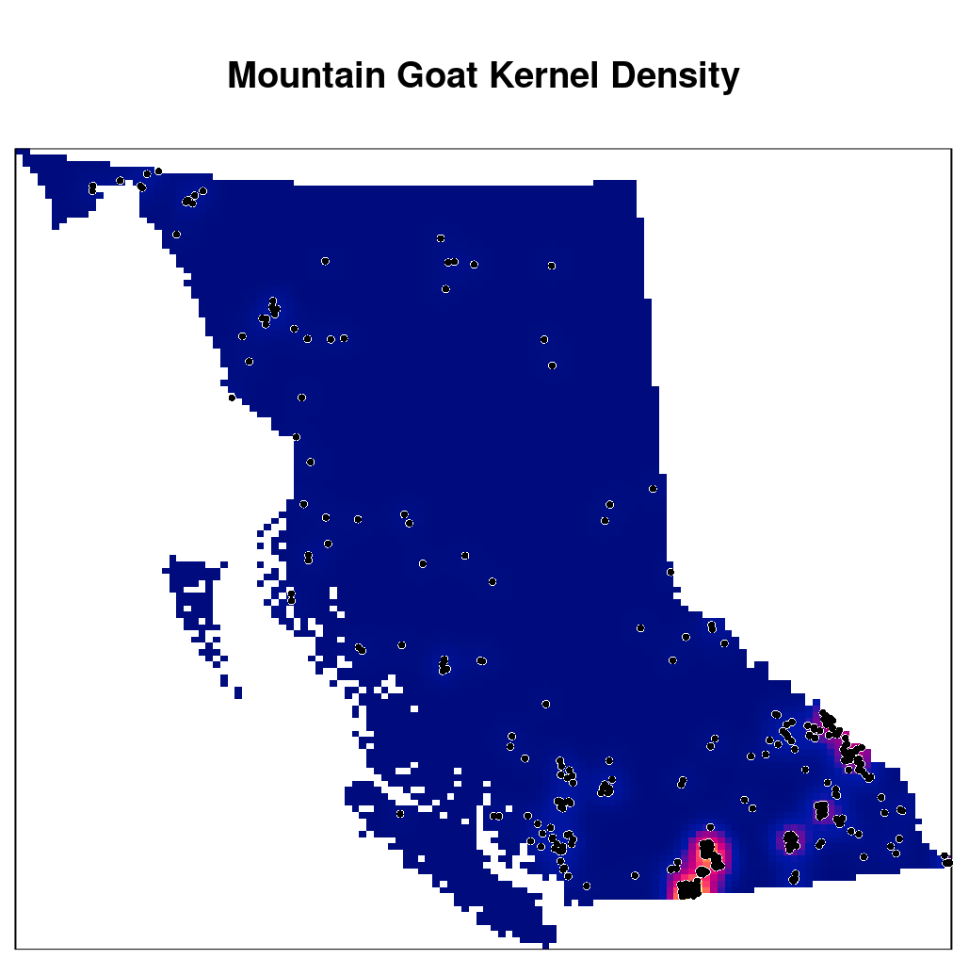

We can see in the kernel density plot above that mountain goat observation intensity is highest in the southwest of British Columbia and in the southeast along the British Columbia-Alberta border.

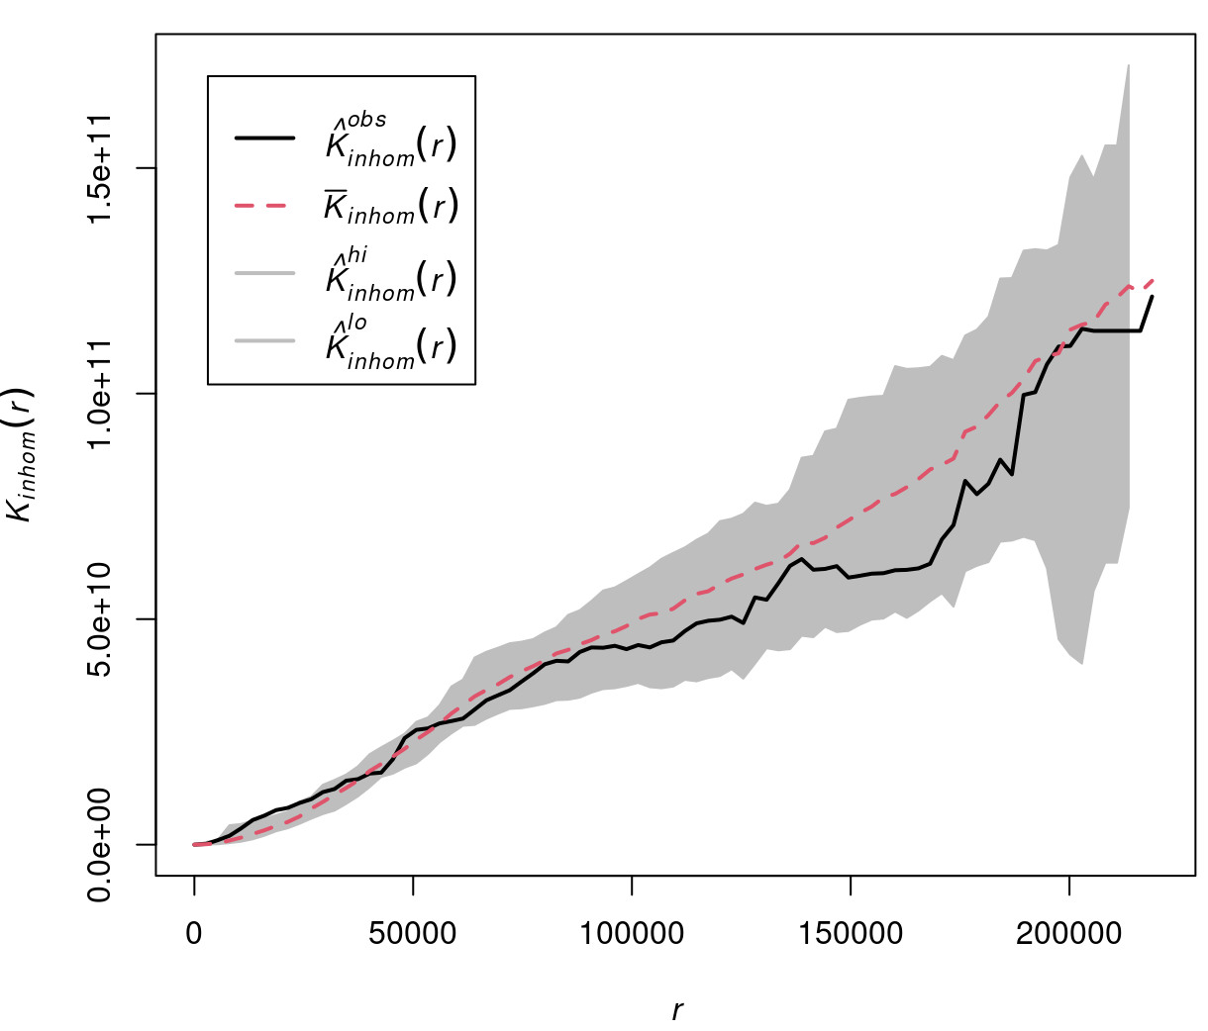
We can see from the Ripley’s K model and plot that the observed K for the most part stays within the bounds of the bootstrapped confidence interval, indicating that mountain goat observations do not appear to be correlated with each other.

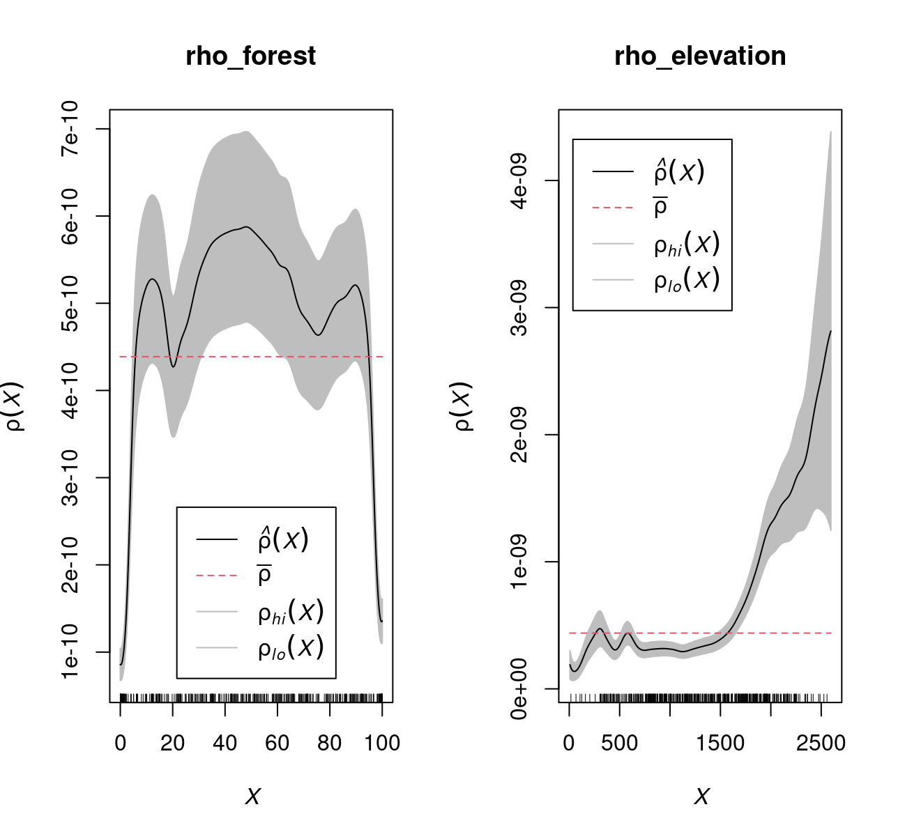
With respect to elevation, mountain goat density is highly positively correlated with higher elevation. However, the pattern is not as clear for percent forest cover. There is a non-linear relationship where mountain goat density is positively correlated with around 10%, 50%, and 90% forest cover, while being strongly negatively correlated with 0% and 100% tree cover.

When deciding the optimal point process model fit to describe mountain goat density within British Columbia, we first compared the model fit between the null model and the multiple regression model. A likelihood ratio test gave evidence that the multiple regression model was a better fit than the null model (Deviance = 257.66; p < 0.0001). Furthermore, a likelihood ratio test also gave evidence that the general additive model was a better fit than the multiple regression model (Deviance = 82.91; p < 0.0001). Below is a plot of the estimated mountain goat population based on the GAM poisson point model:

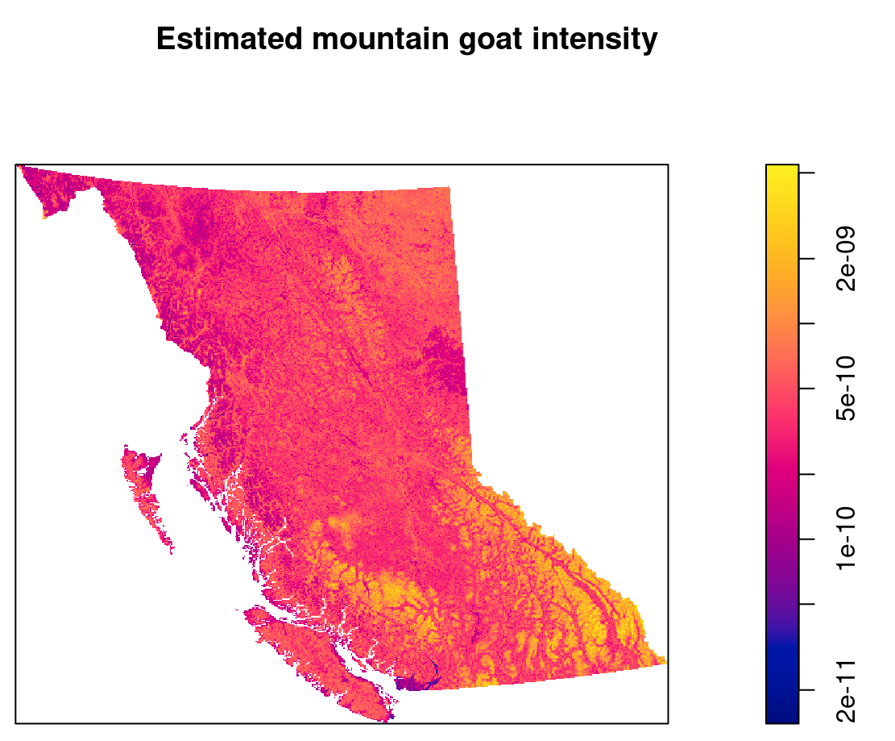

Discussion

From our analyses, it's evident that mountain goats aren't uniformly spread across British Columbia. Instead, they're concentrated in specific patches, with the most significant presence observed in southwest and southeast regions, corresponding to the Cascade and Rocky Mountains. The Ripley’s K plot further illustrates that individual mountain goat sightings aren't correlated, suggesting that factors beyond mere proximity influence their distribution.
Mountain goat intensity is positively correlated with elevation, aligning with expectations given their preference for alpine habitats. Surprisingly, we also find a positive correlation between mountain goat intensity and high forest cover, contrary to our initial hypothesis that higher tree cover would lead to lower goat presence. This unexpected correlation may be explained by their behavior of descending from mountain peaks during winter, seeking out mineral licks in forested areas (Festa-Bianchet & Côté, 2008).
While the GAM-estimated model provided the best fit, its complexity poses challenges for interpretation. Hence, we focus here on the second best performing multiple linear regression model. According to this model, mountain goat intensity (λ) is described by:
λmountain goat intensity = e-23.24 + 0.0011(Elevation) + 0.0067(Forest)

In summary, our analysis reveals some of the spatial distribution complexities of mountain goats in British Columbia. While their clustering in specific regions is evident, unexpected correlations with landscape features like high forest cover challenge conventional wisdom. These findings deepen our understanding of mountain goat ecology in the region and provide valuable insights for further research and management efforts.

References

Bover P, Llamas B, Mitchell KJ, Thomson VA, Alcover JA, Lalueza-Fox C, Cooper A, Pons J. 2019. Unraveling the phylogenetic relationships of the extinct bovid Myotragus balearicus Bate 1909 from the Balearic Islands. Quaternary Science Reviews, 215, 185-195.

Côté SD, Festa-Bianchet M. 2003. Mountain goat. Montana, 2, pp.3-045.

Festa-Bianchet M, Côté SD. 2008. Moutain goats: Ecology, behavior, and conservation of an alpine ungulate. Washington, DC: Island Press.

Fox JL, Smith CA. 1988. Winter mountain goat diets in southeast Alaska. The Journal of Wildlife Management, 362-365.

Hebert, DM. 1971. Natural Salt Licks as a part of the ecology of the mountain goat (Master’s Thesis). University of British Columbia, Vancouver, BC.

