Jianying HE’s report

- The thesis should have a sub-section to summarize the main contribution to the field.
Ok. Check it with Jacques.

- What are the main challenges you faced when developing the modeling framework? Are there any unexpected results during the validation of the numerical model?
The main challenge was identifying the appropriate model coefficients. Hydrogen embrittlement (HE) models involve numerous parameters, and the literature presents a wide range of values even for materials with similar properties. In this work, we selected coefficients that appeared coherent based on our understanding or that provided results consistent with experimental data. However, further effort is needed to accurately determine the coefficients related to hydrogen diffusion and trapping. Additionally, the model development process required extensive testing and debugging, which was expected but still demanding.

- All experimental specimens are extracted from intact pipe. How about weldments that have distinct properties from base material?
This work did not focus on welds. However, another PhD project, focused on experimental aspects, investigated this topic. When simulating hydrogen embrittlement (HE) in welded joints, the model must account for the different zones of a weld—base metal (BM), heat-affected zone (HAZ), and weld metal (WM)—each with distinct material properties, such as anisotropy and varying ductility levels. Incorporating these differences increases the complexity of the simulations.

- Is it possible to incorporate microstructure of materials into the modeling framework, such as phases, different boundaries, precipitates, and secondary particles?
It would be possible, but not within this framework. Our focus was on the macroscopic aspects of hydrogen embrittlement (HE) and how hydrogen affects the mechanical properties of steels. The GTN model accounts for the presence of voids and describes how their nucleation, growth, and coalescence influence material ductility and damage. However, incorporating additional phases, such as secondary particles or precipitates, would require developing a different model with an adapted mesh size and formulation.

- What are the limitations of the current model when applied to real-world scenarios? How transferrable is the model from small specimen to field applications? Are there additional experimental datasets that could be used to further validate the numerical framework?
The main limitation of this model in real-world scenarios and applications is the large number of coefficients it requires. This includes not only the parameters related to hydrogen diffusion and trapping but also the elasto-plastic and damage coefficients. While the latter can be identified using inverse methods, the process can be time-consuming. It is often challenging to determine a set of coefficients that performs well across different types of tests, such as tensile and fracture toughness experiments.

From the simulation results, we see that more ductile (thus higher toughness) is the material, more sensitive it is to size effects. Since HE reduces the toughness of steels, this could render the use of sub-size specimens for material characterization possible, but more studies are still needed for fully understanding the problem.

- How can the findings from the thesis be used to inform industry standards, especially for design of hydrogen-resistant materials?
This model is a useful tool for analyzing hydrogen distribution within a material. When its coefficients are accurately identified, it can also predict the extent of hydrogen embrittlement and the likelihood of hydrogen-induced failure.

- While the hydrogen diffusion model based on the work of Sofronis and McMeeking is widely accepted, it would be interesting to discuss how it compares to more recent models.
From my knowledge, all the models I am aware of consider hydrogen flux influenced by the material’s stress state, meaning hydrogen diffuses toward regions under tensile stress. However, the way hydrogen embrittlement (HE) is modeled varies. Sofronis proposed a hydrogen-induced softening effect, which, despite being simple to implement, did not yield realistic results. At least for the materials we analyzed, hydrogen did not cause softening but instead led to earlier failure, which we accounted for by modifying the GTN model. Other studies, for example, use phase-field fracture models, where the surface energy is defined as a function of hydrogen content in the material.

- It is concluded that the hydrogen concentration is nearly independent of pressurization rate. This is somewhat unexpected. Could this be due to the specific materials or geometries used in this study?
For the disk pressure tests under the pressurization rates considered in our experiments, we found that hydrogen embrittlement (HE) was independent of the pressurization rate, which was unexpected. However, Briottet et al. performed similar tests and also observed no effect of pressurization rate within the same range, confirming this trend. For the DPT, high pressurization rates (dP/dt > 10 MPa/min) must be considered, which we did not test for the standard specimen. Additionally, the standard specimen has a very thin and uniform thickness of 0.75 mm, allowing hydrogen to diffuse rapidly throughout.

- Given the significance of accurate hydrogen concentration predictions, how do you ensure the models remain adaptable to different steel alloys and industrial applications?
The model is easily adaptable since its formulation accounts for large deformations and can capture both ductile and quasi-brittle failure. However, applying it to other steel alloys with significantly different properties poses a challenge. The coefficients identified for our materials would not necessarily yield accurate results for different steels, requiring a new identification process to determine appropriate model parameters.

- How can the thermal desorption spectroscopy (TDS) tests be expanded to better identify trap sites and their associated parameters that affect hydrogen embrittlement?
By conducting TDS tests at different heating rates, we could estimate the various trap types, their associated binding energies, and trap densities from the desorption curves. This would improve our ability to model hydrogen trapping mechanisms more accurately. Additionally, as we have already begun, it would be valuable to perform tests under different strain levels, strain rates, and dwell times to further investigate how these conditions influence hydrogen uptake.

- Are there any emerging experimental techniques that could help further refine your model?
Permeation and TDS for identifying the model’s coefficients, such trap binding energies, trap densities, diffusion coefficient, etc. → Pas vraiment emerging, nano-identation?

- How does carbon monoxide oxidize pipeline surface? What is the mechanism of carbon monoxide inhibiting hydrogen embrittlement?
Carbon monoxide (CO) can oxidize the surface of pipeline steel, leading to the formation of an oxide layer. This layer serves as a physical barrier, restricting the penetration of hydrogen atoms into the metal. However, research by Sandia suggests that, over time, hydrogen can still penetrate the material, and the presence of oxygen may no longer limit hydrogen diffusion. Further studies are still needed to fully understand this phenomenon.

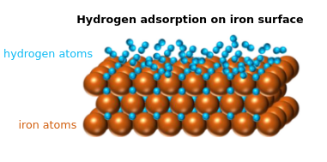

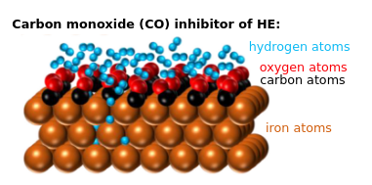

- How does the inclusion of mobile dislocations affect the overall hydrogen diffusion process?
The presence of traps, including dislocations, significantly affects hydrogen diffusion. In a model with high binding energies (>60 kJ/mol), most hydrogen atoms are trapped rather than freely diffusing, which reduces overall diffusion. A simulation with high binding energies creates a "concentration front" that acts as an interface, slowing down the diffusion process. Similarly, if a trap has a high trapping density, most of the hydrogen will be captured, further reducing the diffusion coefficient. The key difference here is that the model assumes the number of dislocations increases with plastic strain, so accurately estimating how dislocations evolve with plastic strain is crucial to capturing the effect on hydrogen diffusion.

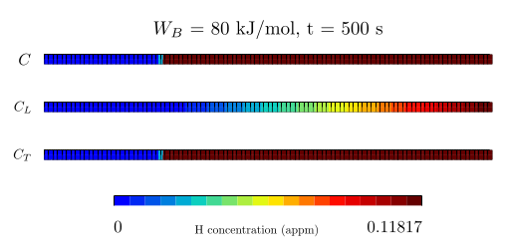

- If you were to continue the research in HE, what specific research direction or focus would you pursue next?
I would focus on identifying the model's coefficients through experiments such as TDS and permeation. The data obtained from these experiments would be valuable for validating the model and would contribute to the hydrogen embrittlement (HE) research community, where there is ongoing debate about which coefficients should be used. Many researchers rely on the same set of coefficients, but that doesn’t necessarily mean these coefficients are well-suited for all simulations.
Additionally, I would explore the correlation between size effects and HE. There is still room for improvement in the model, particularly for fracture toughness tests, such as incorporating remeshing for long crack propagation. This would enable the inclusion of boundary conditions where hydrogen can penetrate through the crack lips. Moreover, it would be interesting to investigate whether hydrogen affects macro and sub-size specimens in the same way.

Yann CHARLES’ report

- N_{T}= 23.26 − 2.33 exp(−5.5p) has not been proposed by Kumnick & Johnson (1980) but by Sofronis & McMeeking (1989).
Sorry for the confusion. Sofronis proposed the NT relation based on the data from Kumnick & Johnson (1980).

- A lot a repetition of information at the beginning of each chapter/section (already said in the bibliographic part) and in the text. This gives the reading a feeling of déjà vu and constant ﬂashback that is a little disturbing.

- References to the doctoral student's published articles are not, in my view, relevant in a doctoral thesis, especially when it is stated that the doctoral results confirm or are conﬁrmed by these articles.

- Please note the constant switch of notation 𝑝-k for the equivalent plastic strain, 𝑝 is used also for the pressure (and average stress p. 31).
To do: replace “p” by “k” where it represents the accumulated plastic strain.

Chapter 3:
- It would have been interesting to start the study on the modification of the geometries of the DPT at the point where it was stopped by Moro 2009.
- What criteria were used for the location of the notch?
To be far enough from the center and from the clamping zone and to produce a maximum value of accumulated plastic strain in this region.

- We note that the minimum thickness was kept constant (0.75 mm): for the same loading rate and the same exposure time, we therefore expect the same penetration of H.
Not really, since the hydrogen distribution depends on the stress state and strain level. Since the three specimens present very different responses, the hydrogen distribution will be different as well.

- Elements of choice on the geometries could have been indicated here.
Add figure with the mesh for the three specimens at the end of the presentation.

- p.54: “it was then reasoned that to obtain an optimal HE sensitivity, the most eﬀective approach is to induce the maximum plastic strain in a region exposed to H2”. This sentence deserves further explanation. If plasticity is so important, does this mean that dislocation trapping drives the HE?
With the model used in this study, the rupture location corresponds to the region where plasticity is maximum and where the trapped hydrogen concentration is at its maximum as well.

- p. 55: “although the displacement at the disk’s center is greater when pressure is applied to the notched side”. From what I understand from Figure 3.16, the experimental curves clearly show that the displacement at failure is the same, but not the failure pressure. The numerical curves stop at more than 10 MPa after the experimental failure.
You're correct. For the experimental data, the displacement remains the same, but the rupture pressure is higher when pressure is applied to the flat side. In contrast, the numerical results do not fully capture this trend, as we obtain the same rupture pressure but different displacements. However, the model still effectively represents the elasto-plastic behavior of the specimen, especially considering that it is an axisymmetric model and no damage is accounted for.
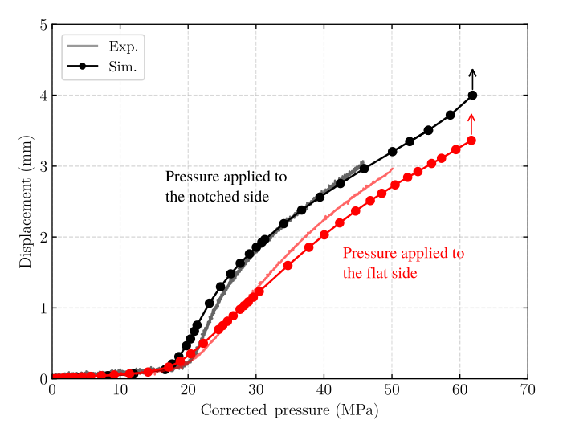

- How can we be sure that the tests were carried out in the zone of maximum embrittlement?
I do not know. It should be interesting to maybe to the tests at lower and higher pressure rates and compare the results.
- a decrease in failure pressure under He can be observed, especially for X52
- for E55, a slight increase in the rupture pressure under H2 can also be detected (no embrittlement at all for the cup disc). Are there experimental dispersions on each point?
Yes, there is some dispersion in each test result. Controlling the pressurization rate precisely is challenging, as it is manually adjusted via a valve, which may contribute to the dispersion. Additionally, the X52 steel itself exhibited some variability between tests.

- p. 67, ﬁg 3.29: the conclusion on the more relevant model is based on dimensionless Ctot maps, in which it can be seen that H is diﬀusing through the whole sample with the ‘low NT’, i.e., “Therefore, the model that aligns most closely with experimental observations”. However, due to the chosen scale representation, it is not possible to know if there has been diﬀusion or not in the sample with the “high NT” (max values x100!), noting that the boundary condition seems to close to 0.3-0.4 appm. Last, the cause of HE is here not indicated, leading to possible misinterpretation of the numerical results: is CT or CL is responsible of the embrittlement process? Depending of the answer, the maps who must be looked at could leads to very diﬀerent conclusions. This must also be connected to the previous assertion: “it was then reasoned that to obtained an optimal HE sensitivity, the most eﬀective approach is to induce the maximum plastic strain in a region exposed to H2”.
In my view, the conclusion is not based on dimensionless maps but rather on a comparison of penetration profiles for two pressurization rates across four different models. The experiments showed that the embrittled depth remains constant across pressurization rates, so our analysis focused on identifying which model best captured similar penetration profiles at different rates. I would maybe argue that C_{T} plays a more significant role in the embrittlement process, as the rupture region corresponds to the area of maximum accumulated plastic strain, which also implies maximum C_{T}. But in my view, the total hydrogen concentration must be analyzed.
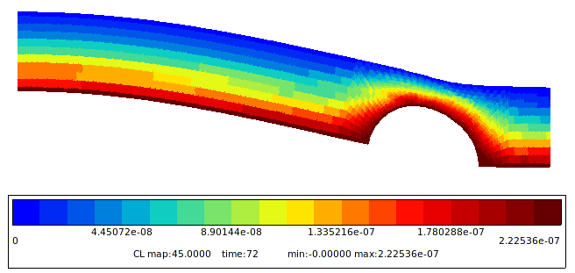

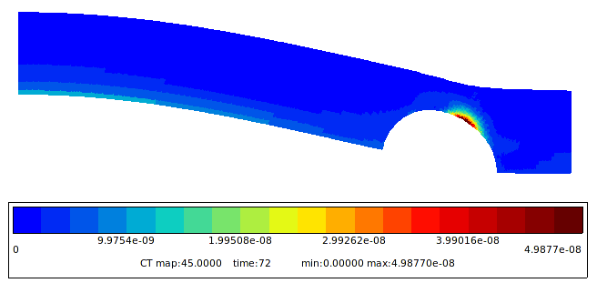
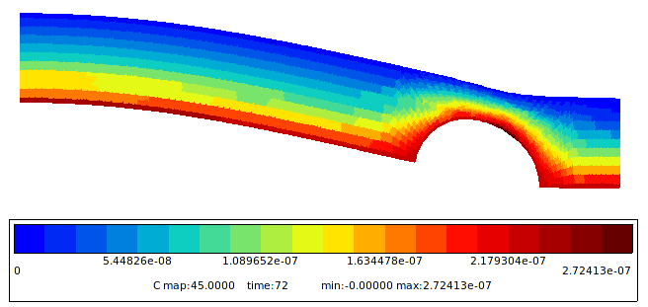
- Fig 3.32: How is the relationship between C and the maximum principal stress calculated? At a given integration point (if yes: where?)
Since we know the expected fracture region for each specimen (cup = center, notched = notch, standard = clamping), we analyzed the values of maximum principal stress in the integration points of this region.

- This chapter lacks a conclusion on the interest of having different shapes: is it useful? What information does it bring? Can they be used to qualify materials for hydrogen storage? This is also related to the reasons that led to the choice of geometry.
Since the standard specimen is very thin, even tough its geometry is simple, it was hard to machine it without bending. The new disk geometries have a more complicated shape, but according to the laboratory shop, it was easier to work with. In addition, it allowed us to obtain fracture outside the clamping zone and always at the expected region, and not at the clamping zone or center, as it could happen for the standard disk.

Chapter 4:
- This section could have gained clarity by comparing the experimental and numerical results directly.

- Table 4.4 is not clear: test under air have no strain rate nor maximal strain + strain rate are sometime displaced in s (!).
The tests where the strain rate is depicted in ”s” means that in fact the specimen was strained during only this amount of time. The tests under air where strain rate or maximal strain are equal to zero means that these specimens were not deformed. Since these tests were very fast, it was chosen to precisely depict the loading time instead of the strain rate. → Mettre plutôt la valeur de strain rate par tout ?

- Fig 4.9 (– 4.11 - 4.13): the impact of H on tensile test cannot be seen as F/S₀ is plotted versus time.
The goal of this study was not to examine the effects of hydrogen embrittlement but rather to analyze the interaction between plasticity and hydrogen diffusion. None of the tests were carried out until rupture; the most deformed specimen was stopped before the onset of necking. The curves of F/S_{0​} versus time were chosen to illustrate the loading duration for each test.

- TDS calibration (ﬁg 4.5): It is not clear what the uncharged sample represents. Could it be initial residual hydrogen? This could be investigated by performing TDS twice on the same sample: if the results are identical, it is a TDS artifact. Otherwise, there is residual H in the samples. This can signiﬁcantly change the conclusion for 𝐾.
“The calibration procedure was performed at the beginning, middle, and end of the test campaign to ensure spectrometer stability.” → The test was performed more than once. Noise? Contamination due to the engravings?

- The same question arises for ﬁg 4.6: “The three additional peaks observed at temperatures above 300°C are attributed to contamination from specimen engraving or other sources not investigated”. The dislocation trap can be located at the new peak, but we can also imagine that, if the other 3 peaks designate 3 irreversible traps, a part of the diffusible H has also been trapped in the latter (because the characteristics seem to have slightly evolved). This is admitted p. 80-81: “Two additional peaks appear at temperatures above 250°C, particularly in the case at 1×10−4 s−1. These peaks may originate from other trap sites with higher binding energies than the ﬁrst peak.” (it can be seen that at 1×10−3 s−1, the contribution of these two additional traps is as important as that of the dislocation).
The tests should be repeated without the specimens' engravings to ensure that the late peaks arise from irreversible traps rather than contamination. Since we were not sure about the origin about these late peaks, they were not considered in the study.
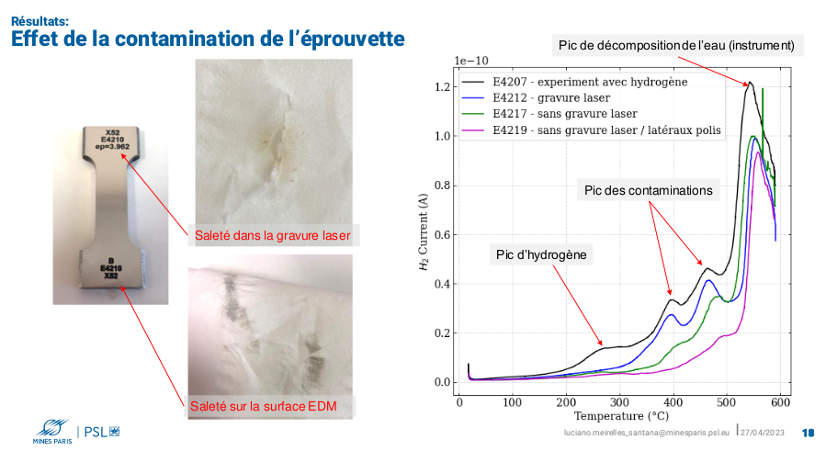

- This section lacks a conclusion: what can be said about the influence of the strain rate? The penetration of hydrogen into the sample is an element that needs to be studied. Specially, the points in Figure 4.10b seem to be aligned. The impact of retention (section 4.4.3) tends to support the impact of the penetration depth, because the higher the plasticity, the lower the apparent diﬀusion coefficient.
The effect of strain rate also depends on exposure time. For tests conducted to the same strain level, a lower strain rate results in a longer exposure time, leading to a higher hydrogen concentration. Conversely, higher strain rates result in lower hydrogen concentrations due to the reduced uptake time for hydrogen.

Section 4.5 - 4.6:
- The identification procedure is not that clear:
  - Why 40 kJ/mol have been chosen for trapping by dislocation? TDS with different dT/dt could have been made to identify this parameter.
TDS campaign made by Jacques in Japan: estimation of WB considering different heating rates. It is true that it was not cited here...
  - The identification of N_{T} needs an estimation of 𝜃_{L} which is not given?
  - How the N_{T} has been identified (“Various functions were tested, and the one that provided the most accurate results is described below”), and based on which experimental data (least square method….)?
The N_{T} function used in this study was an adjusted version of the model proposed by Moro et al. Simulations using the N_{T} relation from Sofronis et al. resulted in zero hydrogen concentration after resting. In contrast, simulations based on Moro et al.'s N_{T} function showed a factor of 2 discrepancy between experimental and numerical results across four strain levels (0%, 3%, 6%, and 12%). To address this, only the saturation value of Moro’s function was reduced by 13%, with its coefficients adjusted accordingly. This was not an optimization process but rather an adaptation of an existing model from the literature to achieve the desired results. To more accurately estimate the N_{T} function, it would be beneficial to repeat the tests with different heating rates and utilize the TDS simulator tool recently proposed by Garcia-Macias et al.

- Moreover, the question of D_{L} can be raised, since the one for iron was used (and perhaps not relevant for the materials studied): there are cases in which the modeling is far from the numerical results (but since we do not know what data were used to define N_{T,} it is difficult to say something for the configurations for which the experimental and numerical results match). Choosing another D_{L} and performing the N_{T} identification again will lead to a different N_{T}(p) that is able to consistently model the point used for identification but not the other configurations.
I agree with you — the D_{L} coefficient used in this study corresponds to that of pure iron. Since the model includes initial traps, it automatically reduces the effective diffusion coefficient due to hydrogen trapping. However, this reduction is still insufficient to match the values observed in pipeline steel, which, in its undeformed state, has a diffusion coefficient of approximately 4×10−10 m²/s. We attempted simulations using this diffusion coefficient, but the results deviated significantly from the experimental data.
Nevertheless, the model still provides a good representation of the experimental trends and hydrogen content, considering the challenges of the experiments and the number of parameters involved. The next step is to accurately determine the key model coefficients, such as N_{T}, W_{B}, and D_{L} through dedicated experiments, including permeation testing and TDS analysis.
- In all the experiments, there is only one critical kinetic term, assuming instantaneous trapping: the diﬀusion of hydrogen through the sample. Using all the data in this chapter could have been very useful to, at the same time, identify D_{L} and N_{T}(p) being able to minimize any distance between the exp. and numerical points.
- The proposed N_{T} validates the proposition of Moro; what consequences could this
conclusion have on the DPT simulation and its results?
I do not have an answer for this since we did not use the same material in both studies. They are both pipeline steels, but with different grades.

Section 5

- H is considered to influence only the nucleation of voids (brittle failure), through a critical stress that is set to an exponential decrease (2 parameters to be identified). How this function was designed?
Hydrogen embrittlement in this study is associated with quasi-cleavage, a fracture mode primarily controlled by stress. Based on this, we proposed a function in which the critical stress required to initiate hydrogen-induced damage decreases exponentially with the total hydrogen concentration. To determine the coefficients of this function, we analyzed the principal stress and total hydrogen concentration in the fracture zones of tensile, fracture toughness, and disk specimens. Using these datasets, we successfully fitted the function's coefficients.

- Once again, no distinction is made between diﬀusive and trapped hydrogen as the cause of HE.
Yes, because we consider the total hydrogen concentration for hydrogen embrittlement.

- The model is applied to a tensile test and convincingly reproduces the experimental data up to 5x10-3 s-1 (macroscopically and locally, in terms of crack initiation), when there is no HE numerically (contrary to experiment). What ingredient of the model needs to be modiﬁed/added to be able to better match the experimental results at high strain rates?
I do not know. The coefficients used here were taken from the literature that provided the experimental data used in the study, but it does not mean that these coefficients are totally correct. Maybe trying to identify the hydrogen-related coefficients would have a positive effect on the numerical results at high strain rates, but not sure.

- The use of ﬂux (Kagayama 2021) is not straightforward, especially since he used a heat transfer analogy, without any reference to the oxide layers that might be broken. How can this ﬂux be related to partially free adsorption surfaces?

Section 6:
- Hydrogen is not included here, as far as I know, and this chapter should therefore be understood as the ﬁrst step in modeling the eﬀect of hydrogen on the mDCT samples.
Exactly. We did not have enough time to do the simulations of size effect combined with hydrogen embrittlement, but this would be the next step.

- Simulations and experiments have been extensively compared: good agreement is observed for X52 but not for E355, indicating that size eﬀects are more pronounced for the latter.
Yes, we still have open questions about the E355 mod. Steel.

Conclusion:
- Chapter 4 would thus have been a very good study upstream of the one on the disk test (chapter 3)
Chronologically the disk pressure test was addressed first.

