Daniel Lopez

2/3/2019

PreLab 8

8.1 A)

|  |  |  |  |  |  |  |  |
| --- | --- | --- | --- | --- | --- | --- | --- |
| A | B | C | X | Y | Z | W | Vout |
| 0 | 0 | 0 | 0 | 0 | 0 | 0 | 0 |
| 0 | 0 | 1 | 0 | 0 | 0 | 0 | 0 |
| 0 | 1 | 0 | 0 | 0 | 0 | 0 | 0 |
| 0 | 1 | 1 | 0 | 0 | 1 | 0 | 1 |
| 1 | 0 | 0 | 0 | 0 | 0 | 0 | 0 |
| 1 | 0 | 1 | 1 | 0 | 0 | 1 | 1 |
| 1 | 1 | 0 | 0 | 1 | 0 | 1 | 1 |
| 1 | 1 | 1 | 1 | 1 | 1 | 2 | 1 |

B) when A=0,B=1,C=1

When A=1,B=0,C=1

When A=1,B=1,C=0

When A=1,B=1,C=1

8.2A)

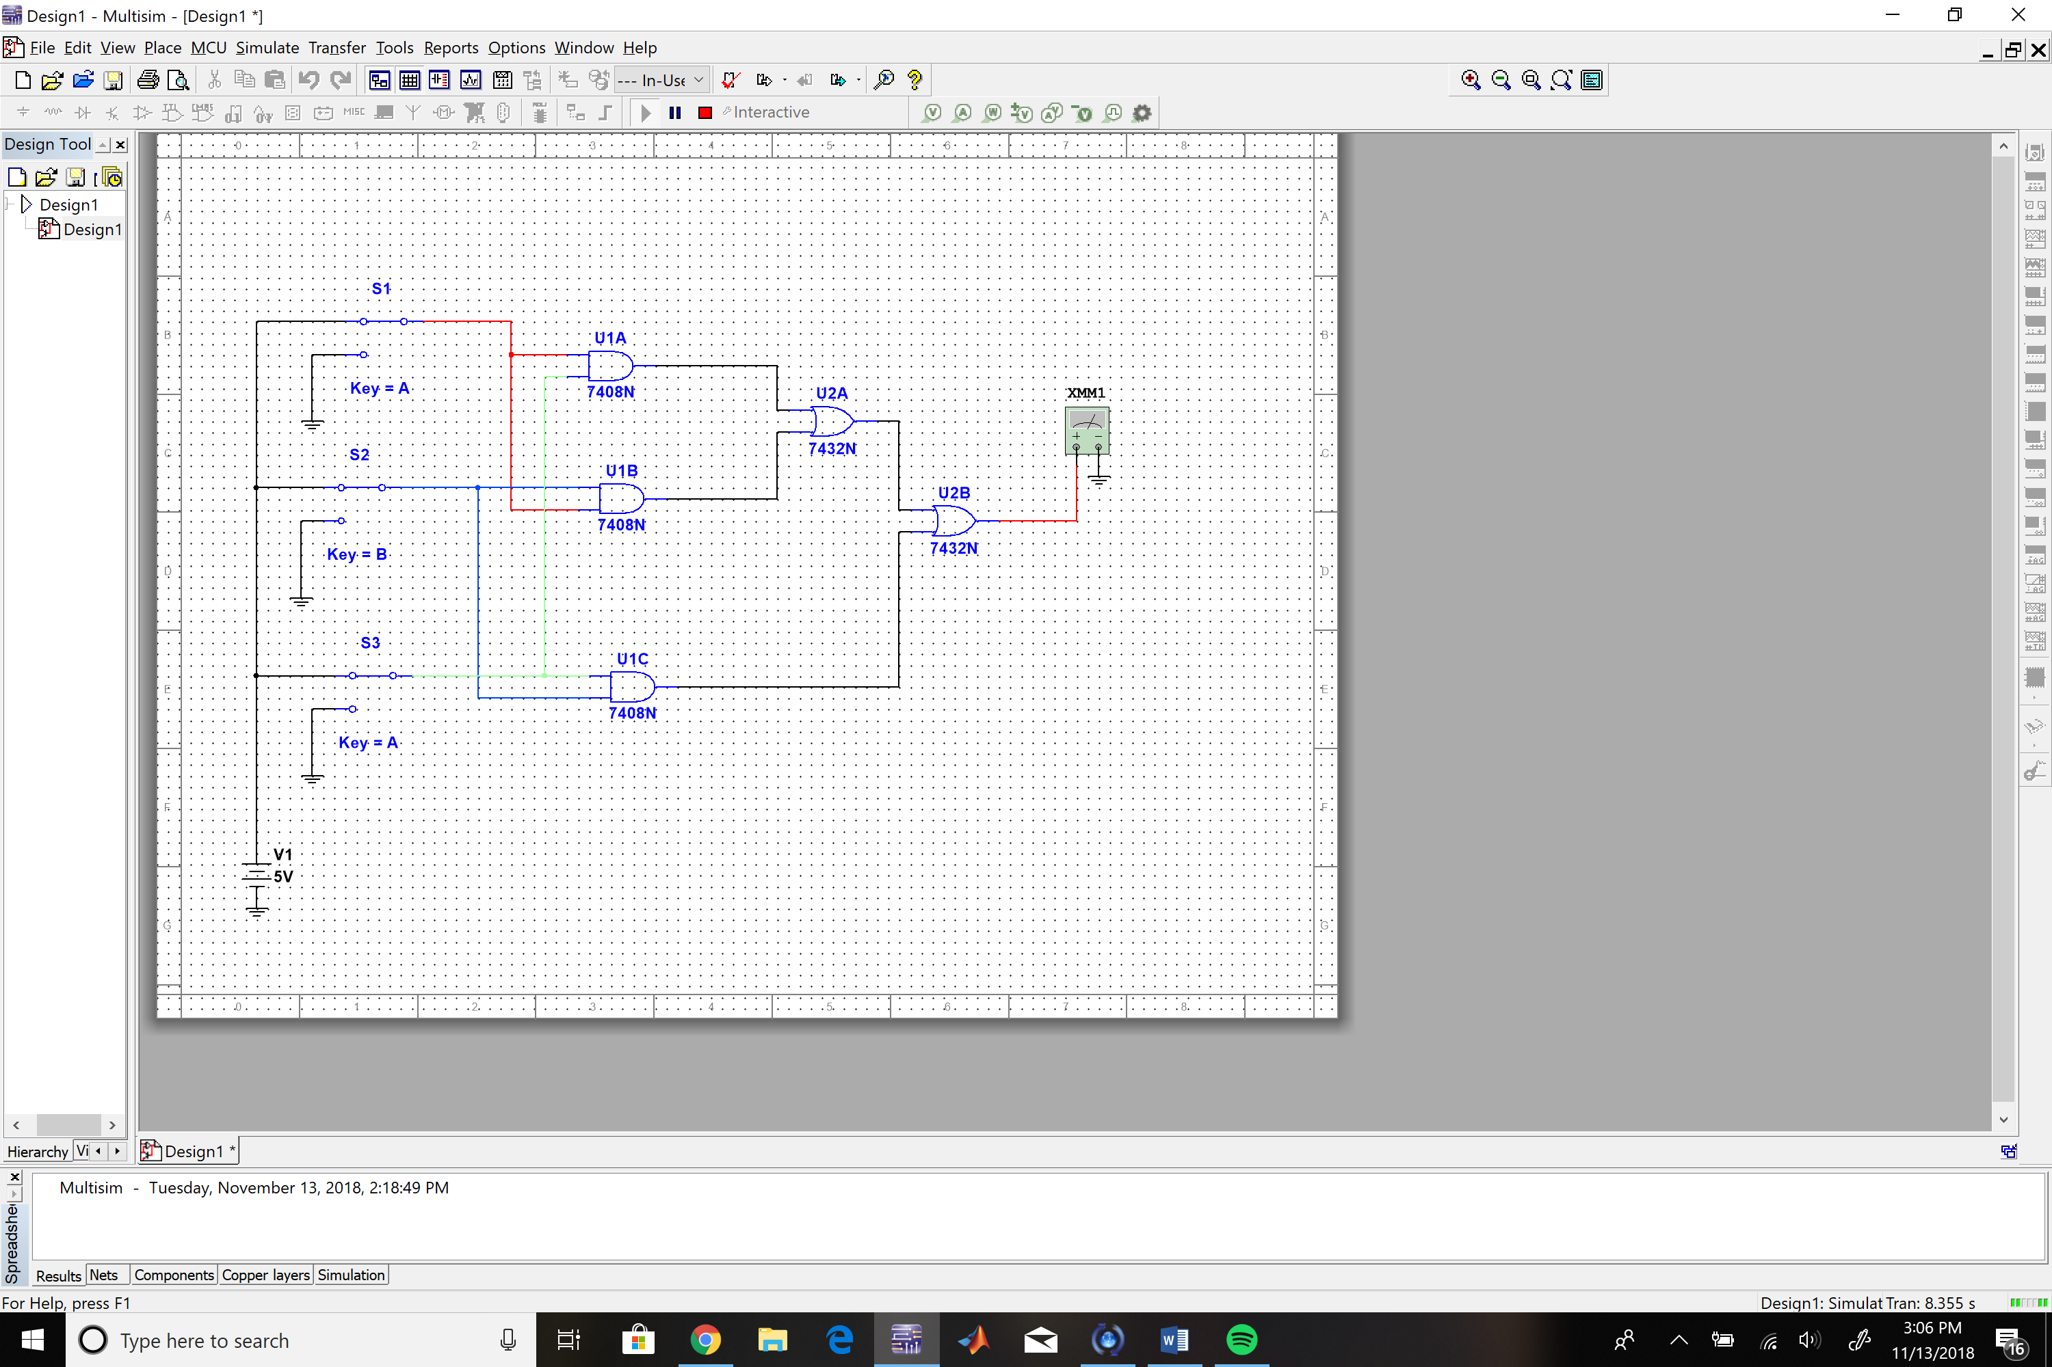

B)

|  |  |  |  |
| --- | --- | --- | --- |
| A(v) | B(v) | C(v) | Vout(v) |
| 0 | 0 | 0 | 0 |
| 0 | 0 | 5 | 0 |
| 0 | 5 | 0 | 0 |
| 0 | 5 | 5 | 5 |
| 5 | 0 | 0 | 0 |
| 5 | 0 | 5 | 5 |
| 5 | 5 | 0 | 5 |
| 5 | 5 | 5 | 5 |

C)

The Vout for tables 2 and & 3 are the same and the results for both agree with each other.