IN CHARACTER PLUGIN FOR UE5.6

Thank you for purchasing the InCharacter Blueprint. Once setup you will be able to create Characters from your MetaHumans with very few clicks. The first one will need a little work in order to retarget the animations.

SUPPORT

If you need help with the plugin, please contact me at support@eptorath.info, you can also get support and documentation on GitHub: https://github.com/dlorre/InCharacter-docs

WHAT IS THIS PLUGIN DOING?

This plugin makes a non destructive conversion from a MetaHuman Blueprint by:

- Creating a child of ACharacter blueprint (actually a child of AInCharacterBase)
- Adding a LODSync component
- Moving the contents of Root > Body in the MetaHuman blueprint to Capsule > Mesh in the target blueprint
- Providing the AInCharacterBase actor class that contains the pre-configured hierarchy
- Transferring all the relevant properties
- Generating a modified skeletal mesh (`_IK_Fix`) for animation retargeting (optional)

You can make your own class child of AInCharacterBase or reparent it later.

If you use this plugin to retarget the animations from the BP_TopDownCharacter, you will need a modified skeleton that is included in the plugin. Then the plugin will create a copy of the MetaHuman skeletal mesh (ending with IK_Fix) and assign that skeleton to it.

Finally you can provide an AnimInstance class to the blueprint and have it initialized. However no default class is given so you’ll have to create it yourself the first time.

PLUGIN SETTINGS

Go to Project Settings > Plugins > In Character :

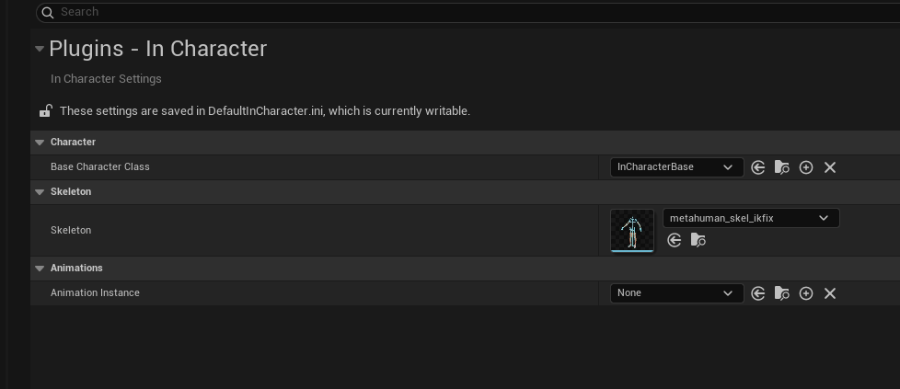
There you can modify three things :

The base character class, you can create another Actor Class that is child of AInCharacter and add your own components to it.

The skeleton : The skeleton provided is the same than the MetaHuman skeleton with 3 virtual bones for the feet and root. If you do not need this you can clear this entry or you can also provide your own skeleton if you wish.

The Animation Instance will be automatically set if you pick one, none is contained in this plugin however a Control Rig for the feet is provided to help you create your own.

CREATING YOUR CHARACTER FROM A METAHUMAN

After creating your MetaHuman, locate its Blueprint in the content folder and right click onto it. From there select Create a Character Blueprint from this MetaHuman

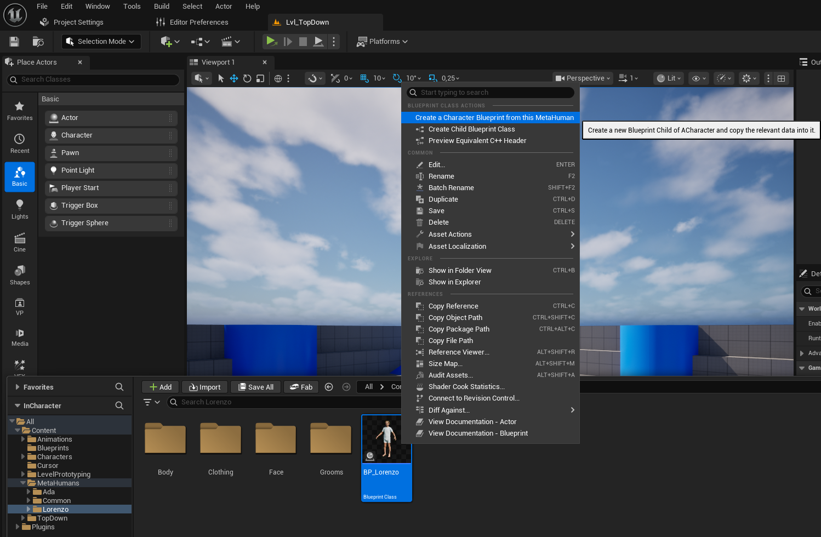

This will create a new Character blueprint right next to it :

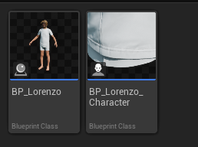

And a copy of the SkeletalMesh will also be created :

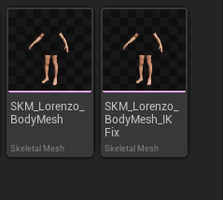

This is necessary to make non-destructive fixes to the IK (i.e not overwriting the original SkeletalMesh).

Don’t forget to save at every step, the simplest is to press Ctrl-Shift+S

MAKING YOUR CHARACTER WALK

The ACharacter class provides the CharacterMovement component that is very helpful for versatile animations. Epic has made the AnimStarterPack available for those who need to animate their characters. You will find more information about it here.

However, as of writing, the AnimStarter pack has not yet been updated for UE 5.6, so we can use instead a pre-configured template such as the TopDown or the ThirdPerson templates.

For the sake of simplicity, I’m assuming that your project is based on the TopDown template, because the ThirdPerson template is a bit more difficult to configure. In either case you will find convenience Blueprints for these templates that you can use as parent for your MetaHuman characters (either by reparenting or directly in the plugin settings).

While the BP_InCharacterTopDown asset is provided in the plugin, it is not possible to do the same for the BP_InCharacterThirdPerson asset because it would not compile without the ThirdPerson template. You will find it in the github repository mentioned at the top of this document under Extras. Simply download it and drag it into your project.

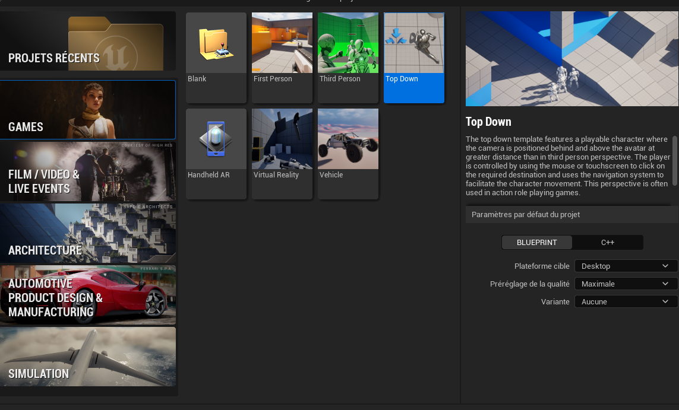
If your project is not based on the TopDown template, you will at least need to create a new project based on it, and copy the Characters folder into your project, the TopDown folder can also be useful if you plan to use its game mode and the other blueprints. While it’s not overly complicated, I suggest you start from a TopDown project and gets acquainted with it.

Once your project is correctly setup, navigate to Content > Characters > Mannequins > Anims > Unarmed :

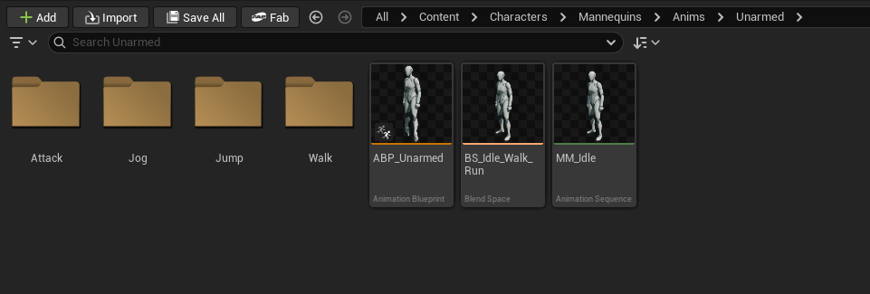
Right-click on ABP_Unarmed and Select Retarget Animations as this will be your source for retargeting animations. Select the target Skeletal Mesh that has been created, its name should end with _IKFix. Then make sure that Auto Generate is checked and select the assets you want to retarget, I usually select these :

- ABP_Unarmed
- BS_Idle_Walk_Run.BS_Idle_Walk_Run
- MF_Unarmed_Jog_Bwd
- MF_Unarmed_Jog_Fwd
- MF_Unarmed_Jog_Left
- MF_Unarmed_Jog_Right
- MM_Dash
- MM_Fall_Loop
- MM_Jump
- MM_Land
- MM_WallJump
- MM_Idle
- MF_Unarmed_Walk_Bwd
- MF_Unarmed_Walk_Fwd
- MF_Unarmed_Walk_Left
- MF_Unarmed_Walk_Right

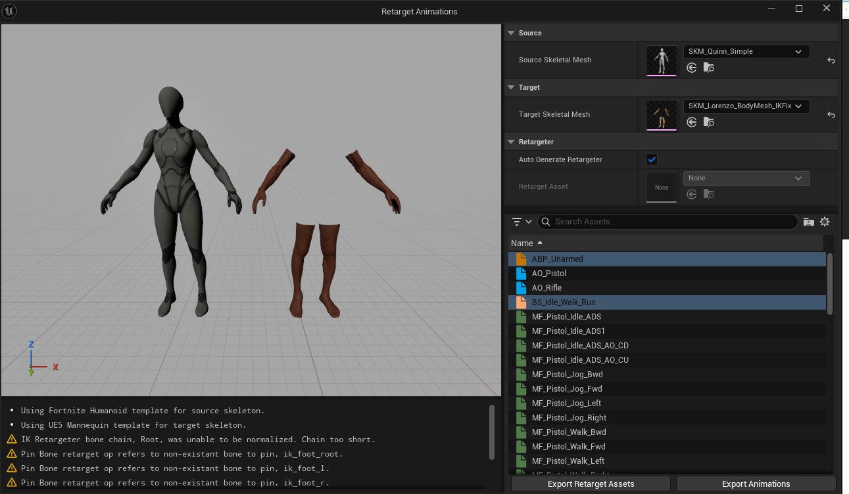

Then click Export Animations, pick the folder you want, then click Export twice. If all went well, you should get something like this :

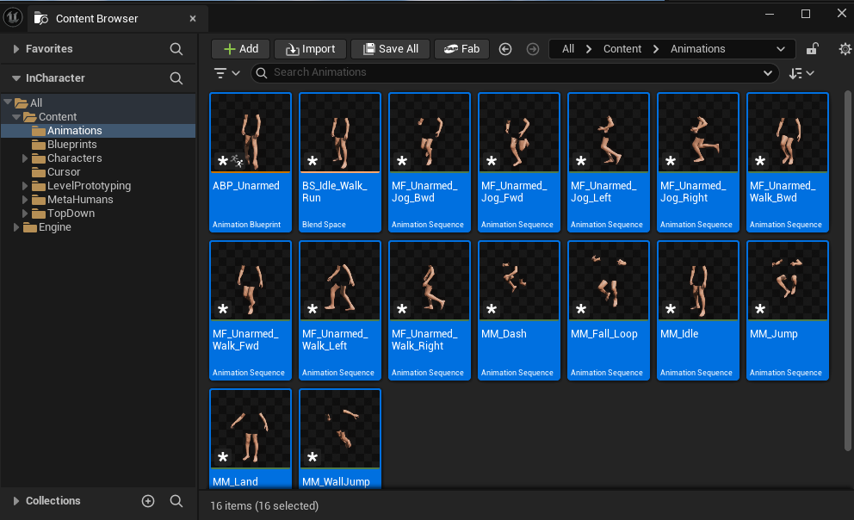
As you can see those are not saved, you will need to press Ctrl+Shift+S again.

There is a final fix to make before your character can walk properly, open the newly created ABP_Unarmed, let’s rename it to ABP_MetaHuman and we will need to make a slight change to it.

Edit ABP_MetaHuman, click on AnimGraph, then ControlRig, then locate the Control Rig Entry.

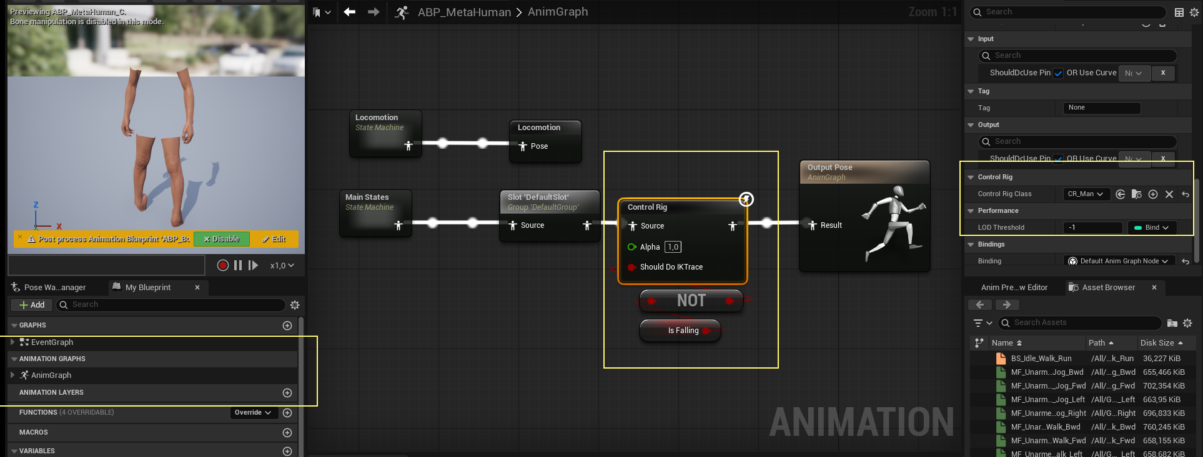

Then select CR_MetaHuman_FootIK for the Control Rig class, this contains a fix for the foot IK.

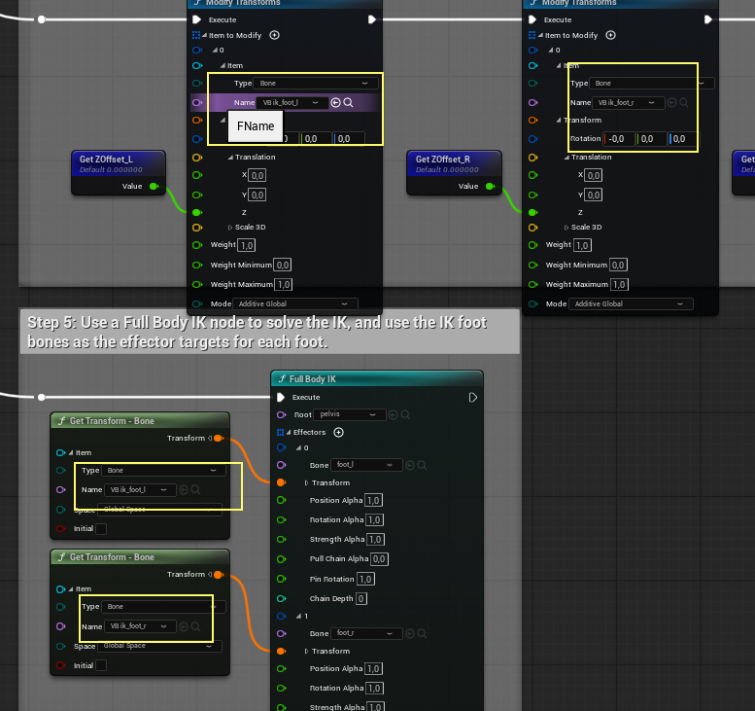
The correct values corresponding to the newly added virtual bones have been set for you:

Compile and Save, and your MetaHuman should be ready for testing.

TESTING YOUR METAHUMAN CHARACTER

AInCharacterBase only contains the minimal content to adapt the MetaHuman as a child of Acharacter. The TopDownCharacter has a SpringArm and a Camera that we will need to add.

You can reuse the BP_InCharacterTopDown blueprint that is included in the plugin, in that case you just need to reparent your new blueprint to that class. Otherwise you can add the components this way :

Open the BP_TopDownCharacter blueprint and copy the SpringArm and Camera components :

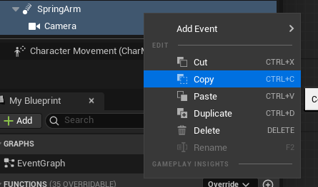

Then open your MetaHuman Character blueprint and paste the SpringArm and the Camera as a child of Capsule :

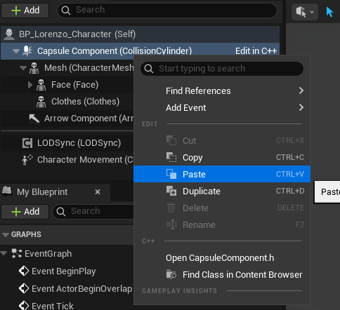

Also click Mesh and set the ABP_MetaHuman we just created.

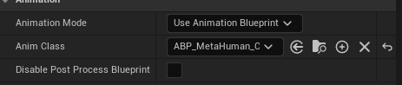

If you are using the level TopDown for your tests, you can quickly check by setting your new character as Default Pawn Class in the World Settings :

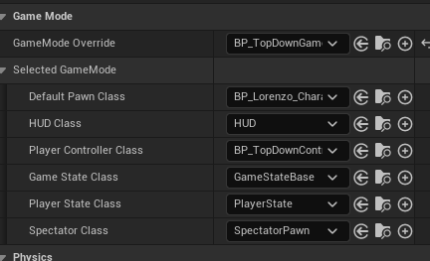

Press play, and if everything is correctly set your character should walk exactly like the TopDown
Mannequin.

TROUBLESHOOTING

If the character does not appear you have to restart the editor :

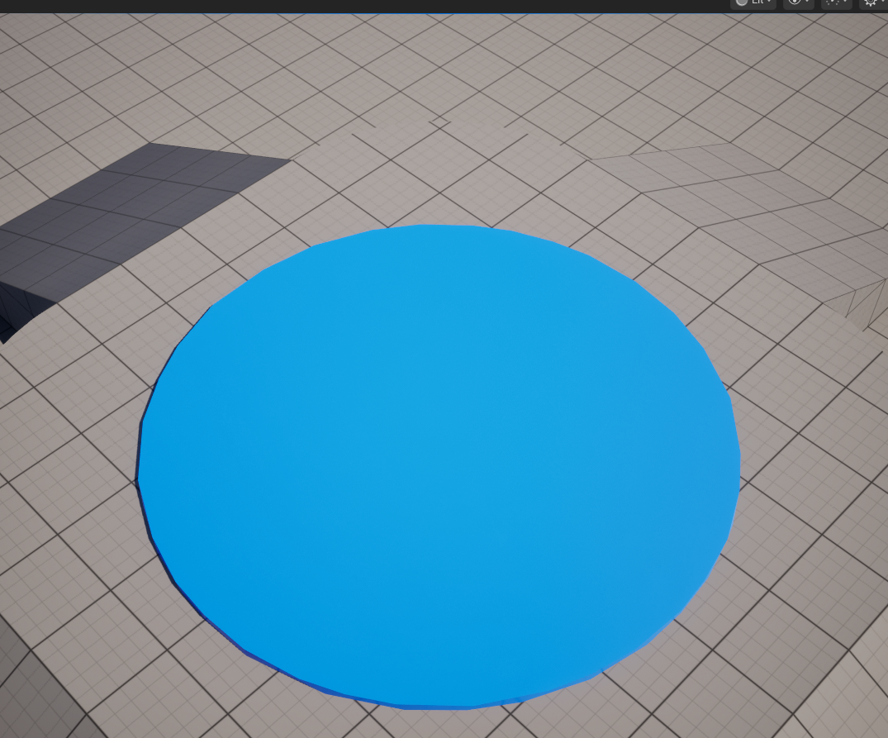

If the character does not rotate then you need to verify that your blueprint has :

Use Controller Rotation Yaw unchecked (false) in the Class Defaults and

Orient Rotation To Movement checked (true) in the CharacterMovement component.

If your character feet are wrong after setting the AnimBlueprint make sure that the skeleton does end with _IKFix, not saving the character blueprint after its creation can lead to this issue.

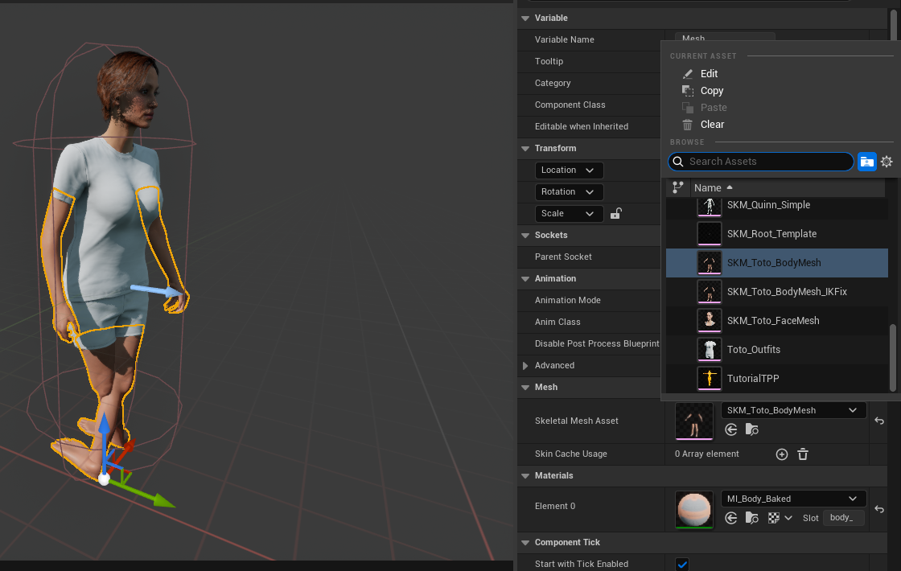

WORKFLOW

Once your first character is done, you can reuse the ABP_MetaHuman we just created, you can also have it automagically set for you by assigning it in the plugin settings.

If you wish to use the TopDownCharacter template permanently you just need to create a child blueprint of InCharacter and add the SpringArm and the Camera as we did. That’s exactly what the BP_InCharacterTopDown class does, however you might want to create your own class.

In any case, you can also set that class in the settings and then your next MetaHumans characters will be created with that parent class without need to reparent or add the components any longer.

