Table of Contents

JTAG Enumeration for Security Research on the Zynq UltraScale+ MPSoC

1. Introduction

1.1 Why JTAG enumeration matters
JTAG is the most privileged hardware-level debug interface on a modern SoC. On an unhardened device, it provides:
- Read/write access to every memory location the SoC can address
- Halt and step control of every CPU (APU, RPU, PMU)
- Direct access to the security control unit’s registers
- Read access to eFUSE shadow registers including device fingerprint, secure-boot policy, and PPK hashes
- The ability to release CPUs from reset and execute arbitrary code at EL3 — the highest ARMv8 privilege level, above any OS, hypervisor, or TrustZone monitor
For an attacker with physical access, JTAG bypasses the operating system entirely. For a defender, JTAG state is what the silicon actually enforces — software-level hardening is irrelevant if the JTAG hardware gates are wide open.
The first question on any new device is: what is the silicon actually gating, and what is it leaving open? Answering it requires reading and decoding roughly eighty registers across seventeen functional sections — the security spine plus power, clocks, resets, A53 state, code-execution discovery, debug topology, memory map probes, peripheral and memory protection units, RPU configuration, IPC fabric, and FPGA configuration status — plus tracking the live state of every domain that could be a debug-relevant target. Doing this by hand is slow and error-prone. The enumeration tool described in Volumes 2 and 3 does it in ten seconds and produces a structured, diffable report.

2. Background
AMD’s Zynq UltraScale+ MPSoC is the platform every step of this workflow targets. The subsections below cover its high-level architecture, variant landscape, boot model, JTAG security gates, and memory layout — in the order needed to understand what enumeration produces.

2.1 The ZynqMP SoC at a glance
The Zynq UltraScale+ MPSoC is a multi-die system-on-chip combining several processor subsystems with FPGA fabric:
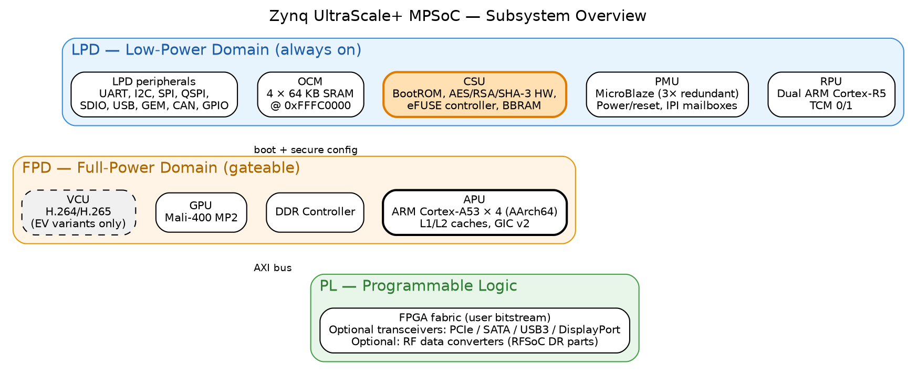
ZynqMP subsystem overview showing LPD, FPD, and PL domains
Two power domains govern everything:
- LPD — Low-Power Domain. Always-on. Contains the RPU, PMU, CSU, OCM (on-chip SRAM), most peripherals
- FPD — Full-Power Domain. Can be gated off. Contains the APU, DDR controller, GPU, VCU, PCIe, SATA, USB3, DisplayPort, GIC
A device booted “JTAG-idle” with the FPD off can still service JTAG debug because the LPD remains powered.

2.2 Boot model
The ZynqMP boot sequence is multi-stage:
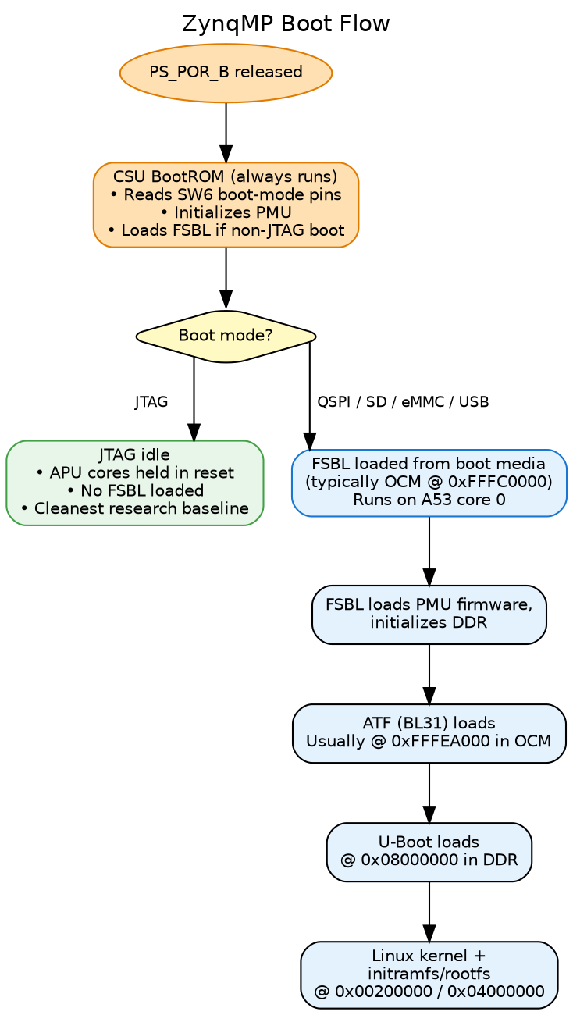
ZynqMP boot flow from PS_POR_B through Linux kernel load
The JTAG-idle state is the cleanest baseline for enumeration: APUs are in reset, no FSBL has run, no secrets have been loaded into peripherals, no peripheral interrupts are active. Most of this paper’s sample data comes from a ZCU102 in JTAG idle.
A device booted from SD/QSPI/eMMC produces a much richer enumeration report because FSBL has run, DDR is initialized, PMU firmware is running, peripherals are alive, and U-Boot or Linux may be visible in memory. The two report types diff against each other to reveal what the FSBL chain actually did.

2.3 JTAG security architecture
This is the part that drives most of the rest of the series.

JTAG chain composition
The ZynqMP exposes two TAPs in series on the JTAG chain:
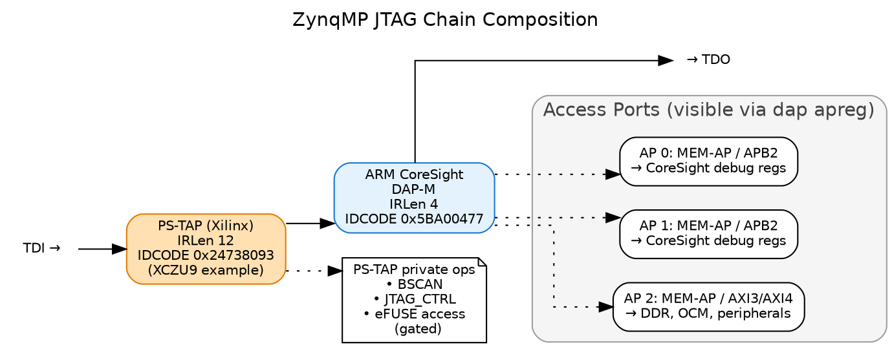
JTAG chain composition: PS-TAP + ARM CoreSight DAP with Access Ports
The PS-TAP is Xilinx-proprietary; the ARM DAP is the standard CoreSight ARM debug-access port. Both must be reachable for full enumeration.

The CSU Secure Stream Switch (SSS)
The CSU implements a multi-input multi-output stream switch that gates which JTAG paths can talk to which security-sensitive blocks. Three SSS paths matter for JTAG enumeration:
JTAG ── ┬─► SSS_DAP_SEC ──► ARM DAP (APU, RPU debug)
│
├─► SSS_PLTAP_SEC ──► PL TAP (FPGA fabric JTAG)
│
└─► SSS_PMU_SEC ──► PMU (firmware execution control)
Each path’s gate is controlled by a 3-bit magic value in CSU.JTAG_SEC (at 0xFFCA0038). Open requires 0b111; any other value gates the path. The 3-bit design is anti-glitch — a single bit flip from fault injection cannot unlock a gated path.

Per-cluster debug authorization (JTAG_DAP_CFG)
A second register CSU.JTAG_DAP_CFG (at 0xFFCA003C) controls what the ARM DAP itself can do, with six 1-bit gates:
Bit | Field | Effect
0 | SSSS_APU_DBGEN | APU halt/step/breakpoint allowed (non-secure world)
1 | SSSS_APU_NIDEN | APU non-invasive trace (ETM, etc.) allowed
2 | SSSS_APU_SPIDEN | APU SECURE-world debug allowed (EL3/TrustZone)
3 | SSSS_APU_SPNIDEN | APU secure-world trace allowed
4 | SSSS_RPU_DBGEN | RPU (R5) debug allowed
5 | SSSS_RPU_NIDEN | RPU trace allowed
These are cluster-wide, not per-core. SPIDEN is the bit that defines whether the device’s secure-world is attackable via JTAG.

eFUSE secure-boot policy
Finally, the one-way fuses in EFUSE.SEC_CTRL (at 0xFFCC1058) control the silicon’s secure-boot policy at hardware level:
Bit(s) | Field | Effect when set
0 | AES_RDLK | AES key in eFUSE cannot be read
1 | AES_WRLK | AES key in eFUSE cannot be written
2 | ENC_ONLY | Boot image MUST be encrypted
3 | BBRAM_DIS | BBRAM disabled as key source
5 | JTAG_DIS | Hardware JTAG disable — irreversible
10 | SEC_LOCK | Lock SEC_CTRL itself — no further fuses settable
[25:11] | RSA_EN | 15-bit magic field requiring specific value to enforce RSA-signed boot
26 | PPK0_WRLK | Primary Public Key 0 hash write-locked
[28:27] | PPK0_INVLD | 2-bit magic field; invalidates PPK0
29 | PPK1_WRLK | PPK1 hash write-locked
[31:30] | PPK1_INVLD | 2-bit magic field; invalidates PPK1
Two fields use magic-value patterns (RSA_EN, PPK_INVLD) rather than single-bit enables — the same anti-glitch defense as the JTAG_SEC gates. A successful glitch attack on a single bit cannot enable RSA bypass or invalidate a PPK.
These three register groups — JTAG_SEC, JTAG_DAP_CFG, and EFUSE.SEC_CTRL — define essentially the entire JTAG-visible security policy of the device. Reading them is the heart of the enumeration workflow described in Volume 2.

2.4 Memory layout overview
ZynqMP’s address space (identical across MPSoC variants):
Range | Block | Notes
0x00000000 - 0x7FFFFFFF | DDR (lower 2 GB) | Main system DRAM. Only accessible after DDR controller init by FSBL.
0xC0000000 - 0xFCFFFFFF | PL aperture / PCIe | Programmable Logic and PCIe BARs
0xFD000000 - 0xFD0FFFFF | DDR controller
0xFD1A0000 - 0xFD1AFFFF | CRF_APB | FPD Clock/Reset (APLL/DPLL/VPLL, RST_FPD_*)
0xFD400000 - 0xFD4FFFFF | SERDES | Gigabit transceivers
0xFD5C0000 - 0xFD5CFFFF | APU registers | RVBARADDR0-3 reset vectors. APU power/reset.
0xFD800000 - 0xFD9FFFFF | GPU (Mali-400)
0xFE000000 - 0xFE00FFFF | GIC distributor
0xFE100000 - 0xFE1FFFFF | VCU (video codec) | EV variants only
0xFF000000 - 0xFF0FFFFF | PS UARTs, I2C, SPI, GPIO, QSPI
0xFF160000 - 0xFF17FFFF | SDIO0/1
0xFF300000 - 0xFF33FFFF | IPI mailboxes | PMU↔APU↔RPU communication
0xFF410000 - 0xFF41FFFF | LPD_SLCR
0xFF5E0000 - 0xFF5EFFFF | CRL_APB | LPD Clock/Reset (IOPLL/RPLL, BOOT_MODE, RST_LPD_*)
0xFF9A0000 - 0xFF9AFFFF | RPU configuration
0xFFC80000 - 0xFFCBFFFF | CSUDMA + CSU | CSU at 0xFFCA0000
0xFFCC0000 - 0xFFCCFFFF | eFUSE controller | DNA, SEC_CTRL, PPK hashes
0xFFCD0000 - 0xFFCDFFFF | BBRAM | Battery-Backed RAM (AES key storage)
0xFFCE0000 - 0xFFCEFFFF | RSA core | Hardware RSA-2048/4096
0xFFD80000 - 0xFFD8FFFF | PMU_GLOBAL | Power/reset of every domain
0xFFDC0000 - 0xFFDDFFFF | PMU RAM (LMB) | PMU firmware runs here
0xFFE00000 - 0xFFE3FFFF | RPU TCM | Tightly-Coupled Memory for R5 cores
0xFFFC0000 - 0xFFFFFFFF | OCM (4×64 KB SRAM) | Default FSBL/ATF load region
This layout is identical across ZCU102/104/106, Ultra96, custom ZynqMP boards, and RFSoCs — the variant-specific differences (VCU, RF tiles, GPU presence) are bonded selections within these address ranges, not different memory maps.

