JTAG Enumeration Lab Setup and Test Architecture
  - Companion to the whitepaper series — reproducing the workflow
Table of Contents

JTAG Enumeration Lab Setup and Test Architecture
This document is the operational companion to the three-volume whitepaper. Where the whitepaper covers what the enumeration workflow finds and how to interpret it, this document covers what hardware and software to buy and install and how the change-validation framework works.
Read this before standing up your own lab. Read it again when you want to extend the toolchain.

1. Hardware

1.1 Reference board
The project’s reference board is the AMD ZCU102 Evaluation Kit. All captured data, sample reports, and case studies in the whitepaper series come from a ZCU102 running in JTAG-idle mode.
Item | Spec | Notes
Board | AMD ZCU102 Evaluation Kit | Built around XCZU9EG silicon, 4-core A53
AMD part number | EK-U1-ZCU102-G | Order from AMD or distributor (Avnet, Digi-Key, Mouser)
Approx. cost | ~$3,000 USD | Educational pricing may be available
Power | 12V DC, 5A barrel jack | Use the included PSU
The workflow generalizes to any ZynqMP-based board (ZCU104, ZCU106, Ultra96, custom XCZU* designs, RFSoC ZCU111/208/216). The toolchain detects variant differences via the IDCODE PART_ID and adapts.

1.2 Host machine
Item | Minimum | Recommended
OS | Kali Linux (any recent release) | Kali rolling on bare metal, or VMware Workstation 17+ guest
RAM | 8 GB | 16 GB
Disk | 50 GB free | 150 GB free (allows Vitis install later)
USB | USB 2.0 ports | USB 3.0 (powered hub recommended — see §1.3)
VMware guest is fully supported and is the project’s reference configuration. USB passthrough caveats are in §2.3.

1.3 Cables and accessories
Item | Notes
USB micro-B cable × 2 | One for JTAG (U33), one for UART (U40). Quality matters; use known-good cables.
Powered USB hub | Optional but recommended in VMware setups — keeps the FT232H stable across guest restarts.
Monitor + HDMI cable | Optional. Useful when booting from SD to see Linux console. Not required for JTAG-only work.
MicroSD card (≥ 16 GB) | Optional. Only required when you want to boot from SD for the booted-state enumeration baseline.
Antistatic mat / strap | Recommended whenever the board is unboxed or handled.

1.4 Physical topology
The connections look like this:
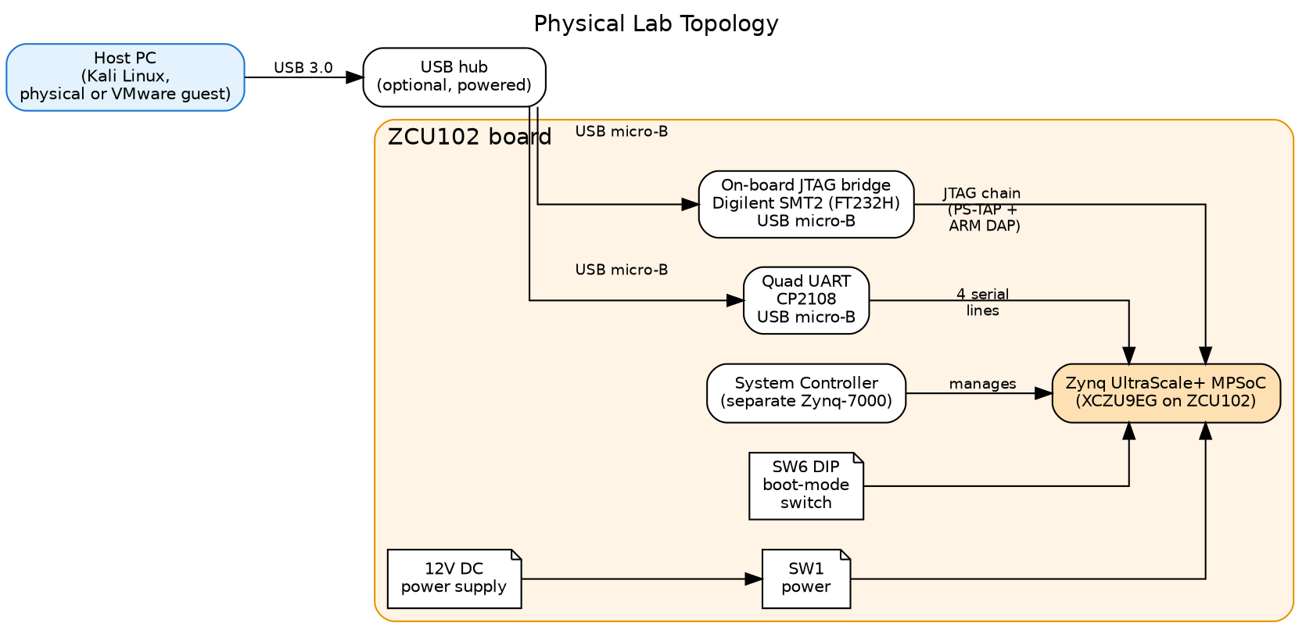
Physical lab topology showing host, USB hub, ZCU102, and its on-board USB endpoints
Key things to understand from this diagram:
- The ZCU102 has two distinct USB micro-B endpoints. Both must be cabled to the host to do the full workflow.
- JTAG via FT232H (U33) appears to the host as USB ID 0403:6014 with product string “Digilent USB Device.” This is the interface openocd/zcu102.cfg selects.
- UART via CP2108 (U40) appears as USB ID 10c4:ea71, which enumerates as four serial devices /dev/ttyUSB0 through /dev/ttyUSB3 (mapping documented in memory/reference_zcu102_ports.md).
- The System Controller is a separate Zynq-7000 on the same board that manages power sequencing, I2C, voltage regulation, and the reset buttons. It’s not normally a research target.
- The SW6 DIP switch sets the boot mode the BootROM reads at PS_POR_B release. All-ON = JTAG idle (the cleanest baseline for enumeration). Other positions select QSPI, SD, eMMC, USB boot.
- SW1 is the power button. Pressing it toggles the SoC’s power state without removing 12V from the board.

2. Software install

2.1 OpenOCD and base tools
These are required for the enumeration workflow itself:
sudo apt-get update
sudo apt-get install -y \
openocd \
tio \
minicom \
screen \
usbutils
Package | Purpose
openocd | JTAG host — runs the enumeration scripts
tio | Friendly serial terminal for UART monitoring
minicom, screen | Alternative serial terminals
usbutils | lsusb for autoconnect’s USB scan

2.2 Whitepaper generation tooling
Required only if you’ll regenerate the PDF/DOCX artifacts:
sudo apt-get install -y \
pandoc \
texlive-latex-recommended \
texlive-fonts-recommended \
texlive-xetex \
graphviz \
imagemagick
Package | Purpose
pandoc | Markdown → PDF/DOCX converter
texlive-* | LaTeX backend for PDF generation
graphviz | Renders the .dot figure sources to PNG
imagemagick | Image conversion and page preview rendering
Total disk footprint for the whitepaper toolchain: ~600 MB.

2.3 udev rule for non-root FT232H access
By default, only root can talk to the FT232H. Without this rule OpenOCD must be invoked with sudo, which is awkward and risky.
Create /etc/udev/rules.d/99-ftdi-jtag.rules:
SUBSYSTEM=="usb", ATTRS{idVendor}=="0403", ATTRS{idProduct}=="6014", \
MODE="0666", GROUP="plugdev"
Then:
sudo udevadm control --reload-rules
sudo udevadm trigger
Unplug and replug the JTAG USB cable. Verify lsusb shows the device and you can run OpenOCD without sudo.

2.4 VMware USB passthrough
If you’re running Kali as a VMware guest, the JTAG and UART USB devices need to be passed through to the guest, not consumed by the host OS.
In VMware Workstation:
- With the guest powered on, open VM → Settings → USB Controller. Confirm USB 3.0/3.1 compatibility is selected.
- Plug in the JTAG cable. A toast notification appears in the guest asking whether to connect the device.
- Alternatively, VM → Removable Devices → Digilent USB Device → Connect.
- Repeat for the UART cable (CP2108 USB Composite Device).
- Inside the guest, verify lsusb shows both devices:
- Bus 002 Device 003: ID 0403:6014 Future Technology Devices International, Ltd FT232H
Bus 002 Device 004: ID 10c4:ea71 Silicon Labs CP2108 Quad UART Bridge
Known gotcha: if the board is powered off, the FT232H disappears from USB enumeration entirely (it draws 3.3V from the board). Power the board first, then connect USB.

3. Project repository setup

3.1 Clone
The project lives at /home/kali/Desktop/research/JTAG in this deployment. Adjust paths for your environment.
mkdir -p ~/Desktop/research
cd ~/Desktop/research
# Clone or copy the project tree here

3.2 Directory layout
JTAG/
├── CLAUDE.md Project guide (status in MEMORY.md)
├── docs/ Documentation (start with README.md)
│ ├── README.md index
│ ├── 01..10*.md focused docs
│ ├── appendix-*.md
│ └── whitepaper/ three-volume whitepaper series
│ ├── 01-foundation.{md,pdf,docx}
│ ├── 02-workflow.{md,pdf,docx}
│ ├── 03-enumeration-reveals.{md,pdf,docx}
│ ├── whitepaper-combined.pdf
│ ├── lab-setup.{md,pdf,docx} (this document)
│ └── figures/ Graphviz sources + PNGs
├── tools/
│ ├── interpret.py capture JSON → findings markdown
│ ├── interpret_lib.py Capture / Annotation / Finding
│ ├── regenerate-qemu-regs.py regenerate register library
│ ├── generate-mock-seed.py raw JSON → mock harness seed
│ ├── check-annotations.py annotation-module self-test
│ ├── golden-test.sh interpret.py vs golden md
│ ├── golden-test-roundtrip.sh enumerate.tcl via mock vs golden
│ └── tcl-smoketest.sh one-command 4-layer test suite
├── openocd/
│ ├── zcu102.cfg manual board config
│ ├── enumerate.tcl main enumeration script (18 sections)
│ ├── discover.tcl first-contact chain probe
│ └── lib/ shared Tcl libraries (incl. mock-openocd.tcl)
├── docs/
│ ├── annotations/zynqmp_{security,general}.py field annotations
│ └── findings/zynqmp_rules.py cross-register rules
├── reports/ enumeration reports (timestamped)
├── tests/golden/zcu102-jtag-idle/ frozen test fixtures
└── logs/ serial captures

3.3 First-time verification
After install, confirm everything works without the board attached:
cd ~/Desktop/research/JTAG
./tools/tcl-smoketest.sh
Expected output:
PASS: enumerate.tcl parses and runs end-to-end under stubs
...
Summary: 2 verified, 0 unverifiable, 4 discrepancies
(CRITICAL=0 MAJOR=4 MINOR=0 INFO=0)
The 4 MAJOR findings are on CSU_IDCODE (IEEE 1149.1 standard fields, known acceptable — see Volume 2 §1.4 for context).

3.4 First-time live verification
With the board powered and USB passed through:
# Optional: confirm the JTAG chain matches expectation
openocd -f openocd/zcu102.cfg -c "init; source openocd/discover.tcl; shutdown"
# Capture
openocd -f openocd/zcu102.cfg -c "init; source openocd/enumerate.tcl; shutdown"
Expected: a markdown report appears in reports/ and §2 of the report identifies the chip as XCZU9 (EG/CG) (or whatever variant your board uses).

4. Test architecture — how changes are validated
The enumeration tooling enforces a gating workflow for any change to the enumeration script or its libraries. This catches bug classes that have repeatedly bitten this project: hand-typed bit fields drifting from silicon truth, Tcl bracket-in-string substitution, register-name collisions at coincidental addresses.
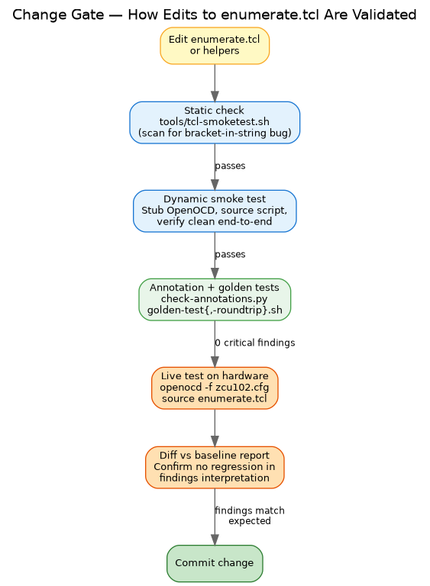
Validation gates: edit → static → smoke → audit → live test → diff → commit

4.1 Gate 1 — static check
tools/tcl-smoketest.sh scans openocd/enumerate.tcl for the bracket-in-string pattern that has caused mid-script crashes in past versions:
"...field-name[N:M]..."
inside a [list ...], [lappend ...], [format ...], or [expr ...] context. Tcl interprets [N:M] as command substitution and fails when “N:M” isn’t a valid command. The static check prevents this from reaching a live run.

4.2 Gate 2 — dynamic smoke test
The same tcl-smoketest.sh stubs every OpenOCD-specific command (targets, safe_rd, safe_wr, read_memory, halt, etc.) and runs enumerate.tcl end-to-end under tclsh. Any uncaught Tcl error fails the test.
This catches:
- Tcl syntax errors (unclosed braces, malformed expr)
- Undefined-variable references
- Bad foreach lists
- The bracket-in-string bugs that the static check missed
Runs in under a second, no board needed.

4.3 Gate 3 — register-layout consistency (built into the script)
Bit-layout consistency is no longer a separate audit step — it’s structural. Every register read in enumerate.tcl goes through dump_reg_qemu <ADDR>, which looks up bit fields directly from openocd/lib/zynqmp-regs-qemu.tcl (auto-generated by tools/regenerate-qemu-regs.py from QEMU C sources). There is no hand-typed bit position anywhere in the capture path, so drift between the script and QEMU’s model is structurally impossible.
The standalone audit tool that previously cross-checked hand-typed dump_reg calls (tools/audit-bit-layouts.py) was retired in the May 2026 cleanup because it had nothing to audit — all sites delegate to QEMU.
What replaces it:
- tools/check-annotations.py — sanity check for the annotation modules: every Annotation’s (register, field) pair must resolve to a real register in zynqmp-regs-qemu.tcl; wildcards (register="*") must match at least one register; no duplicates.
- tools/golden-test.sh + tools/golden-test-roundtrip.sh — diff produced output against frozen golden artifacts (raw JSON, raw markdown, interpreted markdown). Either drift fires a test failure.
- All three gates run from ./tools/tcl-smoketest.sh.
Earlier discrepancy categories (kept for historical context):
Severity | What it means
CRITICAL | Field placed at wrong bit position OR register at wrong address (different register lives there in QEMU)
MAJOR | Field name doesn’t match QEMU’s at that bit position; phantom field that doesn’t exist in QEMU
MINOR | Script omits a field QEMU has at that bit position
INFO | Naming-style differences (e.g., AES_RDLK vs AES_RD_LOCK) — same field, different abbreviation
The audit currently shows 0 CRITICAL, 4 MAJOR (all known-acceptable IEEE 1149.1 standard fields on CSU_IDCODE), 0 MINOR, 0 INFO. Any new CRITICAL or MAJOR introduced by a change must be resolved before the change merges.
The audit also has an --address-only mode that runs faster and only verifies register name matches at each address — useful for catching coincidental-address bugs (the script names register X at address A, but QEMU has register Y at A).

4.4 Gate 4 — live test on hardware
Once the offline gates pass, run the script on the ZCU102:
openocd -f openocd/zcu102.cfg -c "init; source openocd/enumerate.tcl"
The script’s cleanup re-asserts A53 reset at the end of each run, so consecutive runs on the same boot session work without a power cycle.

4.5 Gate 5 — diff against baseline report
After a live run, compare the new report against a saved baseline:
diff -u reports/enumerate-<known-good-timestamp>.md \
reports/enumerate-<new-timestamp>.md | less
The reports have stable structure so meaningful changes appear as specific register-value or findings-text deltas, not noise.
Confirm:
- Section §2 still identifies the correct variant
- Section §4 findings interpretations are consistent with the observed register values (e.g., if JTAG_DAP_CFG.SPIDEN = 1, the findings text says “WIDE OPEN — secure-world debug enabled”)
- No new unexpected ERR or BLOCKED values in late sections
If diffs make sense, commit the change.

4.6 Why the gates exist
The gates aren’t bureaucracy — they exist because each one has caught a real bug in the project history:
- Static check: caught at least three independent bracket-in-string bugs during whitepaper-era editing
- Smoke test: caught Tcl parse errors before any board time was wasted
- Audit: surfaced 89 bit-layout discrepancies in the pre-audit script — many fundamental (e.g., 20 fabricated per-core bits on JTAG_DAP_CFG that didn’t exist in real hardware)
- Diff: catches the case where bit math is correct but the interpretation text wasn’t updated to match — a finding can be silently wrong even when the values it cites are right
Skip any gate and you reintroduce the bug class it was built to prevent.

5. Reproduction-of-results checklist
To reproduce the ZCU102 case study from Volume 2 §3 of the whitepaper:
# | Step | Expected result
1 | Power off the board (SW1 OFF), wait 5 seconds | All LEDs off
2 | Set SW6 boot mode DIP switch to all-ON (JTAG idle) | Visual check
3 | Connect JTAG USB and UART USB cables to host | lsusb shows 0403:6014 and 10c4:ea71
4 | Pass both USB devices through to the VM guest if applicable | Same — verified inside guest
5 | Power on the board (SW1 ON) | Status LEDs come up; FT232H stays enumerated
6 | openocd -f openocd/zcu102.cfg -c "init; source openocd/discover.tcl; shutdown" | TAPs + IDCODEs + AP list match the expected part
7 | openocd -f openocd/zcu102.cfg -c "init; source openocd/enumerate.tcl; shutdown" | Report file appears in reports/ after ~10s
8 | Open the report; check §2 chip identity | XCZU9 (EG/CG) (4-core A53, family=zynqmp)
9 | Check §4 security state findings | SPIDEN=1, SPNIDEN=1 (“WIDE OPEN” findings), EFUSE.SEC_CTRL = 0x00000000
10 | Check §8 A53 release | A53.0 halted at PC 0xFFFC0000, CPSR 0x000003cd (EL3H)
11 | Confirm cleanup re-asserted A53 reset | Final section shows RST_FPD_APU after = 0x00003d0f
If any step diverges from expected, check:
- USB passthrough is current (VMware sometimes drops devices on guest reboot)
- Board is fully powered (FT232H needs 3.3V from board)
- No other OpenOCD instance is running (pgrep openocd)
- For step 6: SW6 is fully all-ON (any bit wrong selects a different boot mode)

6. Common operational issues
Symptom | Likely cause | Fix
lsusb doesn’t show FT232H or CP2108 | Board powered off, or USB not passed through | Power board; check VMware USB passthrough
OpenOCD: JTAG-DP STICKY ERROR at init | A53 was released in prior run, cleanup didn’t complete | Power-cycle board (SW1 OFF, 5s, ON); retry
Permission denied on /dev/ttyUSB* | User not in dialout or plugdev group | sudo usermod -aG dialout,plugdev $USER; re-login
Enumeration report ends partway through | Tcl error in script | Check stdout for the error line; run tcl-smoketest.sh
discover.tcl shows no APs | Target config didn’t load, or DAP examination failed | Verify board config, re-run autoconnect
Audit shows CRITICAL findings | Wrong address or fabricated field introduced | Fix before committing
Combined PDF rebuild slow | LaTeX font setup runs first time on a system | Subsequent runs are fast (~5s per volume)

7. Regenerating the whitepaper artifacts
When the markdown source files in docs/whitepaper/*.md are edited, regenerate the PDFs and DOCXs:
cd ~/Desktop/research/JTAG/docs/whitepaper
# PDFs (per volume)
for vol in 01-foundation 02-workflow 03-enumeration-reveals lab-setup; do
pandoc --defaults=pandoc-defaults.yaml -o "${vol}.pdf" "${vol}.md"
done
# Combined PDF
pandoc --defaults=pandoc-defaults.yaml -o whitepaper-combined.pdf \
01-foundation.md 02-workflow.md 03-enumeration-reveals.md
# DOCXs
for vol in 01-foundation 02-workflow 03-enumeration-reveals lab-setup; do
pandoc --defaults=pandoc-defaults-docx.yaml -o "${vol}.docx" "${vol}.md"
done
When figure source files (docs/whitepaper/figures/*.dot) are edited, regenerate the PNGs:
cd docs/whitepaper/figures
for f in *.dot; do
dot -Tpng -Gdpi=150 -Gsplines=ortho "$f" -o "${f%.dot}.png"
done
Then rebuild the affected PDFs.
When the QEMU register sources at /opt/xilinx/qemu/hw/misc/*.c are updated (rare — only when Xilinx QEMU is upgraded):
python3 tools/regenerate-qemu-regs.py
./tools/tcl-smoketest.sh # confirm capture + interpret still match goldens

See also
- 01-foundation.md, 02-workflow.md, 03-enumeration-reveals.md — the three-volume whitepaper series
- docs/05-enumeration-tool.md — full enumerate.tcl manual
- docs/09-discover-tool.md — discover.tcl reference
- docs/11-enumerated-attributes.md — enumerated security-attribute catalog
- docs/appendix-a-recovery.md — DAP-wedge recovery procedures
- docs/appendix-b-references.md — Xilinx and ARM document references
- CLAUDE.md + the MEMORY.md index — current project status and pending work

