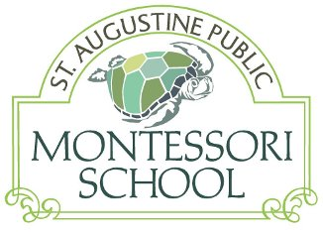

Business Name
Contact
Street Address
City, State Zip

Dear

We are off to an exciting third year at St. Augustine Public Montessori School (SAPMS). Along with reading, writing and arithmetic, our students are learning history, geography, art, sign language, marine biology, German, ornithology, horticulture and yoga.

SAPMS opened in August 2012 to provide elementary-aged students with a learning culture grounded in the Montessori philosophy. This historically proven educational model supports the whole child, creates lifelong learners and encourages collaborative approaches to community leadership. The foundation of this academic excellence is a prepared classroom environment that inspires self-paced, individualized discovery; a love of learning; and respect for self, others and the environment. Montessori education is unique in that it is truly a community endeavor with fully involved parents who work in tandem with teachers and the Board of Trustees to ensure the best possible education for the children.

Many great leaders and thinkers are supporters and/or products of Montessori education, including the founders of Google, the founders of Amazon, Alexander Graham Bell, Thomas Edison, Helen Keller, Mahatma Gandhi, Leo Tolstoy, Anne Frank, the Dalai Lama, Jacqueline Kennedy, Woodrow Wilson, Prince William and Prince Harry.

Typically, Montessori education is available only to those who can afford the costly private tuition. The intent of SAPMS is to provide authentic Montessori education to a diverse community of students in a public charter school that will serve any St. John’s County student, grades 1 through 6. The St. John’s County School District approved SAPMS as a charter school after acknowledging the success of Montessori schools around the state, including those in Fort Lauderdale, Sarasota and the Florida Keys. The availability of Montessori education in St. John’s County strengthens our position as one of the best school districts in Florida – perhaps even the country.

It is because of businesses like yours that we were able to start St. Augustine Public Montessori in 2012. SAPMS has received such overwhelming support and interest and the school’s wait list continues to be extensive and grow. To meet the community’s interest we plan to increase enrollment for the next several years. To accommodate our growing student population, we will need to move to a new location for the next school year. SAPMS will also continually need to fund our Montessori staff salaries, purchase educational materials, as well as meet the requirements of a public school.

We once again respectfully request your support. All donations are tax-deductible and will directly benefit SAPMS and its students. Please fill out the enclosed form and mail it back in the envelope provided. We greatly appreciate your support for this wonderful new educational opportunity in our community!

Sincerely,

