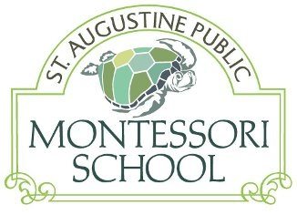

December 10, 2016

Dear

We are pleased to share with you that the St. Augustine Public Montessori School (SAPMS) is now in its fourth year of providing elementary aged students with a learning culture grounded in the Montessori philosophy. The Montessori educational model supports the whole child, creates lifelong learners, and encourages collaborative approaches to community leadership.

Typically, Montessori education is available to only those who can afford the costly private tuition. The intent of SAPMS is to provide authentic Montessori education free of charge to a diverse community of students in a public charter school that will serve any St. John’s County student, grades 1st through 6th. It is because of businesses like yours that we have been able to provide this wonderful educational opportunity.

We respectfully request your support through a silent auction donation and attendance at our upcoming fundraising event, Growing Garden of Success Gala and Silent Auction on Saturday, February 27th at the historic Colonial Quarter at 33 St. George Street. The funds raised from this exciting event will allow us to continue to accommodate more students by funding new classrooms and additional educational materials.

All donations are tax-deductible and will directly benefit SAPMS and its students. At your earliest convenience, please fill out the enclosed form and mail it back in the envelope provided. We greatly appreciate your support as we continue to nurture and grow this unique educational opportunity in our community! Together, we can make a difference!

Sincerely,
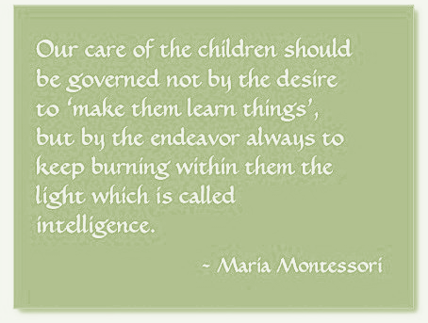

Lielanie Aguilar-Pascasio
Gala Co-Chairperson & SAPMS Parent
267-978-4543
lmlamd@yahoo.com

We cordially invite you to attend the

St. Augustine Public Montessori School
Growing Garden of Success Gala and Silent Auction
on
Saturday, February 27, 2016
6 pm to 10 pm
At the Historical Colonial Quarter at 33 St. George Street

St Augustine Public Montessori School is a registered 501(c)(3), non-profit corporation in the State of Florida (Tax ID # 61-1651459). All contributions are tax deductible.

Company Name ___________________________________________________________
Contact Person ___________________________________________________________
Address ____________________________________________________________
Email ___________________________ Phone Number ____________________

Please check the appropriate box(es):

- Yes, I would love to attend (tickets are $35 if purchased at the school before the event and $40 at the event gate)

Number of tickets ____________

- I would like to provide an in-kind donation for the silent auction.

Item _______________________________________________________________

Value ______________________________________________________________

___ I have enclosed the gift certificate in the return envelope OR

_____________________________ is when the item will be ready to be picked up

For your convenience, we enclosed an addressed envelope for mailing gift certificates and checks for ticket purchases. If you are donating a gift certificate for the Silent Auction, please also include your brochures and/or business cards when you mail the gift certificate so we can display these with your item at the Silent Auction. Thank you again for your support in helping us grow this wonderful educational opportunity to benefit even more children in our community!

Payment Method:
Enclosed Check or Credit Card or PayPal @ www.StAugustineMontessori.com

“The goal of early childhood education should be to activate the child’s own natural desire to learn.”- Maria Montessori

