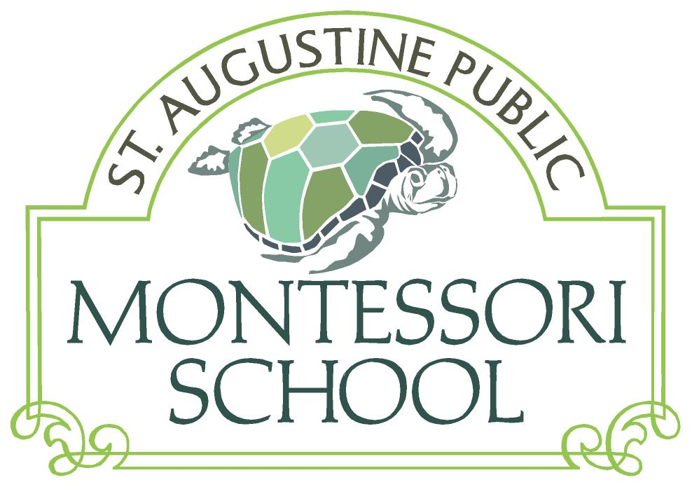

**Donation Details:**

* Your donation is tax deductible. St. Augustine Montessori Community Inc. (DBA, St. Augustine Public Montessori School) is a federal (501)(c)(3) and state non-profit organization.
* Checks may be written to St. Augustine Montessori Community, St. Augustine Public Montessori School or SAPMS.
* Checks may be given to Judi Dunlap, Director. They may also be mailed to the school address: 7 Williams Street, St. Augustine, FL, 32084.
* You may make a one time, lump-sum donation or you may pledge a donation to make monthly or at a later date.
* Credit cards are accepted through PayPal on the school’s website: <http://www.staugustinemontessori.com/support.htm>. You may make a one time or monthly donation through PayPal. PayPal charges a fee, so checks are preferred.
* **Please return your contribution plan in the envelope provided by November 6th.** Don’t forget to put a stamp on the envelope if mailing.

**Requests for Donations from Others**

Our families are an important part of the school’s outreach for other support. We have included two letter templates for your modification and use in recruiting families who might consider sending their children to SAPMS, friends and family (local or remote), and potential corporate/business supporters to our cause. If you’d prefer not to solicit others, maybe you can think of other creative ways to raise a few dollars for SAPMS on your own. Maybe your children have an idea and would enjoy participation

**For comparison: Annual Tuition of Nearby Private Montessori Schools**

|  |  |  |
| --- | --- | --- |
| **Montessori School** | **Location** | **Annual Tuition** |
| Moultrie Montessori | St. Augustine | $ 7,000 |
| Palencia Montessori (K) | Palencia | $ 7,960 |
| Montessori Tides Elementary | Jacksonville | $ 7,200 |
| A Child’s Place Elementary | Jacksonville | $ 8,600 |
| Discovery Elementary | Jacksonville | $ 9,720 |
| Flagler Beach Montessori | Flagler Beach | $ 6,500 |
| Montessori School of Palm Coast | Palm Coast | $ 6,750 |