Mobile Robotics Lab Report #3:

Kinematics of Differential Drive Robot

Heidi Gwinner

Dylan Lozon  
Quinn Austin

Kettering University

College of Engineering

Department of Electrical and Computer Engineering

CE-442: Mobile Robotics

Dr. Girma Tewolde

Spring 2024

Apr 23, 2024

**I. OBJECTIVES 2**

**II. TASKS 2**

Task One: Simulink model for differential drive robot 2

Task Two: Drive the differential drive robot to follow a specified path 2

Task Three: Draw a graph that traces the path your robot follows (extra credit) 2

**III. ANSWERS TO QUESTIONS 3**

- Question One 3

- Question Two 3

- Extra Credit 3

- Graph of Square Path 3

- Graph of Figure-8 Path 4

**IV. TABLES 5**

Task One 5

- Part A 5

- Part B 5

- Part C 5

**V. SIMULINK MODELS & STATEFLOW DIAGRAMS 6**

- Kinematics Model 6

- Square Model 7

- Square Model Drive Chart 7

- Figure-8 Model 8

- Figure-8 Drive Chart 8

# OBJECTIVES

* Create forward and inverse kinematics models of differential drive robot
* Use the differential drive robot model to drive the robot in specified paths within a simulation environment

# TASKS

## **Task One**: Simulink model for differential drive robot

1. Forward kinematics model
2. Forward kinematics model with wheel speeds given in rad/s
3. Inverse kinematics model

## **Task Two**: Drive the differential drive robot to follow a specified path

1. Drive the robot on a square path
2. Drive the robot on a figure-8 path

## **Task Three**: Draw a graph that traces the path your robot follows (extra credit)

# ANSWERS TO QUESTIONS

## **Question One**

* *Recorded value*: 3.51
* *Ideal value*: 3.5
* *The discrepancy is because the simulation (or a real robot) is discretized and can overshoot the exact value it is aiming for in the time between sampling its position.*

## 

## **Question Two**

$ω=\frac{V}{R}$ $ω=\frac{1}{0.75}$ $ω=\frac{4}{3}$

## 

## **Extra Credit**

### *Graph of Square Path*

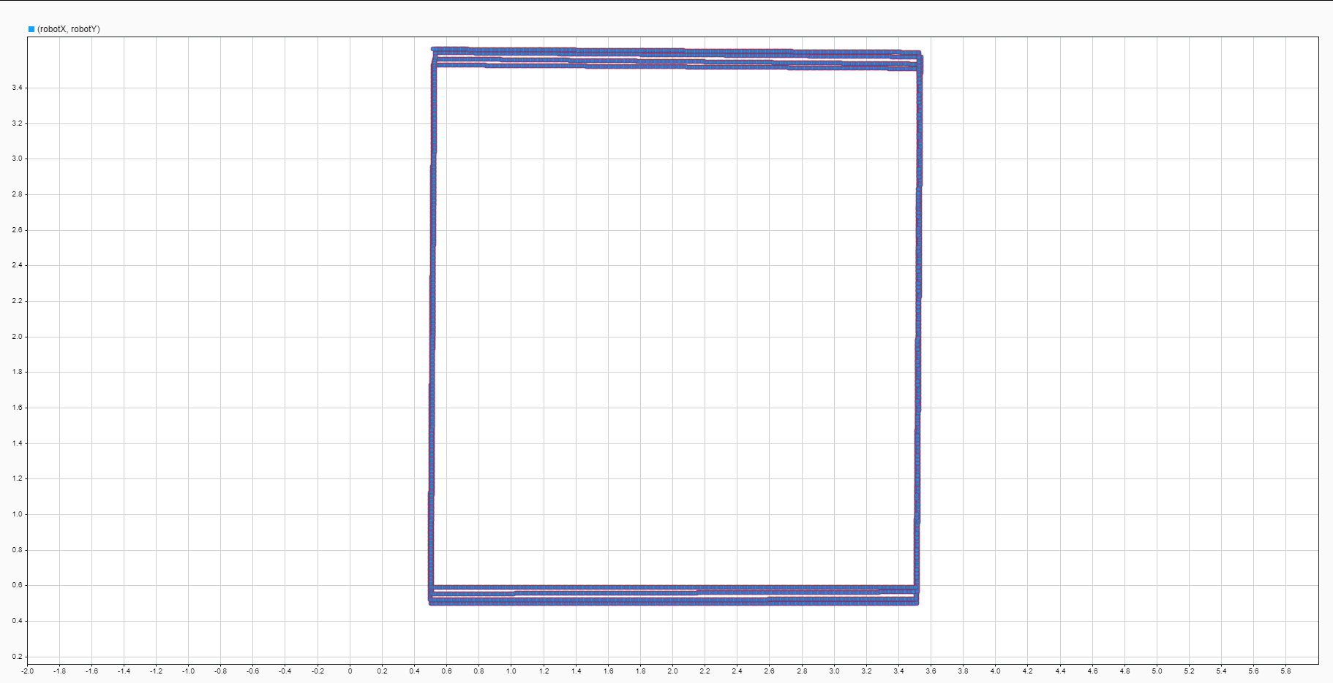

### *Graph of Figure-8 Path*

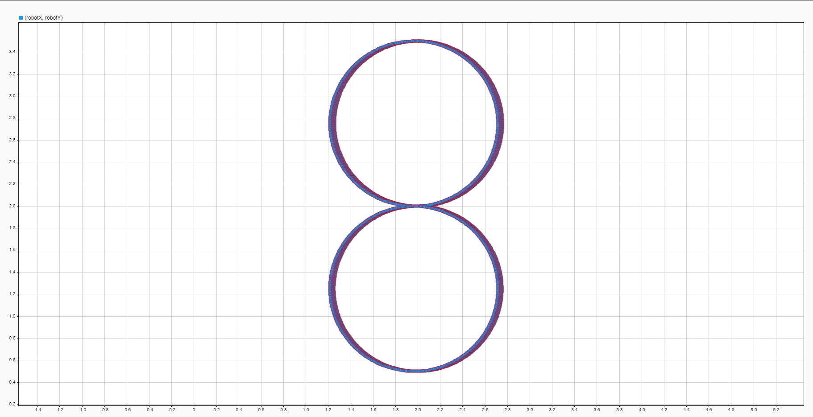

# TABLES

## **Task One**

### **Part A**

| **w_l_rpm** | **w_r_rpm** | **V_m/s** | **W_rad/s** | **r** | **L** |
| --- | --- | --- | --- | --- | --- |
| 60 | 60 | 0.1885 | 0 | 0.03 | 0.1 |
| 60 | -60 | 0 | -3.77 |  |  |
| 60 | 30 | 0.1414 | -0.9425 |  |  |
| 60 | -30 | 0.04712 | -2.827 |  |  |
| -60 | 60 | 0 | 3.77 |  |  |
| -60 | -30 | -0.1414 | 0.9425 |  |  |
| -60 | -60 | -0.1885 | 0 |  |  |

### **Part B**

| **w_l_rad/s** | **w_r_rad/s** | **V_m/s** | **W_rad/s** | **r** | **L** |
| --- | --- | --- | --- | --- | --- |
| 6.283185 | 6.283185 | 0.1885 | 0 | 0.03 | 0.1 |
| $2π$ | 0 | 0.09425 | -1.885 |  |  |
| $2π$ | $-2π$ | 0 | -3.77 |  |  |
| 0 | $3π$ | 0.1414 | 2.827 |  |  |
| 1 | 10 | 0.165 | 2.7 |  |  |
| 10 | 2 | 0.18 | -2.4 |  |  |
| $π$ | 60 | 0.9471 | 17.06 |  |  |

## 

### **Part C**

| **V_m/s** | **W_rad/s** | **w_r_rpm** | **w_l_rpm** | **r** | **L** |
| --- | --- | --- | --- | --- | --- |
| 0.1885 | 0 | 6.283 | 6.283 | 0.03 | 0.1 |
| 0 | 10 | 16.67 | -16.67 |  |  |
| -10 | 10 | -316.7 | -350 |  |  |
| 5 | 25 | 208.3 | 125 |  |  |
| 25 | 5 | 841.7 | 825 |  |  |
| 100 | 0 | 3333 | 3333 |  |  |
| 1 | 1 | 35 | 31.67 |  |  |

# SIMULINK MODELS & STATEFLOW DIAGRAMS

## *Kinematics Model*

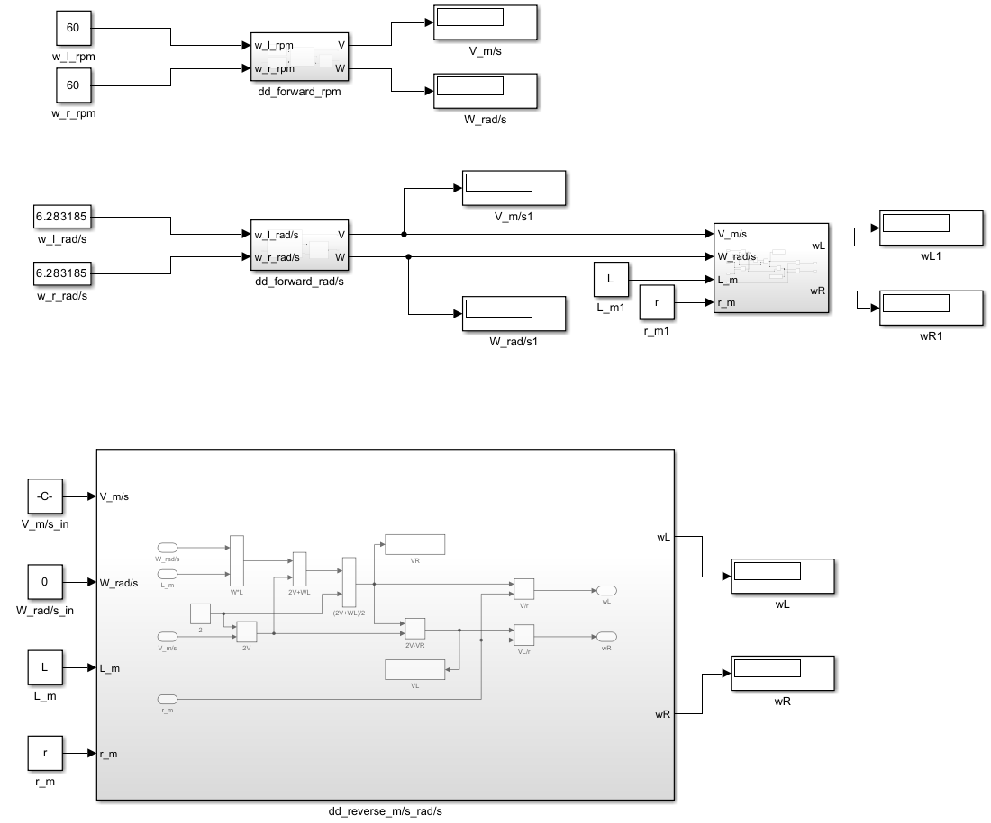

## *Square Model*

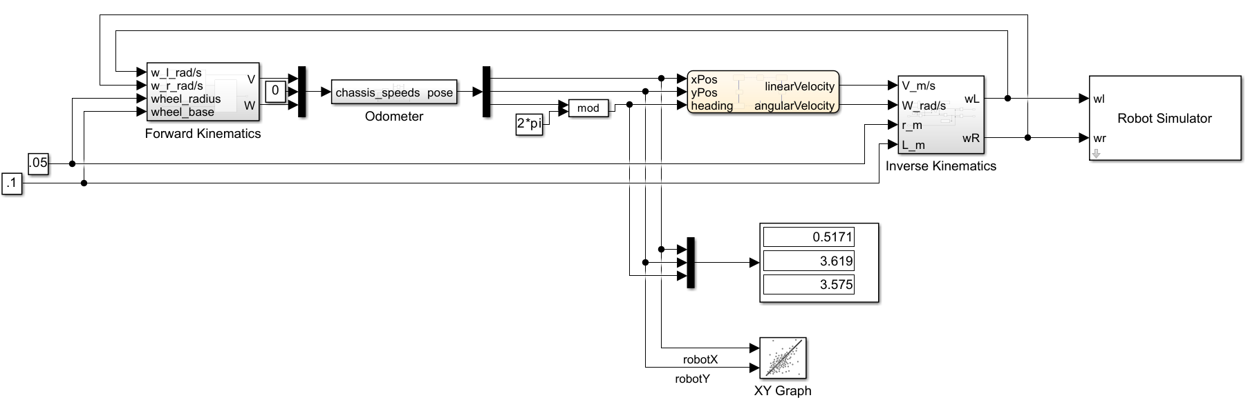

## *Square Model Drive Chart*

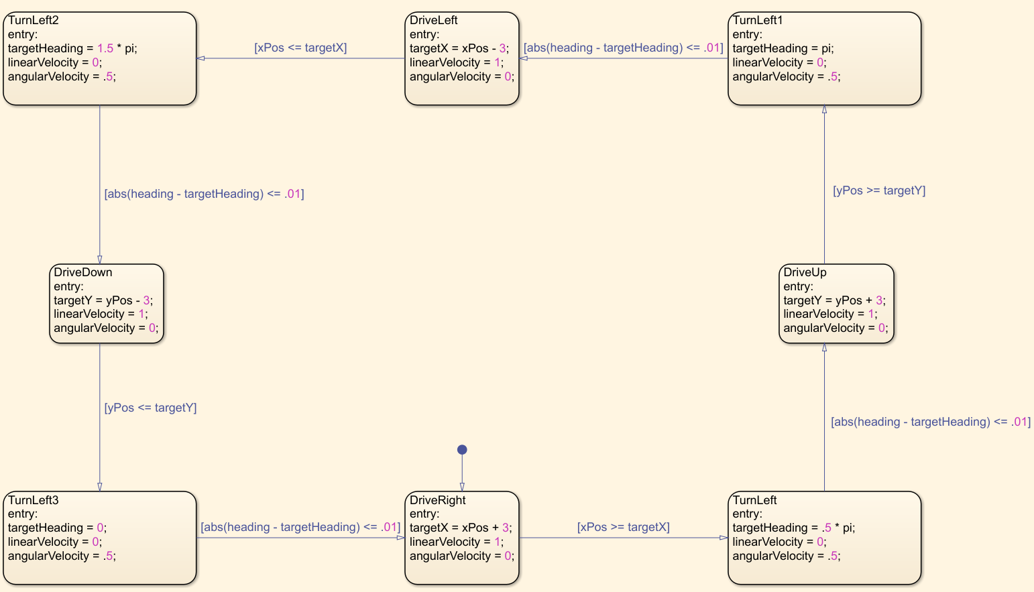

## *Figure-8 Model*

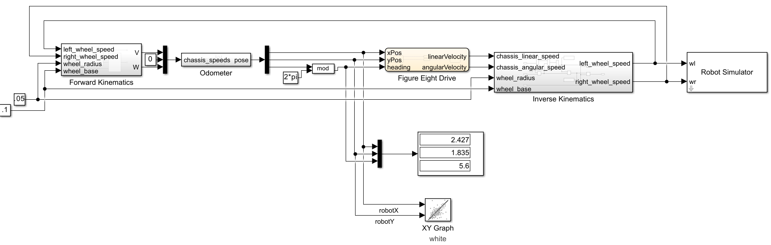

## *Figure-8 Drive Chart*



 