# **Mappy**

# Created on February 17 2018

# **Table of Contents**

1.0. Page 1

2.0. Page 2

# **1.0. Page 1**

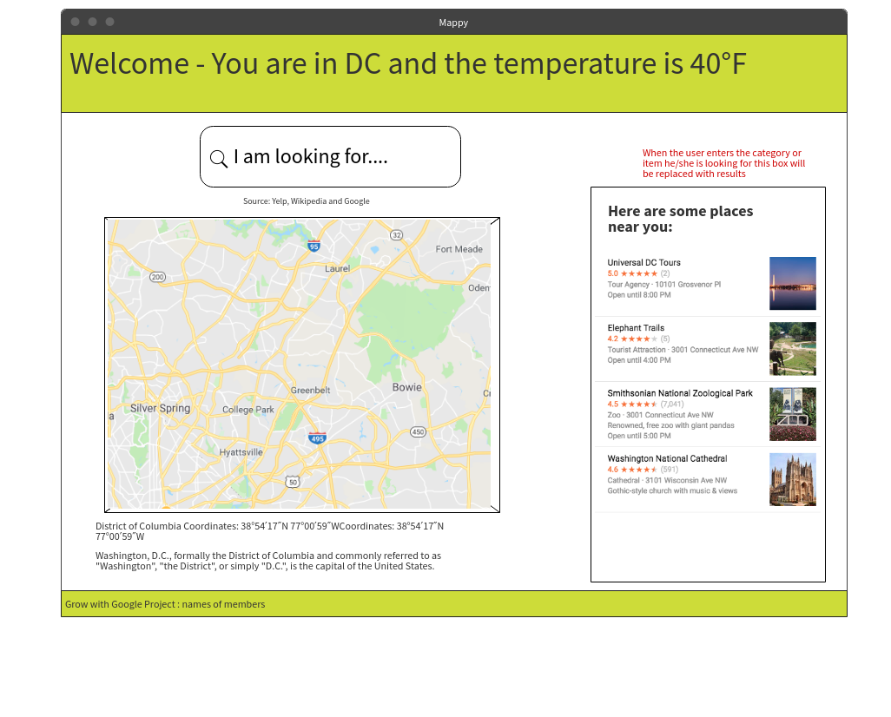

# **2.0. Page 2**

