The DL_POLY Java Graphical User Interface II
W. Smith December 2010

1. INTRODUCTION

The DL_POLY Java GUI II is an upgrade of the original (Mark I) version of the
GUI and incorporates several new features. First among these is the Graphical
Molecular Editor, which allows the user to build complex organic structures and
replicate them to create systems for simulation with DL_POLY. To accomplish
this the GUI has two graphical modes:

- View - for simply viewing the molecular structure in a DL_POLY CONFIG file and also carrying out certain global operations (i.e. affecting the whole configuration) such as insertion of water molecules, replication etc. Which do not change the contents of the CONFIG file as such, but augment them in some way. This mode is equivalent to the previous, sole mode of operation of the Mark I version of the GUI.
- Edit - for graphically editing the structure of a configuration, changing the identities of molecules or atoms, adding or deleting molecules, parts of molecules or atoms.

Secondly, improvements have been made to the force field builders, which now include several new Java classes related to system structures and molecular entities. This will hopefully allow incorporation of additional force fields more easily than before.

The GUI retains the advantages inherent in the previous version, particularly in the free availability of Java, a product of Sun Microsystems, and its portability to all computers that support the Java language. We continue to supply the code as source (though the executable is also included) so it may be developed as desired by users with special needs, provided they are of course willing to learn the Java language.

Other aspects of the new GUI the user should be aware of are as follows:

- The DL_POLY Java GUI is not an applet. It is a full Java application program and cannot be run from within an internet browser. (This is now actually possible with current Java technology, but we have not implemented this for the current version.)
- The appearance of the GUI, its windows and browsers etc. is now based on Java Swing classes and should preserve its appearance better across platforms.
- For the purpose of rendering different atom types in a configuration, the GUI requires the adoption of a naming convention based on the Periodic Table. Up to eight characters may specify an atom name, but the first two must be taken from the proper chemical symbol. If the chemical symbol is a single letter, the underscore (_) must be used. Thus hydrogen and oxygen have the names O_ and H_, while copper and sodium have Cu and Na respectively. Failure to follow this convention results in the ‘grey ball’ syndrome. The only exceptions to these rules are the use of symbols OW and HW for oxygen and hydrogen in water molecules. The TIPS4P water model also requires an additional charge centre, which is given the symbol QW. Other atom naming conventions can be fitted into this scheme by extension beyond two characters. The GUI exploits this in building the Dreiding, Ceramics and OPLS force fields. The user may see what the atom names are in these force fields by inspecting the MINDREI, CERAMICS and MINIOPLS files in the java subdirectory, or by listing them from the Information menu of the GUI.

2. COMPILING THE JAVA GUI

The first requirement for compiling the Java GUI is the availability of the Java software. For national supercomputers and the like, Java should already be available. If it isn’t the system managers should be reminded of their responsibilities to the user community. To install Java on local machines, the Java home page at the Sun Microsystems website http://java.sun.com provides the Java Development Kit (JDK 1.4 or above) for any particular computer. Installation instructions are available from the same site, and are generally straightforward. Once the JDK is installed, the DL_POLY Java GUI may be compiled.

The source code for the Java GUI is found in the DL_POLY java subdirectory.
On entering this type the command:

javac *.java

which will compile the Java source code and construct the Java classes (i.e. the Java executable ‘objects’). Next it is necessary to make a Java ‘jar’ file from the classes. This neatly encapsulates, in a single file, all of the GUI Java classes. (The jar file effectively becomes the GUI executable, which in fact is transportable between systems.) This is done with the command:

jar -cfm GUI.jar manifesto *.class About_DL_POLY Acknowledge //
CERAMICS MINIDREI M INIOPLS WATER.300K TestInfo Licence Disclaimer

the jar command thus works somewhat like the UNIX tar command. Note particularly the requirement to incorporate the file manifesto, which is one of the files in the java subdirectory. The contents of this file inform the java program which of the incorporated classes represents the entry point at execution. (It follows that this file should never be deleted!) The files listed after the *.class specification are information files the GUI requires to operate properly. Note that both the javac and jar commands have been combined in the unix script `build’, which you will find in the java directory.
Invoke this by typing the command

./build

The result of this command is the GUI.jar file, which becomes the working GUI. In addition to compiling the Java source, it is necessary to compile some FORTRAN programs that the GUI calls upon to perform some of the calculations. Inside the java subdirectory are the lower directories GDF and SKW. These contain programs for calculating van Hove correlation functions and dynamic structure factors respectively. Enter each of these directories and type `make’ to build the FORTRAN
programs. This will complete the build of the GUI. Note it may be necessary to change a few of the parameters in the makefiles for these, such as the specification of the FORTRAN77 compiler or the C compiler.

3. STARTING THE JAVA GUI

The GUI.jar file is universally transportable. Once created it can be shipped to any system where Java is featured and it will run just the same (though the various windows may look a little different). In the case of MS Windows machines, it can be activated by double-clicking on the file icon. It is normal practice to run the GUI from within the DL_POLY execute subdirectory, which makes it easy to locate the files it needs from within the DL_POLY directory structure. (Users who experience strange problems running the GUI may find that reverting to this practice resolves the problems.) Assuming you are in the execute directory, to start the GUI in a linux or MS Windows command window type the command:

java -jar ../java/GUI.jar

Unix users may alternatively use the gui script in the execute subdirectory, which incorporates the syntax of this command. After a minute or two, the GUI Graphics Window and the Monitor Window (figure 1) will open onscreen. Both of these windows may be handled in the usual X manner, e.g. moved with the mouse, by clicking and dragging the header panel. The size of each may be changed by clicking and dragging from a corner or edge. The usual window widgets for hiding, enlarging or closing are present. However note that the close widget has been disabled for the Monitor Window. The GUI opens in the View mode.

If the default colour scheme of the GUI offends, try the command:

java -jar ../java/GUI.jar scheme

where `scheme’ is one of the following: monet, picasso, vangogh, cezanne or mondrian, any of which may be more pleasing. The default colour scheme is picasso.

4. FEATURES OF THE GUI

4.1 The Graphics Window

The Graphics Window is the area in which the GUI draws pictures of any molecular configuration selected by the user, or produced by the GUI itself. The view represents the x,z plane, with the x-axis horizontal, z-axis vertical and the positive y-axis projecting into the screen. On the right of this window is a collection of buttons, which manipulate the image on display. These are activated by a single click of the mouse button. Their functions depend on which mode the GUI happens to be. The following applies to the View mode:

- New - opens a file browser (see figure 2) for the user to select a new configuration file for viewing. This button assumes the configuration file is a DL_POLY CONFIG or REVCON file, but other formats can be processed (see later). The GUI normally performs some preselection of the files appearing in the browser to reduce the risk of improper selection.
- Cls - clears the image from the screen and deletes the configuration data

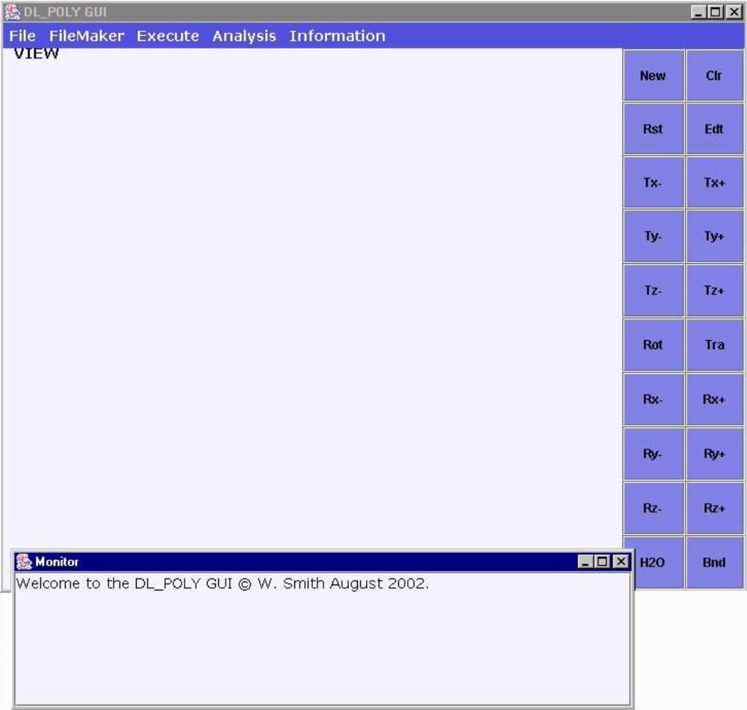
Figure 1. The GUI at start up.

from the GUI internal memory.
- Rst - resets the image to the original picture when the configuration was first loaded. i.e. undoes all user manipulation with the GUI.
- Edt - activates/deactivates the Edit mode.
- Tx- - moves (translates) the image to the left.
- Tx+ - moves the image to the right.
- Ty- - moves the image towards the observer (zoom in).
- Ty+ - moves the image away from the observer (zoom out).
- Tz- - moves image down.
- Tz+ - moves image up.
- Rot - rotates the image to follow the dragged cursor.
- Tra - moves the image to follow the dragged cursor.
- Rx- - rotates the image clockwise about the x axis.
- Rx+ - rotates the image anticlockwise about the x axis.
- Ry- - rotates the image anticlockwise about the y axis.
- Ry+ - rotates the image clockwise about the y axis.
- Rz- - rotates the image clockwise about the z axis.
- Rz+ - rotates the image anticlockwise about the z axis.
- H2O - toggles the visibility of water molecules.
- Bnd - toggles the visibility of stick bonds.

Note that toggling the visibility of water molecules assumes that the oxygen atom is labelled as OW and the hydrogen atoms as HW in the CONFIG file. Clicking the Edt button in View mode activates another column of buttons (and also changes slightly the function of some of the buttons described above). The function of these will be given in the section on the Molecular Editor, which appears later in this document.

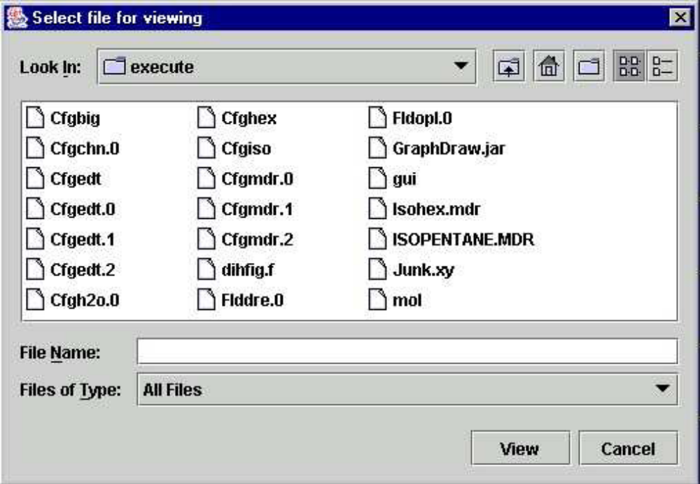

Figure 2: A typical file browser

4.2 The Monitor Window

The Monitor Window is the medium through which the GUI informs the user of actions taken, files created or deleted, errors made by the user and other stuff. It is also the area where text files are displayed if the user requests it. Ideally this window should be kept visible at all times. It is expandable if required and can be reduced (hidden) but not deleted. Note that if there are catastrophic failures during the running of the GUI, the error messages will, of necessity, not appear in this window, but in the X or command window in which the GUI was first invoked.

4.3 The GUI Application Menus

Above the Graphics Window (at the top left) is a menu bar which has a series of drop-down menus (made visible by clicking on the menu name). These menus select the various applications buried in the GUI. The applications are discussed in detail below. The current menus are:

- File - handles file operations, such as viewing, and deleting, resets the GUI and various defaults, prints the Graphics Window and also quits (shuts down) the GUI.
- FileMaker - enables construction of various input files for DL_POLY.
- Execute - controls the execution of DL_POLY and the selection and storage of I/O files.
- Analysis - runs the DL_POLY analysis programs to analyse the simulation results.
- Information - provides licence and other information.

The contents of each menu are made visible by clicking on the menu header. If the Edit mode has been activated, and additional menu appears on the menu bar:

- Editor - sets the defaults for the molecular editor. The details of these will be given under the section on the Molecular Editor, which appears later.The function of each menu is described below.

4.3.1 The File Menu

The File menu contains the following items:

- Quit
- View File
- Delete File
- Defaults
- Reset

To select any item from the menu, the mouse cursor must be dragged down the list and released on the item of choice. Selecting any of these items will initiate a particular action by the GUI. These actions are now described.

- Quit
Selection of this item closes down the GUI, provided it is not in a busy
state (i.e. performing some other action). In View mode no data saving
results from this action, but in Edit mode a backup file will be taken if one
has not been saved by the user. Amendments to the GUI defaults will be
lost. The GUI may also be shut down by clicking on the standard close
widget on the GUI window.
- View File
Any text file in the execute subdirectory may be viewed by selecting this item. On selection the GUI opens a file browser (figure 2) which allows the user to select the file of interest. Selection of the file will result in its display in the Monitor Window (which may need to be enlarged for a convenient viewing).Note that only text files should be viewed, for obvious reasons. Large files may take quite a while to list.
- Delete File
Any file in the execute subdirectory may be deleted by selecting this item.
On selection a file browser appears which permits the user to choose the
required file. Selection of the file will cause its deletion. As a fail safe, the
GUI will first throw up a dialog window to give opportunity to cancel the action.
- Defaults
The GUI contains a number of defaults that may be altered after start up,
such as default rotation angle and translation distance. Selection of this
item opens the Change Defaults panel (figure 3).

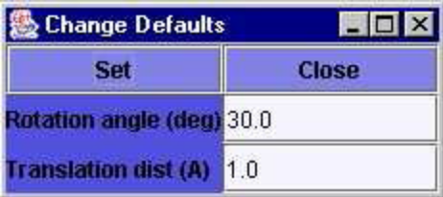
Figure 3: The Change Defaults Panel

The text boxes on the panel show the current values for the defaults. Clicking on the text box beside the parameter description will allow the user to change the value. Clicking the Set button will reset the GUI default. Clicking the Close button will remove the panel.
The parameters that may be changed are:
  - Rotation angle (deg) - angle of rotation for Graphics Window rotation buttons.
  - Translation distance (A) - distance of translation for Graphics Window translation buttons.
- Reset
This option resets the GUI variables back to their starting values (not current defaults) and clears all loaded data from the GUI.
- Print
This option initiates a print of the Graphics Window. A system specific panel is opened for the user to specify the information required to print the picture.

4.3.2 The FileMaker Menu

The FileMaker menu has the following items, some of which also have submenus:

- CONTROL
- CONFIG
- FIELD
- File Type
- Tools

The functions of these are as follows.

- CONTROL
Selecting this menu item will open the first of three panels dedicated to constructing a DL_POLY CONTROL file. A second panel is opened by clicking the More button at the bottom of this, and a third panel is opened by
clicking the More button at the bottom of the second panel. The three panels (figure 4) allow specification of most of the options available in DL_POLY, as described in the DL_POLY manual. The details of each item do not require elaboration here.
Specifying most values required by the CONTROL file is matter of amending the contents of the associated text box. Some variables however, require activation of logical options using ‘check boxes’ (particularly panel 3). Yet others require a choice from a menu of options. The choice of ensemble or electrostatic method on panel 1 or the choice of restart option on panel 2 are examples of this. The user will find the panels intuitively straightforward. When the variables have been defined, the user should click the Make button on panel 1, to create the required CONTROL file. The GUI will name this file CNTROL.n, where n is some integer. Note that the GUI has some internal consistency checks and may refuse to make a CONTROL file that is improperly specified. Watch the Monitor Window for details.

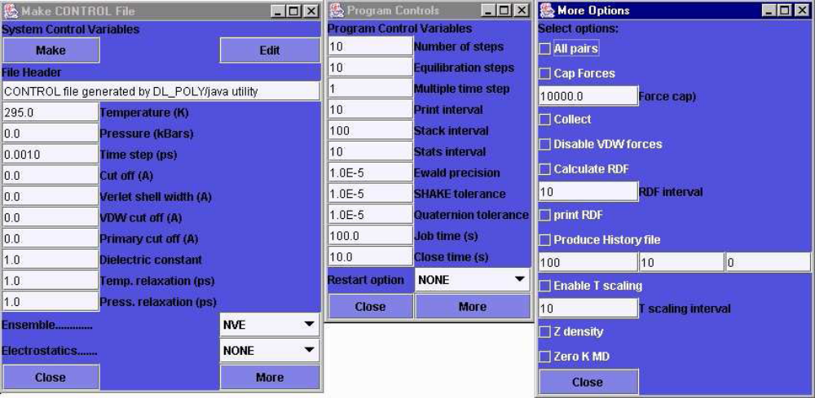Figure 4: The CONTROL Panels

Another way of making a CONTROL file is to use the Edit button on panel 1
to load an existing CONTROL file. This may then be altered using the panels and saved using the Make button. A new CONTROL file will be made alongside the old. When all is finished, the CONTROL file panels may be deleted using the Close button on panel 1. Note you cannot open more than one set of CONTROL panels. This is a restriction that applies to most other panels of the GUI, otherwise things could get confusing.

- CONFIG
This menu item is intended for building DL_POLY CONFIG files. It presents
a sub-menu with the following items
  - Lattice
This item is used for building CONFIG files that may be constructed from a small unit cell, such as a crystal structure. A panel is opened (figure 5) which enables full specification of the CONFIG file contents. On the panel are several text boxes grouped in threes. The first of these specifies the unit cell A vector, the second the B vector and the third, the C vector. The distances are expressed in Angstroms. Beneath these is a set of three boxes to specify the integer replication factors for the unit cell in each of the principal directions (na × nb × nc). The atomic basis for the unit cell is defined at the bottom of the panel. For each atom in the unit cell an atom name may be entered in the text box, followed by the three fractional coordinates of this atom in the unit cell, The Enter button will register the specified atom, with an accumulation number displayed on the panel, bottom right. (Note: It is not essential to use the GUI naming conventions here, but it is wise to do so, especially if one of the recognised GUI force fields is to be used later.)

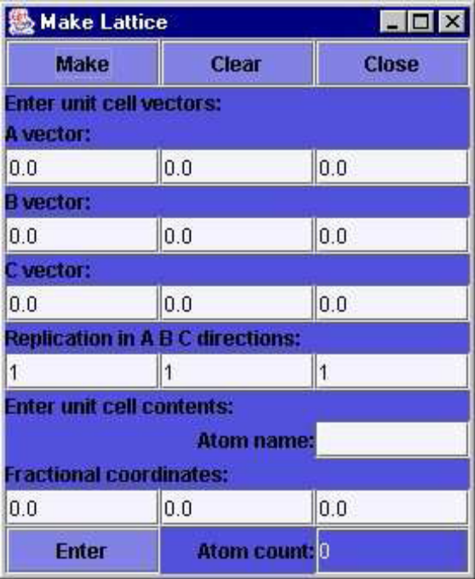
Figure 5: The Make Lattice Panel

When all the required basis atoms have been entered, the user should
click the Make button to create the desired CONFIG file, which the GUI
will name CFGLAT.n, where n is some integer. Simultaneously with this, the lattice is displayed in the Graphics Window. The panel can be reset by using the Clear button. The Close button removes the panel.
  - Chain
This panel invoked by this option (figure 6) enables construction of a small range of chain molecules, particularly surfactants, which may then form the basis for a layered system. The panel supports several labelled text boxes, with which the user may specify the number of carbon atoms in the chain and the XY area per chain (in A²), as required for a layer definition. (A hexagonal arrangement of the chains is assumed.) The chain may be assigned a head group from the menu box on the panel. The current choices are:

    - none;
    - soap i.e. -CO.ONa;
    - carboxy i.e. -CO.OH;
    - phenol i.e. -C6H4OH;
    - TAB, trimethylammino bromide i.e. (-N(CH3)3)+Br-;
    - (EO)n, polyethylether i.e. (-C2H4O-)n.
The number n in the (EO)n case is specified in a labelled text box on the panel. There are also two check boxes. One activates the ‘flip’ option, which turns the chain through 180 degrees, the other duplicates the chain and stacks the two chains one above the other in the z-direction, as in a double layer. The separation between the two is determined by the value in the ‘Z-gap’ text box. When the user has selected the required details, clicking the Make button will create the CFGCHN.n file, where n is an integer, and simultaneously display the molecule in the Graphics Window. Note that the atom naming convention adopted by this facility is compatible with the DL_POLY and Dreiding conventions. Clicking the Close button will delete the ‘Make Chain’ panel. Note that in order to build a full layered system, the user should use the N_fold option that appears under the FileMaker/Tools menu.

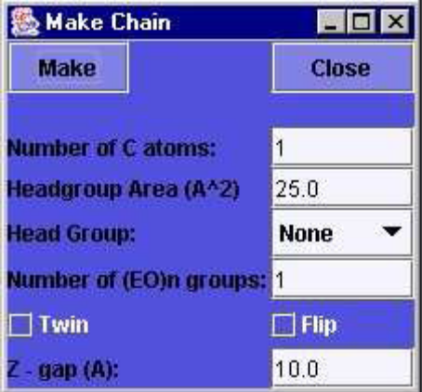
Figure 6: The Make Chain Panel
  - Polymer
The polymer panel opened by this option (figure 7) provides a means to construct an amorphous polymer chain by a temperature dependent self avoiding random walk. This is a rather complicated panel, with many adjustable parameters, but the user need not know too much detail to use it. The first requirement is to specify the desired length of the chain in the first text box. The user needs then to specify the required system volume and temperature in the appropriate labelled text boxes. Clicking the Make button will start the Monte Carlo process that generates the chain. If this is successful a CONFIG file named CFGPOL.n, where n is some integer, will be written. The atom naming convention adopted by this facility is compatible with the DL_POLY and Dreiding conventions.Other labelled text boxes on the panel allow the user to change the particulars of the model. The bond lengths, Lennard-Jones parameters (ε,σ), the C-C bond energy, and the (third order cosine polynomial) dihedral potential parameters are all modifiable, as is the strength of the dihedral 1-4 Lennard-Jones term, which may be scaled by a specified factor.
The chain is always grown with a cubic periodic boundary condition applied. The volume of the box is that specified by the user. However, selecting the PBC check box on the panel, will result in the chain coordinates being written into the CFGPOL file in a ‘folded’ manner, as opposed to a contiguous, unbroken chain.
The Close button deletes the ‘Make Polymer’ panel. The chain build may not be successful, depending on the temperature and volume specified by the user. If unsuccessful the user is advised to increase the volume until success is achieved. The required density may always be obtained in a DL_POLY simulation using one of the NPT ensemble options.

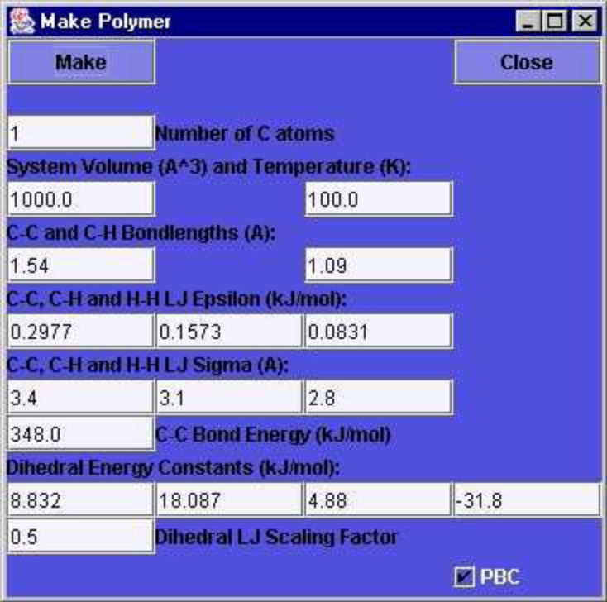
Figure 7: The Make Polymer Panel

  - Bucky
The panel for this option (figure 8) enables the building of a buckminsterfullerene (C60) molecule or a fullerene tube.

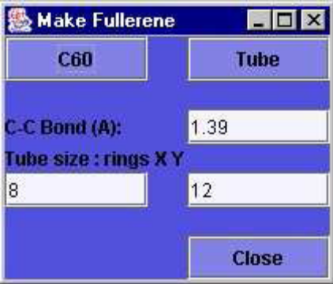
Figure 8: The Make Fullerene Panel

To make a C60 molecule the user need only click the C60 button on the panel. This will create a CONFIG file named CFGBUK.n, with n some integer, and simultaneously display the molecule in the Graphics Window. The C-C bond length may be set to a new value using the labelled text box. To build a carbon nanotube, the circumference and length of the required tube must first be specified. These are given in terms of the number of C6 rings in each direction. Two text boxes are available for this, the labelled X box refers to the circumference, and the Y box to the length. (Note that an odd number of rings specified in the Y box, will produce a continuous tube in the system z direction, by virtue of the periodic boundary condition. An even number will be incommensurate with the PBC.) Clicking the Tube button will create the CONFIG file CFGBUK.n and display the structure in the Graphics Window.
The Close button will delete the ‘Make Fullerene’ panel. Note that the atom naming convention adopted by this facility is compatible with the DL_POLY and Dreiding conventions.

- FIELD
This menu item is for building DL_POLY FIELD files. It opens a sub-menu with the following items:

  - Blank
The Blank FIELD panel (figure 9) is useful for analysing the molecular topology for a CONFIG file, since it will identify the atoms, bonds, angles, dihedrals and inversions in the system and list them in a form compatible with the DL_POLY FIELD specification. However it does not assign force field parameters.
Operation of this panel is simple. The user must click the Make button (if the required molecule is already loaded into the GUI), or the Load button (to throw up a file browser to select the required CONFIG file). This will produce the blank FIELD file, which will have the name FLDBLK.n, where n is an integer. It will also produce a CONFIG file with the name CFGBLK.n to pair with the FLDBLK.n file. [Note: The CONFIG files created by the FIELD file builders may differ from the input CONFIG file in subtle ways. Most importantly, the new CONFIG file will be contiguous i.e. constructed so that all the parts of a molecule are grouped together in the file, otherwise it may not be possible to construct a simple FIELD file.] If the Load button is used, the user can display the loaded file by activating the ‘Display cfg’ option.

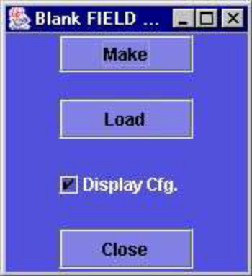
Figure 9: The Blank Field Panel

The Close button deletes the ‘Blank Field’ panel.
Note that for the Blank FIELD facility to work properly, atomic names in the CONFIG file must obey the GUI atomic naming convention.
  - Dreiding
For CONFIG files that are specified with the Dreiding naming convention (see also the MINIDREI file details under the Information menu described below), the panel for this option (figure 10) may be used to build a compatible FIELD file.

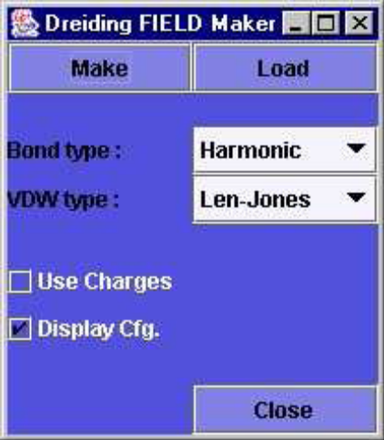
Figure 10: The Dreiding FIELD Maker Panel

This is also a simple panel to operate. A FIELD file may be built from a preloaded CONFIG file by clicking the Make button, or by clicking the Load button to load a file from a browser. The file created will have the name FLDDRE.n , where n is an integer. It will also produce a CONFIG file with the name CFGDRE.n to pair with the FLDDRE.n file. If the Load option is taken, the user may display the loaded structure by setting the Display cfg. check box. The nature of the bonding forces may be altered by selecting either a rigid bond, or Harmonic or Morse bond potentials and by choosing either Len-Jones or Buckingham nonbonded potentials from the box menus. The Use Charges check box enables the GUI to pick up prescribed charges for some atoms (such as the chloride ion). In general however this is not very useful, as the charges for the rest of the molecule (if any) have to be obtained from elsewhere.
The Close button deletes the ‘Dreiding FIELD Maker’ panel.
  - OPLS
The OPLS Field File maker can create an OPLS compatible FIELD file for approriate systems generated by the GUI, or systems compatible with the CONFIG file format with the naming conventions of either OPLS or Dreiding. Selecting this menu option will result in the appearance of the `OPLS FIELD Maker' panel (figure 11).
With this panel an OPLS FIELD file may be built from a pre-loaded CONFIG file by clicking the Make button, or by clicking the Load button to load a file from a browser. The FIELD file will have the name FLDOPL.n, where n is an integer. Since the OPLS force field is a united atom force field, this option will edit out redundant hydrogen atoms and recreate the CONFIG file. The new file will be named CFGOPL.n, where n is an integer.
The Close button deletes the OPLS FIELD Maker panel.

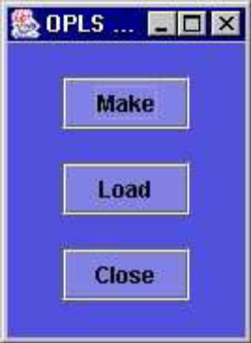
Figure 11: The OPLS FIELD Maker Panel

  - Ceramics
For CONFIG files that are specified with the naming conventions for the Ceramics force fields (see the CERAMICS file details under the Information menu described below), the panel for this option (figure 11) will build an appropriate FIELD file. With this panel a ceramic FIELD file may be built from a pre-loaded CONFIG file by clicking the Make button, or by clicking the Load button to load a file from a browser. The FIELD file will have the name FLDCER.n, where n is an integer. It will also produce a CONFIG file with the name CFGCER.n to pair with the FLDCER.n file. The user may display the loaded structure, if not already visible, by selecting the Display cfg. check box.
Five ceramic force fields are available:

    - LC_a, divalent and tetravalent rigid ions [1];
    - LC_b, trivalent rigid ions [1];
    - LC_c1, shell model ions [1];
    - LC_c2, shell model ions [1];
    - GULP, shell model ions [2];

The user may choose any of these from the menu on the panel. The LC_c1 force field distinguishes between ions in tetrahedral and other
environments, for which different parameters are available. The labelled check box enables the user to specify the tetrahedral option. The Close button deletes the ‘Ceramics Field Maker’ panel.

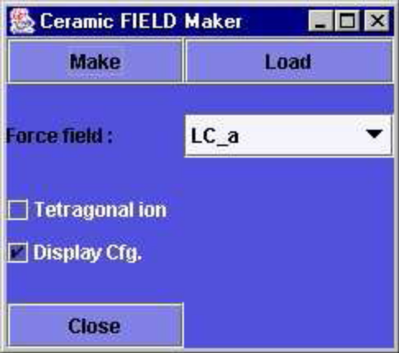
Figure 12: The Ceramics FIELD Maker Panel
  - Table
DL_POLY allows the user to specify nonbonded pair potentials in tabular form. The ‘Make TABLE File’ panel (figure 13) offers some facilities for making such files.
The prime purpose of this panel is to fit a set of data points describing a potential function, and from the fit construct a full TABLE file for DL_POLY input. Two kinds of fit are available: fitting by splines, or by Gaussian functions. The selection is made from the ‘Fitting Option’ menu on the panel. The user must also specify, in the text boxes provided, the names of the atoms for which the pair potential is being defined. Also required are the range of the potential cut off and the number of points for the tabulation (not to be confused with the number of data points). The user may then enter the data to be fitted either by hand or by loading a data file. The Load button enables loading from an XY file, which will will then be fitted and a TABLE file created with the name TABSPL.n (spline) or TABGSS.n (gaussian), with n some integer. Specifying the data by handrequires the user to enter the r and V(r) coordinates, one pair at a time, into the text boxes provided. After each of which the Enter button is pressed. This can be tedious and thus error prone, and a Clear button is vailable to restart the process. When all data coordinates have been entered, clicking the Make button will produce the TABLE file.

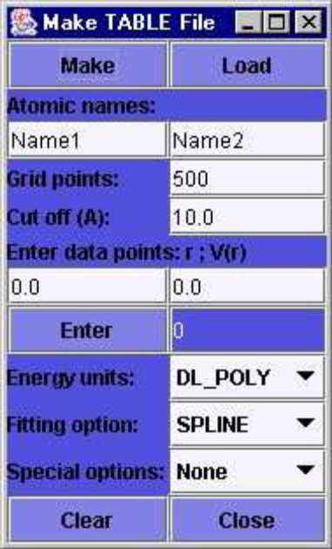
Figure 13: The Make TABLE File Panel

The panel also has some built-in potentials under the ‘Special options’
menu. One is for silica (SiO2) [3] and the other for silver iodide [4]. (Thesehave proved useful for student exercises.) The TABLE files produced are named TABSiO2.n and TABAgI.n respectively.
The Close button deletes the ‘Make Table’ panel.
- File Type
This menu item enables the user to load configuration files with a format different from the standard DL_POLY CONFIG file. The options on its submenu are as follows.

  - CFG - displays DL_POLY CONFIG files.
  - XYZ - displays a standard XYZ file.
  - SEQ - displays a protein sequence PDB file.
  - MSI - displays a CERIUS 2 msi file.
  - MDR - displays a file from the DL_POLY molecular drawing program.

Each of these options (except CFG) will also produce a CONFIG file suitable for input to DL_POLY. These appear with names CFGXYZ.n, CFGSEQ.n or CFGMSI.n respectively, where n is an integer.

- Tools
The GUI provides some utilities that are useful when building DL_POLY
input files. The following are available.

- N_fold
This panel (figure 14) is useful for scaling up systems to multiples of the original, for example taking a single polymer chain and generating a layer.

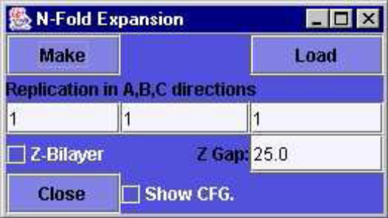
Figure 14: The N_fold Panel

The panel has three text boxes to enter the integer scaling factors in the x,
y and z direction. (For a layer, expand only in x and y.) The button Make can be used for a CONFIG file that is loaded already. The Load button will load a different CONFIG file from a browser. Both options produce a file called CFGBIG.n, where n is the suffix of the loaded CONFIG file. A check box enables the display of the expanded structure. The ‘Z-bilayer’ check box is used to create bilayers, by doubling the system in the z-direction. The text box ‘Z gap’ specifies the separation between the layers. (Note that a bilayer can also be created using the bilayer options in the ‘Make Chain’ application above and expanding the system using N_fold, but ignoring the bilayer option here.)
The Close button deletes the ‘N_fold’ panel.
- BondLengths
The CONFIG file builders for the GUI, such as the polymer and chain options assume certain bond lengths for particular types of bonds. This panel (figure 15) gives the user the opportunity to alter the default values. A generic bond length is reset by typing in the new value into the appropriate text box and clicking the Set button. All subsequent CONFIG files will use the new bond length. Bondlengths are specified in A.
The Close button deletes the ‘Set Bondlengths’ panel.
- Add water
The ‘Add Water’ panel (figure 16) inserts water into a CONFIG file. The water configuration is taken from a file of water molecules equilibrated at 300K and inserted into the CONFIG file, with replication and truncation if necessary. Overlap of the water with the solute is prevented by removal of the offending water molecules. The Make button will add water to an already loaded CONFIG file and the Load button to a file selected from a browser. The file created has the name CFGH2O.n, where n is the integer suffix of the input file. The user may specify the closest approach of water molecules to the solute and between the water molecules at the periodic boundary (necessary if the water source file has been truncated) using the labelled text boxes.

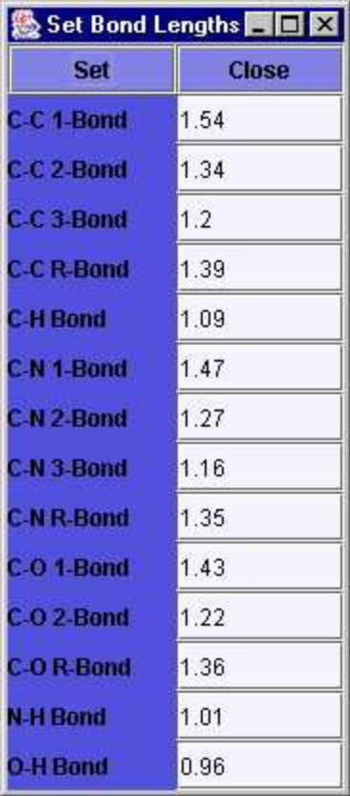
Figure 15: The Set Bondlengths Panel

The ‘Add Water’ panel also has a check box to enable insertion of water in a ‘slab’, for example in a bilayer gap. To do this the user must specify a direction vector in the text boxes provided, and the upper and lower bounds of slab perpendicular to this vector. It is assumed the vector is drawn from the centre of the simulation cell. For example a direction vector (0,0,1) and upper and lower bounds of 3.0 and -3.0 respectively will create a water layer in the x, y direction, 6 A wide, centred on the middle of the simulation cell.
The Close button deletes the ‘Add Water’ panel.
Note that in on order to display the full CFGH2O file, the Graphical Window button H2O must be used to toggle the visibility of the water molecules.

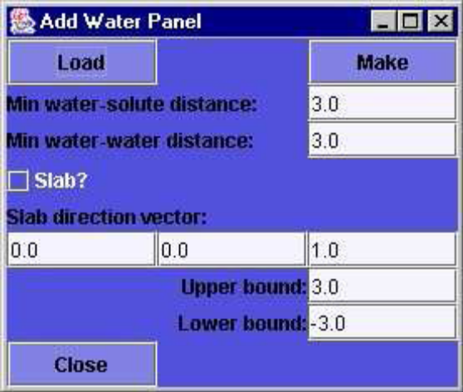
Figure 16: The Add Water Panel

4.3.3 The Execute Menu

The Execute Menu offers facilities for running the DL_POLY executable and for
managing the input and output files. The menu has two items:

- Run DL_POLY
- Store/Fetch Data

The operation of each of these is given below.

- Run DL_POLY
This menu item opens the ‘Run DL_POLY’ panel (figure 17), which hosts several buttons to control a DL_POLY execution.
The upper middle of the panel is dominated by a group of four buttons:
CONTROL, CONFIG, FIELD and TABLE. Each of these buttons opens a
file browser, for selection of the corresponding input file for a DL_POLY run.
It is assumed that all of these files are present in the execute subdirectory
and are the products of the GUI. Thus all potential CONTROL files will begin
with the letters CTR, all potential FIELD files with FLD, all potential CONFIG
files with CFG and all potential TABLE files (if any) with TAB. It is the responsibility of the user to select a consistent set of input files. The
selected file is copied into one of CONTROL, CONFIG, FIELD or TABLE,
which are the files DL_POLY expects to be in the execute subdirectory at
run time.
When the files have been selected, and provided that the execute subdirectory properly contains the DLPOLY.X executable, clicking the Run button will start the DL_POLY program running in the background. Note that this represents a spawned process, and the program will keep running even if the GUI is closed down. There are advantages to keeping the GUI running however.
The status of the job can be obtained by clicking the panel Status button. This will result either in a display of the job elapsed time, if still running, or a statement that the job has finished. This message will appear in the Monitor Window.
The GUI will not allow two jobs to be run at the same time, since there is danger of file corruption. So all jobs must be formally killed, using the Kill button, after completion to permit a following run. A job may also be terminated prematurely by clicking the Kill button.
Neither the Status nor the Kill buttons will operate if the GUI has been closed down meanwhile.

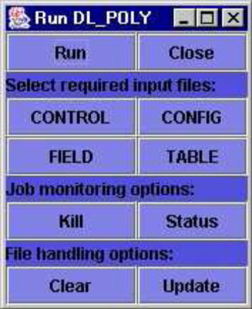
Figure 17: The Run DL_POLY Panel

Input and output files for DL_POLY left lying around in the execute subdirectory after a run may be cleared away using the Clear button. Files required for a subsequent run may be set up using the Update button, which will result in backup copies of the CONFIG and REVOLD files being taken (and given the suffix .BAK), and the files REVCON and REVIVE being renamed CONFIG and REVOLD respectively. Note that it is up to the user to amend the CONTROL file if necessary, using the CONTROL file editor under the FileMaker menu.
Note that because both Clear and Update may result in data loss if inappropriately used, so a dialog box will appear when either is clicked, to provide opportunity to abort the operation.
The Close button deletes the ‘Run DL_POLY’ panel.

- Store/Fetch Data

Selection of this menu item invokes the ‘Data Archive’ panel (figure 18), which provides facilities for storing and retrieving DL_POLY I/O files. The first option available on the ‘Data Archive’ panel is the selection of the standard test cases of DL_POLY. The user must first choose the required test case from the menu box on the panel, then clicking the Select button will result in the data files for this test case being copied into the execute subdirectory. These files may be used immediately for a DL_POLY run, since they already have the correct file names and do not need to be selected again. Note that the GUI automatically selects the leapfrog version of the test data only.
The user may define a storage directory under the DL_POLY data subdirectory and use the Data Archive panel to store DL_POLY I/O files. The user should enter a new directory name in the text box beside the Store button and then click Store. (This action also deletes the original files from the execute subdirectory.) If the nominated directory already exists, an error message appears in the Monitor Window and no action is taken.

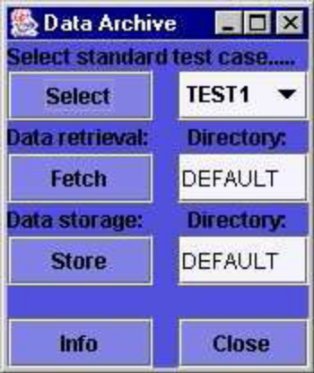
Figure 18: The Data Archive Panel

In a similar fashion the Fetch button will copy DL_POLY I/O files from the directory nominated in the adjacent text box into the execute subdirectory. The nominated directory must be in the DL_POLY data subdirectory. Both the Select and Fetch buttons will first produce a dialog box, to alert the user to a possible data overwrite.
The Close button deletes the ‘Data Archive’ panel.

4.3.4 The Analysis Menu

The Analysis menu provides access to a range of tools for analysing DL_POLY output. The menu items that appear are as follows:

- Statistics – analysis and plotting of system properties
- Structure - spatial correlation functions;
- Dynamics - time correlation functions;
- van Hove - space-time correlation and dynamic structure;
- Display - visualisation;
- Tools - utilities.

Each of these items presents a sub-menu of applications, which are described
below.

- Statistics
This menu option invokes the ‘Statistics’ Panel (figure 19) to allow the user to calculate average values and statistical errors of particular system variables, using information stored in the DL_POLY STATIS file, and display them as a time plot..
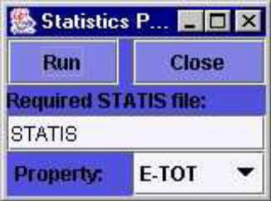
Figure 30: The Statistics Panel

The panel supports a text box for the name of the STATIS file and a menu box for the variables that may be analysed. These are:

  - E_TOT - system total energy;
  - TEMP - system temperature;
  - E_CFG - configuration energy;
  - E_VDW - van der Waals energy;
  - E_COUL - Coulombic energy;
  - VOLUME - system volume;
  - PRESS - system pressure;
  - PMF - potential of mean force virial;

The statistical calculations are initiated by the Run button. While calculating the average value of the selected variable, the GUI also performs a blocking analysis to obtain the optimal statistical error and the error uncertainty. The results are displayed in the Monitor Window. A graph plot of the variable is produced on-screen by the GUI Graph Plotter.
The Close button closes the panel.

- Structure
This menu item invokes a sub-menu of facilities for analysing the static
structure of a system. The following facilities are provided.
- RDF_Plot
The RDF Plotter panel (figure 20) enables the user to plot a radial distribution function produced by DL_POLY. The RDF data are stored in the file RDFDAT, but if the user has renamed this file, the name in the text box available for this purpose must be changed. To produce a RDF plot all the user need do is nominate the two required atom names in the text boxes provided and click the Plot button. (The names are those used to label atoms in the simulation CONFIG or FIELD files.) The GUI will produce a screen plot of the RDF and also create an associated plot file named RDFn.XY, where n is some integer. The onscreen plot is produced by the GUI Graph Plotter (see section 4.4).

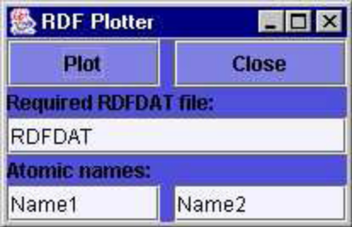
Figure 20: The RDF Plot Panel

Note the names of the atoms present in any CONFIG file may easily be
obtained with the ‘What Atoms?’ facility under the Analysis/Tools menu.
The Close button deletes the ‘RDF Plot’ panel.
- RDF_Calc
The data stored in the RDFDAT file does not necessarily provide a complete account of pair correlations in a system. For example bonded pairs are not described, nor are pairs for which the interaction potential is defined as zero. The ‘RDF_Calculator’ panel (Figure 21) provides the means to calculate these missing correlations using a DL_POLY HISTORY file. The panel can also calculate a total RDF for the system, combining all atom types.

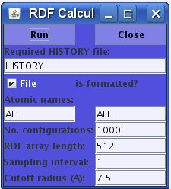
Figure 21: The RDF Calculator Panel

The data required by this panel are as follows. Firstly the name of the HISTORY file is required. (This must be a file in the execute subdirectory.) The default file name is HISTORY. If the file is formatted, the check box on the panel must be set. Next the user must supply the atom names for the pair correlation, as for the RDF Plotter. Note that the name ALL may be used if a total RDF is required. The user must specify the required number of configurations in the HISTORY file using the associated text box. (This may exceed the actual number without harm.) Also required are the length of the RDF array (how many data points in the plot), the HISTORY file sampling interval (e.g. setting 1 will sample all configurations, 2 will sample every other configuration, and so on) and the cut off radius (in A) for the RDF. Text boxes are available for all of these. Clicking the Run button will start the RDF calculation. When finished, the program produces a file named RDFDAT.n, where n is an integer. This file may be plotted using the RDF Plotter described above. The Close button deletes the ‘RDF Calculator’ panel.
- S(k)
The S(k) plotter panel (221) is used to plot a structure factor, based on the RDF data in the RDFDAT file.

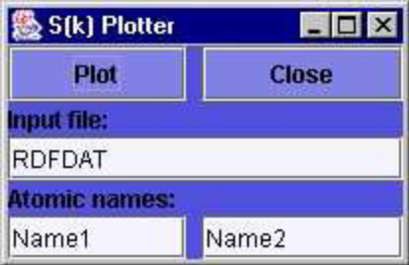
Figure 22: The S(k) Plotter Panel

This panel works in exactly the same way as the RDF Plotter above. The
only difference is that the RDF data are Fourier transformed immediately to give the structure factor. An on-screen plot of this appears, drawn by the GUI Graph Plotter (section 4.4), and a plot file SOKn.XY, where n is an integer, is produced.
- Z_Density
The Z-Density Plotter panel (figure 23) plots the particle density of a
system along the z-direction, taking data from a DL_POLY ZDNDAT file.
This has particular application to layered systems, where, by convention,
the layers lie in the x, y plane. To operate this panel the user must nominate the ZDNDAT file in the appropriate text box and the name of the atom of interest. The Plot button produces an on-screen plot using the GUI Graph Plotter facility (section 4.4) and also writes the plot file ZDENnXY, where n is an integer.

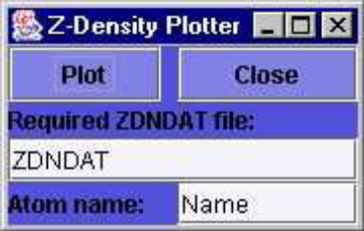
Figure 23: The Z-Density Plotter Panel

Note the names of the atoms present in any CONFIG file may easily be
obtained with the ‘What Atoms’ facility under the Analysis/Tools menu.
The Close button deletes the panel.
- Slice
The ‘Slice’ panel (figure 24) allows a user to cut a slice, or slab of atoms
from REVCON file or any loaded configuration. This can be useful to isolate areas of interest for closer inspection or to construct model surfaces.

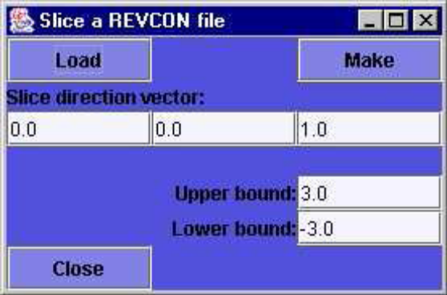
Figure 24: The Slice Panel

To use the slice option the user must define a slice direction vector, (which is perpendicular to the slice faces,) and the upper and lower bounds of the slice measured along the chosen direction. It is assumed the direction vector starts at the centre of the REVCON file. Labelled text boxed are provided for these inputs. To perform the slice operation on a loaded configuration the Make button must be clicked. Alternatively the Load button may be used, to enable selection of a REVCON file from a browser. Both buttons produce a file CFGSLC.n, with n an integer (absent in some cases) taken from the configuration file suffix. The sliced configuration appears in the Graphics Window.
Note: Being an analysis tool, this facility is targeted at REVCON files,
though it will work equally well on CONFIG files.
The Close button deletes the panel.

- Dynamics
The Dynamics sub-menu offers some standard time correlation functions,
namely the mean square displacement (MSD), velocity autocorrelation
(VAF) and force autocorrelation (FAF). These are calculated from the data
in a DL_POLY HISTORY file.

- MSD
The MSD Panel (figure 24) enables a multiple origin MSD calculation to be performed and the result plotted on-screen. The user must specify the HISTORY file name in the labelled text box. The file must be in the DL_POLY execute subdirectory. The default name is HISTORY. A check box is used to indicate that the file is formatted or otherwise. A text box is available for the name of the atom of interest,
which may be specified as ALL if a non-discriminating MSD is required. Text boxes are also provided for the required number of configurations in the HISTORY file, the MSD array length, sampling interval and origin interval. The sampling interval defines the interval between selected configurations in the HISTORY file, for example an assignment of 1 means every configuration is used, while 2 would use every second configuration and 3 every third and so on. The origin interval specifies which of the sampled configurations is to be used as an origin for a MSD array. Thus a specification 1 means every sampled configuration is used as an origin, 2 means every second sampled configuration is used etc. By a quirk of bookkeeping the MSD array length must be divisible by the origin interval. The GUI will enforce this if necessary. Clicking the Run button starts the MSD calculation. On completion the MSD is plotted by the GUI Graph Plotter (see section ()) and a plot file MSDn.XY is created, where n is an integer.
The Close button deletes the MSD panel.

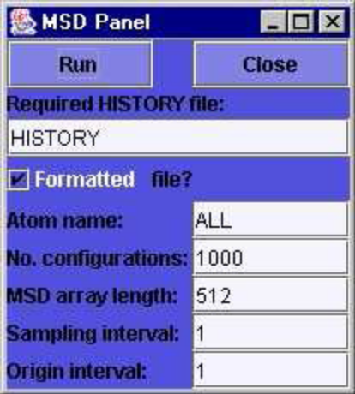
Figure 25: The MSD Panel

- VAF
The VAF panel is identical to the MSD panel in appearance and operation.
Its outputs are a plot of the Velocity Autocorrelation Function data and a
plot file: VAFn.XY, with n an integer. Please consult the above section
describing the MSD panel. Note that the HISTORY file must contain velocity data, and DL_POLY should be directed to produce this when the simulation is performed.
- FAF
The FAF panel is also identical to the MSD panel in appearance and operation. Its outputs are a plot of the Force Autocorrelation Function data and a plot file: FAFn.XY, with n an integer. Please consult the above section describing the MSD panel. The HISTORY file must, of course, contain force data.

- van Hove
This menu item provides a selection of density correlation tools of the kind pioneered by van Hove. (i.e. correlations in both space and time). The facilities available are:
- Gs(r,t)
The panel for the van Hove self correlation function (see figure 26) resembles that for the MSD above, but requires an additional control parameter: the cut off radius, which is the distance over which the spatial correlations are to be evaluated. The calculations are commenced when the Run button on the file browser is clicked and may take several minutes to complete. The results are stored in a file: HOVGSL.n, where n is an integer.
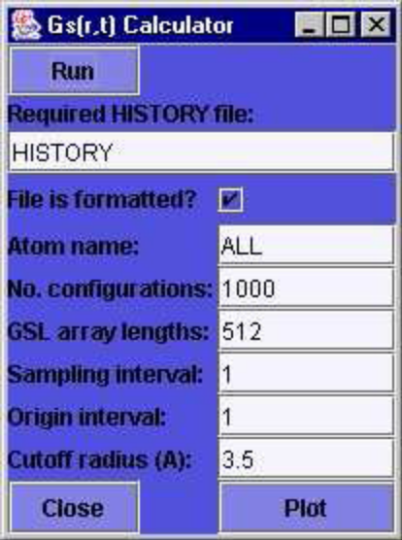
Figure 26: The Gs(r,t) Calculator Panel

Unlike the MSD, VAF and FAF panels this panel does not produce a graph window automatically, since, potentially, a large number of Gs(r,t) functions are produced. (The actual number is announced in the Monitor Window when the calculation finishes.) It is necessary to use the Plot button to invoke the van Hove Plotter and select which of the many functions is required for plotting by entering the sequence number in the text box (see figure 27). The selected plot appears on-screen in the Graph Plotter and each plot produces a plot file: HOVm.XY, where m is thesequence number of the van Hove function in the parent HOVGSL.n file.

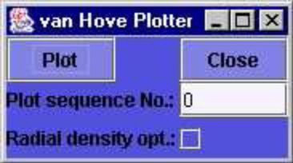
Figure 27: The van Hove Plotter Panel

- Gd(r,t)
The van Hove distinct correlation function panel (figure 28) resembles that for the self correlation function, except that an additional atom name is required, since this is a pair correlation function. The name ALL may be used for indiscriminate correlation functions. The calculations are performed as a background job, which may be monitored using the Status button or terminated with the Kill button on the panel. When the job is finished, plotting the distinct correlation functions, (which are stored in the file HOVGDF.n,) is identical to the self correlation function case.
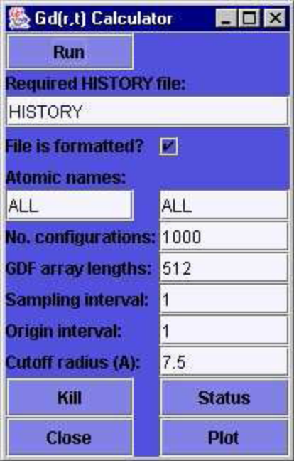
Figure 28: The Gd(r,t) Calculator Panel

- S(k,w)
The dynamic structure factor panel (figure 29) also operates in a manner resembling the self correlation function panel, however there are important differences. Firstly, the calculation (which runs in the background) will accept only formatted HISTORY files. It does not require the names of the atoms, but does require the user to specify whether or not the atomic charges are to be used (to calculate charge density as opposed to particle density). A check box is available for this purpose.

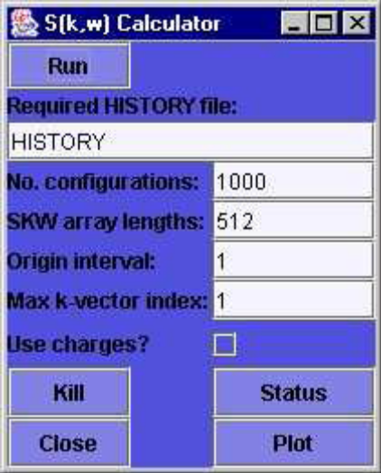
Figure 29: The S(k,ω) Calculator Panel

The maximum k vector is specified by an integer index, which determines
the maximum in all three principal directions (and, incidentally, has a big
impact in the job time!) as in: k=2_L(l,m,n)† where l,m,n are the integers
concerned and L is the cell width. The calculation proceeds via the particle density ρ(k,t), through the intermediate scattering function F(k,t) to the dynamic structure factor S(k,ω). These stages respectively produce files called SPCDEN, DENFKT and DENSKW. The latter two may be displayed by clicking the Plot button, which invokes the dynamic structure factor plotting panel. The panel supports Status and Kill buttons to help manage the background job. The plotting panel (figure 30) resembles the van Hove plotter, but the choice of function to be plotted is specified by the three k-vector indices, for which individual text boxes are provided.

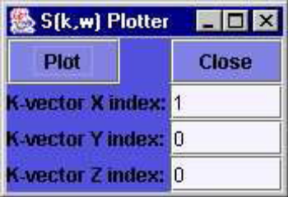
Figure 30: The S(k,ω) Plotter Panel

- Display
The Display menu item offers a facility for displaying REVCON files and (re)plotting various graphs.
- CONFIG
This option displays the contents of the CONFIG file used in a DL_POLY simulation. The selection invokes a display the CONFIG file.
- REVCON
This option displays the contents of the REVCON file produced at the end of a DL_POLY simulation. The selection invokes a display the REVCON file.

- Tools
The Tools menu provides a selection of tools useful for analysing DL_POLY output. The following tools are available:
- What Atoms?
The ‘What Atoms?’ menu item provides a mechanism by which the user may conveniently determine the different types of atom that occur in a CONFIG file. It invokes a file browser with which the required CONFIG file may be selected. A list of atom types within the selected file then appears in the Monitor Window. This facility is useful for analysis purposes, as the atom types (names) are frequently required by the GUI analysis tools.
- Plot
This option invokes a simple file browser, which allows the user to select (i.e. any plot file with a name ending in .XY e.g. abc.XY ) to display with the Graph Plotter.

4.3.5 The Information Menu

The Information menu provides some on-line information of a semi-useful
nature. The information is displayed in the Monitor Window.
- About DL_POLY
Note on authorship and ownership of DL_POLY.
- Disclaimer
Software writer’s incantation to ward off litigation.
- Licence
View of the DL_POLY licence on-screen.
- Acknowledgements
Acknowledgements and thanks to various people and organisations.
- MINIDREI
The contents of the MINIDREI Dreiding parameters file.
- MINIOPLS
The contents of the MINIOPLS OPLS parameters file.
- CERAMICS
The contents of the CERAMICS ceramic parameters file.
- Clear Text
Clear the Monitor Window.

4.4 The GUI Graph Plotter Window

The Graph Plotter Window (figure 31) is invoked automatically by some of the Analysis tools described above and also by selecting the Analysis/Display/Plot menu item. The scale of the graph is calculated automatically and the window provides facilities to display or print a graph plot and also perform some editing. The Graph Plotter presents a large drawing area, with three text boxes at its base and a number of buttons stacked vertically on the right hand side. Most of the functionality of the plotter is controlled by the buttons, which are as follows:

- Load - load and plot a new XY file;
- Spline - Fit data points with spline functions and plot result;
- Dots - Show/hide dots marking data points;
- Lines - Set plot line thickness.
- Print - Open a print dialog box for printing;
- Zoom - Zoom in on selected region of plot (marked with drag box);
- Clear - Delete plot and clear arrays;
- Close - Delete Graph Plotter Window.

In addition to the button operations, the text boxes at the foot of the drawing area allow the user to change the graph annotation. From the left, the first box defines the x axis notation, the second box the y-axis notation and the last defines the graph title. The text in any of these may be edited. Hitting <Return> will insert the changed text into the plot.

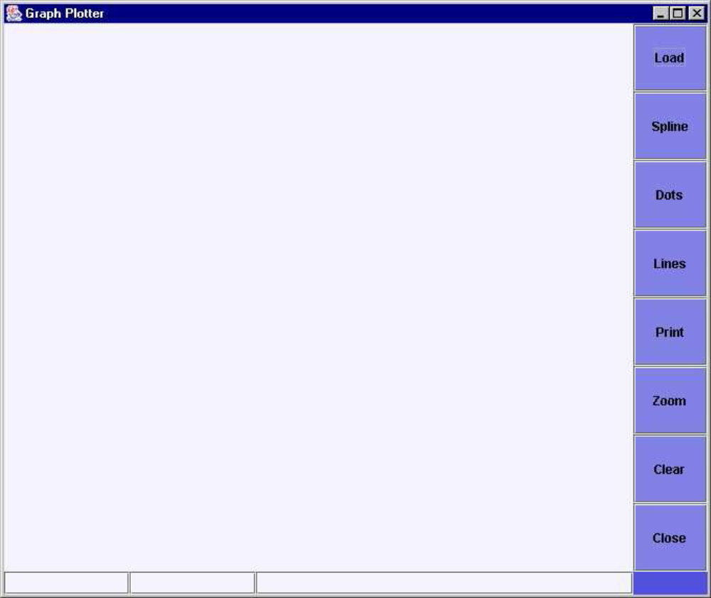Figure 31: The GUI Graph Plotter

The GUI Graph Plotter reads data files with the following format:

• Record 1: File header record
Record starts with the ‘#’ character followed by user text;
• Record 2: Plot title record
Record starts with the ‘#’ character followed by text defining the plot title;
• Record 3: X-axis label
Record starts with the ‘#’ character followed by text defining x-axis label;
• Record 4: Y-axis label
Record starts with the ‘#’ character followed by text defining y-axis label;
• Records 5+: Data points
Records defining the x and y data points of the plot. x and y must be real
numbers separated by at least one space. Scientific (E) number format is
acceptable.
• Last record: Terminator
The data should be terminated with the & character.

This format is equivalent to the common XY format used by many data processing packages.

5. THE MOLECULAR EDITOR

5.1 Introduction

The Molecular Editor gives the user the ability to construct complex organic molecules and replicate them to build a system that can be simulated by DL_POLY.
The Editor is invoked by clicking the Edt button on the right of the GUI, when in View mode. The appearance of the GUI is shown in figure 32. (Similarly, the Editor may be closed by clicking the Edt button in Edit mode.) Invoking the Editor has the following consequences:

- An extra column of buttons appears on the right of the GUI and the way the buttons work is altered. In general buttons no longer produce a direct action, they merely activate an edit mode. The action is usually performed by mouse and cursor operations in the Graphics Window.
- An extra menu: `Editor', appears on the menu bar. This is used to set the editor defaults.
- The rendering of structures in the Graphics Window changes - atoms are drawn smaller.
- A small crosswire appears in the centre of the Graphics Window. This is the `system centre' - the centre of the MD cell and the point about which molecules are rotated when required.

The significance of these features will become apparent in the following text.

5.2 The Buttons of the Molecular Editor

5.2.1 The Mode of Action of the Buttons

A common feature of the buttons in the Edit mode is that clicking on them puts the GUI into a sub-edit mode, which is identified by a text banner appearing in the top left of the Graphics Window. While the GUI is in a subedit mode the molecular structure in the Graphics Window may be edited in the selected manner. Clicking the same button, switches off the sub-edit mode. This is sometimes accomplished by clicking another button, but this action may sometimes activate the second option to work concurrently with the first. The default sub-edit mode is NULL. To obtain the required editing operation, the mouse cursor should be moved to the Graphics Window, where the options of clicking or dragging the cursor may be employed in accordance with the selected edit operation. The following properties should be noted.

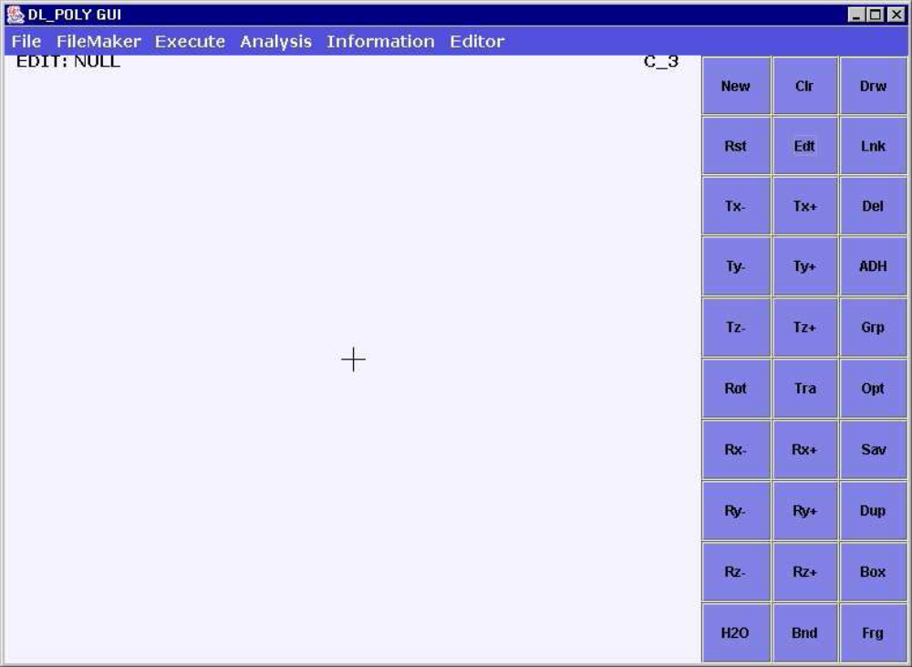Figure 32: The GUI with the Molecular Editor activated.

- For operations that respond to a mouse click, clicking the mouse in an empty part of the Graphics Window will normally perform the operation on the whole structure, or if an atom group has been created (see below), it will operate on that group. If the user clicks on an individual atom, the operation will be applied to that atom only.
- Similarly, for operations that respond to a mouse drag, starting the drag in an empty part of the Graphics Window will perform the operation on the whole structure, or on an atom group if one has been created. If the user starts the drag on an individual atom, the operation will be applied to that atom only.

In the following sections the new buttons that appear in the Edit mode are described separately from those originally present (though with modified function) in the View mode. These sections identify the function of the buttons only. How they are used is described in section 5.4

5.2.2 The `New' Buttons

The new buttons are as follows:

- Drw - activates the drawing mode in the editor.
- Lnk - draw a bond between two atoms.
- Del - delete an atom or group of atoms.
- ADH - add or delete hydrogen atoms.
- Grp - create a group of atoms for editing purposes.
- Opt - optimise the structure.
- Sav - Save the structure in a file.
- Dup - Duplicate a group of atoms.
- Box - Draw a MD cell around structure.
- Frg - Insert a predefined molecular fragment.

5.2.3 The Modified `Old' Buttons

The buttons retained from the View mode have broadly the same meaning as before, though the actual function may be different. The amended functions are as follows:

- New - allows user to read a CONFIG file, in this case for editing.
- Cls - deletes the structure being edited and clears the image from the screen.
- Rst - restores the last structure saved by the editor.
- Edt - activates/deactivates the Edit mode.
- Tx- - moves (translates) the structure to the left.
- Tx+ - moves the structure to the right.
- Ty- - moves the structure towards the observer.
- Ty+ - moves the structure away from the observer.
- Tz- - moves structure down.
- Tz+ - moves structure up.
- Rot - rotates the structure to follow the dragged cursor.
- Tra - moves the structure to follow the dragged cursor.
- Rx- - rotates the structure clockwise about the x axis.
- Rx+ - rotates the structure anticlockwise about the x axis.
- Ry- - rotates the structure anticlockwise about the y axis.
- Ry+ - rotates the structure clockwise about the y axis.
- Rz- - rotates the structure clockwise about the z axis.
- Rz+ - rotates the structure anticlockwise about the z axis.
- H2O - unchanged - toggles the visibility of water molecules.

In the above it should be noted that the sub-edit modes that the translation and rotation buttons act on the molecular structure and not just its image. Real change results from these operations, unlike what happens in View mode. Note that the Ty+ and Ty- buttons, do not `zoom' out and in as happens in the View mode. In Edit mode the structure is displaced only about 0.1 A in either direction and is used to help with optimisation, as will be shown later. Note also that it is permissible to click the axis rotation buttons (Rx+, Ry- etc) after the Rot button to obtain a mouse controlled rotation about the indicated axis. Normally the axis rotation buttons rotate the structure by a prescribed fixed amount. Finally and importantly, please note there is no UNDO button, so you are recommended to save your edits frequently!

5.3 The Editor Menu

The Editor menu appears only in the Edit mode and provides the user with a means for setting the Edit mode defaults. The menu items available are:

- Atoms - sets the default atom for the Draw sub-edit mode;
- Box - sets the default MD cell for the Box sub-edit mode;
- Fragment - selects the molecular fragment for the Fragment sub-edit mode.

These options are described below.

- Atoms
This item provides a sub-menu of possible atom types that may be used in drawing molecular structures. The current list includes:

H_, C_3, C_2, C_1, C_R, O_3, O_2, N_3, N_2, N_1, P_3, P_2, S_3, S_2
Which are atom types consistent with the Dreiding force field. Selection of one of these will make it the default atom for drawing molecular structures. The initial default is C_3.
- Box
This item provides a sub-menu of types of MD cell to contain the edited structure. The following are available: Cubic, orthorhombic, truncated octahedral, rhombic dodecahedral and hexagonal. Selection of one of these will define the shape of the MD cell the GUI will use when the Box sub-edit mode is activated.
- Fragment
This item provides a sub-menu of molecular fragments for insertion into the structure using the Fragment sub-edit mode. The fragments currently available are: Search (default), alanine, benzene, glucose, i-butane, naphthalene, styrene, c-hexane, n-butane, n-hexane, n-decane. Selection of one of these will make it the default molecular fragment to insert into the structure during the Fragment sub-edit mode. The one exception is the Search option, which will open a file browser for selection of an appropriate CONFIG file for insertion.

5.4 The Sub-Edit Modes

- The Null Sub-edit Mode
This mode is the default, to which the GUI returns when any current edit sub-mode is deactivated. It has the following properties:

- If the user clicks on an atom, the atom will be highlighted by a red halo. Also the symbol and number of the atom selected will be printed in the Monitor Window.
- Clicking on a second atom will both highlight the atom, and print its symbol and number in the Monitor Window, together with its distance from the first atom (i.e. bond length determination).
- Clicking on a third atom will both highlight the atom, and print its symbol and number in the Monitor Window, together with its distance from the second atom and the angle between the line linking the first and second atoms and that linking the second and third atoms (i.e. bond angle determination at second atom).
- Clicking any further atom will cause highlighting of the atom and printing of the distance to the previous atom and the angle at that atom in the Monitor Window. Any number of atoms may be clicked in succession, but only three atoms will ever be highlighted.
- Clicking an empty part of the Graphics Window, will de-highlight all selected atoms.
- A double click on any atom will result in its substitution by whatever atom type is the current default.

- The Draw Sub-edit Mode
Clicking the Drw button activates the Draw sub-edit mode. In this mode clicking in the Graphics Window will result in the insertion of an atom of the default type (as defined using the Editor menu). Clicking in another location will create a second atom formally linked to the first via a bond, which is also drawn. Subsequent clicks add additional atoms, each linked to the previous atom. This linking between atoms can be stopped by clicking on an existing atom. The next atom added will not be linked to the previous one, though subsequent additions will continue the linking. Bonds may be edited using the Link sub-edit mode (see below). Clicking the Drw button while in the Drawing sub-edit mode, will deactivate the drawing. Note that an isolated (unlinked) atom is drawn in the X-Z plane with zero Y coordinate. If it is linked to a preceding atom however, it will take the Y coordinate of that atom.

- The Link Sub-edit Mode
Clicking the Lnk button activates the Link sub-edit mode. In this mode, the
user may click on any two atoms and a link (bond) will be drawn between
them. If a link already exists, it will be deleted. In both operations, the first
atom clicked is highlighted. In this way links between atoms may be added
and removed. Clicking the Lnk button while in this mode will deactivate the Link mode.

- The Delete Sub-edit Mode
This mode is activated by the Del button. In this mode the following operations are possible.

- If an atom is clicked, it is deleted from the structure and any links to that atom from other atoms in the structure are also deleted.
- If an atom group is defined, clicking anywhere in the Graphics Window will cause the deletion of the entire group and all links between its constituent atoms and the surviving atoms. Clicking the Del button while in this mode will deactivate the Delete mode.

- The Add/Delete Hydrogen Sub-edit Mode
The Add/Delete Hydrogen sub-edit mode is activated by the ADH button. Its mode of operation is as follows:

- Clicking on a single atom will add hydrogen atoms and associated bonds to the atom, provided that it has none already and its formal valency is unsatisfied.
- Clicking an empty part of the Graphics Window will add hydrogen atoms and associated bonds to all atoms, provided that no atom is linked to any hydrogen atoms already and their formal valencies are unsatisfied. If any atom is already linked to one or more hydrogen atoms, all hydrogen atoms will be deleted (in which case a second click will restore all required hydrogen atoms to satisfy the valency requirements).
- Clicking an empty part of the Graphics Window when an atom group has been defined will add or delete hydrogens as in the previous case, but confining the operation to the atom group only.
- Clicking the ADH button while in this mode will deactivate the Add/Delete Hydrogen mode.

- The Group Sub-edit Mode
This mode is activated by clicking the Grp button. In this mode the user may isolate a group of atoms for special treatment as follows:

- Clicking on any (unhighlighted) atom will add that atom to the group.
- Clicking on an empty part of the Graphical Window and dragging the mouse will draw a square in the window, within which all atoms are to be included in the group. The release of the mouse button will cause all atoms in the drawn square to be highlighted.
- Clicking any highlighted atom will cancel the group.
- Clicking the Grp button while in this mode will deactivate the mode, leaving the grouped atoms highlighted. This group may then be edited independently of the remaining atoms in the system. To cancel the grouping, it is necessary to enter the Group sub-edit mode again and click one of the highlighted atoms. Click the Grp button once again to restore the Null mode.

- The Optimise Sub-edit Mode
The Optimise sub-edit mode is entered by clicking the Opt button. Thereafter the structure in the Graphics Window may be optimised by:

- Clicking an empty part of the Graphics Window (provided no atom group has been created) will cause the optimisation process to commence. The whole structure is optimised with respect to bond lengths and bond angles (not including dihedral angles). It may be necessary to click the window several times to optimise a complicated structure.
- If an atom group has been created, that group alone will be optimised if the window is clicked. If the group is itself connected to other atoms, these connections will be optimised with regard to bond length only. Caution: when using the optimisation, the user should be aware that convergence of the process does not necessarily mean the global minimum has been found. In particular 2 dimensional ring structures may become more stable if one or more atoms are displaced out of the plane before optimisation is undertaken. The Tx, Ty and Tz buttons are useful for this purpose.
- Hint: It is sometimes advantageous to delete all hydrogen atoms in the system using the Add/Delete Hydrogen option, as this will speed up convergence. Restoring hydrogen atoms afterwards will automatically optimise their positions.
- Clicking the Opt button while in this mode will deactivate the optimisation mode.

- The Save Button
Clicking the Sav button causes the GUI to write the current structure as a DL_POLY CONFIG file named CFGEDT.n, where n is an integer, which is sequentially increased with each save. Note the Sav button does not open a sub-edit mode. If the user quits the Molecular Editor without saving the structure, it is automatically saved in a backup file named CFGEDT (with no number).

- The Duplicate Sub-edit Mode
The Duplicate sub-edit mode is activated by clicking the Dup button. Clicking the Graphics Window in this mode will result in the following:

- The duplication of any highlighted group, the new group becoming highlighted in the process.
- The GUI switching to the Move sub-edit mode (normally activated by the Tra button), so that the newly created group may be conveniently relocated as desired.
- Since the new group remains highlighted, the duplication operation may
be repeated as many times as required, though the Dup button will need to be re-clicked for each case.
- Clicking the Dup button while in this mode will deactivate the Duplicate mode.

- The Box Sub-edit Mode
Clicking the Box button will put the GUI into the Box sub-edit mode, which will insert an MD cell shape into the Graphics Window. This may be resized by dragging the mouse across the window. The orthorhombic and hexagonal options may be resized in independent, mutually perpendicular directions if required. The cell size becomes fixed when the Box sub-edit mode is deactivated. If the system already has a MD cell when this option is selected, the existing box will be replaced by whatever default shape has been defined through the Editor menu.
Clicking the Box button while in this mode will deactivate the Box mode.

- Fragment Insertion
Before using the Fra button, the user must select a fragment from the Editor/Fragment menu. A set of possible structures is available, but this may be augmented by selecting the Search option, which will open a file browser allowing the user to select an existing DL_POLY CONFIG file as the required insertion. Clicking the Fra button will activate the Fragment Insertion sub-mode. If the user then clicks the Graphics Window the following will happen:

- Insertion of the selected fragment into the Graphics Window.
- The grouping and highlighting of the inserted fragment.
- Switching to the Move sub-edit mode for relocation of the fragment.

As with the Duplicate sub-edit mode this procedure may be repeated as often as desired.The current set of fragments available in the GUI is somewhat eclectic, but serve to show what is possible. It is not difficult to edit the GUI source to permit insertion of alternative fragments, for example α-amino acids, carbohydrates, polymer monomers etc. The user is encouraged to do this if it suits his or her purpose. The Fragment Insertion sub-edit mode is deactivated by clicking the Fra button once again.

5.5 Molecular Editor Tutorials

The following is a selection of exercises to introduce the capabilities of the Molecular Editor.

5.5.1 Cyclohexane

Start up the GUI and click the Edt button to select the Edit mode. Then
proceed as follows.
- Click the Drw button to enter the Draw sub-edit mode.
- Select the atom type C_3 from the Editor/Atoms menu. (Note, the default atom type at start up is C_3, and may still apply.)
- Click at a position near the centre of the Graphics Window, this will cause
insertion of a C_3 type atom. Click once more nearby to generate a second
C_3 atom. Provided you have not inadvertently double clicked somewhere,
a bond will be drawn between the first and second atoms. Continue the
process, clicking to create atoms in an approximate hexagon on the screen.
(These should be all linked in a chain, but don't worry if they are not - it
can be fixed.) Finally click again on the first atom to close the chain.
- If you have successfully created a ringed chain of atoms, proceed to step 5,
otherwise do the following. Click on the Lnk button to activate the link
editor. Move to where you wish to insert a bond and click on the two atoms
in turn. The first click will highlight the first atom in red. The second click
will draw the bond. Do this for all the `missing' bonds.
- All the atoms defined so far are in the XZ plane (i.e. all with zero Y
coordinate). This flatness must be disrupted before effective structure
optimisation can be done. So: Click on the Ty+ button and then click on
one of the atoms in the ring. Next click the Ty- button and click on an atom
3 bonds away from the first. These two operations displace these atoms
slightly out of the XZ plane, in opposite directions.
- Now click the Opt button to activate the structure optimiser. Click
anywhere in the Graphics Window and the structure will start to optimise.
An energy value is presented near the top of the window, and with each
click the number should become smaller. Eventually, after a few clicks
(don't be too hasty with your clicks!). The optimisation will converge.
- Click the ADH button to add hydrogen atoms to the structure. Insert the
hydrogens by clicking an empty part of the window. All the hydrogens will
be inserted at once. (If you had clicked C_3 atoms one at a time, each
atom would have been hydrogenated individually.) Clicking repeatedly will
add or delete hydrogens in turn.
- After adding the hydrogens, click the Rot button and drag the cursor across
the screen. The new molecule will rotate and reveal the `chair' form for
cyclohexane.
- Click the Sav button to save the structure if you want to keep it.

Other things you can try include repeating the process but without the use of the Ty+ and Ty- buttons and see what difference it makes. Alternatively, see if you can reproduce the `boat' form of cyclohexane.

5.5.2 Benzene

This exercise will create benzene by editing the structure for cyclohexane produced above. Start by clicking the Edt button to enter the Edit mode. Then proceed as follows.

- Click the New button and select the CONFIG file containing the cyclohexane
structure.
- Click the ADH button and click a blank part of the Graphics Window once.
This will strip off the hydrogen atoms. Click the ADH button once again to
exit the Add/Delete Hydrogen mode.
- If necessary, click the Rot button and rotate the structure in the window to
ensure all C_3 atoms are visible. Rotations are accomplished by pressing
the mouse button and dragging the cursor across the Graphics Window.
Click the Rot button again to leave the rotation mode.
- From the Editor/Atoms sub-menu select the C_2 atom type. The change will
appear in the top right corner of the Graphics Window. Before proceeding
further make sure the Edit mode NULL appears in the top left corner.
- Double click on each C_3 atom in turn. Each will be replaced by a C_2 atom
that corresponds to sp² hybridised carbon. Each substitution will be
reported in the Monitor Window.
- Click the Opt button and proceed with optimising the structure by clicking
the Graphics Window. Many clicks will be necessary to converge the
structure (this is not necessarily the best way to construct benzene!).
- Click the ADH button and click a blank part of the Graphics Window once.
This will add the hydrogen atoms to the structure.
- Finally, click the Sav button to save the structure.

It is useful in this case to think about how the benzene structure can be made
more simply, using the cyclohexane case as an example.

5.5.3 Linking Molecular Structures

It is sometimes useful to bring together two or more molecules and link them to make a larger molecule, usually from a library of previously constructed molecular structures. In this exercise you will link together benzene and cyclohexane, for absolutely no good chemical reason other than to show the steps required.
Start the molecular editor and proceed as follows.

- Select the benzene molecule from the Editor/Fragment sub-menu. Next click the Frg button and insert the selected molecule by clicking the Graphics Window. (Clearly it is possible by this means to insert any of the molecular fragments available under this menu, but also any other structure in a stored CONFIG file through the Search option on the menu.)
- The inserted molecule will be grouped (as indicated by the red highlights) and the Edit mode will be set to MOVE. In this mode the molecule may be moved away from the centre of the screen.
- Next select the second molecule (cyclohexane) from the Editor/Fragment sub-menu and insert it with the help of the Frg button, as in step 1. Once again the inserted molecule is highlighted (grouped) and can be moved about independently from the benzene molecule.
- Decide which atoms you wish to link. (Obviously this must make chemical sense!) It is usually sensible (though not strictly necessary) to manipulate the two molecules to bring the two target atoms into close proximity. This can be done by grouping the molecules individually and using the rotation and translation operations to bring about the desired arrangement. Note that:
  - Grouping is activated by the Grp button. Clicking on individual atoms or dragging the mouse will incorporate atoms into the group. If any atom in the group (i.e. any highlighted atom) is clicked, the group will be cancelled.
  - Manipulating the molecule requires use of the Rot, Rx+, Rx-, Rz+, Rz etc buttons in conjunction with the Tra, Tx+, Tx-, Ty+, Ty- etc. buttons as described above. Note that a 2D window may disguise the 3D separation between the molecules. The rotation operations will usually reveal this, and it can be adjusted using the translation operations.
- In this example, in order to make a (sensible!) new bond, a hydrogen atom must be deleted from the target C_2 and C_3 atoms. The Del button activates the delete mode, and clicking on the redundant hydrogen atoms will result in their deletion.
- To make the new bond, the Lnk button must be clicked. Then the two target atoms must be clicked in turn to make the required bond.
- Once the molecules have been linked, it is advisable to relax the structure using the optimisation. Click the Opt button and then click the Graphics Window. Repeated clicks will bring about relaxation of the structure until convergence.
- Finally save the structure using the Sav button. You have created 1-phenyl cyclohexane, or is it 1- cyclohexyl benzene?

5.5.4 Constructing a Molecule and its Field File

To construct a molecule and build its associated force field is a common task. In this example you will construct a molecule, place it in a MD cell, add water and then construct a FIELD file based on the Dreiding force field. The molecule will be propane, but you may construct any molecule of your choice. Start the molecular editor and proceed as follows.

- In the Draw mode (button Drw) construct the propane backbone (three C_3 atoms in a row), optimise the structure (button Opt) and add the hydrogen atoms (button ADH).
- Draw a cubic MD cell around the molecule. This is done by firstly selecting the cube from the Editor/Box sub-menu. Then activate the box editor by clicking the Box button. Clicking the Graphics Window will result in the creation of the MD cell. (Incidentally, if you wish to change the choice of the box after it has been inserted, you can select the new box from the Editor/Box sub-menu, and click the window again to replace the original MD cell.)
- Scale the MD cell to a suitable size by dragging the mouse cursor up or down the window. Clicking the Box button again will deactivate the box editor and fix the cell size.
- Leave the Editor mode by clicking the Edt button.
- You can now add water to the cell through the FileMaker/Tools menu. Select the Add Water option. This will open the Add Water Panel (Fig. 16). Set the water-solvent and water-water distances to suitable values (or use the defaults) and click the panel Make button. If you don't see any water molecules appearing on-screen, click the H2O button to render them visible. The Monitor Window will indicate how many water molecules have been added. The new structure will be stored in a file named CFGH2O.n (with n an integer - see the Monitor Window for details.)
- From the FileMaker/FIELD menu, select the Dreiding option. This opens the Dreiding FIELD Maker Panel (Fig.10). Choose the desired settings and click the Make button. This will create a file: FLDDRE.n (with n an integer – see Monitor Window), which is the FIELD file for the model system you have made.

You can now use the GUI to make a CONTROL file for this system and run a simulation!

REFERENCES

[1] GV Lewis and CRA Catlow, (1985) Solid State Physics C 18 1149.
[2] TS Bush, JD Gale, CRA Catlow and D Battle, (1994) J. Mater. Chem. 4 831.
49
[3] B Vessal, M. Amini, M Leslie and CRA Catlow, (1990) Molecular Simulation
5 1.
[4] A Vashishta and A Rahman, (1978) Phys. Rev. Letters 40 1337.

