DA 204o: Data Science in Practice
Real Time Fake News Prediction
Course Project Report
Version 1.0
Last Update: 16/11/2023

Ritik Agrawal (ritikagarwal@iisc.ac.in)
Sanjana R (sanjana2@iisc.ac.in)
Himanshu Sharma (himanshu5@iisc.ac.in)
Mayank Teckchandani (tmayank@iisc.ac.in)

GitHub Repo
https://github.com/dlquad/iisc-ds-project

Table of Contents
Introduction 3
Problem Statement 3
Data Description 3
Exploratory Data Analysis 3
Model Building 5
Conclusion 6

Table of Figures
Figure 1 - Missing Values Chart 3
Figure 2 - Text Analysis Chart 4
Figure 3 - Word Cloud 4
Figure 4 - NGram Analysis 4
Figure 5 - Sentiment Analysis Chart 5
Figure 6 - Logistic Regression Scores Chart 6
Figure 7 - XG Boost Scores Chart 6
Figure 8 - Bi-Directional LSTM Scores Chart 6
Figure 9 - Models Score Comparison Chart 7

Introduction
Fake news has become a significant challenge in the digital age, impacting public opinion and spreading misinformation. This project aims to develop a machine learning model to detect fake news using data-driven techniques.

Problem Statement
The objective is to classify news articles as either fake or real based on their content. Accurate detection can help mitigate the spread of misinformation and support fact-checking efforts.

Data Description
Dataset used for the project contains, news articles labeled as fake or real. Key features include:
- Title: Headline of the news article
- Text: Full content of the article
- Label: Target variable (fake or real)
Initial data inspection revealed missing values in critical columns. Rows with missing titles or text were removed to ensure data quality, resulting in a clean dataset with complete records for modeling. Data retention after cleaning was above 95%, and memory usage was optimized for analysis.

Exploratory Data Analysis
EDA was performed to understand the distribution of fake and real news, identify key features, and visualize patterns. Key steps included:
- Missing Value Analysis: Visualized and quantified missing data, ensuring only complete records were used for modeling.
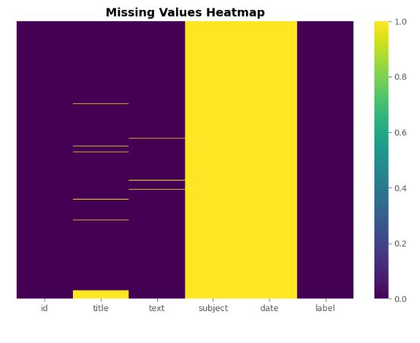
Figure 1 - Missing Values Chart
- Text Analysis: Calculated and visualized the distribution of title and text lengths, as well as word counts, to identify differences between fake and real news articles.
- Text Pattern Analysis
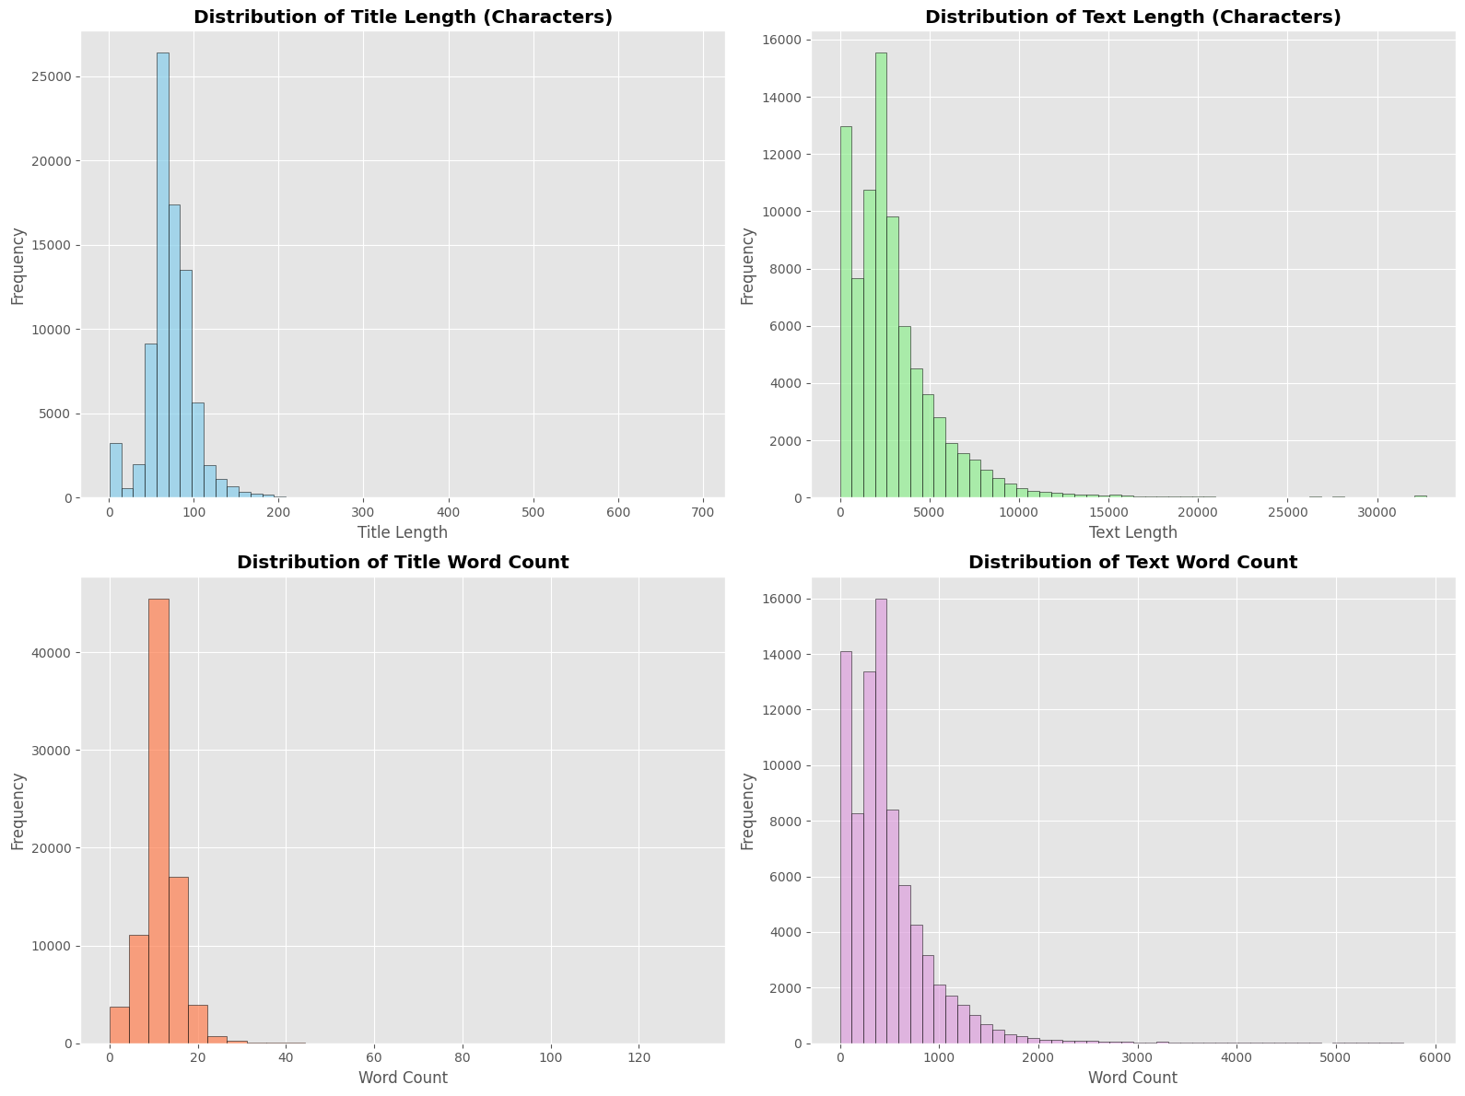
Figure 2 - Text Analysis Chart
- Generated Word Clouds
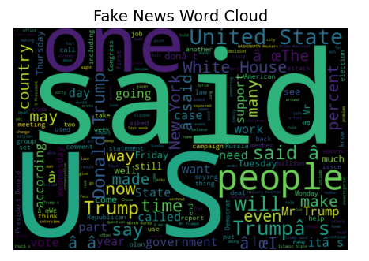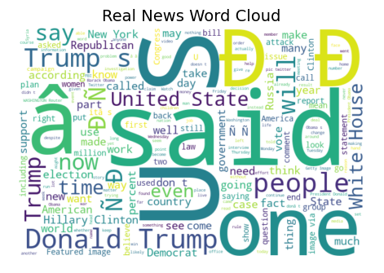
Figure 3 - Word Cloud

- N-Gram Analysis
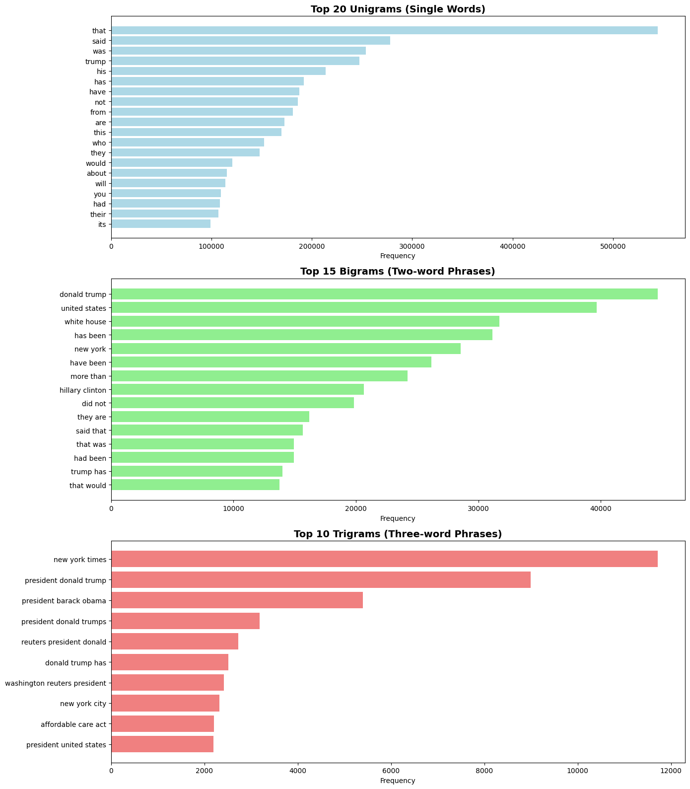
Figure 4 - NGram Analysis
- Sentiment Analysis
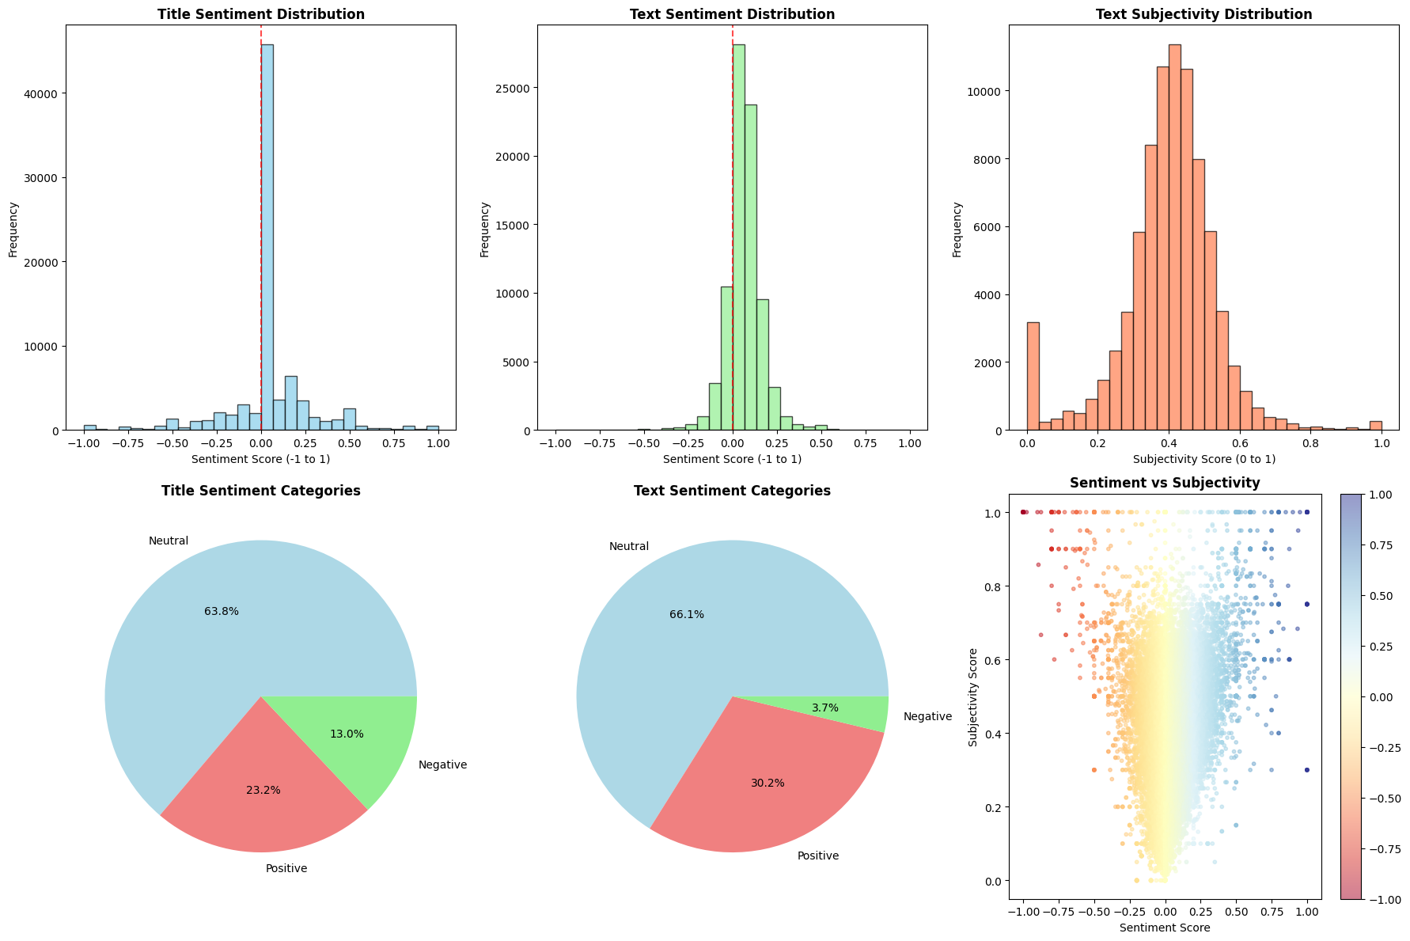
Figure 5 - Sentiment Analysis Chart
- Feature Engineering: Created new features to enhance model performance.
- Text Statistics features, such as title length, text length, title word count, and text word count
- Emotional Indicators and Language markers
- Advanced NLP, TF-IDF vectors (word importance), N-gram features

Visualization: Used histograms, heatmaps, and bar charts to explore data characteristics and relationships.

Model Building
Several machine learning models were explored, including Logistic Regression, XG Boost and Deep Learning Model like LSTM. The modeling pipeline included:
- Text Preprocessing: Tokenization, stop word removal, and regular expression cleaning to standardize text data.
- Vectorization: TF-IDF vectorization to convert text into numerical features suitable for machine learning.
- Model Training: Built and compared models such as Logistic Regression, XG Boost and LSTM.
- Feature Selection: Evaluated the impact of engineered features on model accuracy.

Models Used
- Logistic Regression: Baseline linear model using TF-IDF features. Achieved strong accuracy and interpretability.
  - Accuracy : 80.44%
  - ROC AUC : 0.88
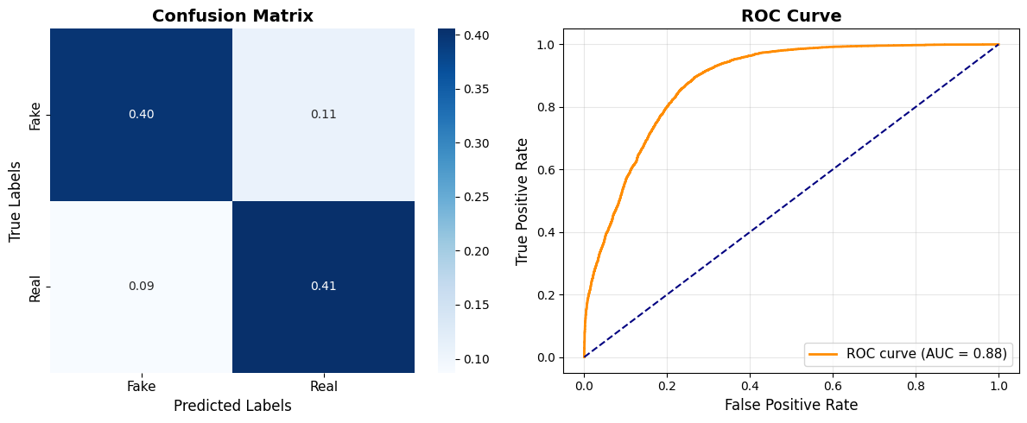
Figure 6 - Logistic Regression Scores Chart
- XGBoost: Advanced gradient boosting model with hyperparameter tuning. Provided highest accuracy and robust performance.
  - Accuracy : 85.14%
  - ROC AUC : 0.93
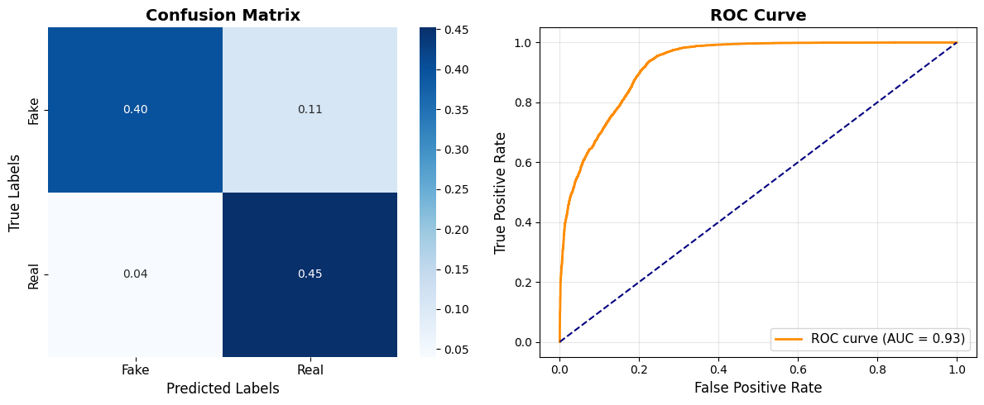
Figure 7 - XG Boost Scores Chart
- Bi-directional LSTM (Deep Learning): Neural network model using word embeddings and sequence modeling. Captured complex text patterns.
  - Accuracy : 87%
  - ROC AUC : 0.87
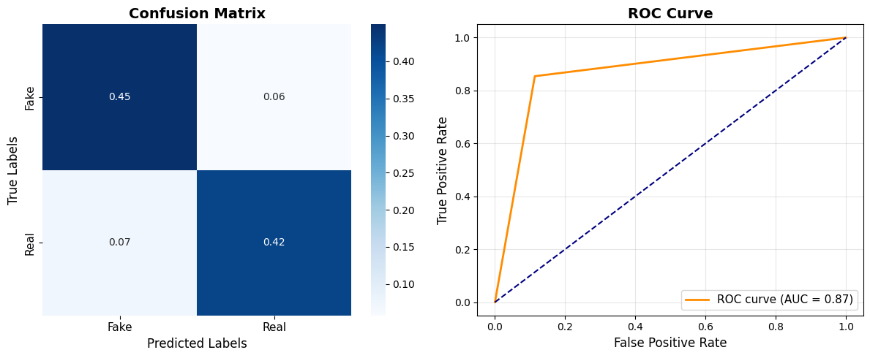
Figure 8 - Bi-Directional LSTM Scores Chart

Conclusion
- Developed a real-time fake news detection system using a combined dataset of fake and real news articles, aiming for accurate binary classification.
- Loaded and explored a comprehensive dataset (combined_final.csv) containing both fake and real news.
- Performed extensive exploratory data analysis (EDA) to understand patterns and characteristics distinguishing fake from real news.
- Engineered a variety of features from text and titles, including length ratios, punctuation, capitalization, presence of URLs, and fake news keywords, to enhance model performance.
- Baseline classical models (Logistic Regression, XGBoost)
- Deep learning model (Bi-LSTM) for improved contextual understanding
- Compared models using metrics such as accuracy, precision, recall, confusion matrix, ROC curve, and precision-recall curves.
- Found that all three models (LR, XGB, LSTM) performed similarly in distinguishing fake vs. real news, with LSTM showing high precision at low recall, and classical models performing consistently across recall ranges.
- Demonstrated that current models have limited separation power, highlighting the need for more advanced architectures.

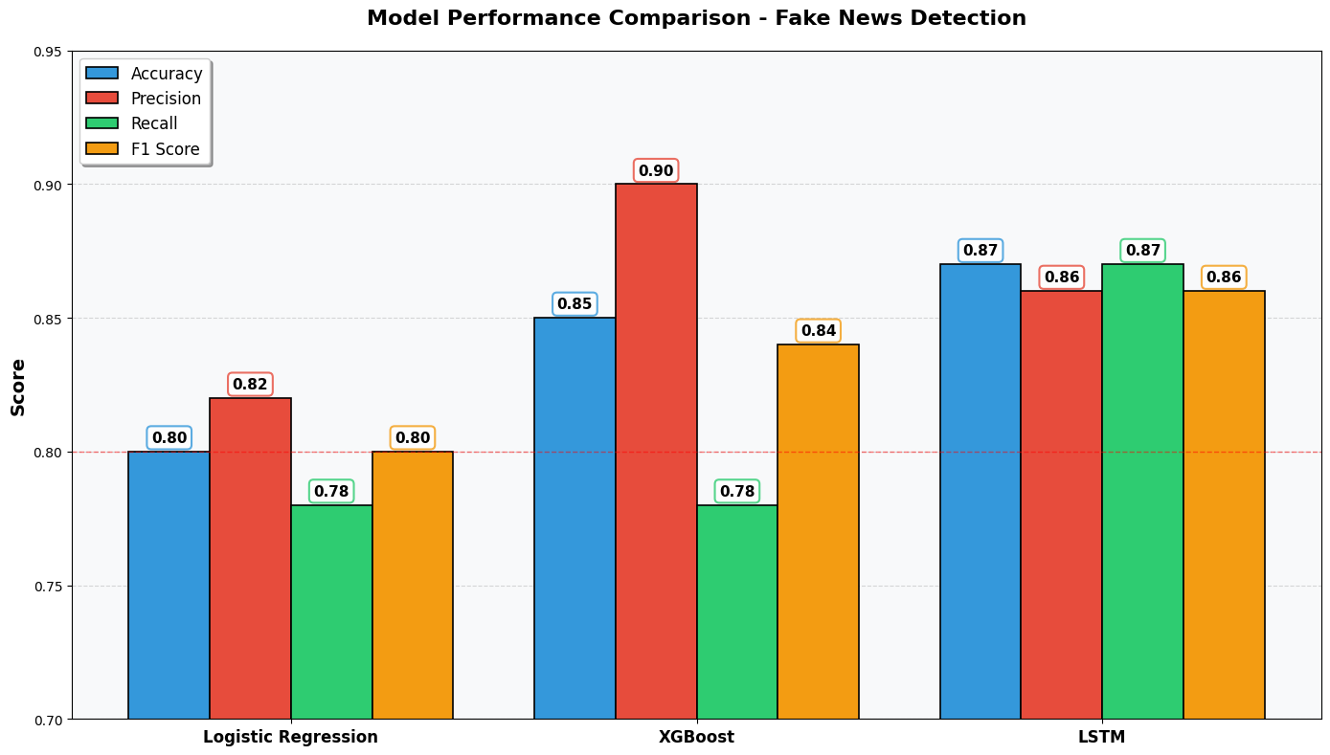
Figure 9 - Models Score Comparison Chart

Future Actions,
- Planned next steps include exploring transformer-based models (e.g., BERT, DistilBERT, RoBERTa, ALBERT) to enhance detection accuracy and speed.
- Will compare transformer models with Bi-LSTM using metrics such as accuracy, F1-score, inference time, and robustness on unseen data.
- Intend to leverage transfer learning by fine-tuning pretrained transformer models on the fake news dataset for better contextual understanding.
- Plan to experiment with ensemble approaches, combining predictions from LSTM, BERT, and classical models (e.g., Logistic Regression, XGBoost) using stacking or weighted averaging for improved reliability.
- Aim to deploy the improved model in the existing Streamlit app, adding a BERT option and optimizing model size for real-time inference.
- The project demonstrates the potential of advanced NLP and machine learning techniques in combating misinformation and sets the stage for future enhancements.

