JOGU ASHWINI  Registered Nurse | Pediatric & Neonatal (NICU) Care  3-61, Near Water Tank, Ponugodu, Nalgonda - 508255, Telangana  Phone: +91 83099 20970 | Email: ashwinijogu9495@gmail.com | 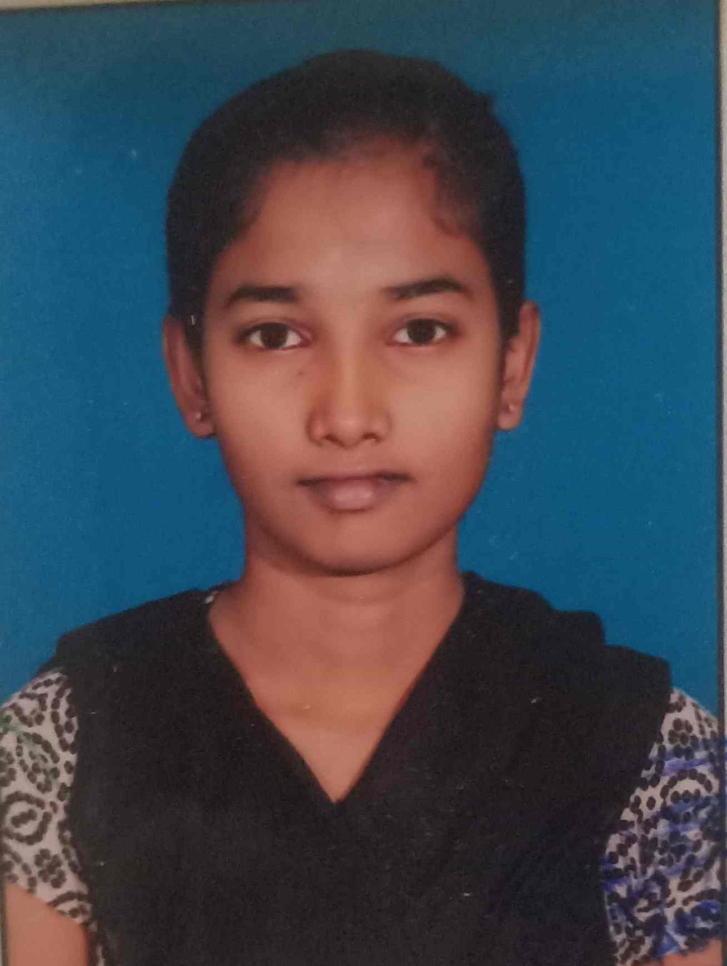

PROFESSIONAL SUMMARY
Dedicated and compassionate Registered Nurse with a B.Sc in Nursing and hands-on clinical experience in the Pediatric and Neonatal Intensive Care Unit (NICU) at Ankura Hospital, Hyderabad. Skilled in monitoring vital signs, administering medications, and delivering family-centred, evidence-based care to critically ill infants and children. Strong commitment to patient safety, infection control, and continuous professional development. Seeking a Registered Nurse role that offers greater scope for growth and responsibility.
CORE COMPETENCIES
- Pediatric & Neonatal (NICU) Care | - Patient & Family Education
- Vital Signs Monitoring & Assessment | - Care Plan Implementation
- Medication Administration & IV Therapy | - Clinical Documentation & EHR
- Infection Control & Aseptic Techniques | - Team Collaboration & Communication
- Emergency & Critical Care Support | - Patient Safety & Comfort Care
PROFESSIONAL EXPERIENCE
Staff Nurse – Pediatrics & NICU July 2025 – Present
Ankura Hospital, Hyderabad
- Provide round-the-clock, attentive nursing care to neonates and pediatric patients in the NICU and pediatric ward.
- Monitor vital signs, administer medications and IV fluids as per physician orders, and accurately document patient progress and care plans.
- Assist physicians during clinical procedures and respond promptly to emergencies; maintain strict infection-control and aseptic protocols for vulnerable patients.
- Counsel and educate parents and caregivers on newborn care, feeding techniques, hygiene, and post-discharge instructions.
- Collaborate closely with doctors, fellow nurses, and support staff to coordinate and deliver high-quality patient care.
EDUCATION
S.No | Qualification | University / Board | Year | Score
1 | B.Sc Nursing | Yashoda Lakshmi College of Nursing | 2020 - 2025 | 75%
2 | Intermediate (Bi.P.C) | Gouthami Junior College, Nalgonda | 2018 - 2020 | 78%
3 | SSC | Sneha High School, Nalgonda | 2018 | 83%
PERSONAL DETAILS
Father's Name | Jogu Sathyanarayana
Date of Birth | 30-09-2001
Gender | Female
Nationality | Indian
Marital Status | Unmarried
Languages Known | Telugu, English, Hindi
DECLARATION
I hereby declare that the above information is true and correct to the best of my knowledge and belief.
Place: Nalgonda Jogu Ashwini
Date:

