Dalton Coughlin

Test Case 1:

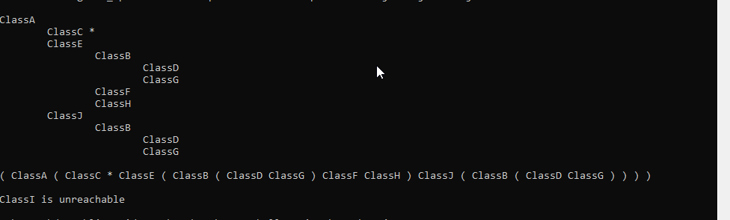

Test Case 2:

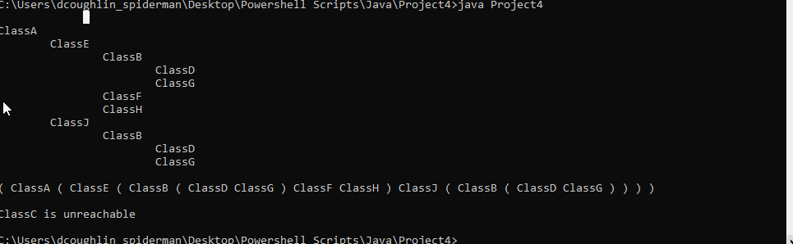

Test Case 3:

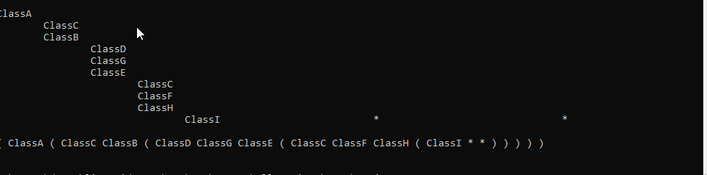

Lessons learned:

This project was interesting because of the depth first search algorithm. I am interested in machine learning algorithms and am already looking into linear regression and KNN, but this was also an interesting way of traversing through a graph tree. It helped me fully understand how the depth first search works in running code instead of seeing it visually. This also helped my understanding of the graph structure and how to process through them as efficiently as possible.