Test_Data.txt

False Strong Ordered and True Weak Ordered

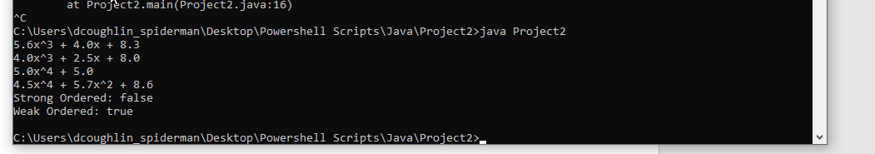

Test_data2.txt

True Strong Ordered and True Weak Ordered

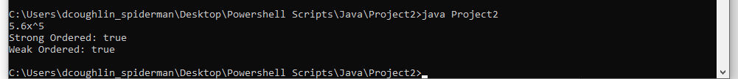

Test_data7.txt

False Strong Ordered and False Weak Ordered



Test_data3.txt

Input of data is incorrect

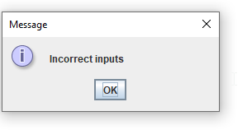

No_data.txt

File is empty

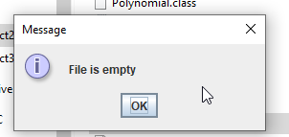

Short description on what I learned:

Working with polynomials was an interesting topic. Splitting up the terms into the coefficient and exponent was I think the best way to do it, which made me learn how to run through these polynomials in a bit of efficient manner. I have not worked with much of the Iterator or Comparable interfaces so it was a nice way of seeing how these can be made of use. Lastly, the logic through going through of the exponents and coefficients was quite a challenge and got me to think about how to go through these types of problems in the future in a different manner.