The Study of Melting Arctic Ice

Introduction

Climate change is unfolding before our eyes instead of a conjecture scenario. It is reported by Intergovernmental Panel on Climate Change (IPCC) that growing fears of feedbacks resulting from human activities will accelerate the warming. This phenomenon reflects directly an emergence of melting ice, an appearance of high sea levels and expansion of the Oceans. A complete melting of the Greenland Ice Sheet could raise global sea level by almost 20 feet within a few hundred years [1]. Sea level have been sensed that it has been rising 0.08-0.12 inches per year (2.0-3.0 mm per year) along most of the U.S. Atlantic and Gulf coasts [2]. Even if no more greenhouse gases were added to the atmosphere, global sea levels would rise another 11 centimeters (4 inches) from thermal expansion alone by 2100 [3]. Moreover, warming is bringing other unpredictable changes. For example, since 1995, the 10-year average has risen dramatically, with the 1997-2006 average at about 14 tropical storms, including about 8 hurricanes. Studies show that this temperature increase links significantly to global warming [4]. 70% of the world's sandy beaches are eroding and retreating at present. However, without taking control of the increase the loss of beach to coastal erosion will increase [5]. According to Nicholls and Leatherman (1995), a 1m sea-level rise would affect 6 million people in Egypt, with 12% to 15% of agricultural land lost, 13 million in Bangladesh, with 16% of national rice production lost, and 72 million in China and "tens of thousands" of hectares of agricultural land[6]. Global warming having been a hot topic, it is our minds that has been captured on changing temperature.

As it is known to us that the climate change has been a tremendous threat to the residents living in the earth. According to observational data and accurate estimations, the actual situation of temperature trends about global surface can be described simply in the below igure1.
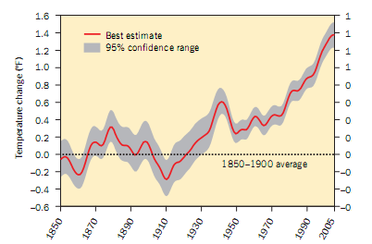
Figure1: Global surface temperature trend in 1850-2005.
Source: CLIMATE CHANGE 101 The Science and Impacts 2006 [1]

Simply, the temperature trend of previous years in 1850-1900 seems to go up and down and the curve fluctuates within the average among these years. However, the path of temperature change gained from the above figure has increased sharply since the greenhouse effect is appeared. Furthermore, the worst issue will occur without our prepared estimations. Historical temperature data change trends can play a significant role in foreseeing the future temperature change tendency. Therefore, seeking the optimal data and analyzing the statistics is the critical and fundamental approach to solve for the influence of greenhouse effect. Consequently, all possible circumstance can be taken into consideration to settle problems effectively.

According to IPCC, the primary factors driving current sea level rise include [2]:
- The change of annual global mean temperature;
- Ice caps melting;
- Melting of the Greenland Ice Sheet and the Antarctic Ice Sheet(to a lesser extent)

The apparent factor is thought to be global mean temperature, because the increasing of temperature leads to accelerate the melting of ice caps. Hence, it seems to more significant to be aware of the analysis between global mean temperature and sea level.

Eventually, the high temperature leads to rising sea level. And this result do harm to costal zones. Therefore, in terms of the suffering or threatened zones, whether habitats are influence or not and it is possible to reside in these regions for them. Low-lying lands are easy to vanish away. Contrarily, the less low-lying lands can’t always be optimal because coastal wetland ecosystems are generally within a few feet of sea level [7]. Sea level rise also causes the vulnerability of coastal areas to flooding during storms. That is to say that a higher sea level will provide a higher base for storm surges. Along with rising sea level, the saltwater will penetrate farther inland or upstream. This effect would impair water supplies, ecosystems, and coastal farmland. Therefore, saltwater intrusion would also harm aquatic plants and animals as well as threaten human water supply [8]. The U.N. report provides an early glimpse of some of the ways in which scientists say climate change will affect people’s health in the decades to come, no matter where they live. Climate change can affect human health directly and indirectly.

In our paper, we take into account all these factors to model the various aspects of global warming trend. The paper first focuses on the impact on environment originating from rising temperature. Then quantitative analysis the about change component of atmosphere (the proportion of carbon dioxide), change temperature, influence relation of melting ice and glacier is made to establish a dynamic model reflecting mutual connection. To express this model, the actual change temperature data is applied into describing the circumstance before or after warm global temperature. Besides, the increase trends for a decade also are capable to attain. On the basis of previous work, an analysis of influence on the rising sea level is made. To present the actuality of the model, situation of Florida is analyzed and disposed. Finally, some corresponding suggestions are made to limit the trend of warm global temperature.

2．Effects on Sea Level from increasing of Temperature
2.1 Future Global Temperature Change Analysis
Greenhouse gas concentrations will increase with a continued increase in average global temperatures, which projected from climate change scenarios [4]. How much and how quickly the Earth's temperature will increase remains unknown given the uncertainty of future greenhouse gas, aerosol emissions and the Earth's response to changing conditions. Building a model to simulate the global temperature change with the uncertain factors has difficult in achieving. Generally, the warmer global temperature has been recognized as part of our issue since 1977. What’s more, annual temperature is increasing year after year, which can be attained from particular data derived from GHCN 1880-12/2007 [8]. Therefore, the change state of global temperature in 1880-2008 can be described as follows:
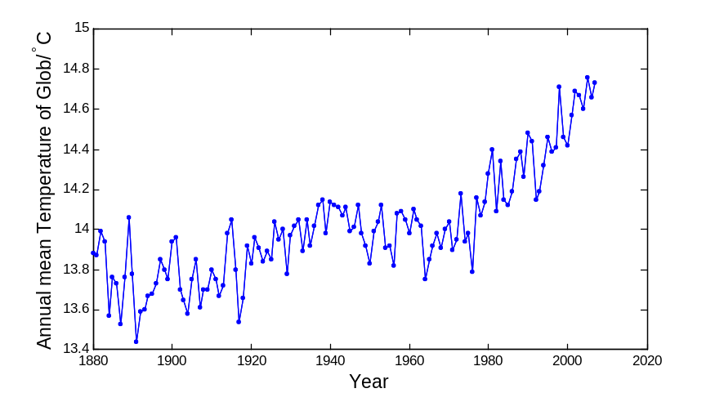
Figure2. Change state of global temperature per year in 1880-2008

We can discover global temperature has been amazedly increasing year by year since 1977. Therefore, according to the analysis of actual increasing temperature data from 1977 to 2007 [5], it is applied into forecasting future increasing temperature tendency.

It is not difficult to gain that annual temperature is increasing year after year. But the rate of increasing in temperature is not same. In fact, effects on temperature are had by many an unsure factor, such as future greenhouse gas, aerosol emissions and the Earth's response to changing conditions and so on. It is normal to face with the different increasing rate. However, in order to reflect satisfactions to the alterative trends, using the fit of least squares analysis to express global temperature trends is illustrated in the following figure3.

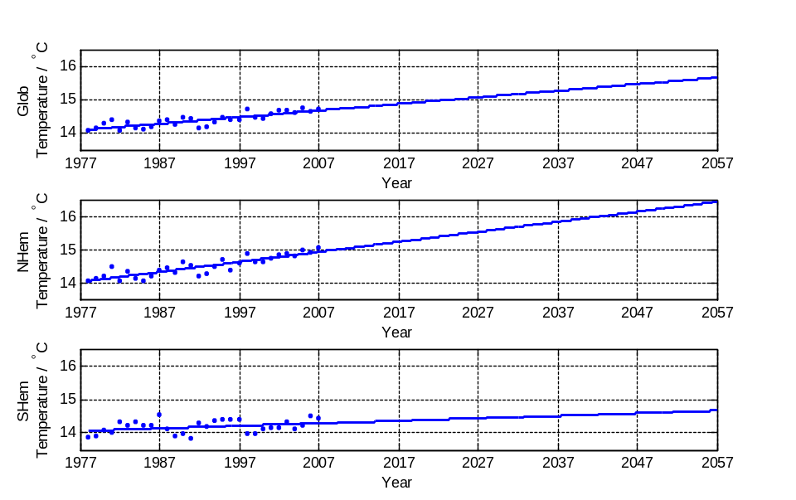
Figure3: Fit of least squares analysis of global temperature trends
It is evident for us to observe the global temperature trends increases year by year. Additionally, the increase in the Northern Hemisphere appears to be more tremendous than the Southern Hemisphere, and global temperature increasing trend is between the South and North.

The fitting equations are showed:

Global Temperature is:
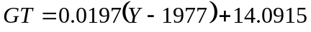
N.HEMI Temperature is:
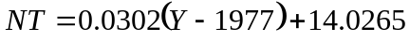
S.HEMI Temperature is:
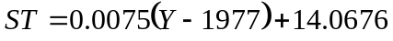
Based on above predictive model, the future data is able to predict and obtain. Global temperature rises by 0.0179°C for an average of annual year. The increase seems to be a relatively weak value. To demonstrate better the increasing temperature influencing other factors, such as the melting ice, the high sea level and so on. So we regard a decade as a unit and then obtain the increasing temperature trends for a decade. As is described in the below table:

Table1: The temperature trends for a decade
Year  area | 2017 | 2027 | 2037 | 2047 | 2057
Global | 14.878 | 15.075 | 15.271 | 15.468 | 15.665
N.Hem | 15.236 | 15.538 | 15.84 | 16.142 | 16.445
S.Hem | 14.369 | 14.444 | 14.519 | 14.595 | 14.67

2.2 The function of the ice melting

Ice in the world generally decrease with the temperature continuing rising. Assume the ice is capable to keep self-adjusted without the affection of human being, a stable state of ice amount is guaranteed. To analyze the further connection between continuous temperature change and melting ice, we centralize an analysis of ice flowing physical process in the first place. Figures are described:
Short-wave radiation reflection

Cooling the surface of ocean
Generate new ice
ice area
Strengthen
Strengthen
Promote

Expand
Positive Feedback

Figure 4: Positive feedback
The temperature difference between the polar and equatorial
Polar atmosphere down cold

Atmosphere-ocean heat transfer

Polar temperature
Enter the polar warm advection
Negative Feedback
Atmospheric circulation

The ice-covered area
Strengthen
weakened
weakened
Reduce
Strengthen
weakened
Strengthen
weakened
Strengthen
Increased
Lower
Increased
Strengthen
Figure 5: Negative feedback

From figure 4 and figure 5 above, melting ice and forming is a process of positive and negative action. As it is the process that ensure the temperature normal and ice amount balance dynamic. In addition, the flowing ice acts significantly on global temperature considering the process. Consequently, the condition of N.Hemi is our main consideration.

But in fact, melting ice amount is much more than forming per year going with temperature. Derived from the law of conservation of energy, the imbalance of ice between absorbing and releasing is actual situation:
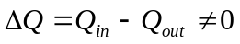

To describe the phenomenon that imbalance of absorbing and releasing energy, we research two phase of absorb and release separately. Above all, the located situation of northern ice is obtained. Besides, all the ice is floating at sea level except for Greenland. Figure 6 is illustrated as follows:
Water
snow
Sea Ice
Surface touching air
Surface touching ocean
与海水接触面积
Figure6: The located situation

Part of the floating ice touches air directly, while the other part only contact with ocean. Therefore, to present better the energy exchange, we analyze carefully the energy relationship among ocean, ice and air.

- Energy exchange between ocean and air
As for this connection between ocean and air, we attach consideration to the way that sunlight is radiate towards ocean via the medium of air: ocean absorbs heat given by the sun. But ocean has a definite reflectivity on sun radiation.

Sequentially, energy radiated from air acts on ocean: long-way frequency from radiation of air towards ocean has a direct proportion with air temperature (air radiation outside towards is a inverse proportion). Hence, energy radiated from air towards ocean generates a direct proportion with air temperature (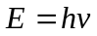,indicates Planck constant ).

Eventually, on the basis of Stefan-Boltzmann Law：The energy radiated by a blackbody radiator per second per unit area is proportional to the fourth power of the absolute temperature. So we treat ocean as ideal blackbody radiator.

Integrating three factors above, an energy relationship can be gained as follows:
Ocean Surface
Sun radiation
Reflection from ocean towards sun
Radiation from ocean towards air
Long-way from sun radiation
Ocean
Figure 7: Energy exchange between ocean and air

According to construct energy exchange between ocean and air and obtain the law of conservation of energy, heat intension of ocean received from sun and air is illustrated (absorbing and releasing energy by area and time unit):
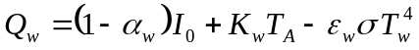
Where
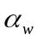is rate from ocean reflecting to sun;
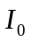 is heat intension of sun radiation;
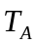 is air temperature of surrounding ice;
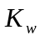 is a constant about the proportion of air temperature and radiate heat intension;
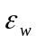 is a rate constant about ocean reflecting to air;
is a constant of Stefan-Boltzman; and
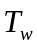 is ocean surface temperature.

- Energy exchange between ice and air

In the above relationship, it only refers to energy exchange between ocean and air. Then energy exchange between ice and air is taken into consideration. The exchange principle between ice and air is accordant to the way between ocean and air. However, distinguishes are the rate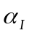 from ice towards sun and the rate 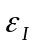 from ice towards air. Similarly, figure 8 expresses a relationship energy exchange between ice and air:
Figure 8: Energy exchange between ice and air
Water
snow
Sea Ice
Sun radiation
Reflection from ice towards sun
Long-way from air radiation
Radiation from ice towards air

Based on the law of conservation of energy, we attain the heat intension from ice towards air:
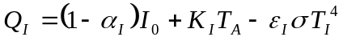
Where
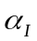 is rate from ice reflecting to sun;
 is heat intension of sun radiation;
is long-way radiation rate of ice;
is a constant of Stefan-Boltzman; and
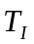 is the ice surface temperature.

- Energy exchange between ocean and ice

The two processes above calculate the influence of air, but in reality, apart from floating ice in ocean has energy exchange with air, it also links to energy exchange with surrounding ocean. So ice heat intension absorbing from ocean has a direct proportion with the difference of ocean and air temperature:
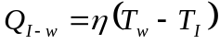

Where
is rate of heat exchange between ocean and ice;

By an analysis about energy exchange of ocean, ice and air, we detect there is a mutual influence among three aspects. What is more, a dynamic model about ice absorbing and releasing energy is obtained:
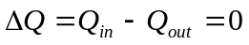
Where
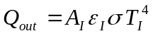

Furthermore, simplify and calculate the dynamic energy conservation equation, and get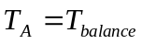. 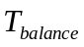 is a constant and a uniform value of ice amount. Sequentially, let be a critical value. When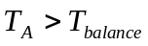, ice begins to melt; on the contrary, when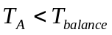, water starts to freeze.
We develop the model of dynamic energy conservation equation, and ice amount relates directly to temperature. In section 1, a liner connection between temperature and time is built. Therefore, a construction about melting ice rate and time is presented:
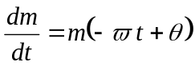
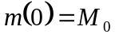
Where
is a constant; and
is a constant;
is ice mass; and
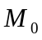 is initial ice mass when.
A integration is necessary to solve for a relation about ice massand time:
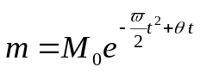
2.3 The Relative between Temperature and Sea Level

When the process of melting ice is continuous, the global sea level is rising. As for the whole global sea level, the rising height can be described via dividing the volume of ice melting into water by ocean area:

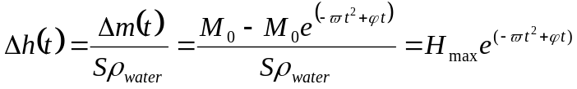
Where
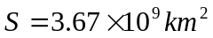is ocean area of global surface;
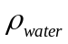 is water density;
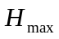 is the maximum height at which sea level reaches after that the rest of northern ice has melted .

In terms of the above model, the ＮＡＳＡdata is applied to fit and illustrate: 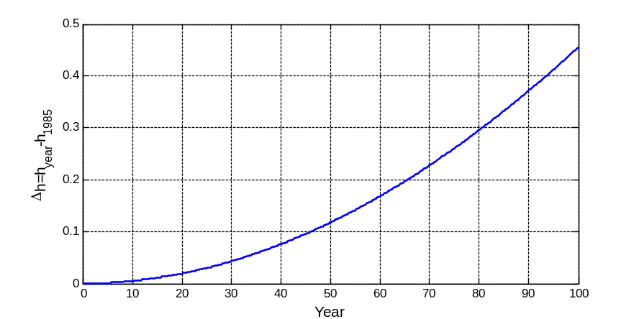
Figure 9: Height of sea level

Figure 9 shows that the height of sea level keeps a rapid and continuous increase.
Fitting equations, and obtain:

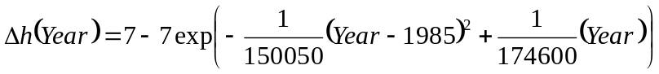

We also calculate the data of every decade to illustrate the height of rising sea level, as is showed below:

Table 2. The height of rising sea level
Year | 2007 | 2017 | 2027 | 2037 | 2047
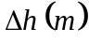 | 0.0489 | 0.0835 | 0.1271 | 0.1795 | 0.2405

3．Impacts
In the above part, the dynamic model about change component of atmosphere (the proportion of carbon dioxide), change temperature and melting glacier is developed. With the help of this model, it is simple to get an actual value of rising sea level and it is 4mm/yr. Although it is 4mm/yr, there seems to be a relatively small amount of change. However, this phenomenon will bring about disasters including many affected aspects, such as geography, ecosystem, climate and Society.

3.1 Changes of Geography
It is clear that the direct impact due to sea-level rise is land losses. In U.S, about 5000 square miles of dry land are within two feet of high tide [9]. Because land within a few feet above the tides could be inundated by rising sea level, unless additional dikes and bulkheads are constructed. According to different geographical terrain, our model simulates the practical amount of loss.
In the beginning, a figure of the simple beach is designed to calculate relation between the height of rising sea level and the area of disappearing actually. See figure 10:
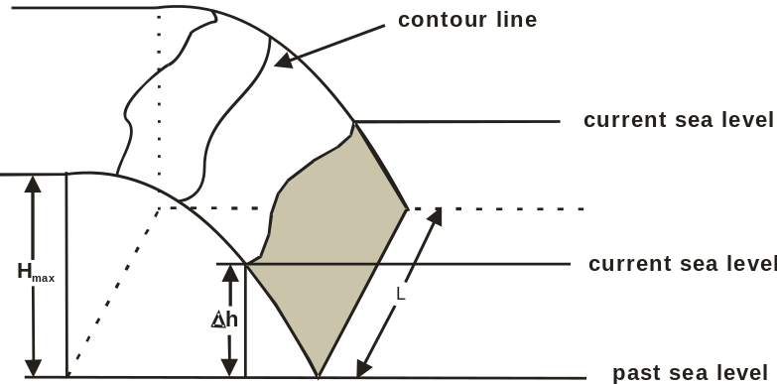
Figure 10: a simple beach about the inundated height and the area of disappearing

Observing from the above figure, let be the length of beach, and 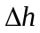 is the height of rising sea level. Furthermore, the value of is increasing up along with the change time. Within the assumed period, the height of beach is not considered to vary, which means the equation of contour line is aware. Hence, it is known that the length of beach. Sequentially, 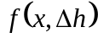 can be worked out to present that sea has covered the area after rising the height. The shaded part describing flooding area from the above figure can be illustrated:
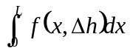
The upper formulation referring to a simple calculation only describes a model that ocean covers areas. And an assumption about the heightof rising sea level is less than or equal to the maximum heightof the beach profile. When the ocean continues rising until the maximum height is exceeded, the circumstances can be divided into two parts. As it is showed in the below figure:
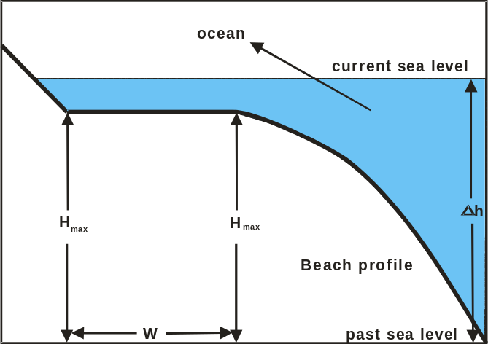
Figure 11: horizontal landform
In the figure 11, when the ocean rises up to, the whole areas in same height go through flood until the emergence of land exceeding. Considering this situation, the covered land area is:
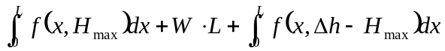

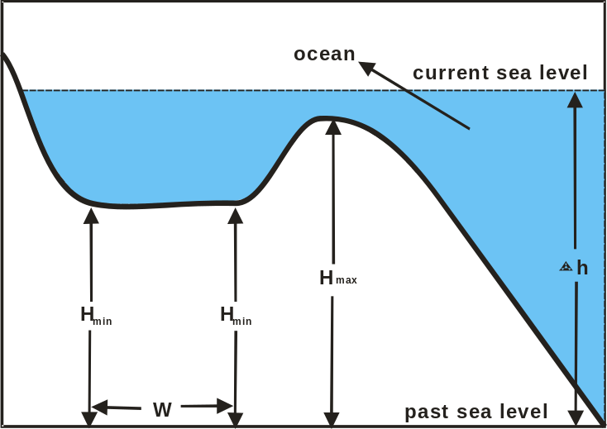
Figure 12: Low-lying lands

In the figure 12, when the ocean rises up to, the low-lying lands with the minimum height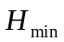 will be filled soon because of the particular location. Then the sea level will go on increasing till.

3.2 The influence of Ecosystem
Coastal wetland ecosystems, such as salt marshes and mangroves are particularly vulnerable to rising sea level because they are generally within a few feet of sea level (IPCC, 2007). In additional, Duboisí's research has shown that observed values of beach erosion were two to three times greater than the erosion predicted for that year [10]. Therefore, it is necessary to obtain an exactly predicted model to reflect rising sea level having an effect on coastal wetland ecosystems.

First of all, the osmosis of ocean should be taken into account with the function of which aquifers form coastline, a natural gradient exists towards the coast and groundwater discharges into the sea. Based on the literature [11], the osmosis leads to erode beach that is vertical to the beach profile section. As figure 13 is described below:

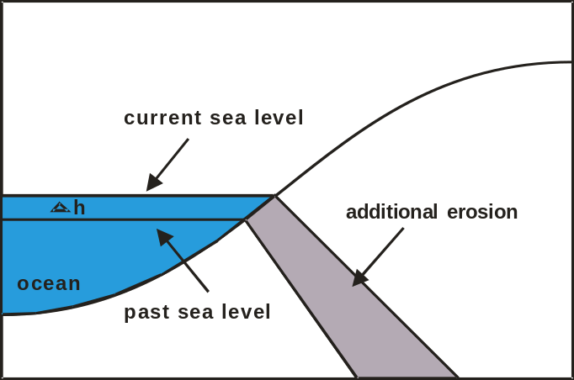
Figure13: the osmosis of ocean

Attaining consequence from the above figure, compared with the surface touching with ocean, the erosion of deep land appears to be more destructive. Therefore, along with the heightof rising sea level, the additional beach erosion can be presented:

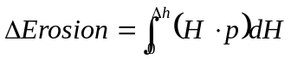
Where:
: is the height of beach;
: is an average slope of the beach profile
3.3 Abnormal Climate
Sea level rise also increases the vulnerability of coastal areas to flooding during storms. A certain reason for this abnormal climate, which a given storm surge from a hurricane or northeaster builds on top of a higher base of water. Coastal Zone would experience an increase percent in annual damages for rise in sea level.

According to the data from NASA, comparisons are made about the alterative rate of hurricane frequency, the alterative rate of area temperature and the alterative rate of sea level in the sate of American, Florida, from 1977 to 2007. Furthermore, the alterative frequencies are fitted and predicted as follows:
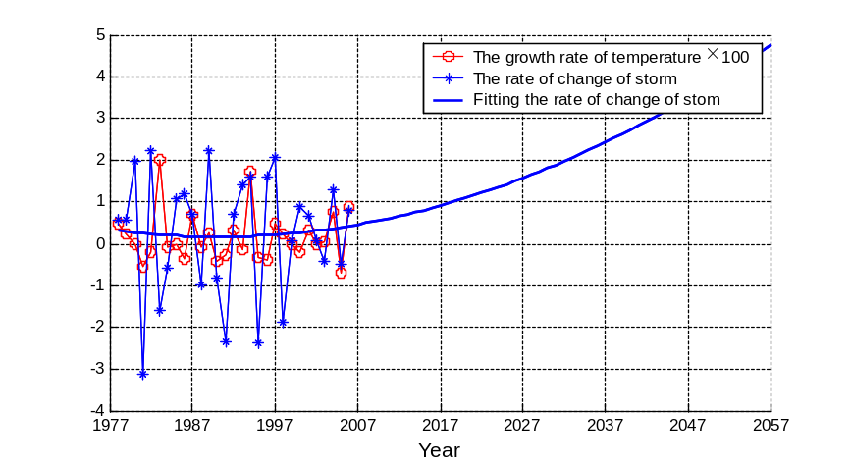
Figure 14: Hurricane prediction

Figure 14 shows that alternative rate of hurricane frequency has a strong positive correlation with the alternative rate of area temperature and the alternative rate of sea level. Moreover, a weak alternative rate of temperature and seal level results in more hurricane frequencies. For instance, when temperature increases by 0.01°C, the frequencies will reach as three times as before. That is to say, the hurricane frequencies will probably become 90 times per year in 50 years. Owing to hurricanes break out most in summer, the residents will suffer this disaster in June, July or August annual year.

3.4 The influence of Society
Rising sea level would allow saltwater to penetrate farther inland and upstream. Higher salinity impairs both surface and groundwater supplies [12]. This effect would impair water supplies, ecosystems, and coastal farmland. In additional, saltwater intrusion would also harm aquatic plants and animals as well as threaten human water supply. This terrible information influences negatively the habits in large metropolitan areas.

Sub-optimal functioning of the sewerage systems of coastal cities with resulting health impacts (WHO 1996, chapter 7). This land/sea interaction results in very complex agricultural systems, where irrigation and rain-fed agriculture may be practiced in alternate seasons, with attention to irrigation water quality (salinity) and to the washing out of salts by rains before planting crops.

Some states prohibit new houses in areas likely to be eroded in the next 30-60 years. Concerned about the need to protect property rights, Maine, Rhode Island, South Carolina and Texas have implemented some version of "rolling easements". It means that people are allowed to build unless they will remove the structure if and when it is threatened by an advancing shoreline (Titus, 1998).

4．Implementation: Florida Case
After discussing the impacts on the land due to the rising sea level, a case of Florida is concentrated on to demonstrate better our model. From the past along the Florida shore, the sea level is rising 1 inch every 11-14 years. Approximately 328 miles of sandy beaches are eroding enough to threaten existing developments and recreation areas. That’ s about 40 percent of Florida beaches. Thence, Florida Case is a good example for testing the influence of greenhouse effects. In this section, we only consider the 50 years to predict the changes of the future in Florida. Because in section 2, we obtain that the amount of CO2 is the key factor to cause warm temperature, as a result, a series of environmental problems approach. Therefore, it is assumed that the CO2 export can be taken control due to the command of government after 50 years. However, the CO2 export still stay in an awful state and enable to worsen the whole environment in 50 years.

4.1 Case Study
Florida has 4,500 square miles of land within 4.5 feet of sea level. Mangrove swamps comprise most of the land within 1-2 feet above sea level, while areas between 2 and 4.5 feet are mostly freshwater wetlands. If sea level rises a few feet, however, then saltwater could invade part of the Everglades, threatening both that ecosystem and the aquifer that lies beneath it. In section 2, a data about the sea level will go up by 24 cm after 50 years. Fortunately, very little development is less than 4.5 feet above sea level，apart from some Mangrove swamps area within 1 feet. A consideration about coastal wetland ecosystems presents a worsening state is taken owing to the osmosis of ocean in 50 years.

In section 3, we had built a model to calculate the coastal erosion when sea level arises. In Florida, they have about 18 square miles mangrove swamps within 1-2 feet above sea level. These areas will almost cover with saltwater. By using our model, there is 14.75 square miles area eroded by ocean.

Besides, Florida has two Tornado Seasons. One is The Summer Season, from June until September has the highest frequencies, the other is the Deadly Spring Season, from February through April is characterized by more powerful tornadoes because of the presence of the jet stream[13 ]. There are high risk factors for Tornado casualties and economic losses. Table *** indicates State tornado casualties U.S. From this table, we recognize that the tornado is quite serious towards Florida. But what is more important is tornado can not be predicted. Hence, we only take the effects on tornado towards Florida within 50 years.

Table 3. State tornado casualties in U.S. 1950-2006
Fatalities |  | Injuries
State | Percentage | State | Percentage
1. Florida | 46.8 | 1. West Virginia | 50.5
2. Kansas | 40.7 | 2. Louisiana | 40.1
3. Georgia | 37.0 | 3. Missouri | 39.3
4. Louisiana | 28.7 | 4. Georgia | 29.9
5. Tennessee | 27.1 | 5. Florida | 29.5

As we have already fitted and predicted the alterative rate of tornado frequencies in the state of American, Florida, in 50 years. Because of unpredicted and destructive hurricanes, the application of expectation is used to present the possible frequencies in future. Based on calculation, there will be an accurate prediction that it will have encountered 32 times till 2053.
5．Propose

Solving for the melting of north polar ice caps due to warm global temperature, we divide this issue into three aspects. First of all, an analysis of global environment changes is made referring to the increasing temperature. Quantitative analysis making on historical temperature, it proves that the global warming exists and alters severely. Besides, given analyzing a physical mechanism about the melting of north polar ice caps, it demonstrates that continuous alterative temperature results to rising sea level and works out a connection of global rising sea level per year. Hence, rising sea level causes respective effects including life and activity of human, consequently, we qualified these factors. Eventually, taking Florida as an example, the suffering effects are analyzed due to actual circumstances.

We confirm that global warming has been a sever issue affecting largely human activities so far after finishing the above contents. Despite the sea level rising by 0.24m has a weak connection with disappearance of coastline in 50 years, and no effects on human life is evident, the increasing sea level will strengthen house effects, as a results, it causes a vicious circle. A figure about rising sea level in 100 years:

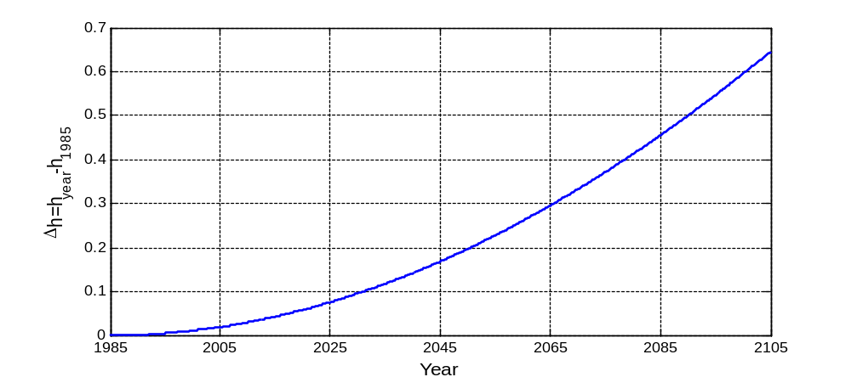
Figure 15: Rising sea level in1985-2105

Above figure shows sea level increases at a rapid speed regardless of the control of temperature. According to our calculation of our model, global temperature will increase to 16.6C, and sea level will rise by 49cm till the year of 2107. In addition, such a rate is considered as 1.59 times as in 50 years and as 4.95 times as today. Figure 16 is showed.
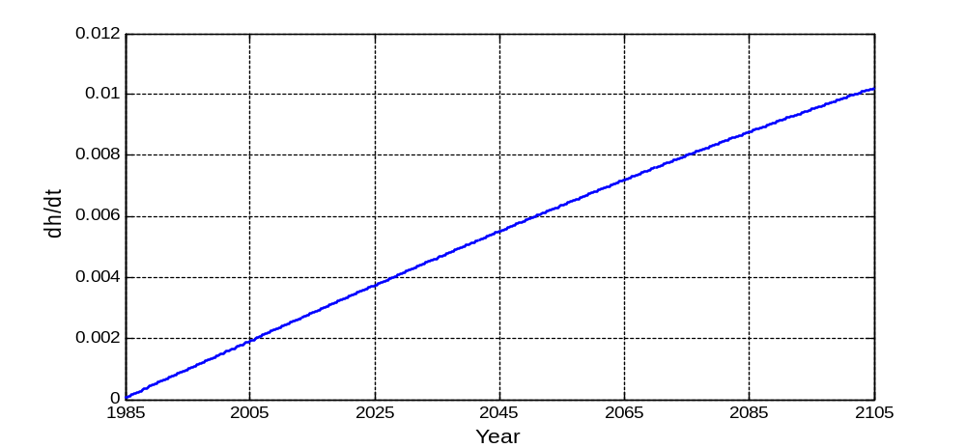
Figure16. Rising sea level rate and time

Rising sea level rate grows high along with time obtained from above figure. Effective measures are taken to block the rising temperature, even something available is done to decline annual average temperature. As follows, particular temperature is adjusted to rising sea level trends.
Referring to above issues, necessary and effective intensionfavors people to cope with house effect. Suggestions to deal with house effect are supplied from positive modification and negative response.

Negative response：Property owners and federal, state, and local governments are already starting to take measures to prepare for the consequences of rising sea level. Several states have adopted policies to ensure that beaches, dunes, or wetlands are able to migrate inland as sea level rises. Most coastal states are working with the U.S. Army Corps of Engineers to place sand onto their beaches to offset shore erosion. Property owners are elevating existing structures in many low-lying areas, encouraged by lower flood insurance rates. However, it is effective just in the short term.

Positive modification： The chief factor affecting rising temperature is the proportion of CO2. The amount of CO2 increasing, the whole ecosystem will be destroyed largely. In fact, every country makes efforts to decrease amount of CO2 as soon as possible. Moreover, improvement can be sensed according to the latest literature. In the opposite, the influence of releasing CO2 is limited by global economy as a economic indicator, CO2. Therefore, the relation between CO2 and global temperature is mainly considered. Based on fitting the density of CO2 data per year, the connection about the density of CO2 and global temperature is also easy to gain.

Therefore, a possible time and method is chosen to control the amount of CO2 recognizing the temperature stays in a stable condition.
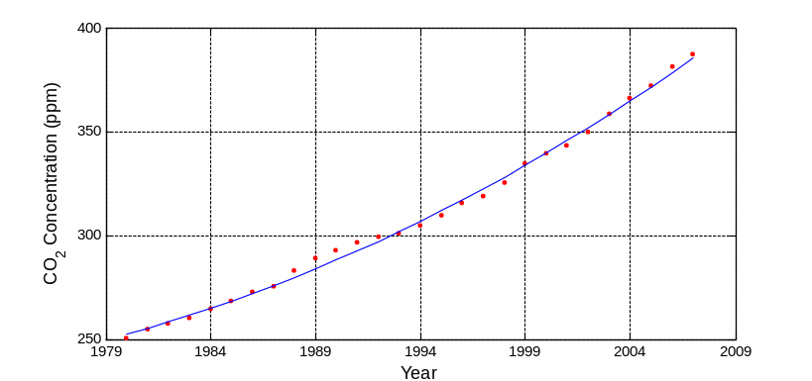
Figure 18: average of CO2 density in per year
Source: Trends in Atmospheric Carbon Dioxide - Mauna Loa[14]

The fitted connection of CO2 density and time:

Where:
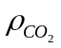 is the density of CO2;
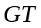: is global temperature.

With the application of actual data, alterative mount of sea level is affected by different control factor and control original time. If time is controlled early or intension is measured largely, it is beneficial to decline rising rate of sea level. Contrarily, sea level possibly enables a decline.

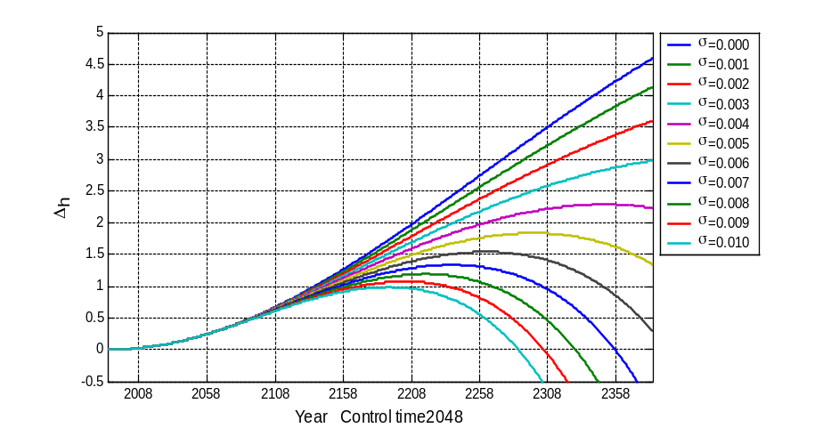
Figure 17. Different control factor in 2048
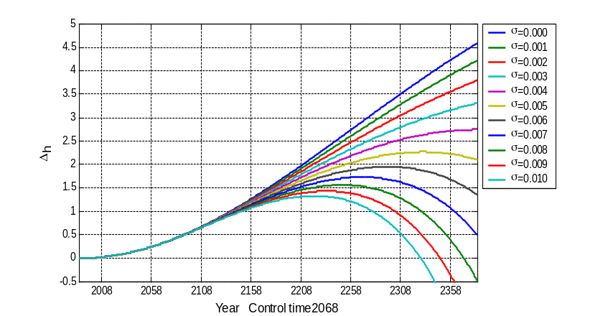
Figure 18. Different control factor in 2068

We can dominate the density of CO2 to protect sea level from rising. If so, the actual issue is how to choose a dynamic model to integrate the balance of CO2 release and the increase of economy. Some suggestions are proposed:

- Ceasing corporation of releasing lots of CO2;
- Modifying economic frame to reach a economic system of energy saving;
- Protecting tropical rain forest, due to the adjustment of forest. The photosynthesis of forest can absorb C02, and release more.
- Strengthening the cooperation of nations. Global warming is caused by develop nations, it is because they have used the large majority of resources, such as coal, oil and so on. For developing countries is lack of economy, CO2 is not only controlled but also wasted a mounts of resources. Hence, the lead of developed country should be realized, as well as some fund and supplied technology.

Reference
[1] CLIMATE CHANGE 101 Retrieved February 17, 2008 from
http://www.pewclimate.org/docUploads/101_Science_Impacts.pdf
[2] Sea level Rise Reports. U.S. environmental protection agency. Retrieved February 17 2008 from
http://yosemite.epa.gov/oar/GlobalWarming.nsf/content/ResourceCenterPublicationsSeaLevelRiseIndex.html
[3] Climate Change Inevitable in 21st Century Sea Level Rise To Outpace Temperature Increase Retrieved February 17, 2008 from http://www.ucar.edu/news/releases/2005/change.shtml
[4] Hurricanes and Global Warming. Retrieved February 17, 2008 from
http://www.pewclimate.org/hurricanes.cfm#severe
[5] Hazards of Sea Level Rise .Retrieved February 17, 2008 from http://cfa-www.harvard.edu/space_geodesy/SEALEVEL/
[6] Potential impacts of sea-level rise on populations and agriculture .Retrieved February 17, 2008 from http://www.fao.org/sd/EIdirect/EIre0047.htm
[7] Coastal Zones and Sea Level Rise Retrieved February 17, 2008 from http://www.epa.gov/climatechange/effects/coastal/index.html
[8] Hazards of Sea Level Rise: An Introduction Retrieved February 17, 2008 from http://cfa-www.harvard.edu/space_geodesy/SEALEVEL/
[9] Coastal Zones and Sea Level Rise. EPA. Retrieved February 17, 2008 from http://www.epa.gov/climatechange/effects/coastal/index.html
[10] Dubois, R. N., Barrier beach erosion and rising sea level, Geology, 18, 1150-1152, 1990.
[11] 3.4 Source Book of Alternative Technologies for Freshwater Augmentation in Latin America and the Caribbean
[12] Regional Impacts of Climate Change (IPCC) mash; North America, 1998, Available: [Online][1999, January 27]
[13] Florida Hazard Watch – Tornadoes. Retrieved February 17, 2008 from http://www.floridadisaster.org/bpr/EMTOOLS/Severe/tornadoes.htma
[14] Trends in Atmospheric Carbon Dioxide - Mauna Loa. Retrieved February 17, 2008 from http://www.esrl.noaa.gov/gmd/ccgg/trends/

Appendix
Annual_Mean_Temperature.m
function [ag,an,as]=Annual_Mean_Temperature
% Annual mean Temperature Anomalies in .01 C
% Glob
Tg=[7 14 28 40 9 34 15 12 19 35 ...
39 26 48 44 15 19 32 46 39 41 ...
71 46 42 57 69 67 60 76 66 73];
% NHem
Tn=[5 13 21 49 4 35 12 4 19 36 ...
46 32 64 52 18 28 48 71 36 59 ...
89 61 62 75 85 86 80 99 92 104];
% SHem
Ts=[-13 -11 9 0 34 21 33 22 21 53 ...
12 -11 -3 -18 31 18 36 41 39 39 ...
-2 -3 13 16 14 34 12 22 52 42];
axes('position',[0.1,0.7,0.8,0.2]);
ag=Temperature_fit_and_figure(Tg,'Glob');
axes('position',[0.1,0.4,0.8,0.2]);
an=Temperature_fit_and_figure(Tn,'NHem');
axes('position',[0.1,0.1,0.8,0.2]);
as=Temperature_fit_and_figure(Ts,'SHem');

Temperature_fit_and_figure.m
function [a]=Temperature_fit_and_figure(T,s)
T=T./100; % Divide by 100 to get changes in degrees Centigrade.
T=T+14; % Tg is the Annual Mean Global Temperature (1958~2007)
t=1:30;
a=polyfit(t,T,1);
tt=1:0.001:80;
TT=polyval(a,tt);
plot(t,T,'.','markersize',5);
hold on
plot(tt,TT,'linewidth',2);
ylim([13.5,16.5]);
set(gca,'xticklabel','1977|1987|1997|2007|2017|2027|2037|2047|2057|2067');
xlabel('Year','fontsize',10);
ylabel({s ...
'Temperature / {\circ}C'});
grid on

Temperature_forecast.m
function Yt=Temperature_forecast(Years);
% Compute the annual mean temperature of some years
if nargin==0;Years=[2017 2027 2037 2047 2057];end
dt=Years-1977;
[ag,an,as]=Annual_Mean_Temperature;
tg_years=polyval(ag,dt);
tn_years=polyval(an,dt);
ts_years=polyval(as,dt);

syms Year_ Glob NHem SHem
YGNS=[Year_;Glob;NHem;SHem ];
tg_n_s=[tg_years;tn_years;ts_years];
Yt=[YGNS [Years;vpa(tg_n_s,4)]

Block_Factor.m
function Block_Factor
for k=1:4
figure
ye=k*20+23;% control time
x=ye:0.1:400;
x1=[0:0.1:ye];
yy=7-7*exp(-x1.^2./150050+x1./174600);
y=[];
for af=0:0.001:0.01
y1=7-7*exp(-(x).^2./150050+(x)./174600+af*2/(150050*3).*(x-ye).^3); % af is the block factor
y=[y;[yy(2:end),y1]];
plot([x1(2:end),x],y,'linewidth',2)
ylim([-0.5,5])
set(gca,'xtick',[23:50:400])
set(gca,'xticklabel',[23:50:400]+1985)
xlabel(['Year Control time',num2str(1985+ye)],'fontsize',12);
ylabel('\Deltah','fontsize',12)
legend('\sigma=0.000','\sigma=0.001','\sigma=0.002',...
'\sigma=0.003','\sigma=0.004','\sigma=0.005',...
'\sigma=0.006','\sigma=0.007','\sigma=0.008',...
'\sigma=0.009','\sigma=0.010',-1)
grid on
end
end

Storm_of_Florida.m
function Storm_of_Florida
Tn=[5 13 21 49 4 35 12 4 19 36 ...
46 32 64 52 18 28 48 71 36 59 ...
89 61 62 75 85 86 80 99 92 104];
Tn=Tn./100+14; %temperature of florida
b =[6 9 11 11 5 4 12 11 11 7 ...
12 11 14 8 6 8 7 19 13 8 ...
12 15 15 12 16 16 17 30 9 17]; %the storm of florida

cr=(diff(b,1,2)./b(1:end-1));
tr=100*(diff(Tn,1,2)./Tn(1:end-1))
i=1:29;
p=polyfit(i,tr,2)
xi=1:0.1:79;
yi=polyval(p,xi);

plot(i,tr,'*-',i,cr,'o-r')
hold on
plot(xi,yi,'linewidth',2)
grid on
legend('\sigma=0.000','\sigma=0.001','\sigma=0.002','\sigma=0.003',...
'\sigma=0.004','\sigma=0.005','\sigma=0.006','\sigma=0.007',...
'\sigma=0.008','\sigma=0.009','\sigma=0.010',-1)
set(gca,'xticklabel',[1977:10:2057])
xlabel('Year','fontsize',12);
legend('The growth rate of temperature \times 100',...
'The rate of change of storm',...
'Fitting the rate of change of stom')

