Resume

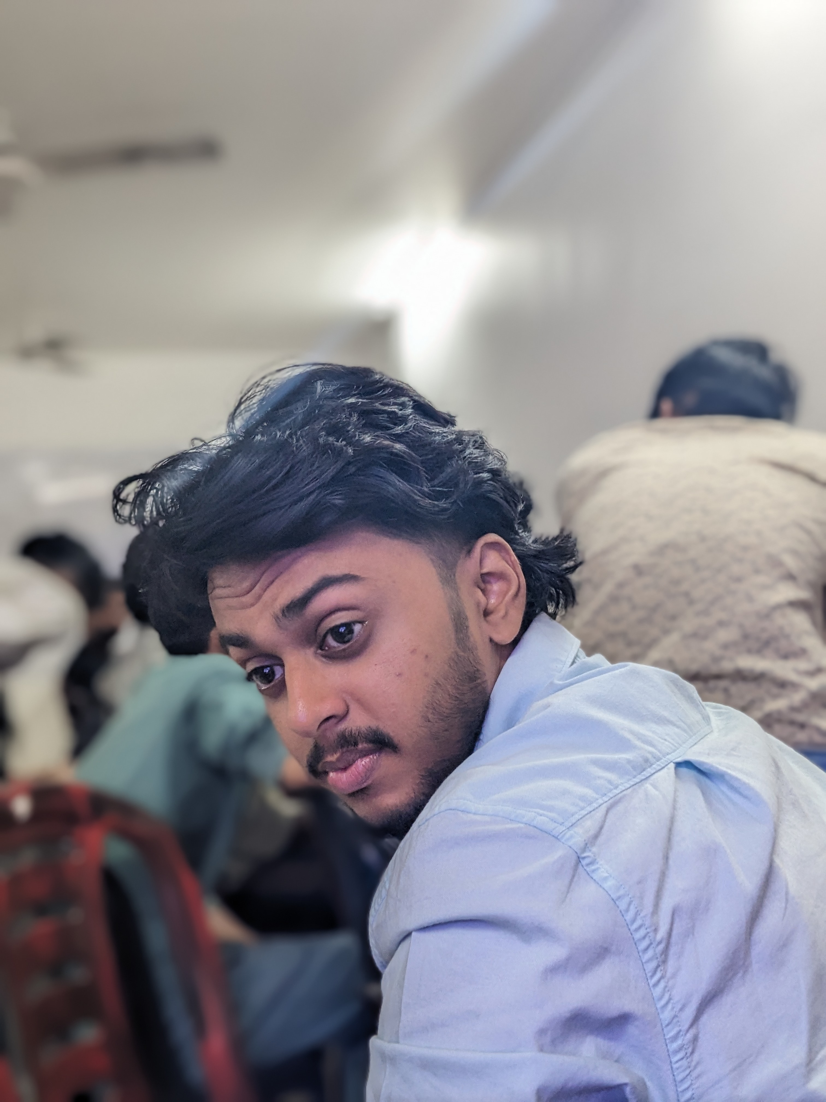

|  |  |  |
| --- | --- | --- |
| shabeeb |  |  |
| 9070078234sha123@gmail.com |  |

Address :

calicut

673613

kozhikode

Contact : 9070078234

Qualification : degree

Experience : 2

Skill set :

I hereby declare that all the information given above is true and correct to the best of my knowledge.

Name : shabeeb

Date : 2025-03-05