- Install pfsense
- Download the pfsense iso from the https://www.pfsense.org/download/
- Load the instance on the virtualbox
- Create 1 bridge pfsense adapter, and 4 internal adapters, each one for each subnet
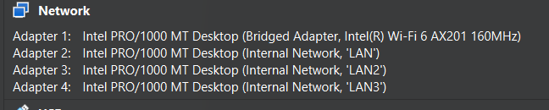
- Enter pfsense, click on OK, and then install
- Then lets set the WAN interface and LAN interface, I will chose em0 as the WAN int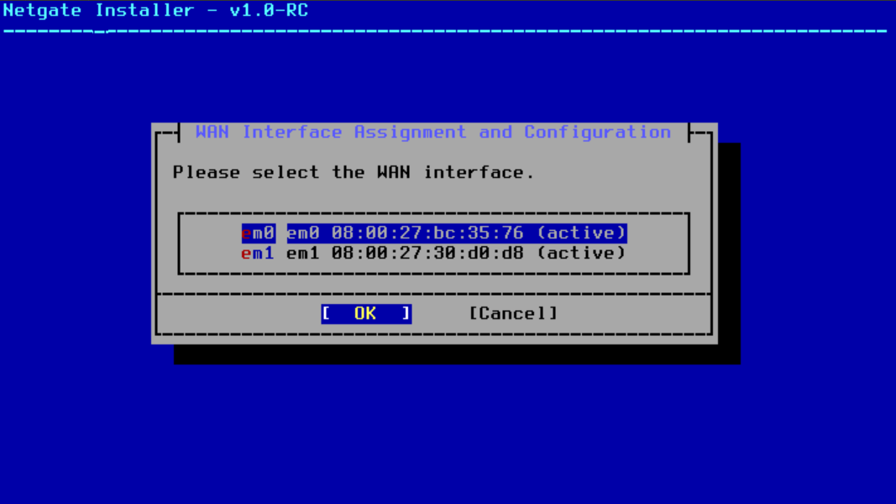
- Press continue, we will config the IP later 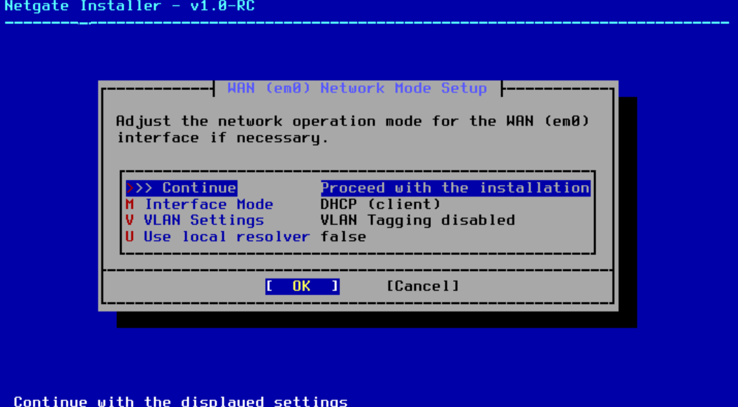
- Lets chose em2 as the LAN int And lets continue without givinng it an IP for now too
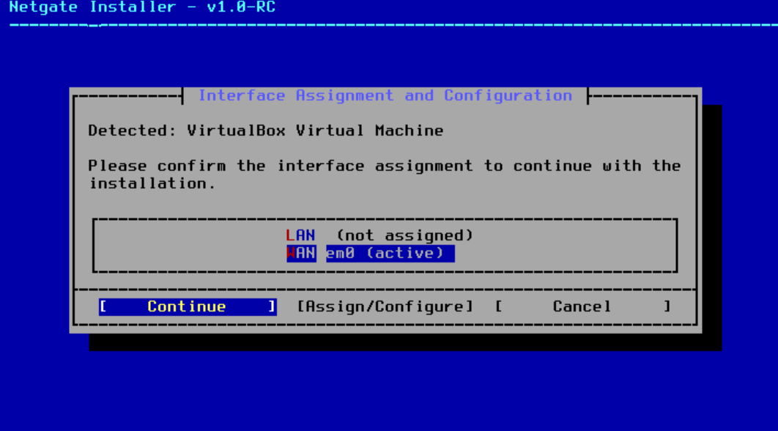
- Click install for the community option, and click retry validation if you have a liscence key 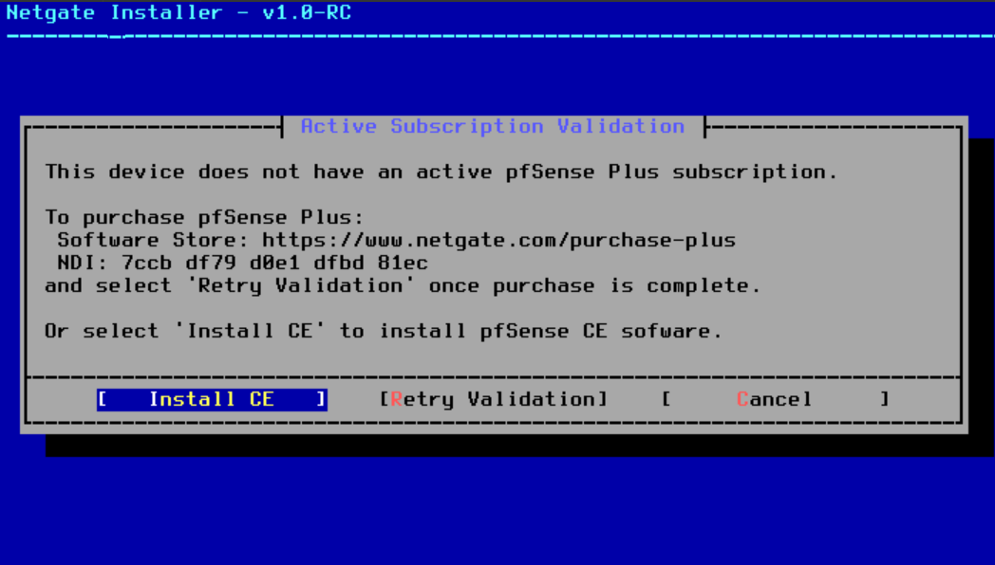
- Press continue for the file sys 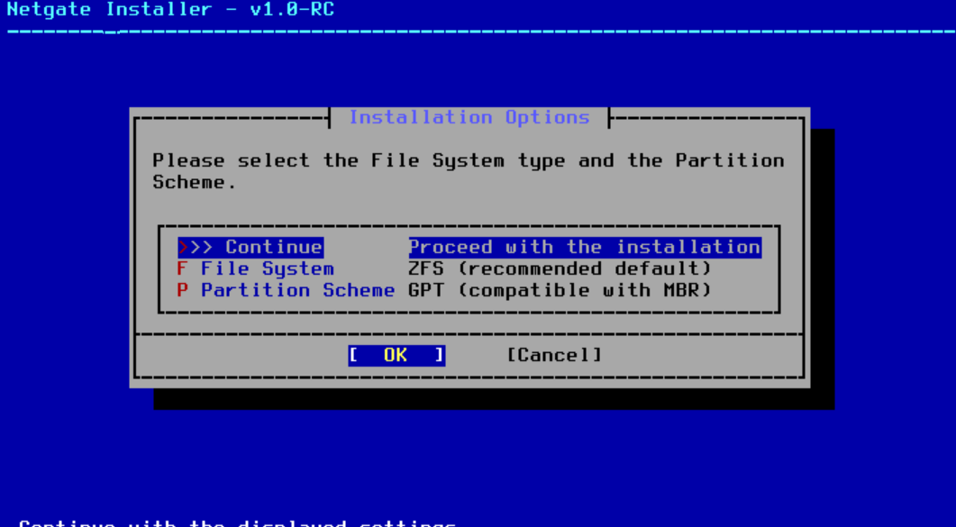
- Click continnue for the next option
- Click space for check the disk option, then click continue 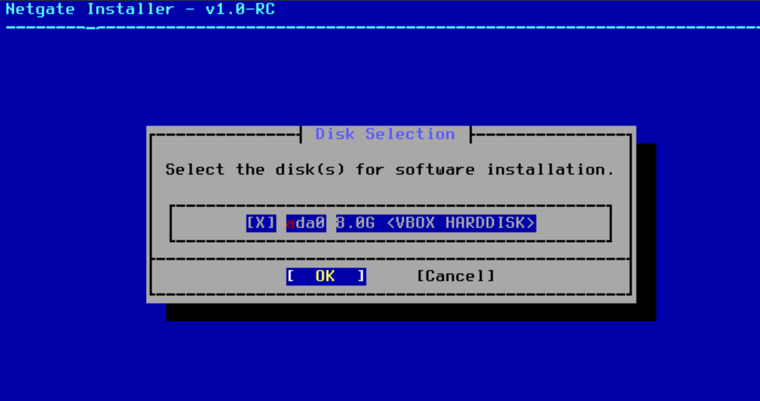
- Click continue for the next option
- You may get a prompt when they ask for which version to install, always chose the stable and last one, then click continue and wait until it install 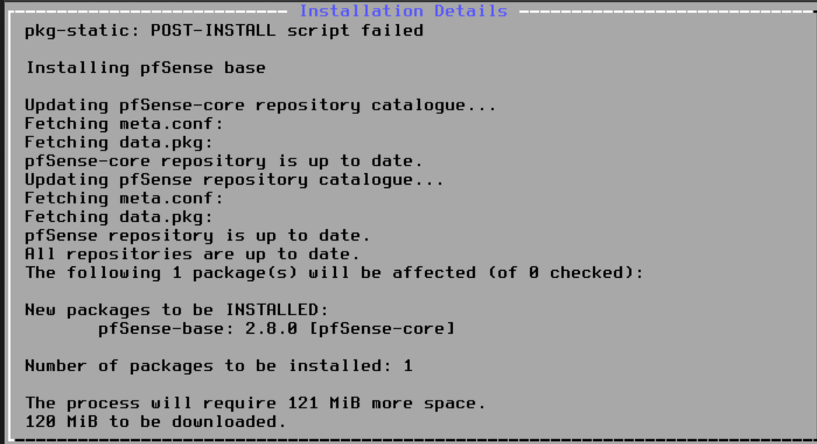
- After that, click reboot, and close the VM instanse “poweroff from the gui”
- And go to its storage settings, and remove the iso, it need to loo, emty, like this
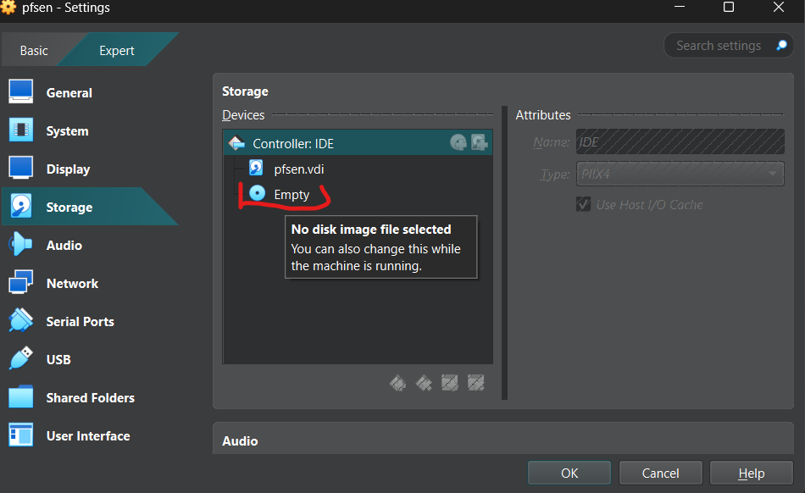
- Then boot up the pfsense instance again
- We will find that the WAN interface, got an IP from the DHCP, and the LAN interface got a static one by default, but lets change it, by typing option 2 to enter IP interface settings
- We chosed interface number 2, then set an IP then the subnet, also set that ip to be the default getway for the LAN, press enter, and skip IPV6 setting, we don’t need them in this lab, enter “y” for enabling dhcp on the LAN interface, so the windows/centos/metaspoitable machines linked to that interface will get an IP from the pfsense DHCP, and set the DHCP ip range that shoud be distrubuted “make sure to not start from the 20.20.20.1 which is the pfsense IP”, and set http as the protocol for entring the pfsense settings via the web by pressing enter.
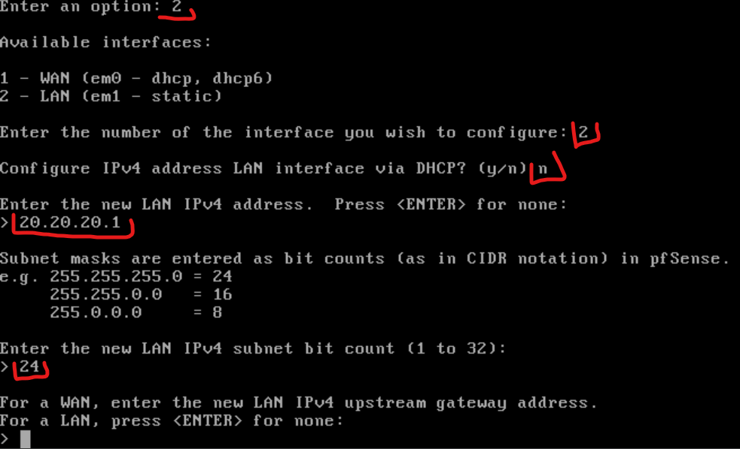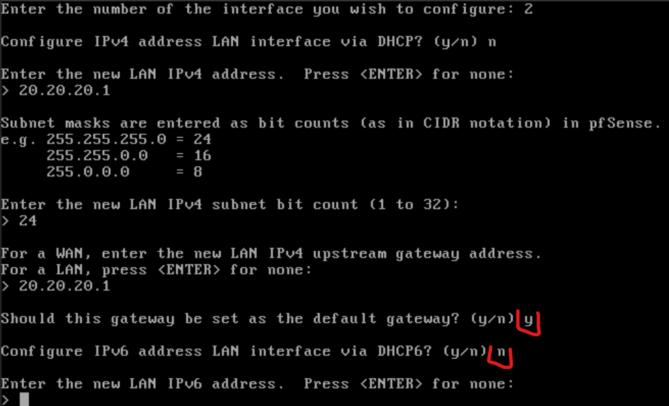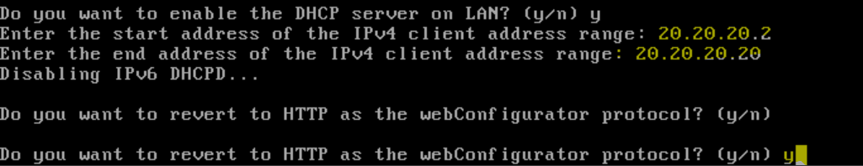
- Now lets intiate the window instance, and see if it will get an IP automatically from the dhcp of pfsense in the LAN subnet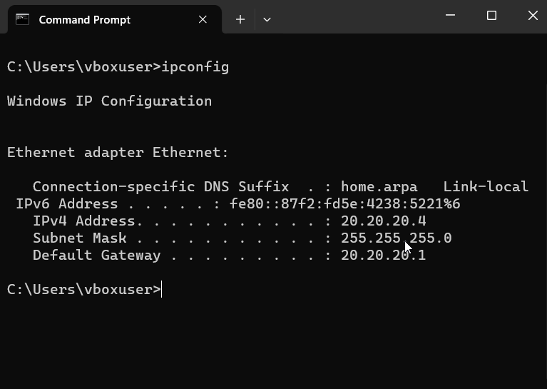
- As we can see we got an IP from the DHCP of pfsense LAN interface
- Now lets enter the pfsense web 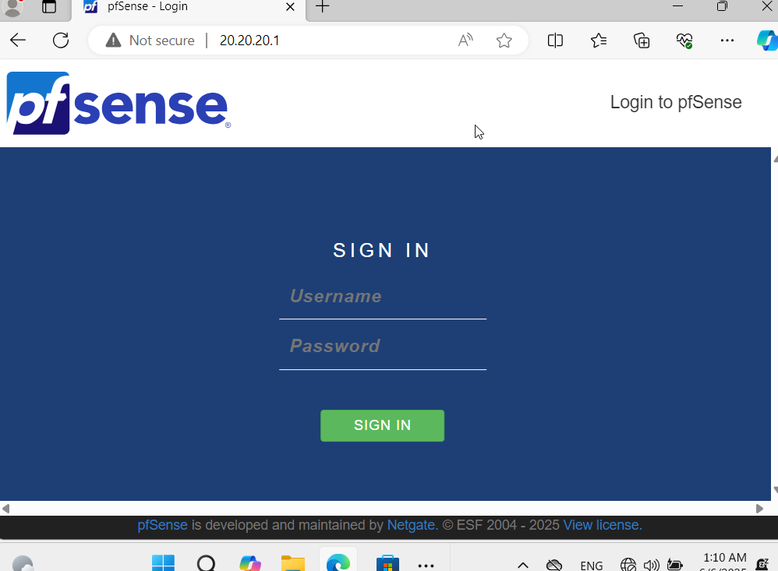
- We can see that we could get into it
- default credential, admin:pfsense 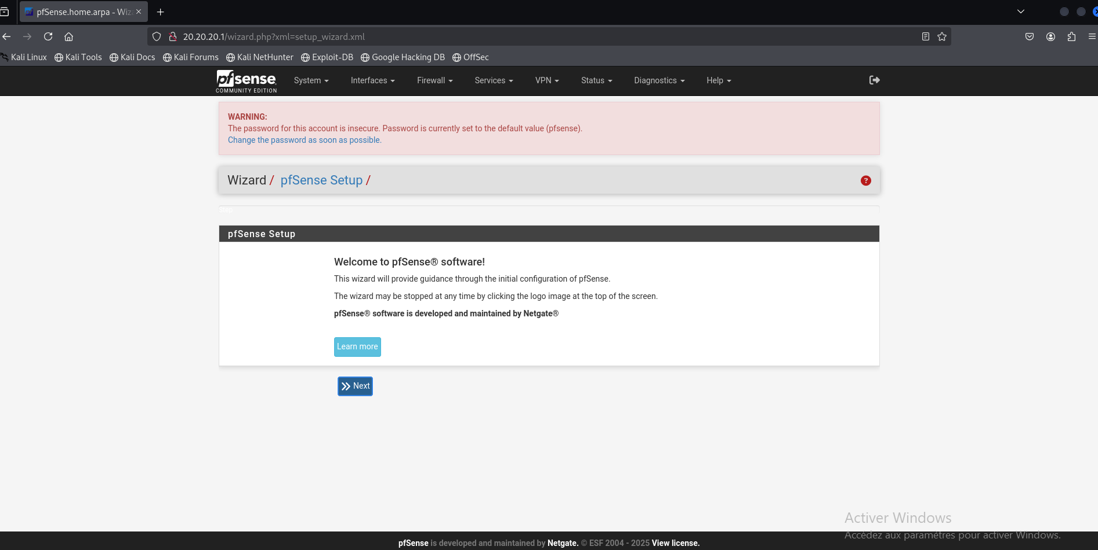
- Go take your time jumping in the pfsense features, and be familiar with the site then come back
- Now go to the navbar, and click interfaces, and eneter to assignment, so we can add interfaces on our pfsense “more interfaces, more subnets”, just make sure you already had more internale virtual iterfaces, on that instance from the virtualbox settings
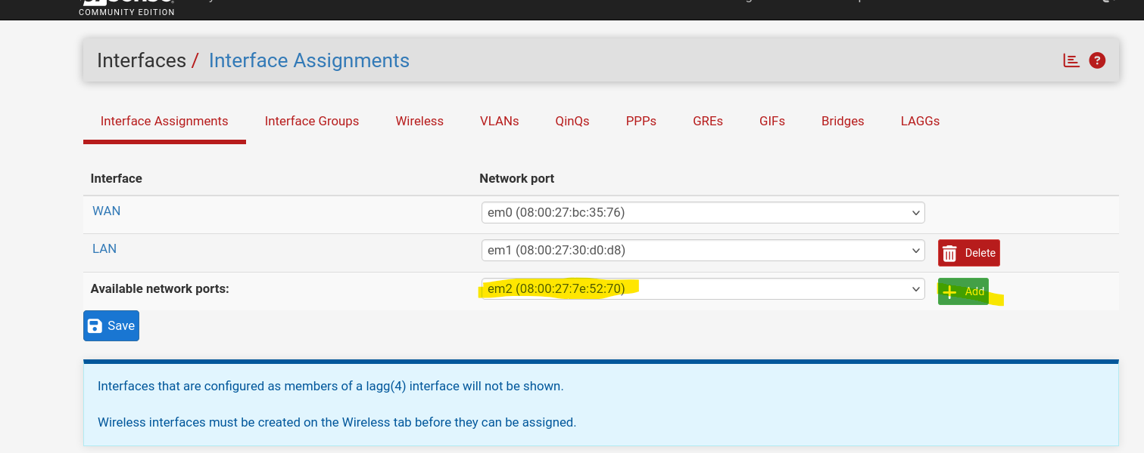
- Chose the interfaces “em2, em3” and click add so we can add an interface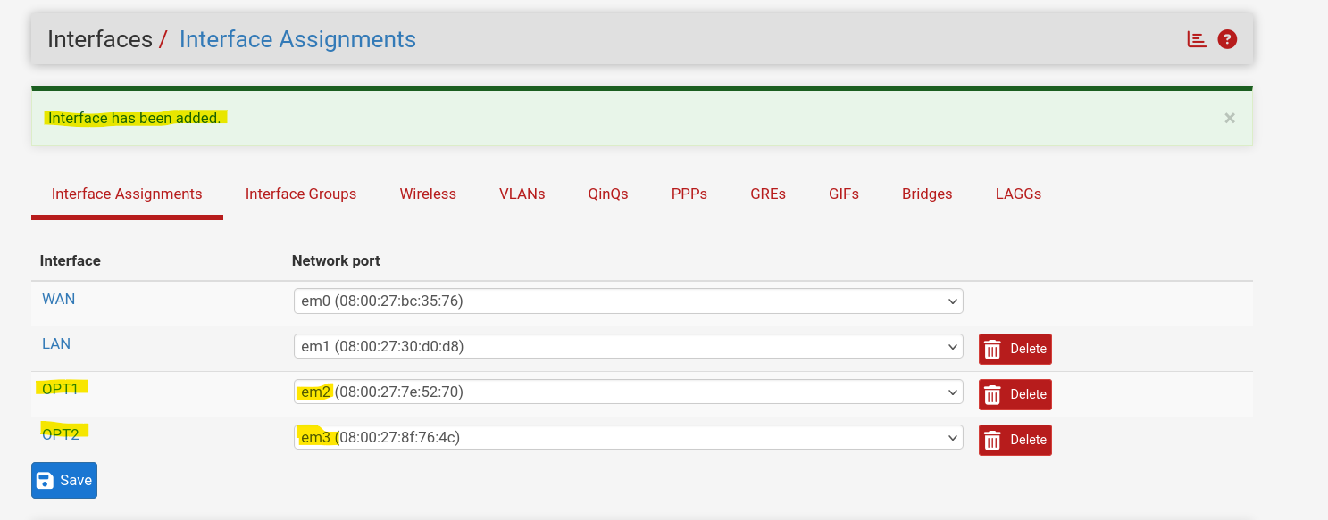
- Now that we added new interfaces let set on them these following settings: IP, DHCP, ACCEPT any any on the firewall rules
- For IPs and getway, and dhcp we will set them on the pfsense terminal as we have done to the LAN interfaces before
- Ecample for LAN3:
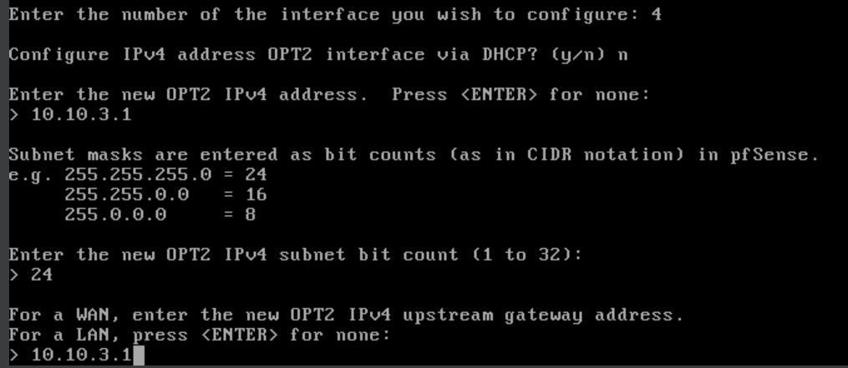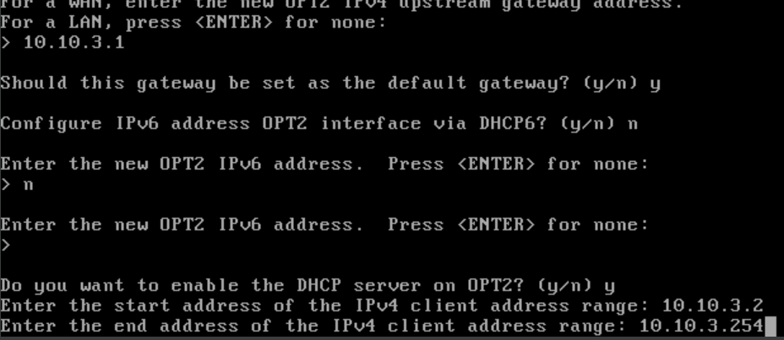
- TOPOLOGY :
- LAN: kali or attacker public subnet 20.20.20.0/24, getway 20.20.20.1/24
- LAN2: SOC subnet with IP subnet 10.10.2.0/24 getway 10.10.2.1/24
- LAN3: employers with IP subnet, will be an old kali machine version, for respecting the hardware conditions 10.10.3.0/24 getway 10.10.3.1/24
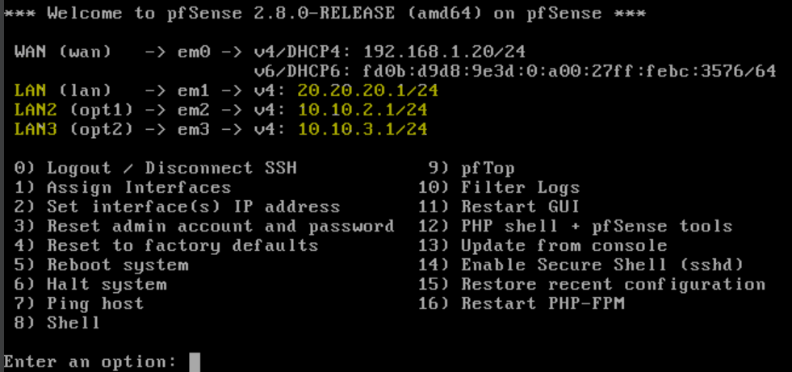
- Now lets accept all the any traffics on these interfaces, dst: any, src:any. Go to firewalls in the navbar and click rules:
- Selecte the IPV4 rule and copy it and past it on the other LANs’ intefaces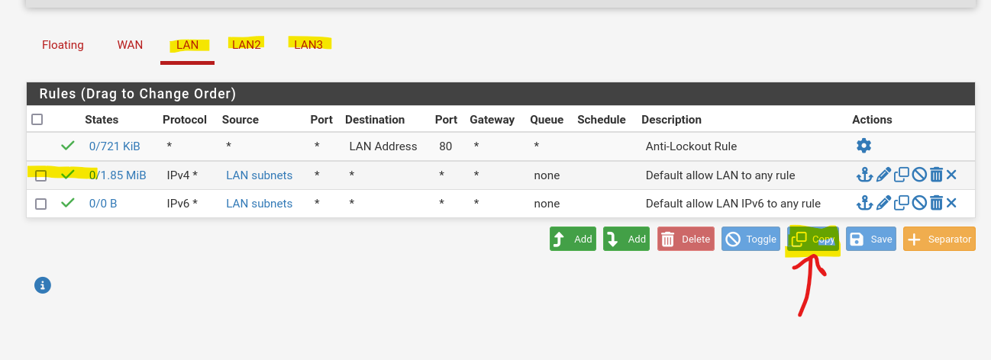
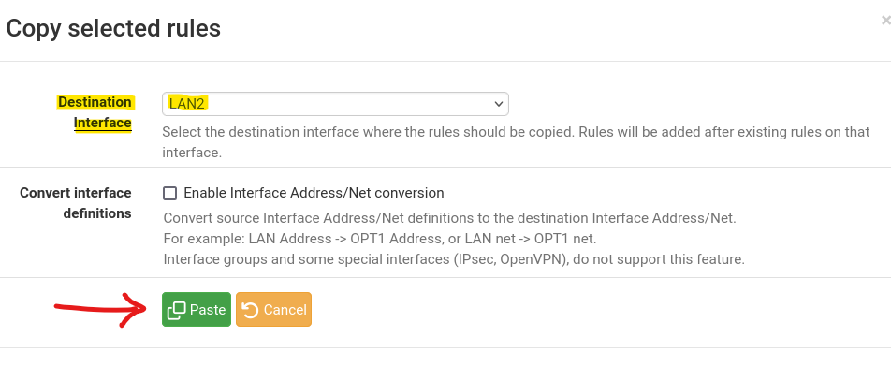
- Go the to interface where we PASTED the rules, LAN2 as example. click on the pen icon for editing the rule, and we want to edit the “source” interface, of the LAN2 one, because we copied it from LAN interface so it still has the source interface as the LAN one, and do the same for the other interfaces
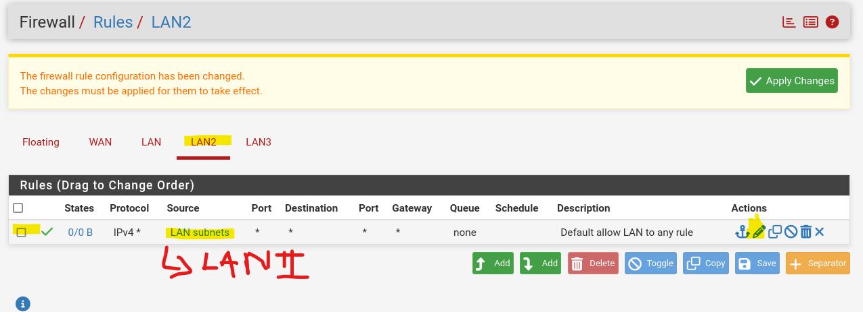

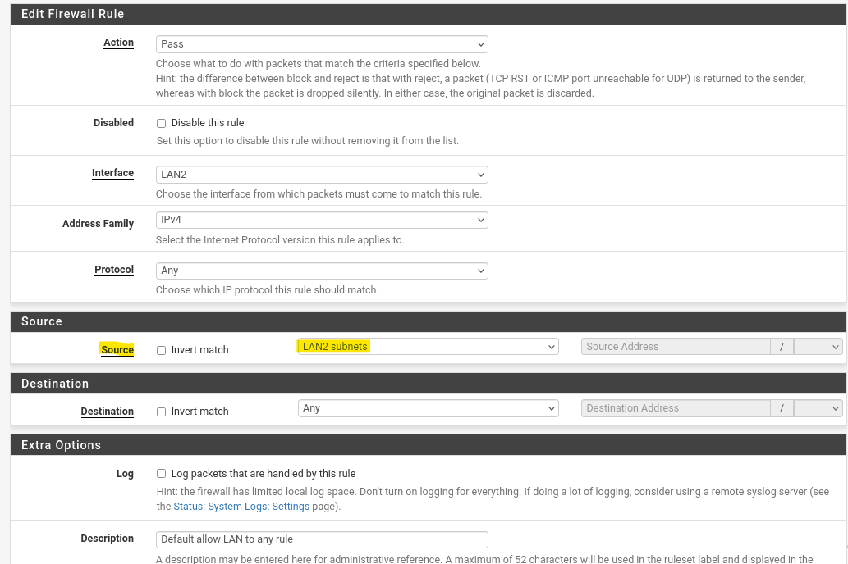
- The click save at the bottom and apply changes
- Now lets open our centos9 instance, that has a virtual LAN2 interface on the virtualbox level “which mean it is on the LAN2 internal network”, and see if we ill get an IP from the pfsense LAN2 POOL with 20.20.200.0/24 subnet
- Now let add suricata, IDS/IPS package in the pfsense, in system > package manager > avaible packages, search suricata, then click install, and confirm
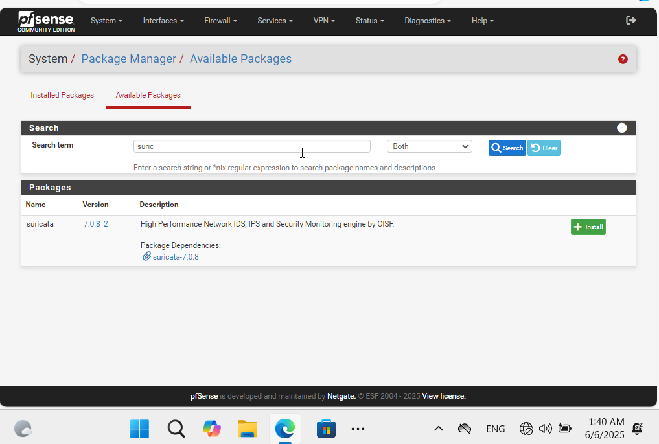
- After that under services > cirucata > interfaces, we need to add interfaces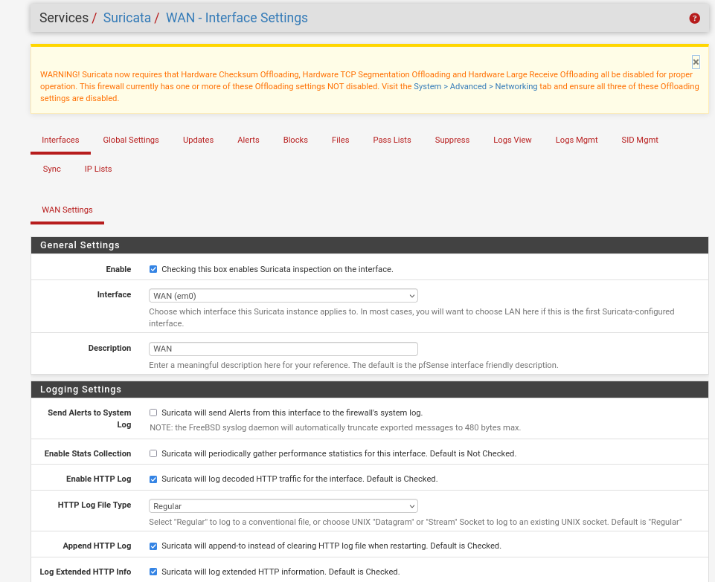
- But firstly lets disable the offloading settings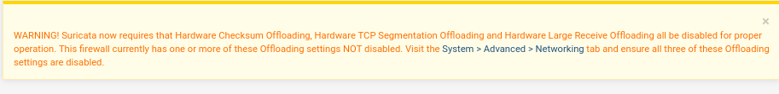
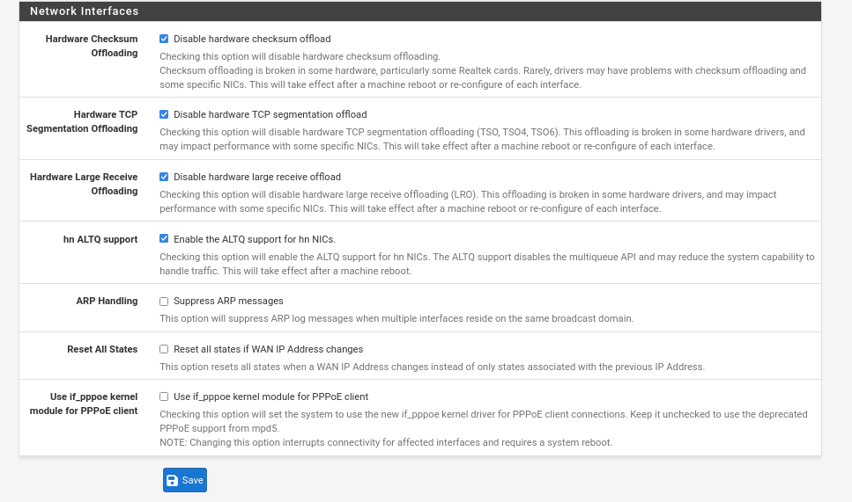
- Then we hit save and let it reboot
- Now add an interface, with the rules you want
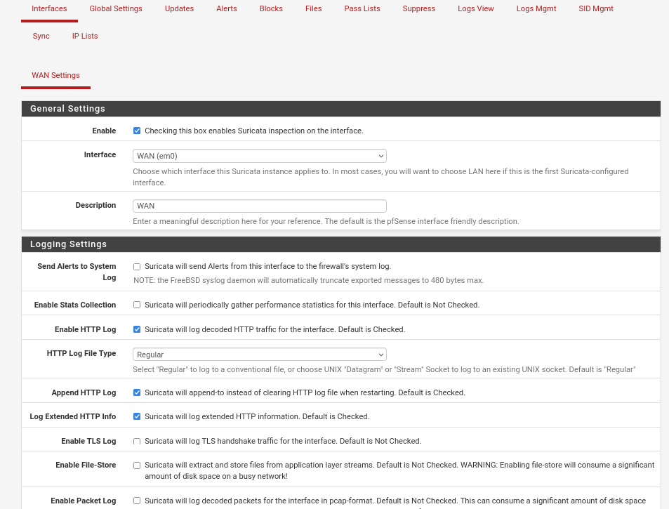
- I enabled the blocking settings
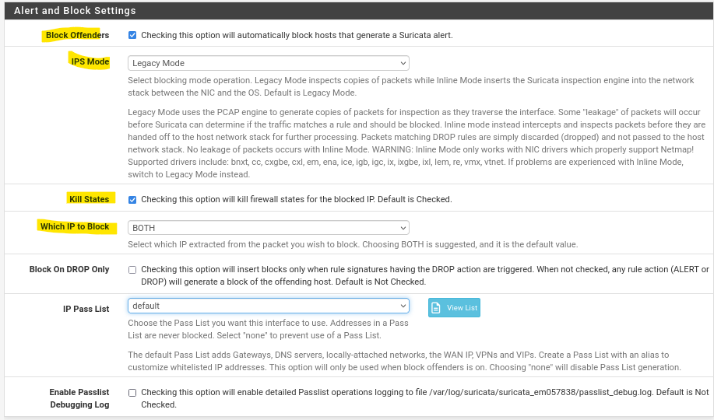
- Save the changes
- Lets add the LANs interfaces, but this time we want just to monitor no blocking settings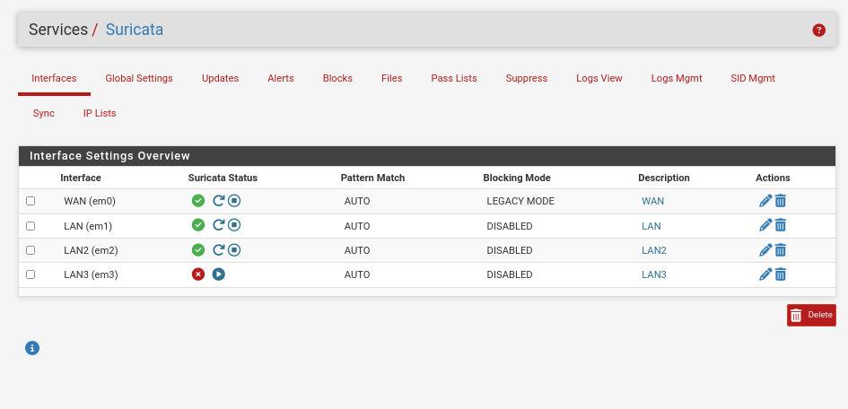
- NOTE: don’t forgot to suricata on those interfaces after we just set that on them
- On the globale setting we add the rules we want to the suricata service
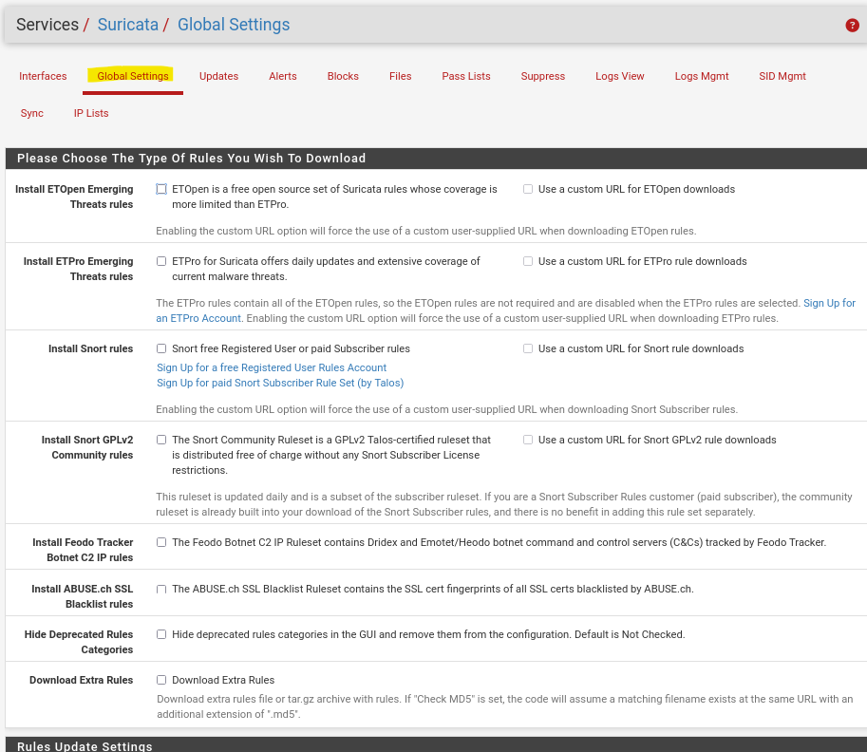
- Lets enable the update settings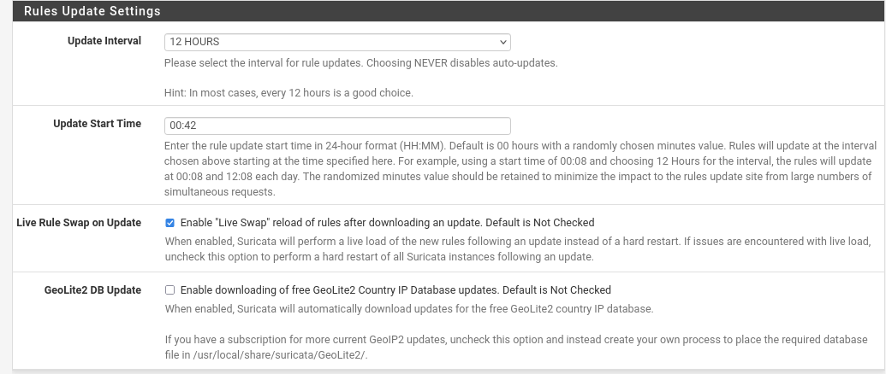
- Then we click save
- We go to the update settings, and we click update to update the suricata rules/setting we just set
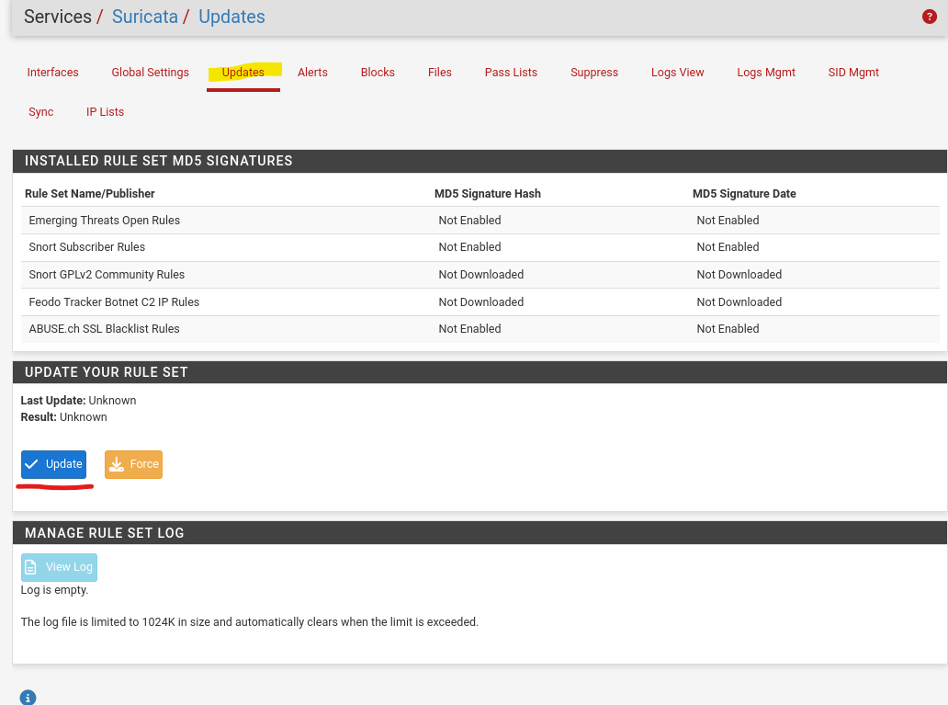
- Lets verify if we got an IP for the employer machine “kali old version”
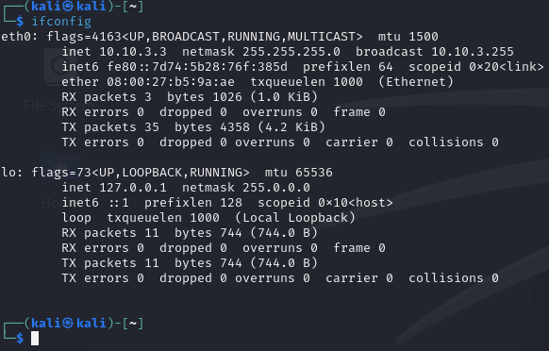
- We did get an IP for the employer machine, from the pfsense LAN3 interface

- Install wazuh
- Link: https://documentation.wazuh.com/current/deployment-options/virtual-machine/virtual-machine.html
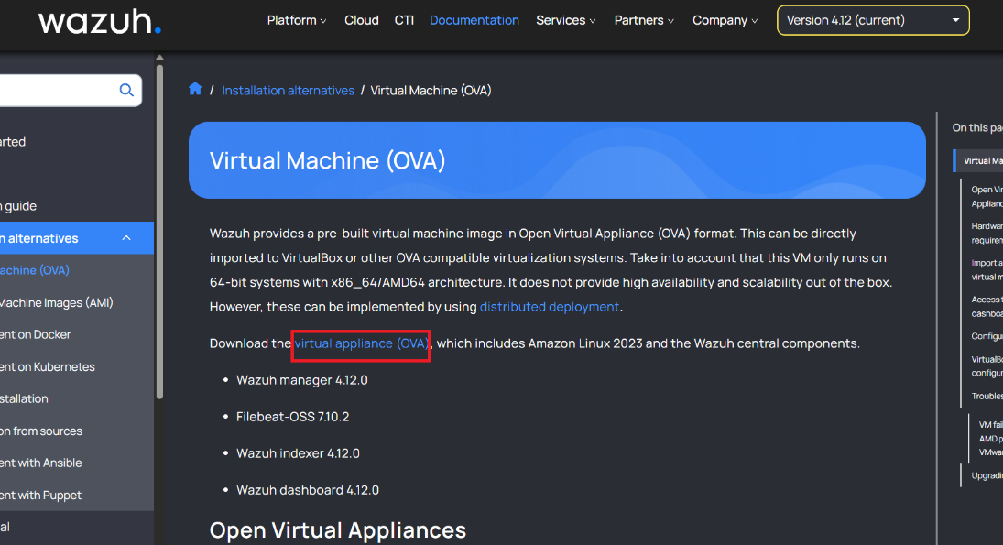
- Open the wazuh ovm on the virtualbox
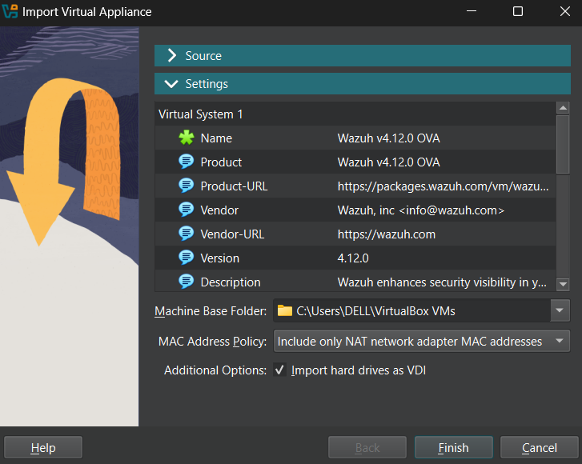
- Click finish, and lets set an internal adapter to it “LAN2”
- Start the wazuh instance
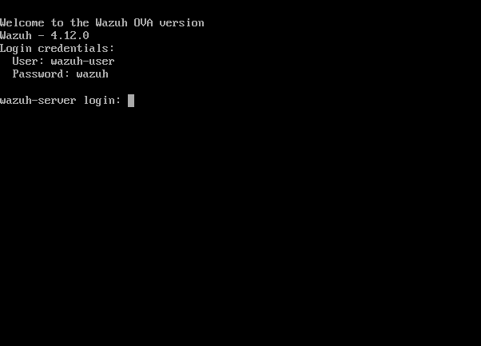
- Lets login
- Enter to the bash: sudo bash
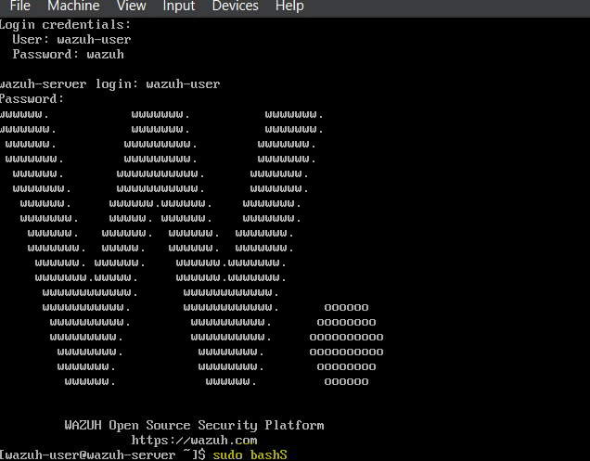
- Type ifconfig, and we will find that it got an IP address from the DHCP 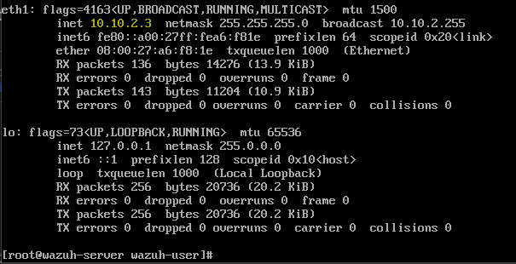
- Now lets enter the wazuh web interface “from the employer machin”


- The default credentials are admin:admin
- We have no agent yet
- Now lets download the wazuh agent on the employer machine “kali”
- Note: next steps should be done by a root user or privileged user
- Install the GPG key:
- curl -s https://packages.wazuh.com/key/GPG-KEY-WAZUH | gpg --no-default-keyring --keyring gnupg-ring:/usr/share/keyrings/wazuh.gpg --import && chmod 644 /usr/share/keyrings/wazuh.gpg
- Add the repository :
- echo "deb [signed-by=/usr/share/keyrings/wazuh.gpg] https://packages.wazuh.com/4.x/apt/ stable main" | tee -a /etc/apt/sources.list.d/wazuh.list
- Update the package information :
- apt update
- Deploy the wazuh agent:
- WAZUH_MANAGER="IP_of_of_the_wazuh_manager" apt-get install wazuh-agent
- Or enter after installing the wazuh-agent, set the wazuh manager’s IP address in this file /var/ossec/etc/ossec.conf
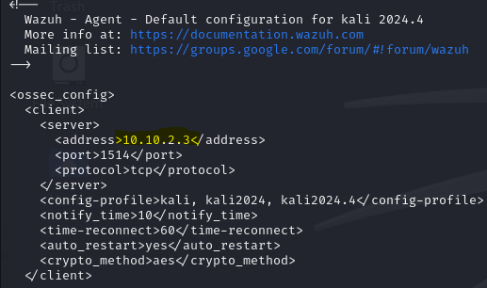
- Enable and start the wazuh agent:
- systemctl daemon-reload
- systemctl enable wazuh-agent
- systemctl start wazuh-agent
- now lets check the wazuh agents on the wazuh manager web interface
- under agent management > summury
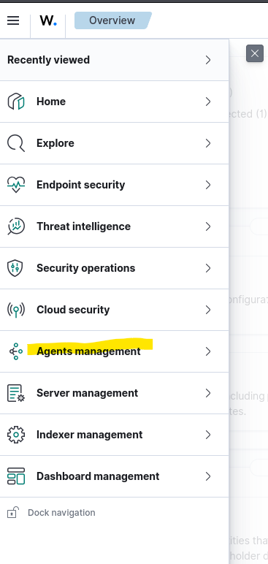
- and we will se that our wazuh client/agent is there and active
