Security lab : in virtual box

Requirement:

* Some pre-knowledge on virtualbox
* Networking fundamentals
* pfsense installed in Virtualbox, with internal interfaces, LAN, LAN2, LAN3 and one bridge
* Kali installed Virtualbox, with internal interface LAN
* centos installed Virtualbox, with internal interface LAN2

Topology:

* LAN1 “in internal interface” is the LAN where we have the kali machine, and linked with a pfsense interface, the IP range in 20.20.20.0/24, the pfsense will be the dhcp/firewall/getway..
* LAN2 “in internal interface” is where we have the centos machine , and linked with a pfsense interface LAN2, the IP range in 20.20.230.0/24, the pfsense will be the dhcp/firewall/getway..

1. Enter pfsense, click on OK, and then install
2. Then lets set the WAN interface and LAN interface, I will chose em0 as the WAN int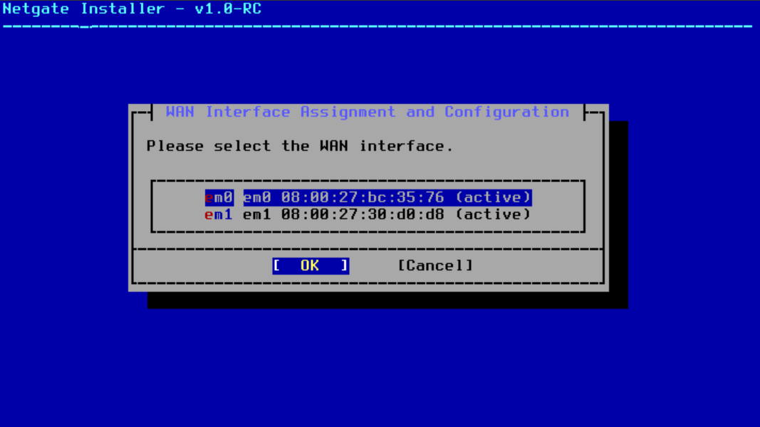
3. Press continue, we will config the IP later 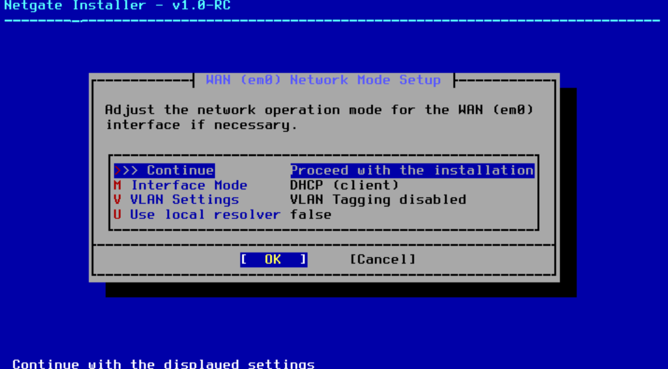
4. Lets chose em2 as the LAN int And lets continue without givinng it an IP for now too

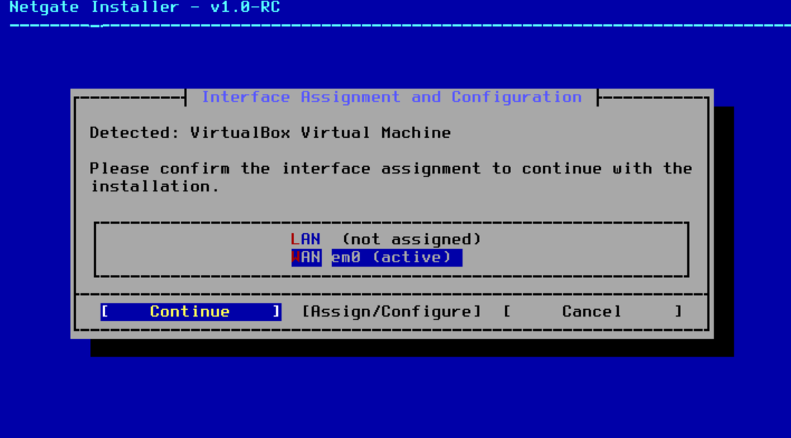

1. Click install for the community option, and click retry validation if you have a liscence key 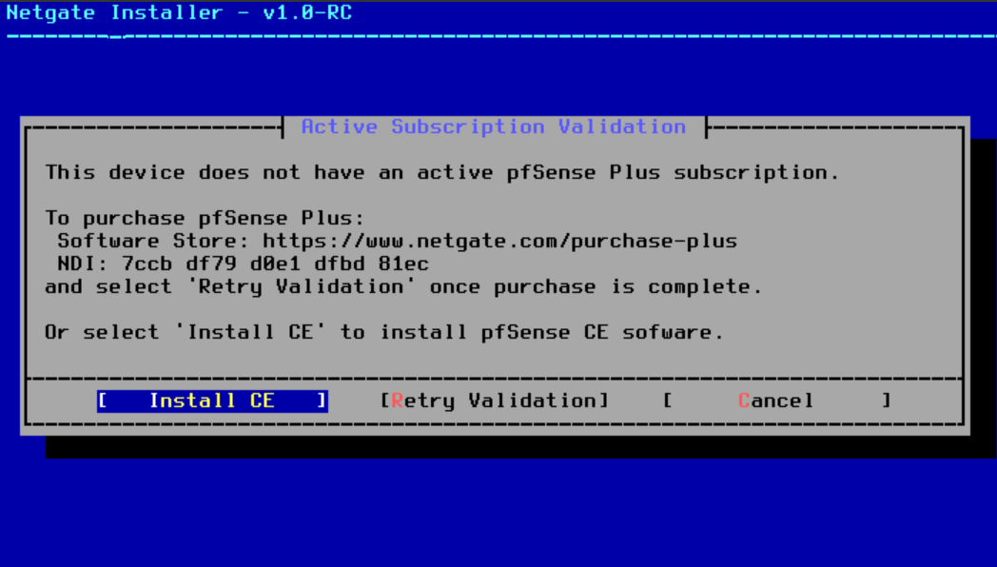
2. Press continue for the file sys 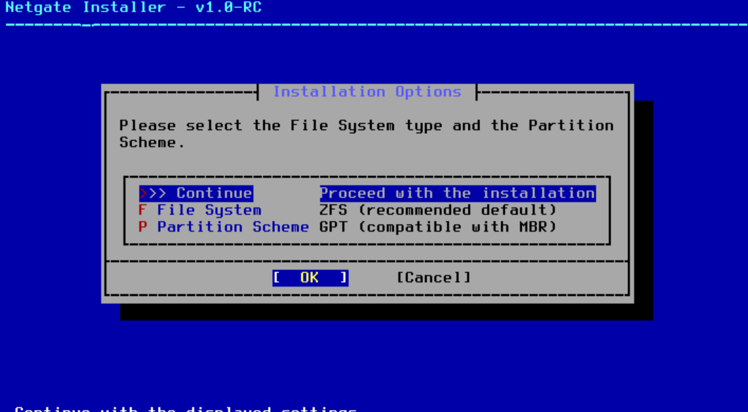
3. Click continnue for the next option
4. Click space for check the disk option, then click continue 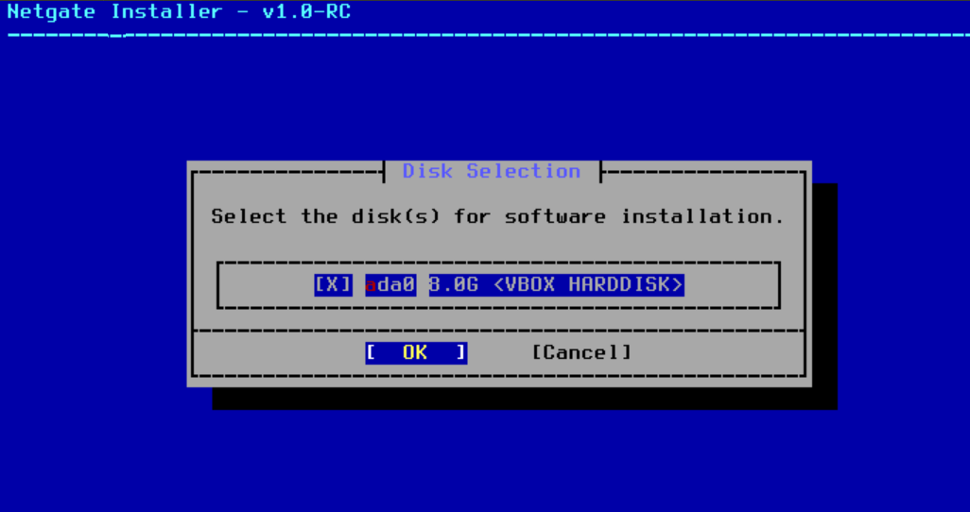
5. Click continue for the next option
6. You may get a prompt when they ask for which version to install, always chose the stable and last one, then click continue and wait until it install 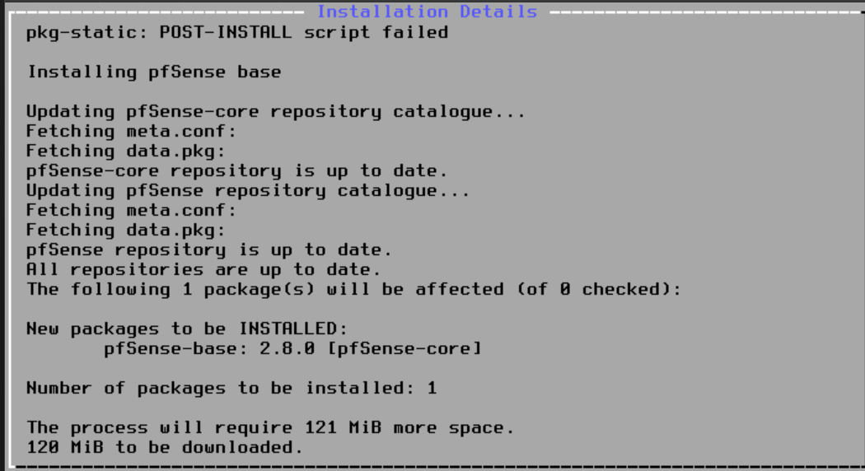
7. After that, click reboot, and close the VM instanse “poweroff from the gui”
8. And go to its storage settings, and remove the iso, it need to loo, emty, like this

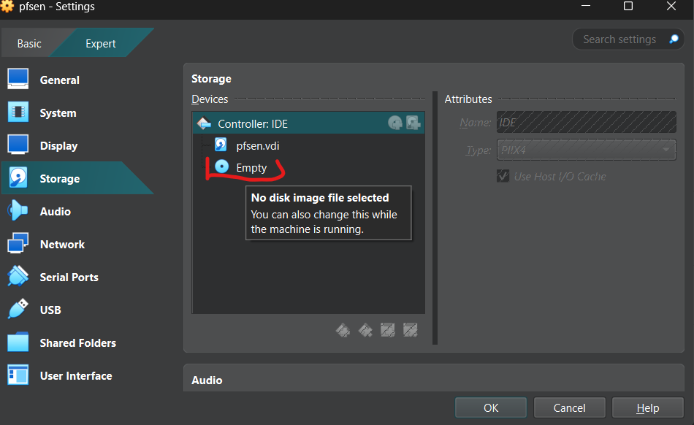

1. Then boot up the pfsens instance again
2. We will find that the WAN interface, got an IP from the DHCP, and the LAN interface got a static one by default, but lets change it, by typing option 2 to enter IP interface settings

* We chosed interface number 2, then set an IP then the subnet, also set that ip to be the default getway for the LAN, press enter, and skip IPV6 setting, we don’t need them in this lab, or don’t, up to your case, but enter “y” for enabling dhcp on the LAN interface, so the kali machine and any other machin linked to that interface will get an IP from the pfsens DHCP, and set the DHCP ip range that shoud be distrubuted “make sure to not start from the 20.20.20.1 which is the pfsens IP”, and set http as the protocol for entring the pfsens firewall setting via the web by pressing enter.
* 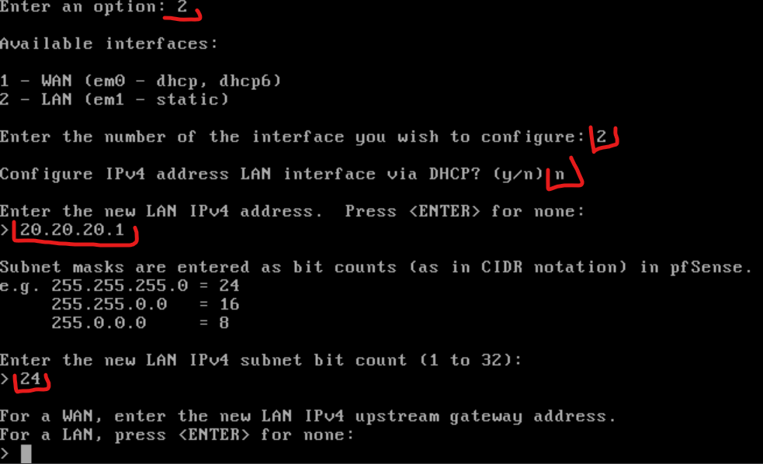 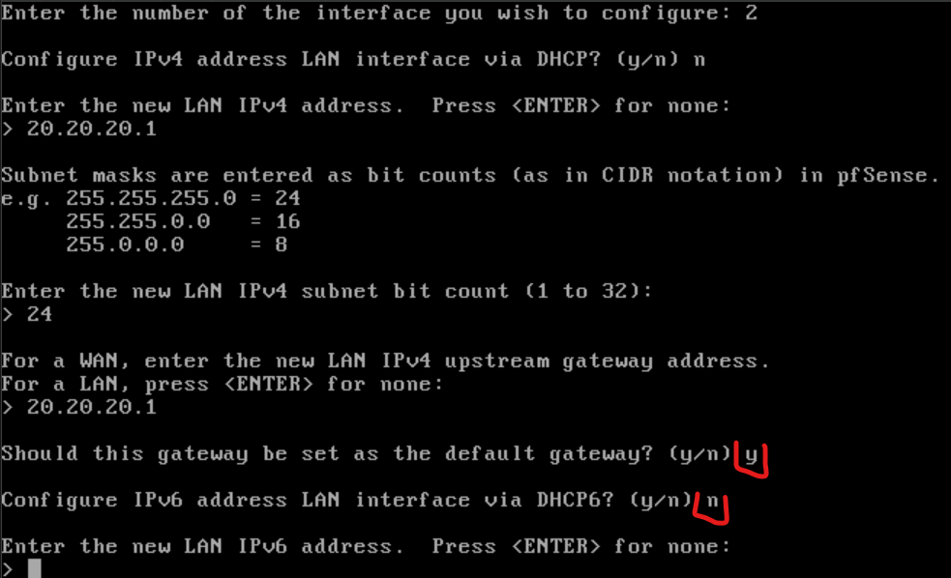 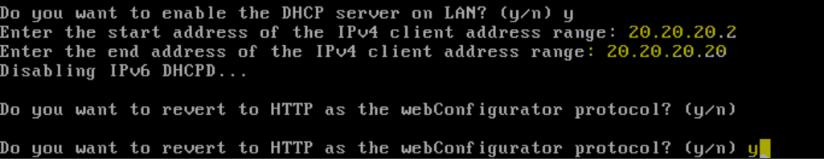

1. Now lets intiate the kali instance, and see if it will get an IP automatically from the dhcp of pfsens

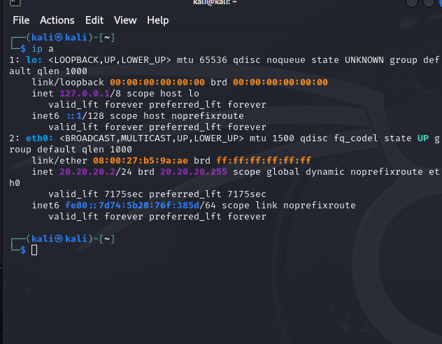

* As we can see we got a one on the eth0

1. Now lets open the pfsens on the fireforx 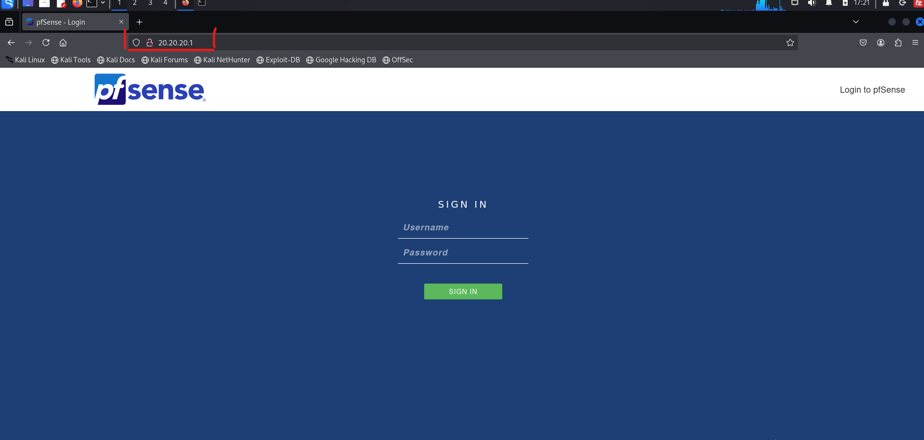
2. Default credential, admin:pfsense 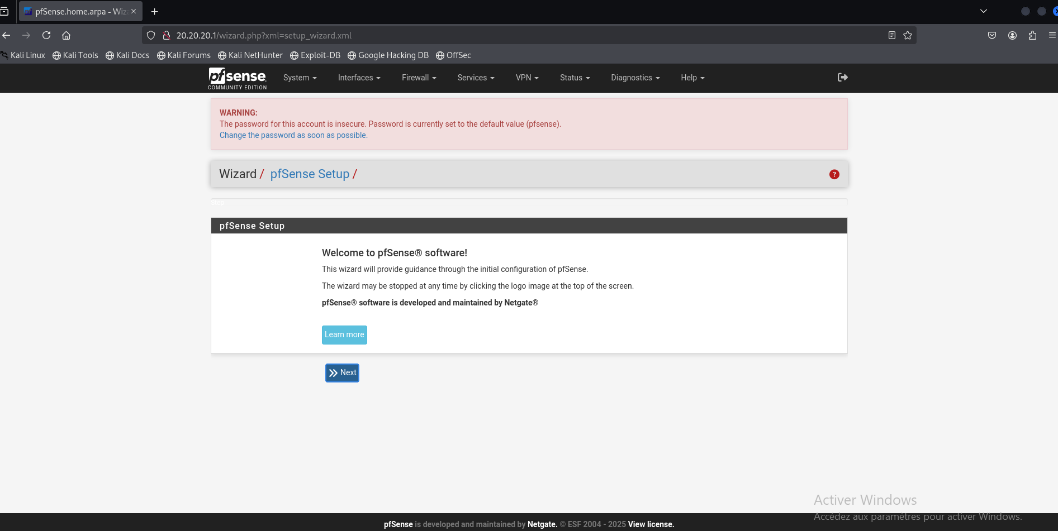

* Go take your time jumping in the pfsense features, and be familiar with the site then come back

1. Now go to the navbar, and click interfaces, and eneter to assignment, so we can add interfaces on our pfsense “more interfaces, more subnets”, just make sure you already had more internale virtual iterfaces, on that instance from the virtualbox settings

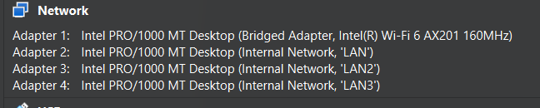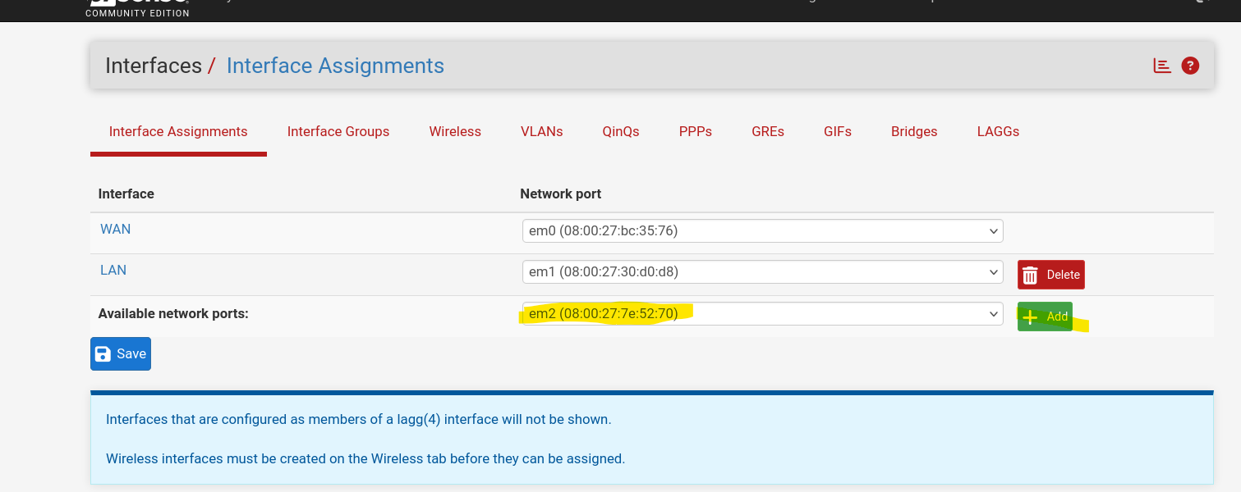

* Chose the interfaces “em2, em3” and click add so we can add an interface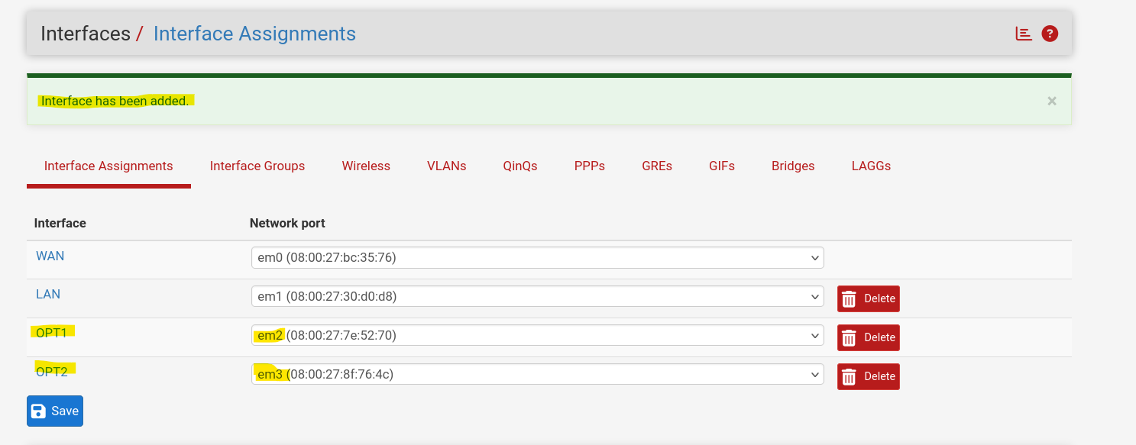
* I acttually added more than just a one interface, but our work is on LAN, and LAN2
* Now that we added new interfaces let set on them this following: IP, DHCP, DNS, ACCEPT any any on the firewall rules
* For IP, in the navbar go to interfaces and click/chose the interface you want to configure “OTP1 or OTP2”, and from there enable it firstly and set a name, a static IP, getway

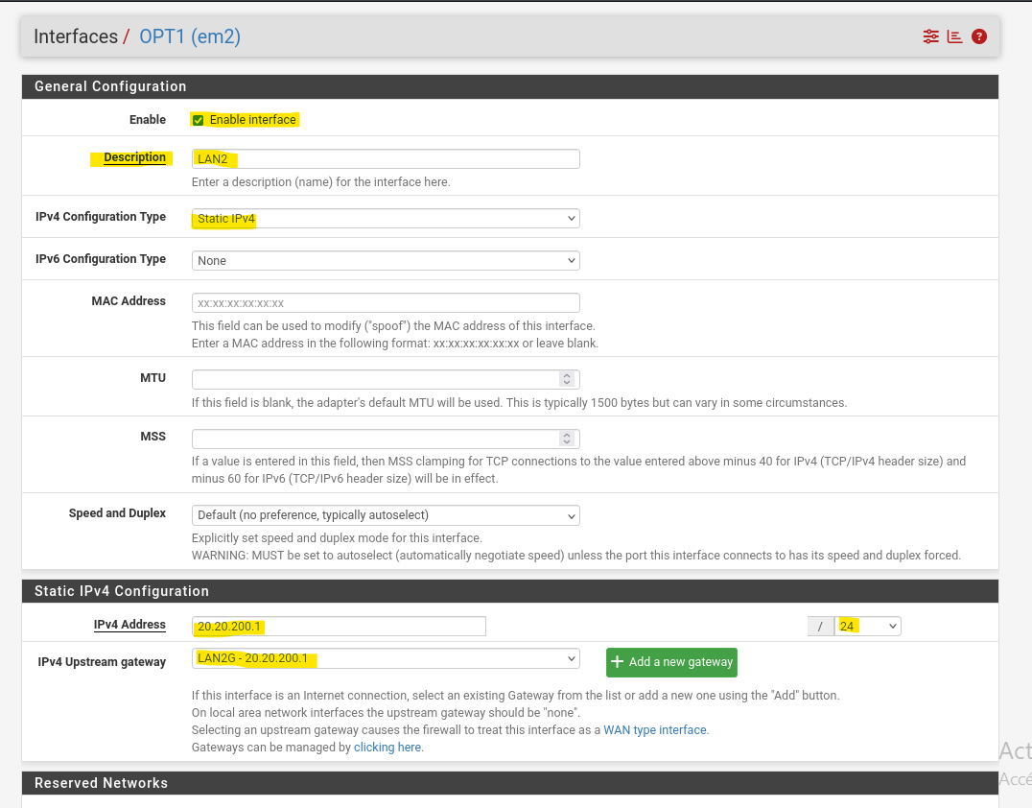

* Click save and apply changes
* And do the same for the other interface
* TOPOLOGY :
* LAN: has kali machine with IP subnet 20.20.20.0/24, getway 20.20.20.1/24
* LAN2: will have centos9 with IP subnet 20.20.200.0/24 getway 20.20.200.1/24
* Now lets set the DHCP on each interface, go to the service, click the DHCP server, and set these options, DHCP IP, DHCP POOL, DNS . then click save and aplly changes.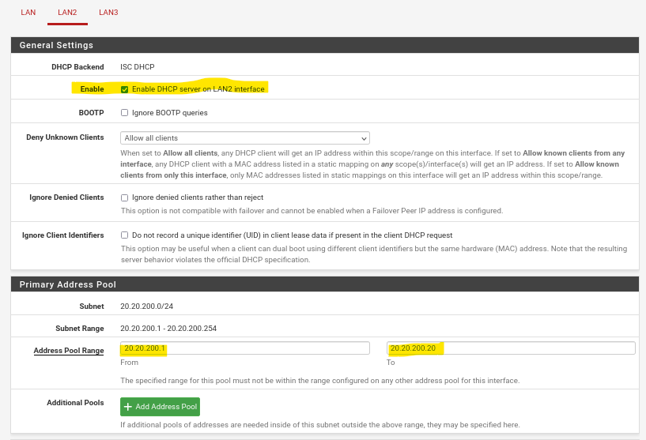
* Make sure to start the pool from 20.20.20.2, not 20.20.20.1, like I just did, I correct it later by the way

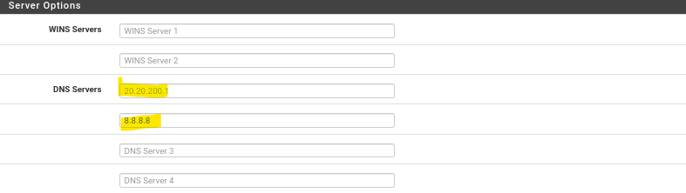

1. Now lets accept all the any traffics on these interfaces, dst: any, src:any. Go to firewalls in the navbar and click rules:

* Selecte the IPV4 rule and copy it and past it on the other LAN intefaces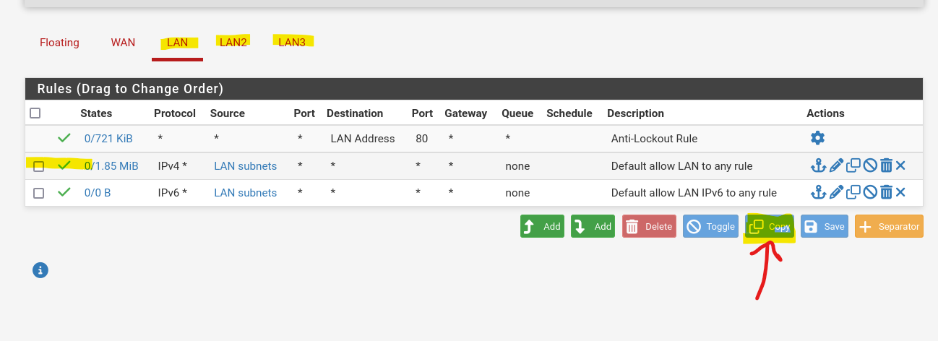

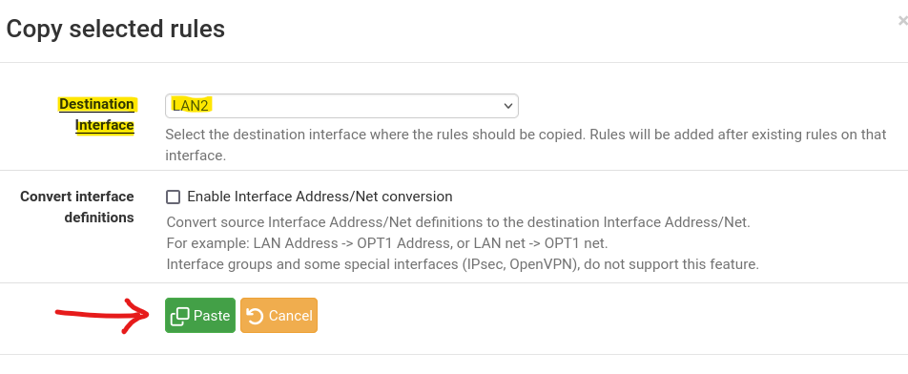

* Go the to interface where we PASTED the rules, LAN2. click on the pen icon for editing the rule, and we want to edit the “source” interface, to the LAN2 one, because we copied it from LAN interface so it still has the source interface as the LAN one, and do the same for the other interfaces if you have.

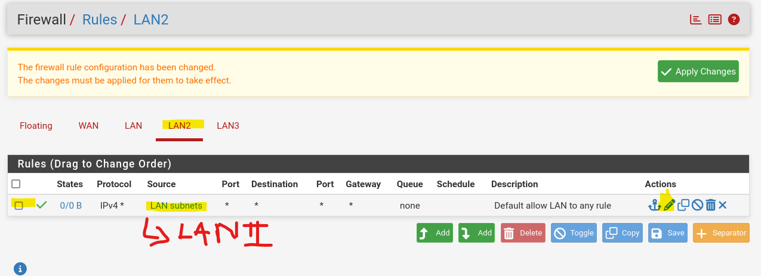

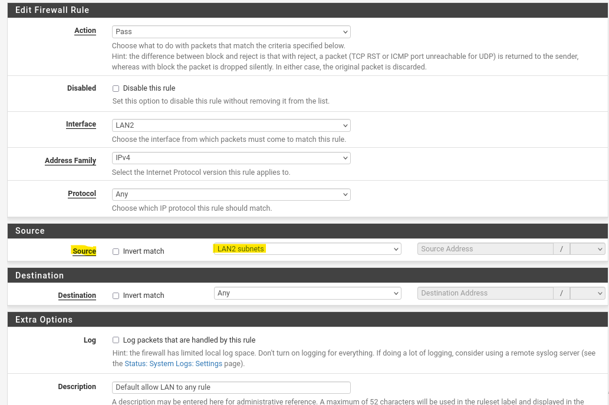

* The click save at the bottom and apply changes

1. Now lets open our centos9 instance, that has a virtual LAN2 interface on the virtualbox level “which mean it is on the LAN2 internal network”, and see if we ill get an IP from the pfsense LAN2 POOL with 20.20.200.0/24 subnet 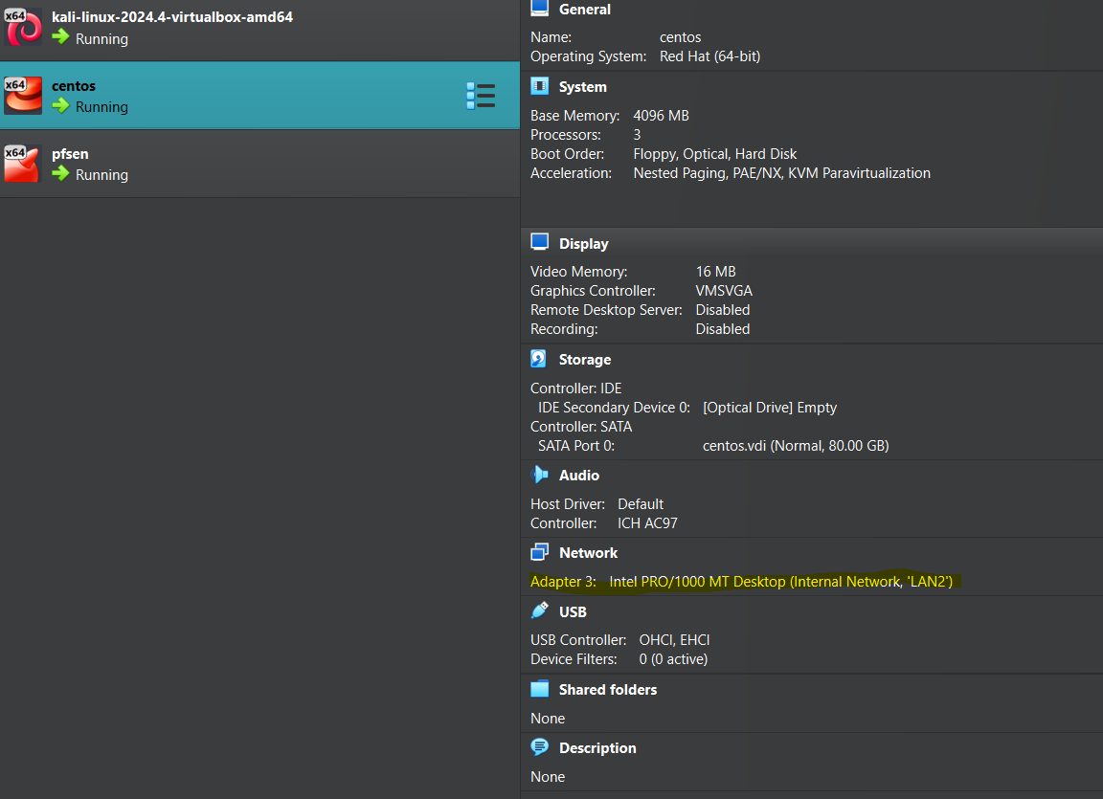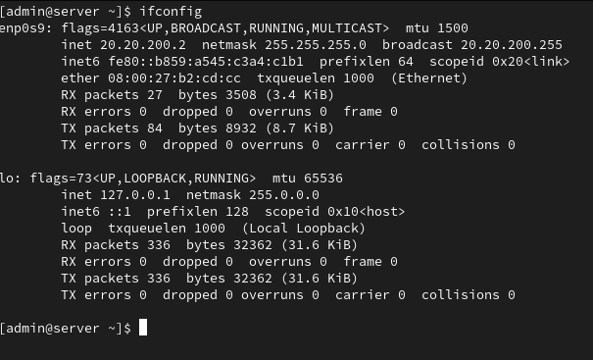

* We notice that it could get an IP. And we could ping the default getway and all, now, letj the security guy do his work on the firewall and all the other thing concerning that