## The Todo List Application

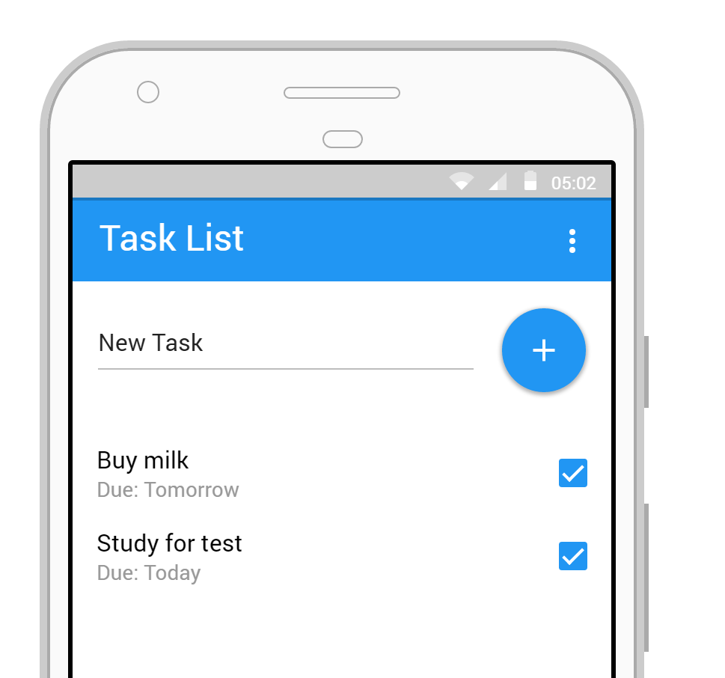

The Todo List helps users keep track of tasks that need to be completed.

Tasks can be:

* created
* deleted
* marked as complete

Task items have *labels*, *due dates* and *priorities*. The user can also *search* for tasks based on a set of filtering criteria.

## Architecture

All of the task list data is stored in a backend system. The user interaction is handled by a frontend application. The API you are designing will expose the list data to the frontend application.

TODO LIst

Application

List Data

API

End User

## Instructions:

* Design an API for a frontend TODO List application to use (use the style that the instructor specifies)
* Your finished design should include URIs, methods and sample responses
* Choose a presenter to showcase your design