**Hangman App**

### **Contents**

1. **Contents** 2

**2. Introduction** 3

2.1 Overview 3

**3. Application** 4

3.1 Purpose 4

3.2 Data sets 4

3.3 Rules 4

### **2. Introduction**

### Overview

This document describes Hangman app. Hangman is a game, where user has to guess predefined password by choosing single letters. Firstly the sentence contains only a row of dashes, which are representing each letter in the word. If user chosen a letter, which is in a password, it will placed in a correct location. If not, player will lose life which is represented by adding lines to hangman drawing. Player wins if whole password is completed and loses if the drawing is completed.

### **3. Application**

### Purpose

Application allows to play Hangman game. User can choose a game mode: word or proverb by typing it. It will randomly generate a password and the game will begin.

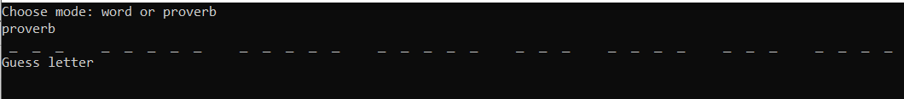

### Data sets

Each game mode randomly chooses one word/sentence from data set. Words come from package english-words. There is a set of 61569 words containing lower-case letters and no punctuation.

Proverbs comes from site [[word example]](https://www.wordexample.com/list/proverbs-in-english). It contains nearly 500 phrases.

### Rules

User starts the game with 6 lives, this value might be patched in future if balance will be required.   
Player needs to guess a letter. Program can accept both lower and upper-case letters. They will be converted to lower-case letters because all words and sentences contain only them. If player picks right letter, it will be placed in proper place.  
  
If sentence does not contain chosen letter, player will lose one life and few lines will be added to the drawing. Player also loses life if wrong input is entered or letter, which was previously used (even if it was a correct one). These settings don’t allow infinite runs.

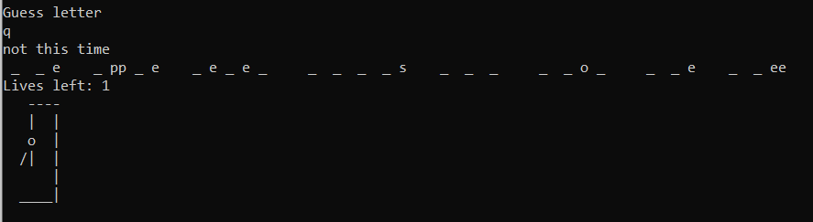

Game ends if there are no lives left or whole sentence is completed. After that the sentence will be displayed and user can choose to play again by typing reset.