Math 128b, Section 3 Name_____________________________________
First Examination

Spring 2000

Please show all your work on these pages.

Formulas are on the last page.

Question | Points | Score
1 | 12
2 | 10
3 | 10
4 | 8
5 | 10
6 | 10
7 | 12
8 | 12
9 | 16
Total | 100

- You want to approximate the area under the graph of f(x) = x³ between x = 6 and x = 8 using two rectangles.
- Find points x₀, x₁, x₂ dividing the interval [6, 8] into two equal subintervals:

x₀________ x₁_______ x₂________

- Find the midpoints, m₁ and m₂, of the two subintervals and the width, Δx, of each subinterval:

m₁________ m₂________ Δx__________

- Find the sum of the area of the rectangles that approximates the area under the graph.

- On the graph of f(x) = x³ below, draw clearly the rectangles whose area is represented by your answer to part (c).

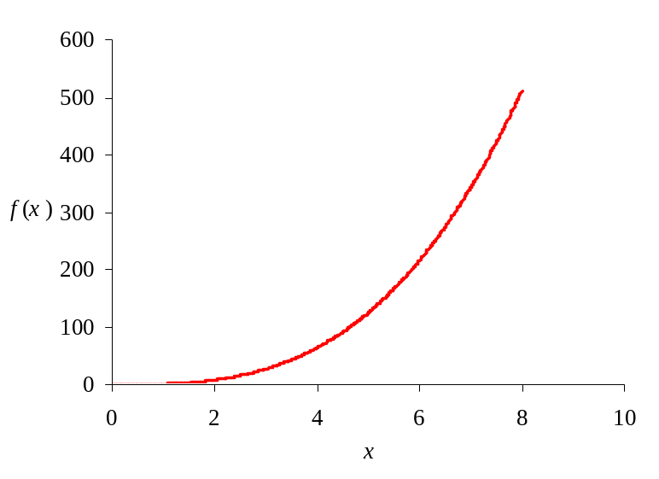

- The time between innovations is represented by the random variable X, with p.d.f f_{X}(x) = xe^{-x} for x ≥ 0, where x is measured in years.
- Using an integral, write an equation representing the fact that the probability is 0.54 that the time between innovations is between 1 and 3 years.

- Write an integral whose value is the average time between innovations.

- Values of the p.m.f of a discrete random variable X is given in the following table.
x | 2 | 10 | 16
f_{X}(x) | 0.2 | 0.7 | 0.1
- Calculate the mean of X.

- Calculate the variance of X.

- Calculate the standard deviation of X.

- Three people are sampled and asked the price of their home; their answers were $29,000, $35,000, and $53,000.
- Calculate the sample mean, 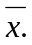

- Calculate the sample standard deviation, s.

- Customers at a computer store buy either a Mac or a PC. The probability that a customer purchases a Mac is 0.3. Groups of four customers come into the store and make their choices independently. Using the table below of probabilities of the Binomial distribution with n = 4 and p = 0.3, calculate:
- The probability that none of the four customers in a group buy a Mac.

- The probability that three or more Macs are sold to a group of four customers.

- If the computer store expects 50 groups of four customers in a day, how many Macs should they expect to sell on an average day?

x | f_{X}(x)
0 | 0.2401
1 | 0.4116
2 | 0.2646
3 | 0.0756
4 | 0.0081

The spreadsheet below approximates the area under the graph of f(x) = 0.1x² + 3 between the points x = a and x = b, using n midpoint rectangles.

- (a) What are the values of n________? a________? b________? Δx_________?

(b) What formula is in cell E3?

- (c) Write an integral that gives the area being approximated.

- What is the approximate value of this integral?

 | A | B | C | D | E | F | G
1 | i | x_{i} | m_{i} | f(m_{i}) | i^{th} area |  | Sum
2 | 0 | 10 |  |  |  |  | 30.26666
3 | 1 | 10.02 | 10.01 | 13.02001 | 0.2604
4 | 2 | 10.04 | 10.03 | 13.06009 | 0.261202
5 | 3 | 10.06 | 10.05 | 13.10025 | 0.262005
6 | 4 | 10.08 | 10.07 | 13.14049 | 0.26281
7 | 5 | 10.1 | 10.09 | 13.18081 | 0.263616
.
.
.
96 | 94 | 11.88 | 11.87 | 17.08969 | 0.341794
97 | 95 | 11.9 | 11.89 | 17.13721 | 0.342744
98 | 96 | 11.92 | 11.91 | 17.18481 | 0.343696
99 | 97 | 11.94 | 11.93 | 17.23249 | 0.34465
100 | 98 | 11.96 | 11.95 | 17.28025 | 0.345605
101 | 99 | 11.98 | 11.97 | 17.32809 | 0.346562
102 | 100 | 12 | 11.99 | 17.37601 | 0.34752

Match the quantities (a) --- (e) with the correct diagram (I) ---(V) below. Assume that X is a continuous random variable with probability distribution f(x) for x ≥ 0.

- P(1<X<2) ___________

- P(X>1)_____________

(c) Probability that X is no more than 2_______________

- Probability that X is less than 1________________

- Write a description (similar to (a)-(d) above) for the graph that you have not matched.
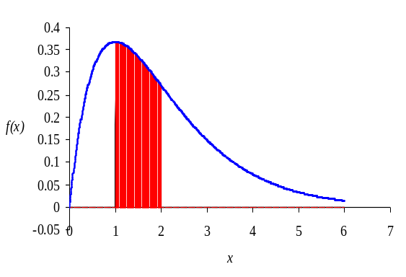
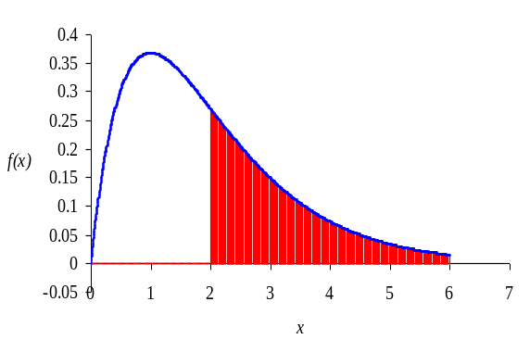
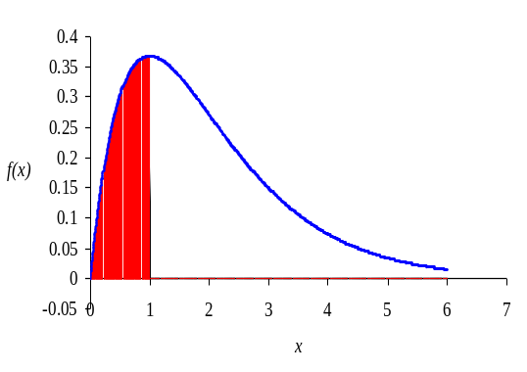
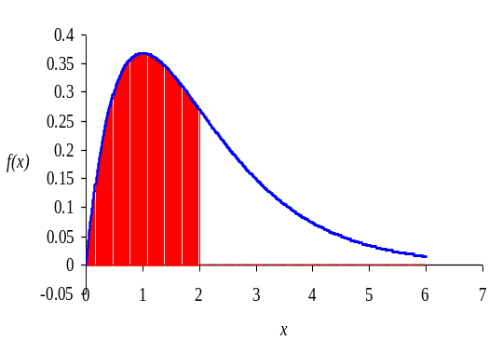
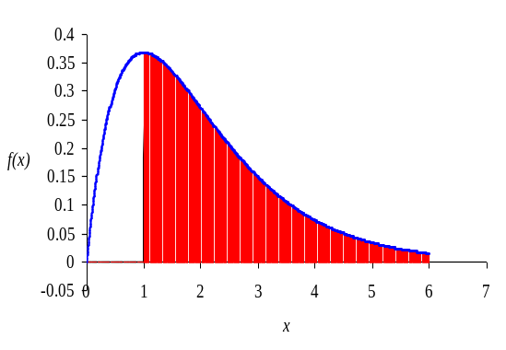
(V)
(IV)
(III)
(I)
(II)

- Match each of the p.d.f.s in (a)---(d) with one of the graphs in (I)—(VI).

- Normal distribution with a mean of 8 and standard deviation of 1 is Graph:___________

- Normal distribution with μ = 0 and σ = 3 is Graph:________________

- Normal distribution with μ = 8 and σ = 3 is Graph:________________

- The standard normal distribution is Graph: _____________________

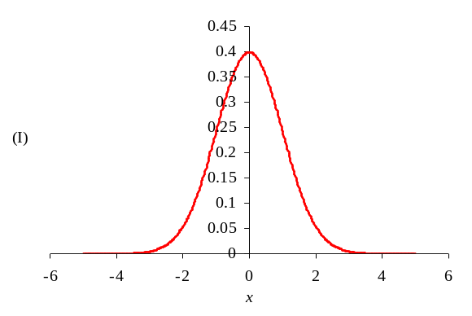
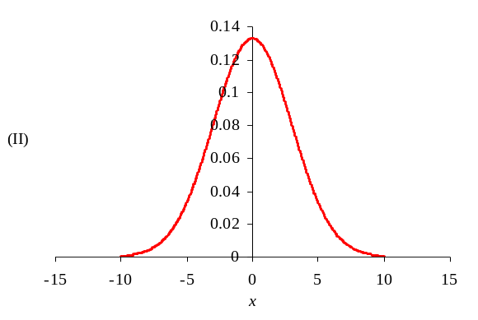
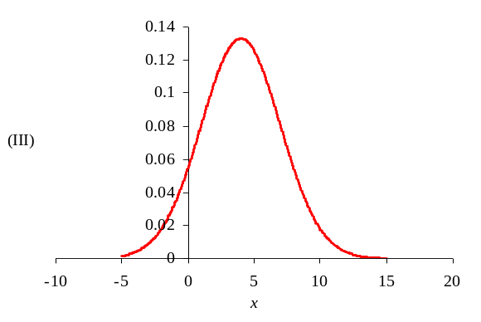
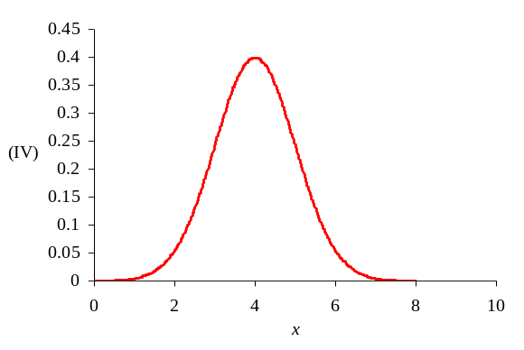
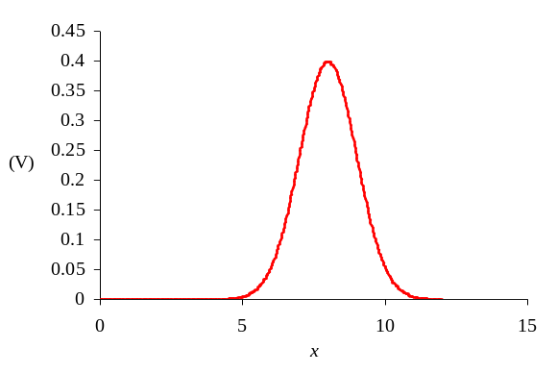
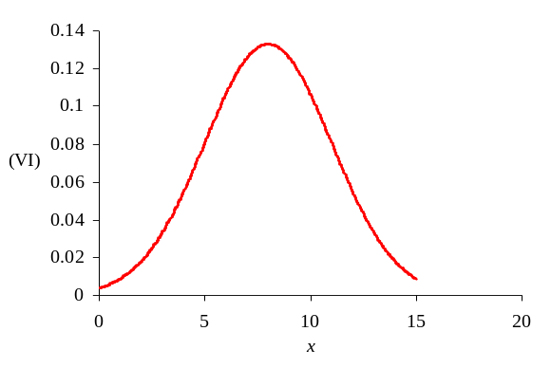

- The speeds of cars on a highway are normally distributed with a mean of 61 mph and a standard deviation of 6 mph.
- Estimate the fraction of cars traveling less than 55 mph.

- Estimate the fraction of cars traveling more than 73 mph.

- The speeds of a random sample of 4 cars are averaged. What is the standard deviation of the distribution of sample means?

- Estimate the probability that the average speed of a sample of 4 cars is above 67 mph.
Formulas

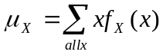

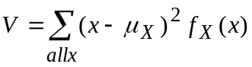
σ_{X} = 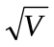
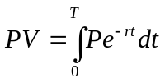
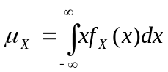
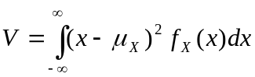
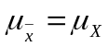

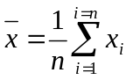
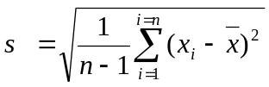
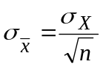

Normal Distribution
68% within 1 standard deviation of mean
95% within 2 standard deviations of the mean
99.7% within 3 standard deviations of the mean
Binomial Distribution
Mean is np
Variance is np(1-p)

