Math 128b, Section 3 First Examination Solutions Spring 2000

- (a) x₀ = 6, x₁ = 7, x₂ = 8.
- m₁ = 6.5, m₂ = 7.5, Δx = 1.
(c) Sum of areas of rectangles = f(m₁)Δx + f(m₂)Δx = (6.5³)(1) + (7.5³)(1) = 696.5.
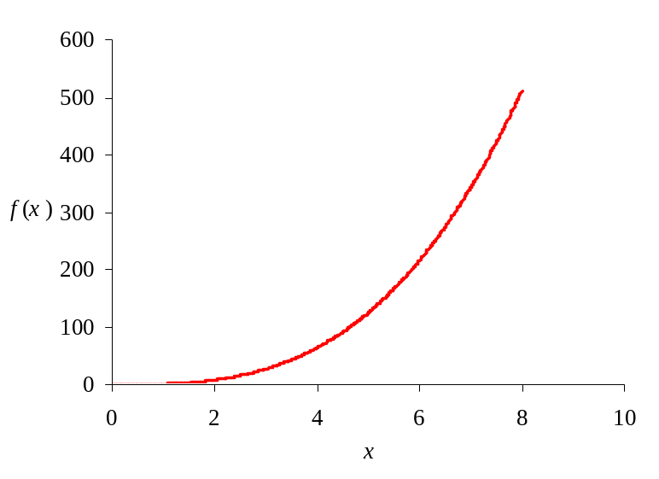
(d)
- (a) Probability = 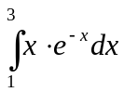 = 0.54.
- Average time between innovations = 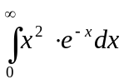.
- (a) Mean of X = μ_{X} = 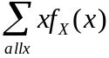 = 2(0.2) + 10(0.7) + 16(0.1) = 9.
(b) Variance of X = Var(X) = 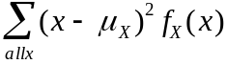
= (2-9)²(0.2) + (10-9)²(0.7) + (16-9)²(0.1) = 15.4.
(c) Standard deviation of X = σ_{X} = 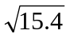 = 3.92.
- (a) 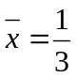(29000 + 35000 + 53000) = 39,000.
- s =
- (a) 0.2401.
- (b) 0.0756 + 0.0081 = 0.0837.
- (c) Mean = np = 4⋅0.3 = 1.2. This means that, on average, 1.2 Macs are sold per group. Thus, if 50 groups arrive in a day, on average 1.2(50) = 60 Macs are sold per day.
- (a) n = 100, a = 10, b = 12, Δx =0.02.
(b) = D3*0.02.
- 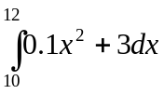.
- 30.26666.
- (a) is (III) (b) is (V) (c) is (II) (d) is (I)
(e) (IV) is Probability that X is greater than 2.
- (a) is (V) (b) is (II) (c) is (VI) (d) is (I).
- (a) Since 55 is one standard deviation below the mean, and 68% of the cars are within one standard deviation of the mean, approximately 32%/2 = 16% of the cars are below 55 mph.
- Since 73 is two standard deviations above the mean, and 95% of the cars are within two standard deviations of the mean, approximately 5%/2 = 2.5% of the cars are above 73 mph.
- The distribution of sample means has mean 61 and standard deviation 6/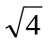= 3.
- Since for the mean of a sample, 67 is two standard deviations above the mean, there is approximately a 2.5% chance that a group of 4 cars has an average speed above 67 mph.

