Math 128b, Section 3, SECOND EXAMINATION SOLUTIONS, Spring 2000

- (a) Total cost = Fixed cost + Variable cost = $600,000 + $200(55) = $611,000.
- Total cost in dollars = 600,000 + 200q.
- (a) When q = 10, the price is D(10) = 400 – 0.03(10)² = 400 – 3 = 397 dollars.
- If q = 0, the price is $400. At or above this price, no good are demanded.
3. To estimate the derivative from the table, we calculate the difference quotient:
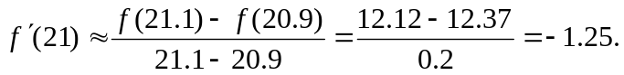

4. Some answers are shown on the graph.
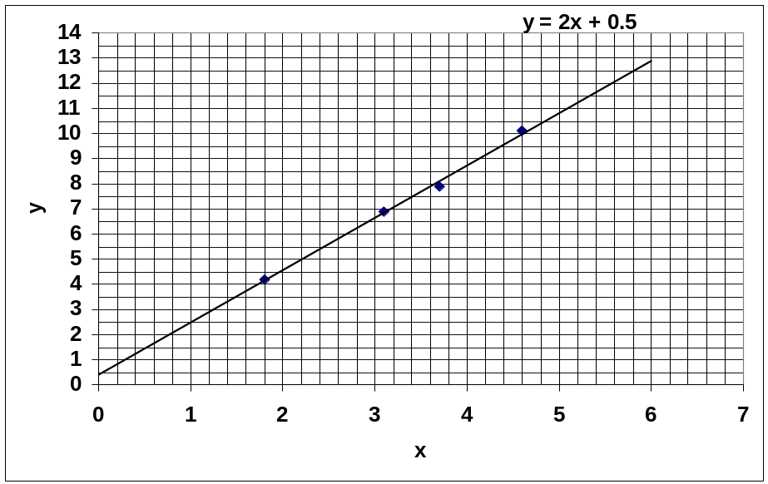

- The line cuts the y-axis at approximately 0.5, so the value of y when x = 0 is approximately 0.5.
- The line goes approximately through the points (0, 0.5) and (4, 8.5), so
Slope 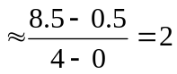.
- The answers to parts (c) and (d) tell us that the equation is approximately
y = 2x + 0.5.
5.
- The revenue increases then decreases; the cost increases for all q.
- The company makes a profit whenever revenue is above cost; that is for q between about 75 and 1170 thousand units.
- Maximum revenue is approximately $152 million.
- Maximum revenue occurs at q ≅ 900 thousand units.
- Maximum profit is approximately $48 million.
- Maximum profit occurs at q ≅ 800 thousand units.
6.
- The fact that marginal cost is three line segments tells us that the marginal cost per unit has three different values, depending on the quantity produced. The fact that the three successive lines are at decreasing costs tell us that there are economies of scale in this business.
- The units of the 400 are thousands of units of the item being produced. The units of the 200 are millions of dollars.
- The fact that MR(400) = 200 tells us that when 400 thousand units have already been produced, an additional 1000 units will generate approximately an additional 200 million dollars of revenue.
- Revenue is a maximum where MR(q) = 0, provided MR(q) is positive to the left of the point and negative to the right. This occurs at q ≅ 910.
- Profit is maximum where MR(q) = MC(q). In addition, MR(q) must be above MC(q) for values of q to the left of the point and MR(q) must be below MC(q) to the right of the point. This occurs at q ≅ 600 and q ≅ 600. Without furthe information, we cannot tell which gives the larger profit.

7. Using the difference quotient;
