Math 128b, Section 3 Name_____________________________________
Final Examination

Spring 2000

Please show all your work on these pages.

Formulas are on the last page. You may use a calculator.

Question | Points | Score
1 | 8
2 | 4
3 | 6
4 | 4
5 | 8
6 | 4
7 | 8
8 | 4
9 | 6
10 | 6
11 | 6
12 | 8
13 | 6
14 | 6
15 | 8
16 | 8
Total | 100

- A sample of three student’s hourly wages was as follows: $9.50, $7.75, $10.50.
- Find the mean of these wages.

- Find the standard deviation of these wages.

- If the $7.75 wage were replaced by a larger value, would the following quantities increase or decrease, or does it depend in the exact value of the replacement wage?
- The mean wage.

(ii) The standard deviation.

- Given D(q) = –0.1q² + 50, estimate MD(20) using h = 0.01.

- A batch of 5730 units of a product is made at a fixed cost of $1200 and a variable cost of $10 per unit; the product sold for $12 per unit.
- What profit is made?

- What is the break-even point for this production process? (In other words, how many units should be produced for the profit to be zero?)

4. A random variable has the probability distribution given by the p.m.f in the table.
x | 10 | 20 | 25
f_{X}(x) | 0.3 | 0.5 | 0.2

- Find the mean of X.

- Find the standard deviation of X.

- Each of the following graphs could represent one or more of the following functions: Demand, Revenue, Cost, Profit. Under each graph, write the function(s) it could represent. Give a reason for your choice. (A function may be used more than once.)
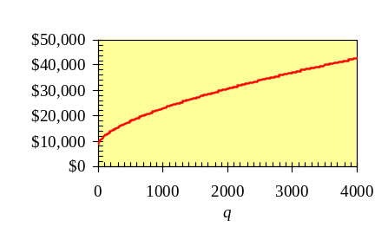
(a)

Function(s):__________________________________Reason:
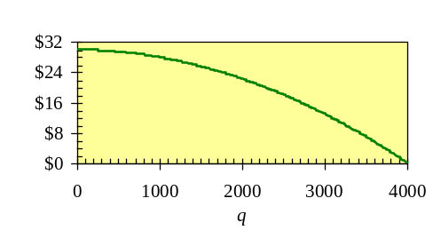
(b)

Function(s):___________________________________Reason:
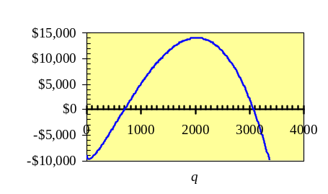
(c)

Function(s):___________________________________Reason:
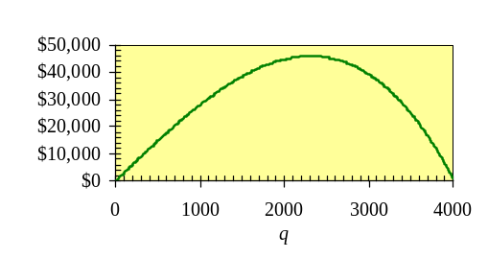
(d)

Function(s):____________________________________Reason:

- Let X be a continuous random variable with probability density function f(x) for x ≥ 0. Each of the quantities in (a) —(d) is the result of calculating one of the integrals in (I)—(V). Which one? (No integral is used more than once. No reasons need.)

- The mean of X.________________

- The probability that X is between 2 and 3_________________

- The number 0_________________

- The number 1___________________________

(I)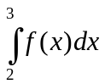 (II)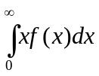 (III)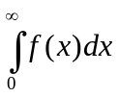 (IV)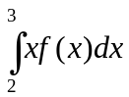 (V)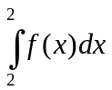

- Use the functions D(q), R(q), C(q), P(q),MD(q), MR(q), MC(q), and MP(q) to represent the following statements.
- 50 units of an item can be sold at $20 each.

- After 500 items have been produced, increasing production by one unit leads to a $7 increase in revenue.

- At a production level of 255 units, the marginal cost and marginal revenue are equal.

8. Consider the following integrals. The graph of f(x) is shown below.
(I) 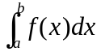 (II)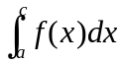 (III)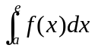 (IV)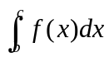 (V)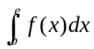
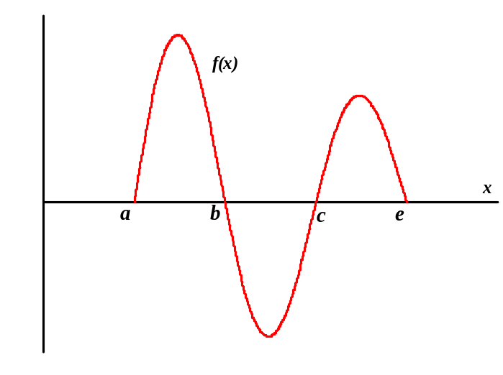

- Which integrals are negative?

- List the integrals in order of increasing size below.

List integrals (I)–(V) here
Smallest (most negative) integral
Next smallest
Next
Second largest
Largest integral

- The time during which a pregnant woman carries her baby before giving birth is called the gestation period. The gestation period has a mean of about 270 days (9 months) with a standard deviation of about 14 days (two weeks). Assume that the length of the gestation period, X, is normally distributed, so μ_{X} = 270 and σ_{X} = 14.
- Estimate the percentage of women who deliver their babies at least two weeks early. (That is, carry their babies for 256 days or less.)

- Estimate the percentage of women who are more than four weeks overdue. (That is, carry their babies for 298 days or more.)

- There are 20 companies bidding on an oil lease. Each company uses the same bidding strategy and all geologists provide estimates that are normally distributed about the true value with the same standard deviation.
- What is the probability that Company #1 wins a particular bid?

- If the companies bid on 120 leases, how many times can Company #1 expect to win the bid?

- If the winning bid is, on average, $5 million below the true value of the lease, how much profit can Company #1 expect to earn by making 200 bids?

- Each of the statements (a)—(c) leads to one or more of the algebraic statements (I)-(VIII). Write (I)-(VIII) in the spaces given. No reasons are needed.
- Revenue is maximized if 500 units are produced.
Leads to:_____________________________________

- A production level of 500 units is break even point.
Leads to:_____________________________________

- The sale of an additional unit brings in an extra $500 in revenue.
Leads to:______________________________________

- R(500) = 0
- MR(500) = 0
- R(q) = 500
- R(500) = C(500)
- R(q) = C(q) = 500
- MR(q) = 500
- MR(500) = MC(500)
- MR(q) = MC(q) = 500

- The following figure shows an exponential trend-line fitted to data for the population, P, in millions, of Phoenix.
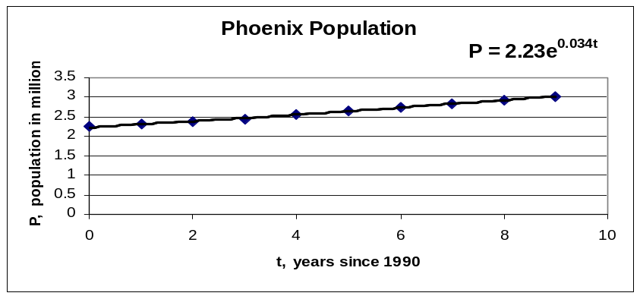

- At what continuous percentage rate has the population of Phoenix been growing?

- What population is predicted for 2002? (Note that t is in years since 1990.)

- What population is predicted for 2050?

- Comment in the reliability of the estimates in parts (b) and (c).

- The graph of the function f(x) = –4x + 12 is shown in the figure. Find:
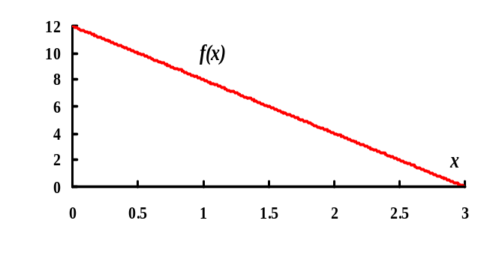
- 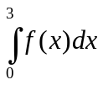

- 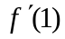

- Using the graph of f(x) below, estimate (roughly) the values of 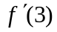and 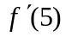.
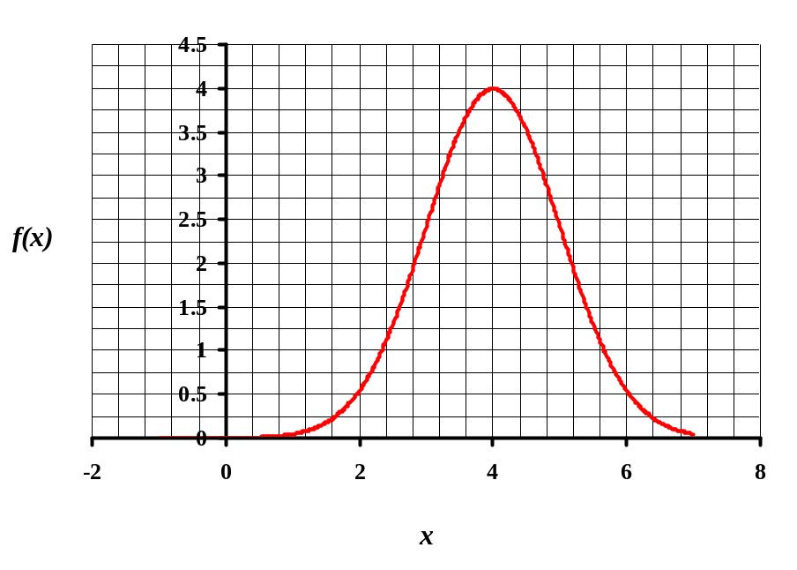

- Match each of the functions (I)–(IV) with its derivative (A)–(D). No reasons need be given.
Function (I) has derivative_________________________
Function (II) has derivative_________________________
Function (III) has derivative_________________________
Function (IV) has derivative_________________________

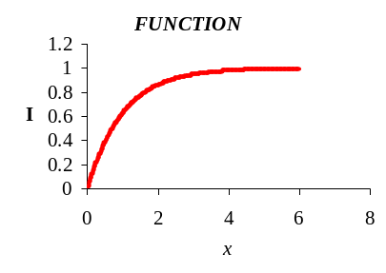
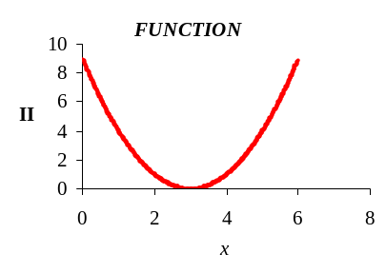
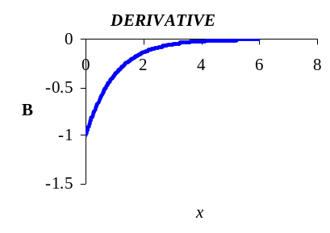
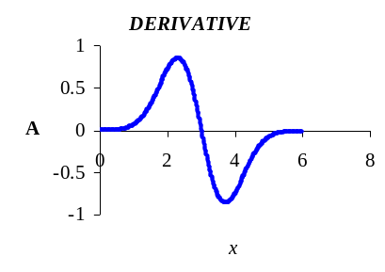
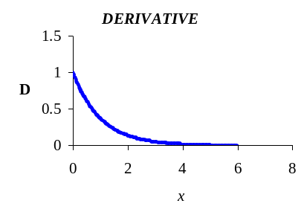
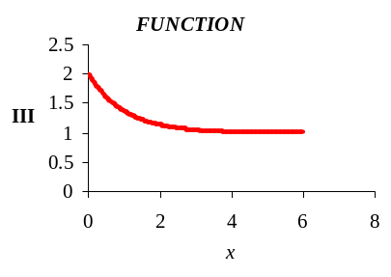
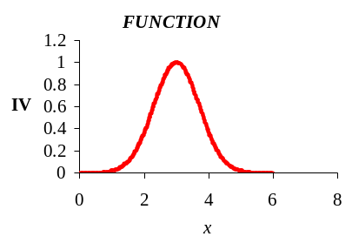
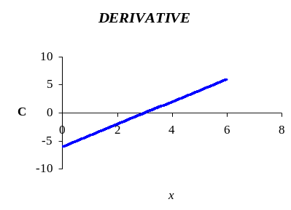

- Geologists’ estimates for the value of the oil in a tract of land are normally distributed around the true value, $250 million, with a standard deviation of $25 million dollars. We take the averages of random samples of 100 of these estimates.
- What is the mean of these averages?

- What is the standard deviation of the distribution of these averages?

- What is the probability of getting an average of over $255 million?

Formulas

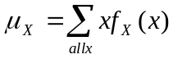

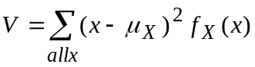
σ_{X} = 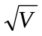
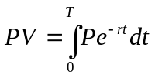
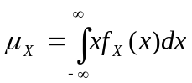
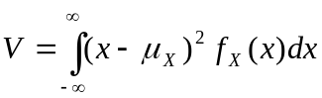
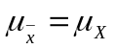

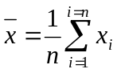
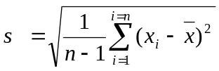
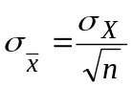

Normal Distribution
68% within 1 standard deviation of mean
95% within 2 standard deviations of the mean
99.7% within 3 standard deviations of the mean
Binomial Distribution
Mean is np
Variance is np(1-p)

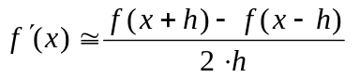R(q) = q⋅D(q) P(q) = R(q) − C(q) MP(q) = MR(q) − MC(q)

