Math 128b, Spring 2000, SOLUTIONS TO FINAL EXAM, Section 3

1.
- Mean = 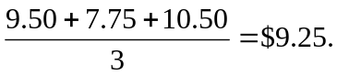
- Standard deviation = 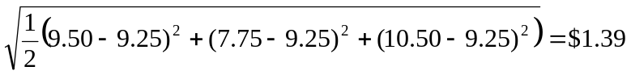.
- (i) If the $7.75 is replaced by a larger value, the mean wage will increase.
(ii) What happens to the standard deviation depends on the new value. The standard deviation decreases as the wage increases toward the mean and then increases.
2. Using the definition of the derivative:
.

3. (a) Cost of making the units = 1200 + 10(5730) = $58,500.
Revenue obtained by selling the units = 12(5730) = $68,760.
Therefore: Profit = 68760 – 58500 = $10,260.
(b) At break-even point, cost equals the revenue. If q units are produced, the revenue is $12q and the total cost is $1200 + 10q. Thus at the break even point,
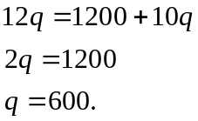.

Thus 600 units should be produced.

4. (a) Mean = (0.3)10 + (0.5)20 + (0.2)25 = 15.
(b) Standard deviation =
5.
- Cost function because it is always increasing.
- Demand function because it is always decreasing.
- Profit function because increases and decreases; cannot be revenue because it takes on negative values.
- Profit or revenue because it increases and decreases; can be either as it is never negative.

- (a) is (II); (b) is (I); (c) is (V); (d) is (III).

7. (a) D(50) = 20.
- MR(500) = 7.
- MR(225) = MC(225). Alternatively, MP(225) = 0.

8. (a) Integrals (IV) and (V) are negative.
- (IV) < (V) < (II) < (III) < (I).

- Two weeks early is one standard deviation below the mean, so the percentage of women falling in this category is about 16%.
- Four weeks overdue is more than two standard deviations over the mean. The percentage of women falling in this category is about 2.5%.
10.
- Probability that any one company wins the bid is 1/20.
- It can expect to win about 120(1/20) = 6 times.
- The company expects to win about 200(1/20) = 10 times, and make $5 million in profit each time they win. Thus the total profit they expect is $50 million.

- (a) is (VI): MR(500) = 0.
- (b) is (IV): R(500) = C(500)
- (c) is (VI): MR(q) = 500.

- Continuous growth rate is 0.034 or 3.4% per year.
- In 2002, we have t = 12, so 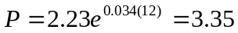million people.
- In 2050, we have t = 60, so 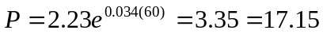million people.
- The first estimate is much more reliable that the second; the growth rate of Phoenix is not likely to remain constant for 60 years.
13.
- The integral is the area under the line, which is a triangle, so
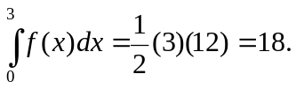
- The derivative is the slope of the line, so 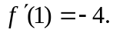
- At x = 3, the graph is rising, so the slope is positive. Drawing the tangent line at x = 3, we estimate
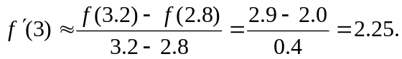
Because of the symmetry of the graph, at x = 5 the slope is negative but has the same magnitude as at x = 3. Thus,
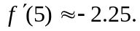

15. (I) is D; (II) is C: (III) is B; (IV) is A.

16.
- The mean of these averages is the mean of the original distribution, $250 million.
- The standard deviation of these averages is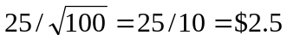million.
- The distribution of averages is also normal; $255 is two standard deviations above the mean of the distribution of averages ($250), so there is a 5%/2 = 2.5% probability of the average being above $255.

