Math 128b, Section 2 Name_____________________________________
Final Examination Four digit PIN number if you want your grade

Spring 2000 emailed _________________

Please show all your work.

Formulas are on the last page. You may use a calculator.

Have a great summer!

Question | Points | Score
1 | 4
2 | 5
3 | 7
4 | 4
5 | 6
6 | 6
7 | 6
8 | 8
9 | 6
10 | 6
11 | 6
12 | 4
13 | 6
14 | 6
15 | 10
16 | 10
Total | 100

- At a price of $10, there are 2450 units are sold.
- What is the revenue?

- The 2450 items are produced at a total cost of $1700. What profit is made?

- Given D(q) = –0.1q² + 300, estimate MD(20) using h = 0.1.

- Sales data from a sample of three locations was as follows: 580 units, 720 units, and 800 units.
- Find the mean of these sales figures.

- Find the standard deviation of these sales figures.

- If the 580 figure were replaced by a larger value, would the following quantities increase or decrease, or does it depend in the exact replacement figure?
(i) The mean.

(ii) The standard deviation.

- A company receives revenue at a continuous rate of $4000 million per year for three years, starting today. If the interest rate is 5%, compounded continuously, write an integral representing the present value of the revenue.

- What do the following statements tell you in practical business terms? The 800 represents the number of units of a product.
- R(800) = $40 million.

- MP(800) = $20 thousand.

- MC(800) = $30 thousand.

- Each of the statements (a)—(c) leads to one or more of the algebraic statements (I)-(VIII). List the statement(s) in the space provided. (No reasons are needed.)

- Profit is maximized if 500 units are produced.

Leads to________________________________________

- At or above a price of $500, no units are bought.

Leads to________________________________________

- There is break-even point at 500 units.

Leads to________________________________________

- P(500) = 0
- MP(500) = 0
- P(q) = 500
- R(500) = C(500)
- R(q) = C(q) = 500
- MP(q) = 500
- D(0) = 500
- D(500) =0

- Match each of the functions (I)–(IV) with its derivative (A)–(D). No reasons needed.
Function (I) has derivative_________________________
Function (II) has derivative_________________________
Function (III) has derivative_________________________
Function (IV) has derivative_________________________

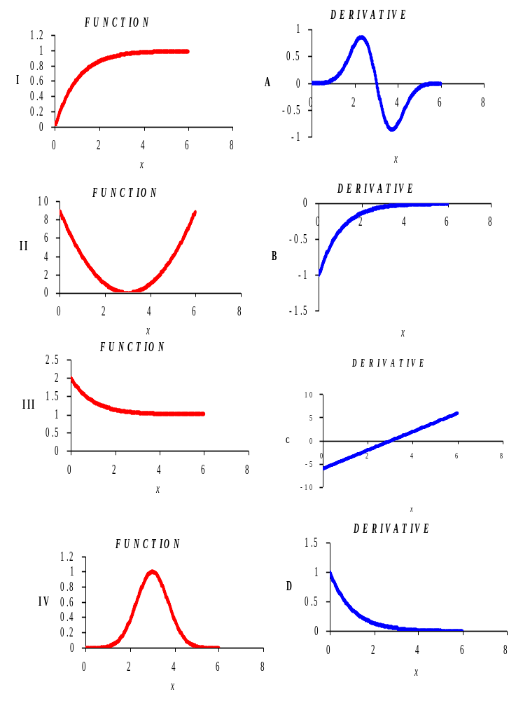

- The following figure shows an exponential trend-line fitted to data for the Tucson population, P, in thousands, since 1970.
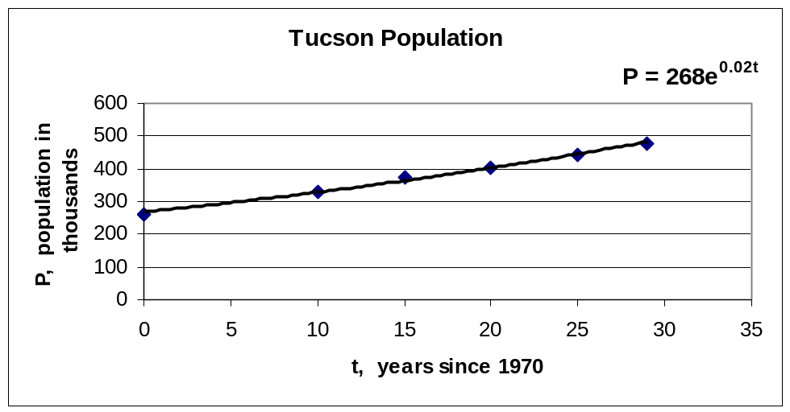

- At what continuous yearly percentage rate has the population of Tucson been growing?

- Use the formula to predict the population in 2002. (Note that t is in years since 1970.)

- Use the formula to predict the population in 2050.

- Which of the predictions in parts (b) and (c) do you think is more reliable? Why?

- Let X be a continuous random variable with probability density function f(x) for x ≥ 0. Each of the quantities in (a) —(d) is the result of calculating one of the integrals in (I)—(V). Which one? (No integral is used more than once. No reasons need be given)

- The mean of X.________________

- The probability that X is between 3 and 4_________________

- The number 0_________________

- The number 1___________________________

(I)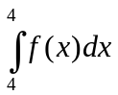 (II)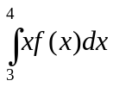 (III)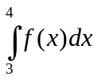 (IV)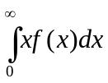 (V)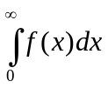
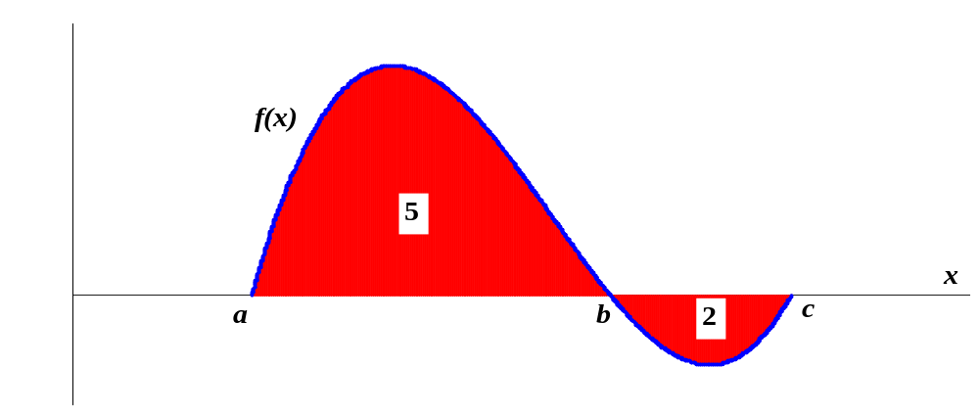
- Calculate the following integrals using the areas shown on the graph of f(x) below.

- 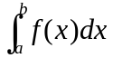

(b)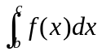

(c)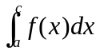

11. The figure below can be used to estimate consumer surplus.
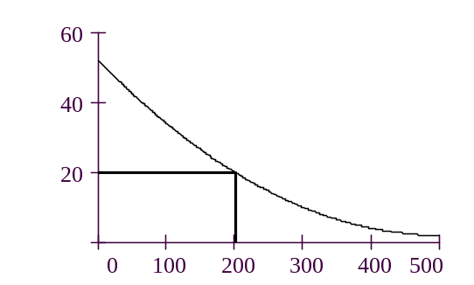
$
$
$
q

q

- What function does the curve represent?

- On the graph, shade and label the region that represents the consumer surplus when q = 200.

- On the graph, shade and label the region that represents the revenue when q = 200.

- Using the graph, estimate the revenue when q = 200.

- Using the graph, estimate the consumer surplus when q = 200.

- The following graphs show a p.d.f. and a c.d.f.
- On the p.d.f graph, shade the region representing the probability that x is between 1 and 2.
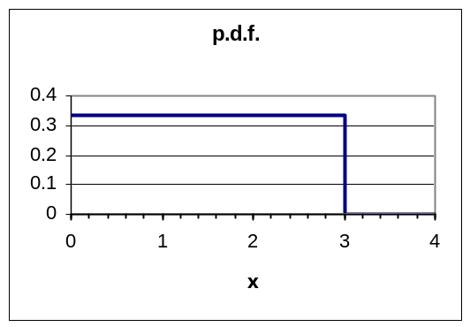
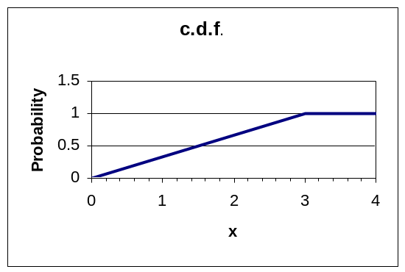
- On the c.d.f graph, mark clearly the value of the probability that x ≤ 2.

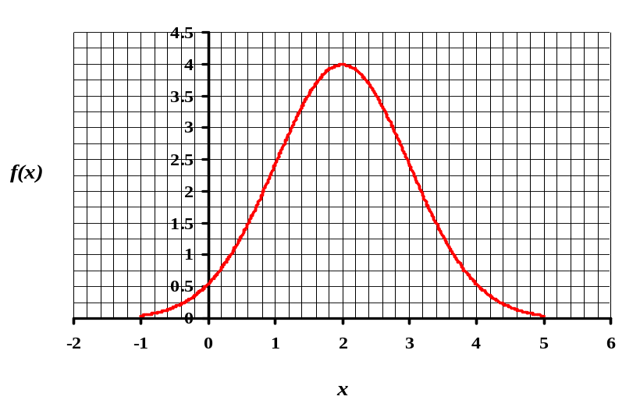
- Using the graph of f(x) below, estimate (roughly) the value of 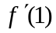.

- The time during which a pregnant woman carries her baby before giving birth is called the gestation period. The length of the gestation period is normally distributed and shown in the following figure.
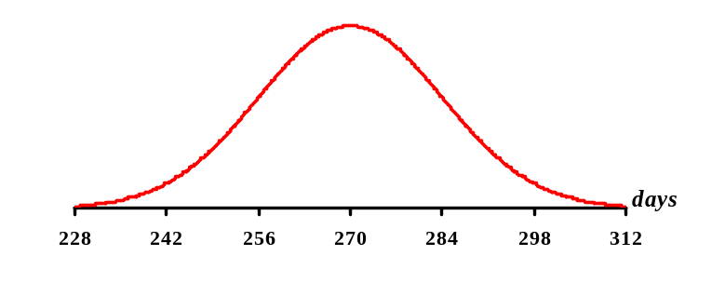

- Estimate the mean gestation period (in days).

- Estimate the standard deviation (in days).

- A company is looking at its sales data of a new item from its outlet stores. The data are normally distributed with a mean of 52 units per week and a standard deviation of 8 units per week.
- What is the probability that a randomly chosen outlet store sells more than 60 units per week?

- The company now looks at the average sales of the item from 4 randomly chosen outlet stores. What is the mean of the distribution of average sales?

- What is the standard deviation of the distribution of average sales?

- What is the probability that the average sales of 4 randomly chosen outlet stores is over 60 units per week?

- A group of companies bid on an oil lease. Each company has an estimate of the value of the lease supplied by a geologist. The estimates are normally distributed around the true value of the lease.
- In everyday terms, explain briefly what is meant by “the winner’s curse”.

- The companies have the option of bidding separately on the lease, or in rings of 2 companies each. Which is larger: The winner’s curse for separate bids or for ring bids? (Reasons not needed.)

- If the size of the ring in part (b) is increased, does the winner’s curse increase or decrease? (Reasons not needed.)

Formulas

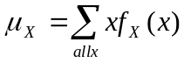

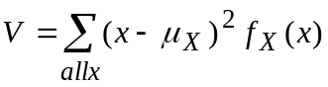
σ_{X} = 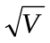
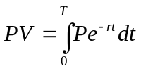
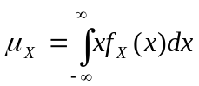
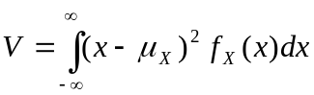
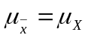

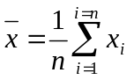
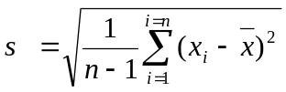
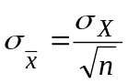

Normal Distribution
68% within 1 standard deviation of mean
95% within 2 standard deviations of the mean
99.7% within 3 standard deviations of the mean
Binomial Distribution
Mean is np
Variance is np(1-p)

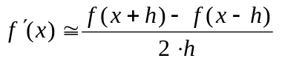R(q) = q⋅D(q) P(q) = R(q) − C(q) MP(q) = MR(q) − MC(q)

