MATH 128b, Section 2 SOLUTIONS TO FINAL EXAMINATION May 2000

- (a) Revenue = 2450(10) = $24,500.
(b) Profit = 24500 – 1700 = $22,800.
- Since MD(q) is the derivative:

- (a) Mean = 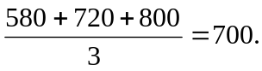
(b) Standard Deviation = 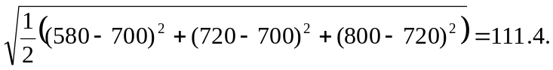
(c) (i) Increasing the lowest value, 580, definitely increases the mean.
(ii) Increasing the lowest value, 580, may or may not increase the standard deviation. Small increases will decrease the standard deviation; large ones will increase it.
- Present Value = 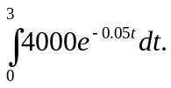
- (a) The revenue earned by selling 800 units is 40 million dollars.
(b) After 800 units have been produced and sold, the addition profit earned by selling one additional unit is 20 thousand dollars.
(c) After 800 units have been produced, the addition cost to produce one additional unit is 30 thousand dollars.
- (a) is (II), MP(500) = 0.
(b) is (VII), D(0) = 500.
(c) is (IV), R(500) = C(500).
- (I) is D, (II) is C, (III) is B, (IV) is A.
- (a) 0.02 or 2% per year.
(b) In 2002, t = 32, so Population = 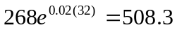thousand people.
(c) In 2050, t = 80, so Population = 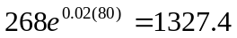thousand people.
(d) The estimate for 2002 is more likely to be accurate, as we have not assumed the growth rate is constant at 2% per year for as long. Extrapolation far beyond the data given is less reliable.
- (a) Mean is (IV),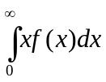.
(b) P(3 < X < 4) is (II)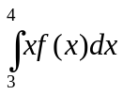.

(c) is (I), since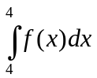= 0.
(d) is (V), since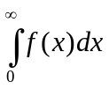= 1.
- (a) 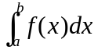= 5 (b)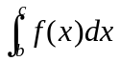 = –2 (c)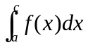= 5 – 2 = 3

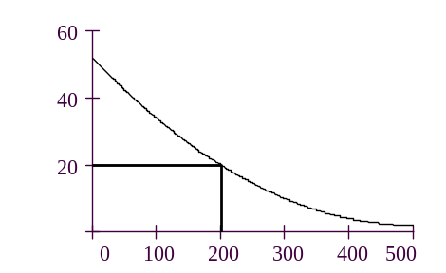
- (a) Demand function.
$
$
$
q
CS
R

(b) and (c)

- Revenue = 200(20)= $4000.

- Consumer Surplus 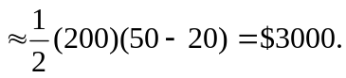

- (a) Probability is given by area under line between x = 1 and x = 2.
(b) Probability is given by value on vertical axis corresponding to x = 2.

- At x = 1, the graph is rising, so the slope is positive. Drawing the tangent line at x = 1, we estimate
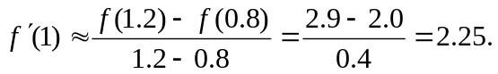
- (a) Mean is about 270 days.
(b) Standard deviation is about 14 days.
- (a) Since 60 is one standard deviation above the mean, probability is
(100-68)/2 = 16%.
(b) Mean is still 52.
- (c) Standard deviation is now 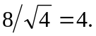
- (d) Since 60 is now two standard deviations above the mean, probability is
- (100-95)/2 = 2.5%.
- (a) If all companies bid the signal given by their geologist, the company which wins the bid will loose money. The reason for this is that some of the bids are above the true value of the lease; in particular the highest bid will be above the value of the lease. The average amount of money lost per bid is called the winner’s curse.
(b) Winner’s curse for separate bids is larger.
(c) Decrease.

