Math 128a
SOLUTIONS FOR STUDY GUIDE 1
Fall, 1999
prepared by
Richard B. Thompson

The following questions examine parts of the material which will be covered on Test 1.

Consider a randomly selected new Tucson area small business. Let L be the event that it stays in business for the next 5 years, and let M be the event that it is located in a shopping Mall. Chamber of Commerce records yield the following estimates for probabilities. P(L) = 0.20, P(M) = 0.40, and the probability of either L or M is 0.50.
L

M

1. Label the regions which represent the following events. (i) L and M. (ii) M but not L. (iii) L ∩ M^{C}.

2. Compute the following. (i) P(L and M). (ii) P(L^{C} ∩ M^{C}). (iii) The probability that neither L nor M happens. (iv) P(M^{C} ∪ L). (v) P(M|L). (vi) P(L|M).

(i) P(L and M) = P(L ∩ M) = P(L) + P(M) − P(L ∪ M) = 0.20 + 0.40 − 0.50 = 0.10.

(ii) P(L^{C} ∩ M^{C}) = P((L ∪ M)^{C}) = 1 − P(L ∪ M) = 1 − 0.5 = 0.5

(iii) The probability that neither L nor M happens = P(L^{C} ∩ M^{C}) = 0.5 (See part (ii).)

(iv) P(M^{C} ∪ L) = P((M ∩ L^{C})^{C}) = 1 − P(M ∩ L^{C}) = 1 − (P(M) − P(L ∩ M)) = 1 − 0.4 + 0.1 = 0.7

(v) P(M|L) = P(M ∩ L)/P(L) = 0.1/0.2 = 0.5

(vi) P(L|M) = P(L ∩ M)/P(M) = 0.1/0.4 = 0.25

3. Describe the shaded region (i) in words, and (ii) in set symbols.
L

M

(i) The business does not last for five years and is not located in a shopping mall.

(ii) P(L^{C} ∩ M^{C})

4. (i) Are L and M independent? (ii) Are L and M mutually exclusive?

(i) P(L)⋅P(M) = 0.2⋅0.4 = 0.08, but P(L ∩ M) = 0.1. The events are not independent.

(ii) P(L ∩ M) = 0.1 ≠ 0. Hence, L ∩ M ≠ ∅, and the events are not mutually exclusive.

5. What is the real-world interpretation of the statement that, "P(L) = 0.2?"

Out of a huge number of new small business in the Tucson area, approximately 20% of them will be in business for the next 5 years.

6. If P(L) and P(L|M) are different, explain in real-world terms what that difference tells you about small businesses.

P(L) = 0.2 < 0.25 = P(L|M). Hence, it is more likely that a small business in the Tucson area will last for 5 years, if it is in a shopping mall.

A spinner stops at numbers 1, 2, or 3 with the probabilities 0.5, 0.3, and 0.2; respectively. You are to make two independent spins and record the numbers. Let X be the random variable which gives the sum of the numbers obtained on the two spins.

7. Set up a sample space, S, for this experiment, and assign realistic probabilities to each of the 9 outcomes.

Let (n,m) denote an n on the first spin and an m on the second spin. Let S = {(1,1), (1,2), (1,3), (2,1), (2,2), (2,3), (3,1), (3,2), (3,3)}. Since the spins are independent, P((n,m)) = P(n)⋅P(m).

Outcome | (1,1) | (1,2) | (1,3) | (2,1) | (2,2) | (2,3) | (3,1) | (3,2) | (3,3)
Probability | 0.25 | 0.15 | 0.10 | 0.15 | 0.09 | 0.06 | 0.10 | 0.06 | 0.04
x | 2 | 3 | 4 | 3 | 4 | 5 | 4 | 5 | 6

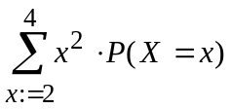
8. Compute the following. (i) P(2< X ≤ 5). (ii) P(X = 6) (iii) E(X). (iv)

x | 2 | 3 | 4 | 5 | 6
P(X = x) | 0.25 | 0.30 | 0.29 | 0.12 | 0.04
(i) P(2< X ≤ 5)= P(X = 3) + P(X = 4) + P(X = 5) = 0.30 + 0.29 + 0.12 = 0.71

(ii) P(X = 6) = 0.04

(iii)

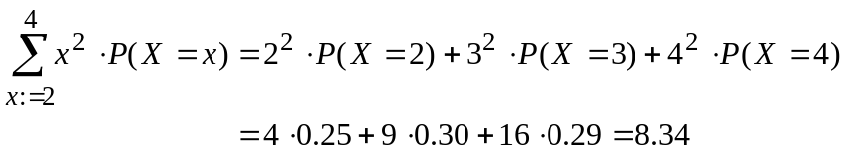
(iv)

9. What is the real-world interpretation of the number E(X)?

If sets of two spins are repeated for a huge number of times, the average value of the sums will be approximately 3.4.

The following problems refer to the data in only the first 20 loan records in the file Bank Records.xls, and uses the notation of Class Project 1.

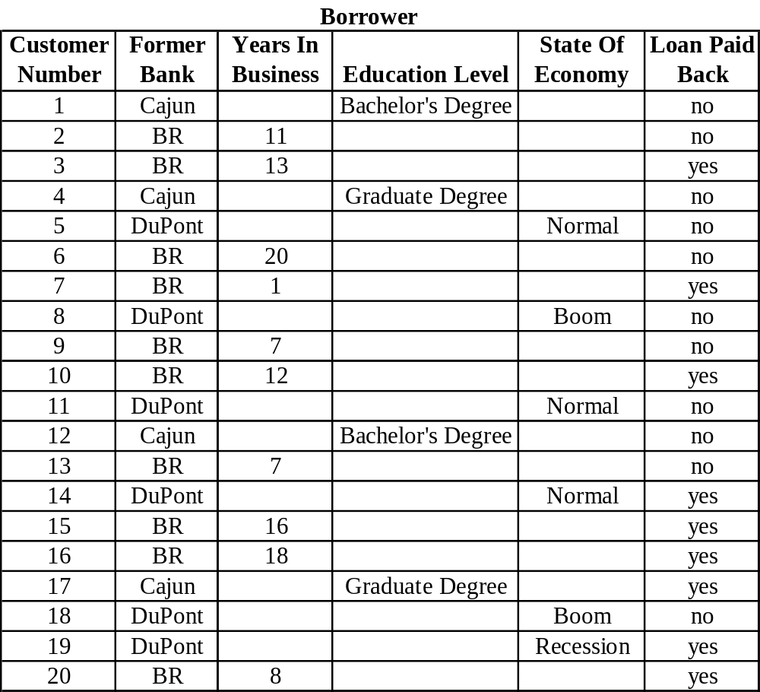

10. Use this data to estimate the following. (i) P(S). (ii) P(S_{DP}|C_{DP}). (iii) P(C_{DP}|S_{DP}).

(i) P(S) ≅ 9/20 = 0.45

(ii) P(S_{DP}|C_{DP}) ≅ P(S_{DP} ∩ C_{DP})/P(C_{DP}) = (1/6)/(3/6) = 1/3

(iii) P(C_{DP}|S_{DP}) = P(C_{DP} ∩ S_{DP})/P(S_{DP}) = (1/6)/(2/6) = 1/2

