Math 128a
SOLUTIONS FOR STUDY GUIDE 2
Fall, 1999
prepared by
Richard B. Thompson

The following questions explore parts of the material which will be covered on Test 2.

Problems 1, 2, and 3 refer to a sum of $20,000 which is deposited in a savings account that pays an annual rate of 4.9%.

1. What is the effective annual yield on the account, if interest is compounded continuously? Give your answer as a percentage, rounded to 2 decimal places, e.g., x.xx%.

Solution. y = e^{r} − 1 = e^{0.049} − 1 ≅ 0.0502 = 5.02%

2. What is the future value of the account after 5 years, if interest is compounded continuously?

Solution. F = P⋅e^{r⋅t} = $20,000⋅e^{0.049⋅5} ≅ $25,552.43

3. What is the future value of the account after 5 years, if interest is compounded quarterly?
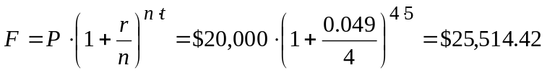
Solution.

4. If interest is compounded continuously at 6.5%, what is the present value of a future payment of $50,000 that is to be made 8 years from now?

Solution. P = F⋅e^{−r⋅t} = $50,000⋅e^{0.065⋅8} ≅ $29,726.03

5. Fill in the Frequency, Relative Frequency, and Percentage columns, as they would be done by the Histogram and other functions in Excel. Do this manually, not with the help of Excel.

Data | Bins | Frequency | Relative Frequency | Percentage
2.4 | 3 | 4 | 0.33 | 33%
5.5 | 4 | 2 | 0.17 | 17%
4.0 | 5 | 3 | 0.25 | 25%
5.1 | 6 | 2 | 0.17 | 17%
5.0 | 7 | 1 | 0.08 | 8%
3.0
4.7
5.0
2.8
3.6
2.7
6.2

Problems 6 and 7 refer to the following plot of ratios for 600 weekly closes on a stock.
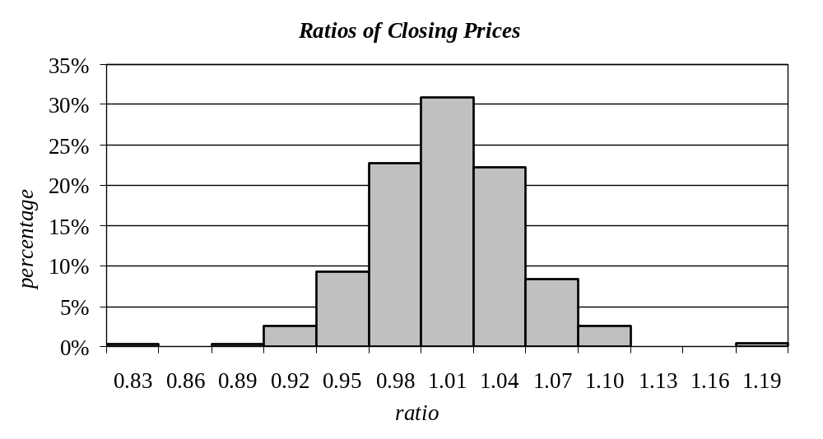

6. Approximately how many ratios were between 0.995 and 1.025?

Solution. Approximately 0.31⋅600 = 186 ratios.

7. Assuming that these ratios are a random sample for the random variable R, which gives the weekly ratio of closes, estimate P(R ≥ 1.025).

Solution. P(R ≥ 1.025) ≅ (number of ratios ≥ 1.025)/600
≅ (0.22 + 0.08 + 0.03 + 0.01)⋅600/600 = 0.34

8. Let X be the random variable giving the value of the S and P 500 Index on July 1, 2001. Is X finite or continuous? Is f_{X} a p.m.f. or a p.d.f.?

Solution. X is a continuous random variable, with a p.d.f.

9. Let Y be the random variable giving the number of months in the year 2001 when the S and P 500 Index has a monthly high above 1,600. Is Y finite or continuous? Is f_{Y} a p.m.f. or a p.d.f.?

Solution. Y is a finite random variable, with a p.m.f.

10. For each graph, select the statement that is most likely to be correct.

a. The function is a probability mass function for a finite random variable.
b. The function is a probability density function for a continuous random variable.
c. The function is a cumulative distribution function for a finite random variable.
d. The function is a cumulative distribution function for a continuous random variable.
e. None of the above.
Hint: look carefully at the numbers on the axes.

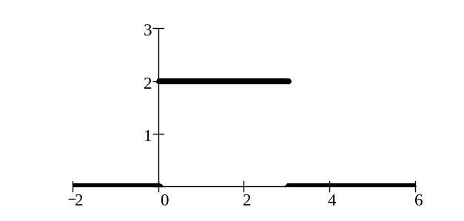
(i)

___ a. ___ b. ___ c. ___ d. _x_ e.
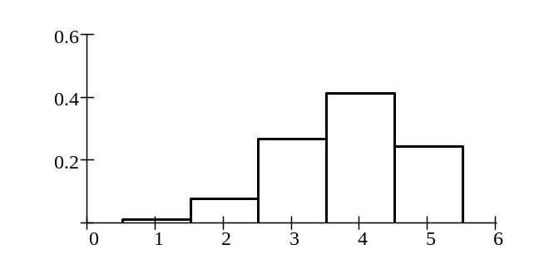
(ii)

_x_ a. ___ b. ___ c. ___ d. ___ e.

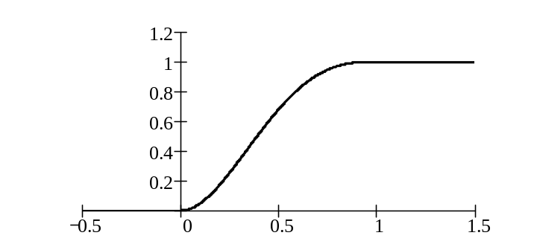
(iii)

___ a. ___ b. ___ c. _x_ d. ___ e.

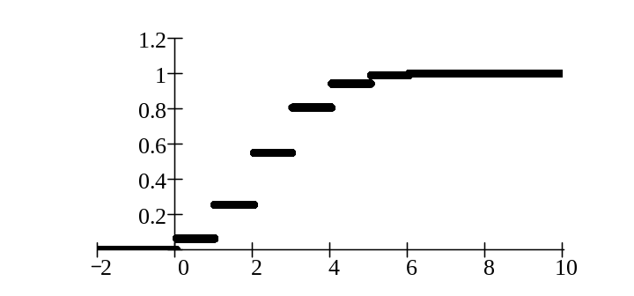
(iv)

___ a. ___ b. _x_ c. ___ d. ___ e.

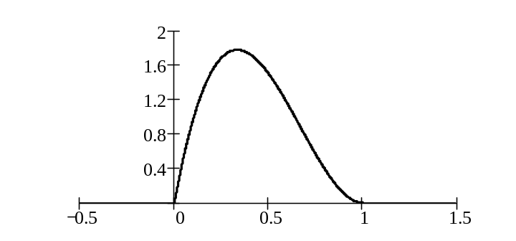
(v)

___ a. _x_ b. __ c. ___ d. ___ e.

10. A random variable W has the following values and probabilities.

w | 0 | 1 | 2 | 4 | 8 | 16
P(W = w) | 0.1 | 0.1 | 0.2 | 0.2 | 0.3 | 0.1

(i) The c.d.f., F_{W} has F_{W}(8) = _0.9. (ii) The p.m.f., f_{W} has f_{W}(8) = _0.3.

(iii) The c.d.f., F_{W} has F_{W}(10) = _0.9. (iv) The p.m.f., f_{W} has f_{W}(10) = _0_ .

11. T is a uniform continuous random variable on the interval [2, 6].

(i) The p.d.f., f_{T} has f_{T}(3) = _0.25 . P(T = 3) =_0_ .?

12. For each of the following functions, tell were it is located in Excel, and describe its use.

(i) VLOOKUP (ii) IF (iii) RAND

(iv) HISTOGRAM (v) RANDBETWEEN (VI) SORT

Solution. (i) VLOOKUP is found in the Lookup and reference functions. It is used to find the number in a given column, based upon the value in another column.

(ii) IF is found in Logical functions. It is used to choose between two expressions, depending upon the truth of a given statement.

(iii) RAND is found in the Math & trig functions. It is used to generate an observation of a continuous random variable which is uniform on [0, 1].

(iv) HISTOGRAM is found under Tools/Data Analysis. It is used to count the number of data points which lie within specified ranges.

(v) RANDBETWEEN is found in the Math & trig functions. It is used to generate random integers between given limits.

(vi) SORT is found under Data. It is used to sort data points by columns or rows.

Problems 13, 14, and 15 refer to a 10 week European call option on ABC stock with a strike price of $90.

13. A few of the historical adjusted weekly closing prices are shown below.

Week of | Adjusted Close | Ratio
Nov. 15, 1999 | $86.89 | 1.0109
Nov. 8, 1999 | $85.95 | 1.0198
Nov. 1, 1999 | $84.28 | 0.9800
Oct. 25, 1999 | $86.00 | 1.0126
Oct. 18, 1999 | $84.93

Fill in the column with ratios of weekly closes and compute the mean ratio for the given period.

Solution. The mean ratio is (1.0109 +1.0198 + 0.9800 + 1.0126)/4 = 1.0058

14. Suppose that the only possible closing prices of ABC, at the end of the option, are $84, $91, and $93. If the three closing values are all equally likely, what is the expected value of C, the closing value? What does E(C) tell you about the future value of the option?

Solution. E(C) = $84⋅(1/3) + $91⋅(1/3) + $93⋅(1/3) = $89.33. This number does not tell us anything about the future value of the option.

15. Under the conditions in Problem 14, what is the expected future value of the option?

Solution. Let F give the future value of the option. E(F) = $0⋅(1/3) + $1⋅(1/3) + $3⋅(1/3) = $1.33.

