*The 9th East Asian Workshop for Marine Environment and Energy (EAWOMEN2 2019)*

*Osaka, Japan*

*October 27-29, 2019*

Sustainability assessment based on the Aquaculture Intensity Index (AII) approach: a case study in Oita prefecture, Japan

*Hongxia Gao*, Yulong Wang**, Shuchuang Dong*** and Daisuke Kitazawa\*\*\**

*\* Department of Systems Innovation, Graduate School of Engineering, The University of Tokyo,*

*Chiba-ken 277-8574, Japan, hxgao@iis.u-tokyo.ac.jp*

*\*\* Graduate Program in Sustainability Science - Global Leadership Initiative, Graduate School of Frontier Sciences, The University of Tokyo,*

*Chiba-ken 277-8563, Japan, yulong.wang@s.k.u-tokyo.ac.jp*

*\*\*\*Institute of Industrial Science, The University of Tokyo,*

*Chiba-ken 277-8574, Japan, dongsc@iis.u-tokyo.ac.jp, dkita@iis.u-tokyo.ac.jp*

# ABSTRACT

The nutrient load generated by excessive coastal aquaculture farms leads to self-pollution, destroying aqua-environment and lead to a decline in aquaculture production. In order to assess the sustainability of coastal aquaculture and estimate the optimal aquaculture intensity in the future, a simplified Aquaculture Intensity Index (AII) is proposed. Several variables such as annual fish production was utilized, of which the deep learning satellite image object detection technology is applied to estimate the number of fish cages. Case study of several aquaculture farms in Oita prefecture found that the fish production model has a high accuracy working with satellite image analysis results. Furthermore, the AII of aquaculture farms vary greatly which reach different orders of magnitude. Current study is the base for the future work to find an optimal AII value to assess the sustainability of fish farms.

# KEYWORDS

Sustainability assessment; Aquaculture Intensity Index (AII); Fish production model; Satellite image object detection.

# INTRODUCTION

In recent years, coastal aquaculture production has increased rapidly with causing the pollution problem. The intensity of aquaculture in coastal areas has been a key variable of the red tides and hypoxic or anoxic water masses occurrence. As Club of Rome indicated [1], the increase in aquaculture intensity does not lead to a linear increase in fisheries, and even leads to a reduction in production. Determining the optimum aquaculture intensity is important for the sustainable development of aquaculture.

Many coupled numerical models of hydrodynamics and ecosystems in coastal waters have been developed to make estimations. For instance, a three-dimensional (3D) ocean model coupled with ecosystem and individual-based submodels, Marine Environmental Committee (MEC) [2-3], was developed to explore the aquaculture capacity, biochemical impact and ecological footprint. In these models, topography, tides, currents, surface forcing, and river boundaries need to be delicately configured, meanwhile, the application of an ecosystem submodel should consider regional specificity, and large-scale temporal and spatial dynamic prediction are not easy. In general, applying a sophisticated simulation is time consuming and tedious for data preparation, and it is still difficult to make a regional evaluation for collections of fisheries farms based on limited data. On the other hand, current published statistical database on annual aquaculture production, the Marine Aquaculture Production Statistics [4], have detailed statistics records over years but focuses on administrative division rather than fishery farm division. It surveyed the production of both fishery and aquaculture, from the category of inland, sea surface, coastal, offshore, and pelagic. However, the accuracy of such production data cannot be used to assess in fishery farm level, which leaves difficulties to estimate the farm intensity.

The construction and application of an appropriate index determines the feasibility of assessing the aquaculture sustainability. A Sealing Index of Bay [5] was proposed to evaluate the closure of the offshore bays of Japan, which had experienced frequent red tides since the 1960s. This index evaluated the water exchange ability by non-dimensioning the surface area of the water, the width of the bay mouth, the average water depth of bay mouth and inner bay. However, the spread of waste materials from aquaculture farms cannot ignore the tides and flow. In 2006, the Ocean Policy Research Institute proposed a comprehensive approach [6] to the health assessment of 88 semi-closed bays across the country from the perspective of ecosystem stability and material circulation fluency. Assessment in aquaculture farm scale has become the next step of the work.

In order to evaluate the sustainability of fish farm, an index called Aquaculture Intensity Index (AII) is proposed in this research, based on the annual aquaculture production and the farm dimension information, and a case study is conducted in several bays of Oita prefecture, where yellowtail and tuna are majorly cultured.

# METHODS

## 1) Fish production model

The formula of annual fish production of each farm is derived from Rebecca's study [7], in which the production per year was calculated by dividing the total farm output by the number of years between stocking and harvest. Considering the continuity of fishery farming, the annual fish production is defined as the ratio of total fishery production to stock cycle, as shown in Eq. 1:

|  |  |  |
| --- | --- | --- |
|  |  | (Eq. 1) |

where [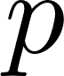](https://www.codecogs.com/eqnedit.php?latex=p%250) (kg year-1) is the annual production of a fish farm. [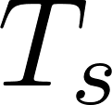](https://www.codecogs.com/eqnedit.php?latex=T_%7Bs%7D%250) (year) is the period between stocking and harvest of a specific fish species, the subscript [](https://www.codecogs.com/eqnedit.php?latex=s%250) represents different species of fish, and [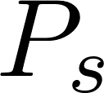](https://www.codecogs.com/eqnedit.php?latex=P_%7Bs%7D%250) (kg) is the corresponding total output during [](https://www.codecogs.com/eqnedit.php?latex=T_%7Bs%7D%250). Considering that some farms stock more than one fish species, [A close up of a logo
](https://www.codecogs.com/eqnedit.php?latex=m%250) denotes species number in a farm, annual production of a farm is the sum of annual production of each species, .

To calculate the total production of each species, the formula shown in Eq. 2 is used:

|  |  |  |
| --- | --- | --- |
|  |  | (Eq. 2) |

where [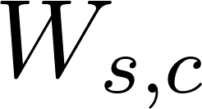](https://www.codecogs.com/eqnedit.php?latex=W_%7Bs%2Cc%7D%250) (kg) is the weight of seawater inside each fish cage, which is calculated by [](https://www.codecogs.com/eqnedit.php?latex=W_%7Bs%2Cc%7D%250) =[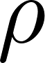](https://www.codecogs.com/eqnedit.php?latex=%5Crho%250) [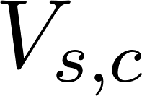](https://www.codecogs.com/eqnedit.php?latex=V_%7Bs%2Cc%7D%250), and the subscript [](https://www.codecogs.com/eqnedit.php?latex=c%250) represents different number of fish cages. [](https://www.codecogs.com/eqnedit.php?latex=V_%7Bs%2Cc%7D%250) (m3) means the volume of fish cage and [](https://www.codecogs.com/eqnedit.php?latex=%5Crho%250) (1,025kg m-3) is the density of seawater. The area of fish cage is measured from satellite images and mean depth of a cage is assumed 8 meters. [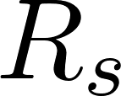](https://www.codecogs.com/eqnedit.php?latex=R_%7Bs%7D%250) is the stock rate of species, which means weight ratio of stocked fish and seawater inside the cage when the fish are available for harvest. [A close up of a logo
](https://www.codecogs.com/eqnedit.php?latex=n%250) denotes cage number of a species in a farm. Table 1 shows the parameter value of each species, the values of which are based on interviews with local farmers.

**Table 1 The stock rate and harvest period of two species fish.**

|  |  |  |
| --- | --- | --- |
| Parameter | Value | |
| Yellowtail | Tuna |
|  | 3.0% | 0.3% |
| (year) | 2.0 | 3.0 |

## 2) Aquaculture intensity index

Kitazawa [8] proposed an indicator for evaluating the sustainability of farms and this paper simplifies this indicator: considering annual production, area and mean water depth of fish farms (see Eq. 3).

|  |  |  |
| --- | --- | --- |
|  |  | (Eq. 3) |

where [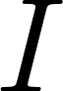](https://www.codecogs.com/eqnedit.php?latex=I%250) (kg m-3) means the aquaculture intensity index. Smaller [](https://www.codecogs.com/eqnedit.php?latex=I%250) means lower culture intensity and higher sustainability. [](https://www.codecogs.com/eqnedit.php?latex=p%250)(kg), [](https://www.codecogs.com/eqnedit.php?latex=A%250) (m2), and [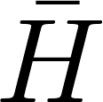](https://www.codecogs.com/eqnedit.php?latex=%5Cbar%7BH%7D%250) (m) are the annual production, surface area, and mean depth of each farm, respectively. The greater the water depth, the more easily the excretion is spread, and the bottom pollution is less likely to occur. The larger the area of the farm, the smaller the stocking density and the smaller the local water quality pollution.

# Materials

The calculation period of this research is 2017. The AII approach is applied in the coastal area of Tsukumi city and Saiki city, where farms of yellowtail and tuna of Oita prefecture located (see Fig. 1), accounting for about 91% of the fish production of Oita prefecture in 2017.

## 1) Data source and preparation

In the research area, the aquaculture farm is marked out by red and light blue polygons (see Fig. 2) based on the Aquaculture Database (<http://www.yousyokugyojyou.net/index2a.htm>), the Coastal Environmental Information Service (CeisNet), Environmental Sensitivity Index (ESI) database (<https://www1.kaiho.mlit.go.jp/JODC/ceisnet/index.html>) and the Aquaculture Survey Database ([http://](http://www.yousyokugyojyou.net/gyojyo/gyojyodatabase.php)<http://www.yousyokugyojyou.net/>), 26 red polygons of which show the Yellowtail and Tuna farms. The topography is integrated in a GIS based database from Japan Oceanographic Data Center (JODC, <https://www.jodc.go.jp/jodcweb/index_j.html>) with 500 meter resolution, which is used to estimate the AII. The satellite images are downloaded from Google Earth historical data server in the geographic Tagged Image File Format (geo-TIFF) tiles at 20th zoom level, which are spliced later to high resolution satellite images of interested aquaculture farms.

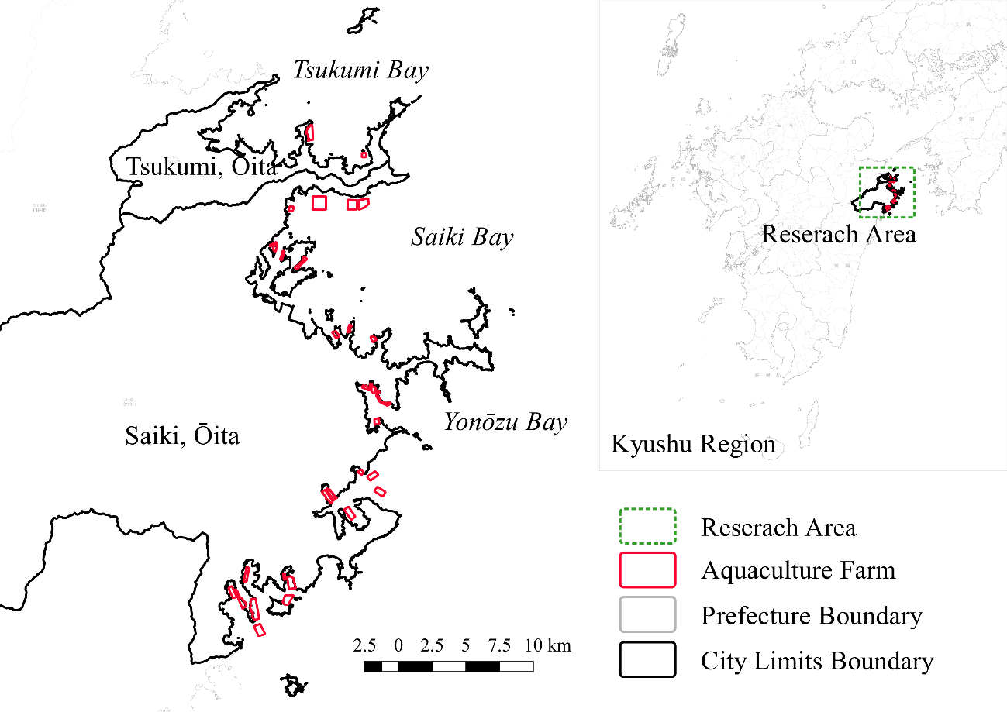

**Fig. 1 Research area and the aquaculture farms.**

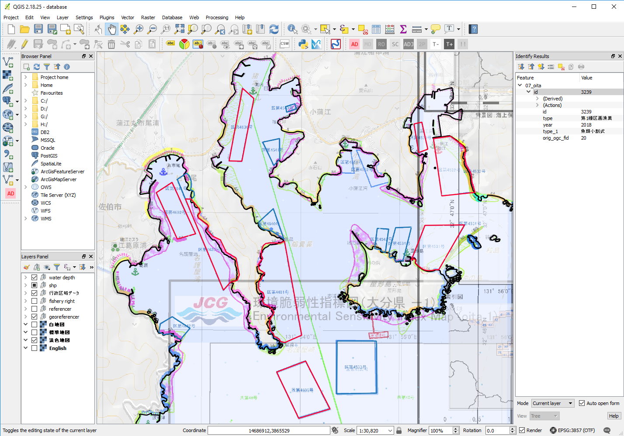

**Fig. 2 An integrated GIS database of aquaculture farms.**

## 2) Aquaculture cage detection and counting

Detection and counting of aquaculture cages from a large number of satellite images is achieved by applying the Faster R-CNN framework based on the TensorFlow software library (TF Faster R-CNN) [9]. The object detection technology is a primary application of deep learning in the field of imagery, which has been widely used, for example, merchant ship detection from satellite images [10], and the Faster R-CNN is the state-of-the-art framework for target detection.

This application uses own training dataset with 150 satellite images be labeled manually in advance. The target detection mission focuses on aquaculture cages in satellite images, in which two subtasks are included. One of the subtasks is to generate the classes information of aquaculture cages, namely the classification task, which will locate the aquaculture cage and distinguish the classes name of the cage, such as “square”(cyan bounding box), “round” (green bounding box), and “ship” (white bounding box) (see Fig.3). The second is to output the geographic location information of the target, the positioning task, which will output the center latitude and longitude and scale of the bounding box. The area of the aquaculture cage will be estimated on the basis of the bounding box scale, and the number of aquaculture cages will be estimated based on the length of the bounding box latitude and longitude vector.

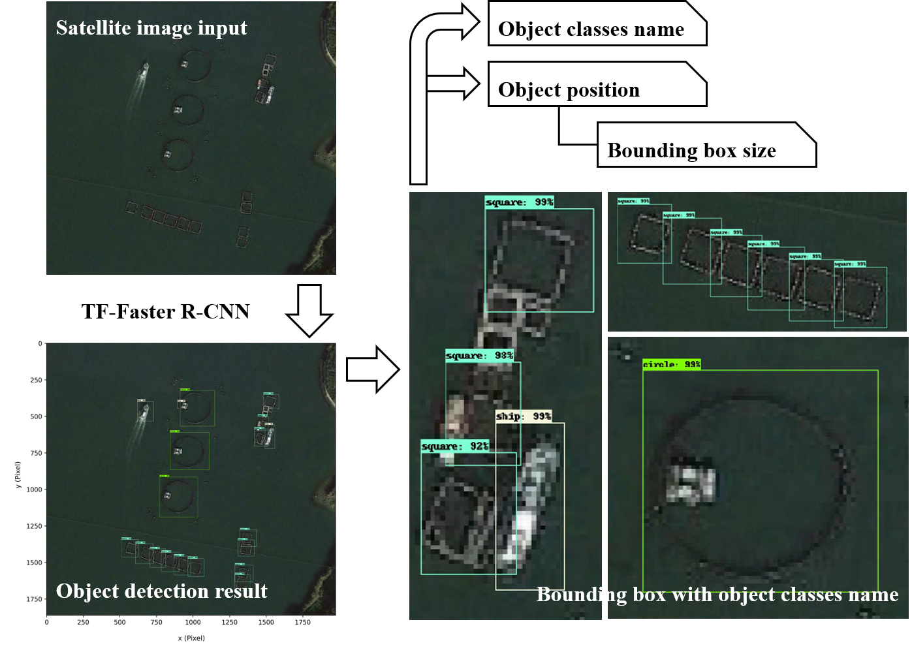

**Fig. 3 Diagram of fish cage detection and counting working flow.**

# RESULTS AND DISCUSSION

In order to verify the fishery production model, the production of two species of fish produced by aquaculture farms in the region area are verified, namely the total output of Yellowtail and Tuna in Oita Prefecture: [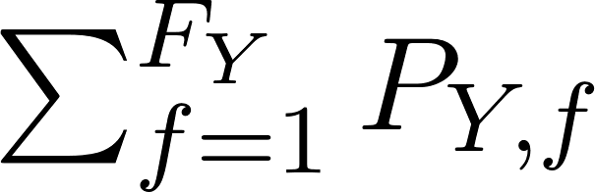](https://www.codecogs.com/eqnedit.php?latex=%5Csum_%7Bf%3D1%7D%5E%7BF_%7BY%7D%7DP_%7BY%2Cf%7D%250) and [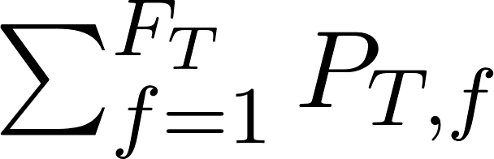](https://www.codecogs.com/eqnedit.php?latex=%5Csum_%7Bf%3D1%7D%5E%7BF_%7BT%7D%7DP_%7BT%2Cf%7D%250). Wherein, the subscript [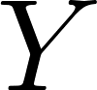](https://www.codecogs.com/eqnedit.php?latex=Y%250) indicates the species of Yellowtail, meanwhile the subscript [](https://www.codecogs.com/eqnedit.php?latex=T%250) represents the species of Tuna; the subscript [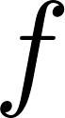](https://www.codecogs.com/eqnedit.php?latex=f%250) represents the farm No. corresponding to the produced fish species; in addition, [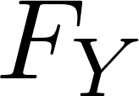](https://www.codecogs.com/eqnedit.php?latex=F_%7BY%7D%250) is the number of Yellowtail farms, and [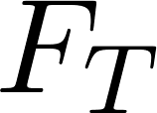](https://www.codecogs.com/eqnedit.php?latex=F_%7BT%7D%250) is the number of Tuna farms.

Compared with the Marine Aquaculture Production Statistics [4] of 2017, the estimated yellowtail production of Oita prefecture is 0.82% higher than the statistical production, and the calculated tuna production is 3.68% higher than the statistical production. Table 2 indicates that the fish production model has excellent performance coupling with TF Faster R-CNN cage detection framework. The possible causes of the deviation may be caused by the deviation while doing calculation of cage volume or the assumed stocking rate.

**Table 2 Estimated and statistical Yellowtail and Tuna production in the year of 2017, Oita.**

|  |  |  |  |
| --- | --- | --- | --- |
| Species | Estimated Production | Statistical Production | Deviation |
| (103kg) | (103kg) |
| Yellowtail | 19,650 | 19,488 | 0.82% |
| Tuna | 903 | 871 | 3.68% |

Another result is presented in the form of an AII map, as shown in Figure 4. 26 aquaculture farms are plotted in the form of a scatter points on a plane Cartesian coordinate system, of which the [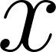](https://www.codecogs.com/eqnedit.php?latex=x%250) axis is Farm water volume ([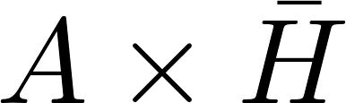](https://www.codecogs.com/eqnedit.php?latex=A%20%5Ctimes%20%5Cbar%7BH%7D%250), unit: [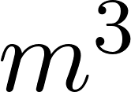](https://www.codecogs.com/eqnedit.php?latex=y%250) axis is Farm annual production ([](https://www.codecogs.com/eqnedit.php?latex=p%250), unit: [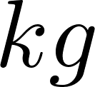](https://www.codecogs.com/eqnedit.php?latex=kg%250)). Farm AII values distribution contours are plotted and labelled.

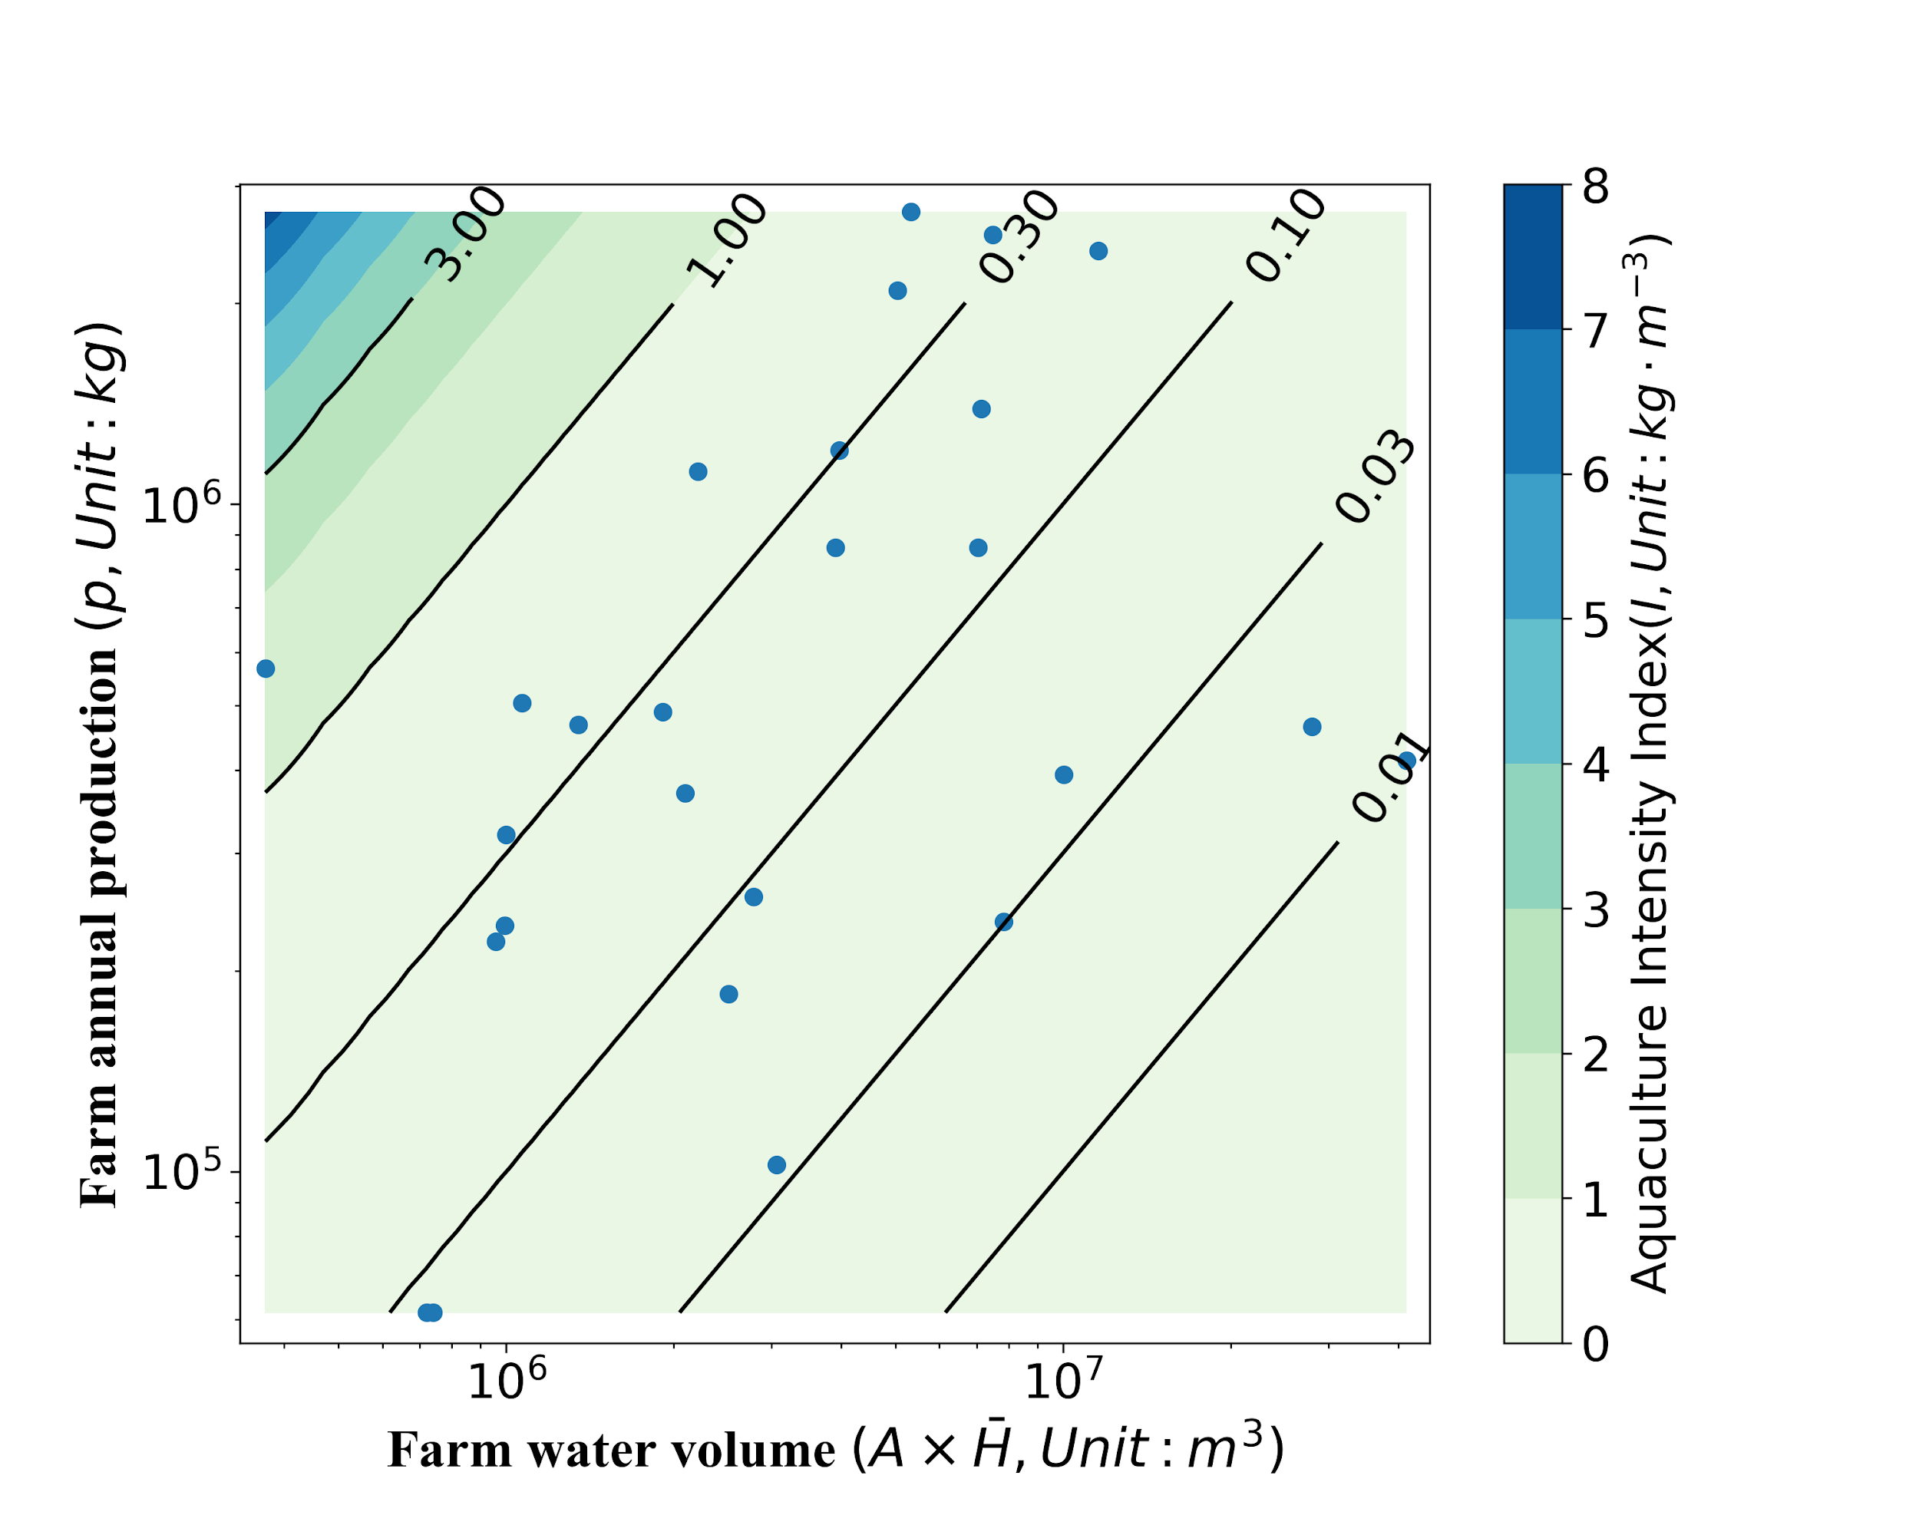

**Fig. 4 AII distribution map of aquaculture farms.**

As shown in the distribution of farm AII, only one farm has relative high intensity value which is greater than 1.00, while about two-thirds of the farms index are scattered between the range of 0.10 to 1.00, and another one-third are located on the range between 0.01 to 0.10. The AII of aquaculture farms varies significantly, even reaching different orders of magnitude. This phenomenon indicates that the allocation of farm cages and planning of fish harvest have large different between farms.

# CONCLUSIONS

The stocking rate values used in this study are practiced data. Generally, farmers would like to increase the stocking density in order to maximize the profit in the licensed area. However, the excessive stocking density must lead to self-pollution problems in the aquaculture area. This is the issues about the balance between aqua-environmental standards and increasing food demands. Therefore, it is important to assess the capacity of the farm and maximize the aquaculture production within the capacity to meet food demands. The results can provide reference for making aqua-environmental standards and stock density of fish farms to ensure sustainable development of marine aquaculture. In the future, the area analyzed by this method will be enlarged and finding an optimal AII value will be conducted, combining with water current and water quality information, such as total nitrogen, total phosphorus, and the reports of occurrence of red tides, to evaluate the sustainability of aquaculture farms.

# ACKNOWLEDGEMENT

This research went smoothly with a variety of helps. The data which is important to the publishing of research come from National Land Numerical Information download service, Hydrographic and oceanographic department of the Japan Coast Guard and the Aquaculture Survey Database. I would like to express my gratitude.

# BIOGRAPHY

Hongxia Gao is a Master course student at Department of Systems Innovation, Graduate School of Engineering, The University of Tokyo. Her main field of research area are making sustainability assessment of coastal and marine aquaculture in Japan, and the GIS-based database initialization and visualization.

# REFERENCES

[1] Donella, H.M., Dennis, L.M., Jorgen, R. and William, W.B., 1972, *The Limits to Growth*, Potomac Associates, Washington, DC.

[2] Kitazawa, D., Zhou, J., Park, S., Zhang, J., Dong S., Li Q. and Yoshida, T., 2019, Study on numerical analysis of environmental capacity in aquaculture area. Japan Society of Fisheries Engineering Proceedings, 2019, 99-100. DOI: 10.18903/pamjsfe.2019.0_99. (in Japanese)

[3] Zhang, J., and Kitazawa, D., 2016, Assessing the bio-mitigation effect of integrated multi-trophic aquaculture on marine environment by a numerical approach. Marine pollution bulletin, 110(1), 484-492. DOI: 10.1016/j.marpolbul.2016.06.005.

[4] Ministry of Agriculture, Forestry and Fishieries (MAFF), “The Marine Aquaculture Production Statistics”. Minister's Secretariat Statistics Department Production Distribution Consumption Statistics Section of Ministry of Agriculture, Forestry and Fishieries. Accessed Aug. 2019. <http://www.maff.go.jp/j/tokei/kouhyou/kaimen_gyosei/>. (in Japanese)

[5] Kunimatsu, T., and Muraoka, H., 1989, *Model Analysis of River Pollution*, Gihodo Shuppan, Tokyo. (in Japanese)

[6] Ocean Policy Research Institute, 2006, *Health Checkup Survey Report of Closed Bay*, Ocean Policy Research Institute, Tokyo. (in Japanese)

[7] Rebecca, R.G., Halley, EF., Dietmar, G., Peter, K., Michael P., Michael, R., Steven, DG., and Benjamin, S.H., 2017, Mapping the global potential for marine aquaculture. Nature Ecology & Evolution, 1(9), 1317. DOI: 10.1038/s41559-017-0257-9.

[8] Kitazawa, D., 2016, *A simple assessment method for sustainability of aquaculture farms*, Unpublished report. (in Japanese)

[9] Ren, S., He, K., Girshick, R., & Sun, J., 2015, Faster R-CNN: Towards real-time object detection with region proposal networks. In Advances in neural information processing systems, 91-99. arXiv:1506.01497v3.

[10] Zhang, S., Wu, R., Xu, K., Wang, J., & Sun, W., 2019, R-CNN-Based Ship Detection from High Resolution Remote Sensing Imagery. Remote Sensing, 11(6), 631. DOI: 10.3390/rs11060631.