*The 9th East Asian Workshop for Marine Environment and Energy (EAWOMEN2 2019)*

*Osaka, Japan*

*October 27-29, 2019*

### Sustainability assessment of aquaculture farm: a compared study in several bays, Japan (Aquaculture intensity evaluation compared study in Oita, Japan)

Hongxia Gao*\*, Yulong Wang**, Shuchuang Dong*** and Daisuke Kitazawa\*\*\**

*\* Department of Systems Innovation, Graduate School of Engineering, The University of Tokyo,*

*Chiba-ken 277-8574, Japan, hxgao@iis.u-tokyo.ac.jp*

*\*\* Graduate Program in Sustainability Science - Global Leadership Initiative, Graduate School of Frontier Sciences, The University of Tokyo,*

*Chiba-ken 277-8563, Japan, yulong.wang@s.k.u-tokyo.ac.jp*

*\*\*\*Institute of Industrial Science, The University of Tokyo,*

*Chiba-ken 277-8574, Japan, dongsc@iis.u-tokyo.ac.jp, dkita@iis.u-tokyo.ac.jp*

# ABSTRACT

Nutrient loadings produced by excessive near-shore aquaculture farms lead to self-induced pollution, destroying the surrounding environment and resulting in decline in aquaculture production. In order to assess the aquaculture sustainability of several farms in Japan, a simple index, combined fish production and water volume of fish farm is established to evaluate the aquaculture intensity. Satellite image analysis method is used to count the number of fish cages. A statistical model is established to calculate the annual production of fish farms. This research takes a compared study in several bays in Oita, Japan. The result can provide reference for making environmental standards of fish farms and aquaculture density decision and ensure sustainable development of marine aquaculture in Japan.

# KEYWORDS

Aquaculture sustainability; Culture intensity index; Satellite image analysis; Fish production model

# INTRODUCTION

In recent years, coastal aquaculture production has increased rapidly with causing the contamination problem, the intensity of aquaculture in coastal areas has been a key variable of the red tides and anoxic water masses occurrence. As Club of Rome indicated [1], the increase in aquaculture intensity does not lead to a linear increase in fisheries, and even leads to a reduction in production. Determine the optimum aquaculture intensity is important for the sustainable development of aquaculture.

Many coupled numerical models of hydrodynamics and ecosystems in coastal waters have been developed to make estimations. For instance, a three-dimensional (3D) ocean model coupled with ecosystem and individual-based submodels, Marine Environmental Committee (MEC) [2-3], was developed to explore the aquaculture capacity, biochemical impact and ecological footprint. In these models, topography, tides, currents, surface forcing, and river boundaries need to be delicately configured, meanwhile, the application of an ecosystem submodel should consider regional specificity, and large-scale temporal and spatial dynamic prediction are not easy. In general, applying a sophisticated simulation is time consuming and tedious for data preparation, and it is still difficult to make a regional evaluation for collections of fisheries grounds based on limited data. On the other hand, current published statistical database on annual aquaculture production, the Marine Aquaculture Production Statistics (海面漁業生産統計調査) [4], have detailed statistics records over years but focuses on administrative division rather than fishery ground division. It surveyed the production of both fishery and aquaculture, from the category of inland, sea surface, coastal, offshore, and pelagic. However, the accuracy of such production data cannot be used to assess in fishery farm level, which leaves difficulties to estimate the farm intensity.

养殖密度指数

The intensity of aquaculture,

In this article, an indicator is established to assess the aquaculture intensity based on the annual aquaculture production and the fishery farm dimension information in the Oita Sea. 未完待续，补充指数部分。

# METHODS

In recent years, coastal aquaculture production has increased rapidly with causing the contamination problem, the intensity of aquaculture stocking in coastal areas has been a key variable of the red tides and anoxic water masses occurrence. As Club of Rome indicated [1], the increase in aquaculture density does not lead to a linear increase in fisheries, and even leads to a reduction in production. Determine the optimum aquaculture stocking density is important for the sustainable development of aquaculture.

## 1）Fish production model

The formula of annual fish production of each farm is

|  |  |  |
| --- | --- | --- |
|  |  | （1） |

where *P*(kg) is the annual production of each fish farm. *V*(m3) is the volume of each cage. *ρ* (=1,025kg m-3) is the density of seawater. *r* is the stock rate of fish, mean weight ratio of stocked fish and seawater inside the cage. *n* is the number of cages in each fish farm. *y* is the year of culture cycle.

这一个段落，主要说明为什么 Pti = Pi / y，关键是y这个养殖周期的说明，这一部分要十分详细，让人理解这个公式的含义。然后再将话题转移到每个渔场的产量，他的计算公式由公式二表示。

|  |  |  |
| --- | --- | --- |
|  |  | （2） |

The production data used in previous case studies is basically from field surveys. However, due to business secrets, fishery production information is not easy to get. The method proposed here provides a new way of estimating aquaculture production and can estimate a larger range of fish production, not limited to a single fish farm.

Table 1 Parameter value

|  |  |  |
| --- | --- | --- |
| parameter | value | |
| yellow tail | tuna |
| *r* (kg kg-1) | 3% | 0.3% |
| *y* | 2 | 3 |

## 2）Culture intensity index

The environmental impact of fish farm is not only related to stocking density (weight of fish stocked per unit cage volume), but also to the physical conditions of the farm. The greater the water depth, the more easily the excretion is spread, and the bottom pollution is less likely to occur. The larger the area of the fishery, the smaller the stocking density and the smaller the local water quality pollution. Therefore, this study takes the farms as the object and considers the fishery production, farm area and water depth as parameters to establish the evaluation index of culture intensity.

|  |  |  |
| --- | --- | --- |
|  |  | （3） |

where *I* (kg m-3) means the aquaculture intensity index. Smaller *I* means lower culture intensity. *P*(ton) is the annual production of each farm. *A*(m2) is the total area of each farm and *d*(m) is the mean depth of the farm.

## Materials

１）Research site

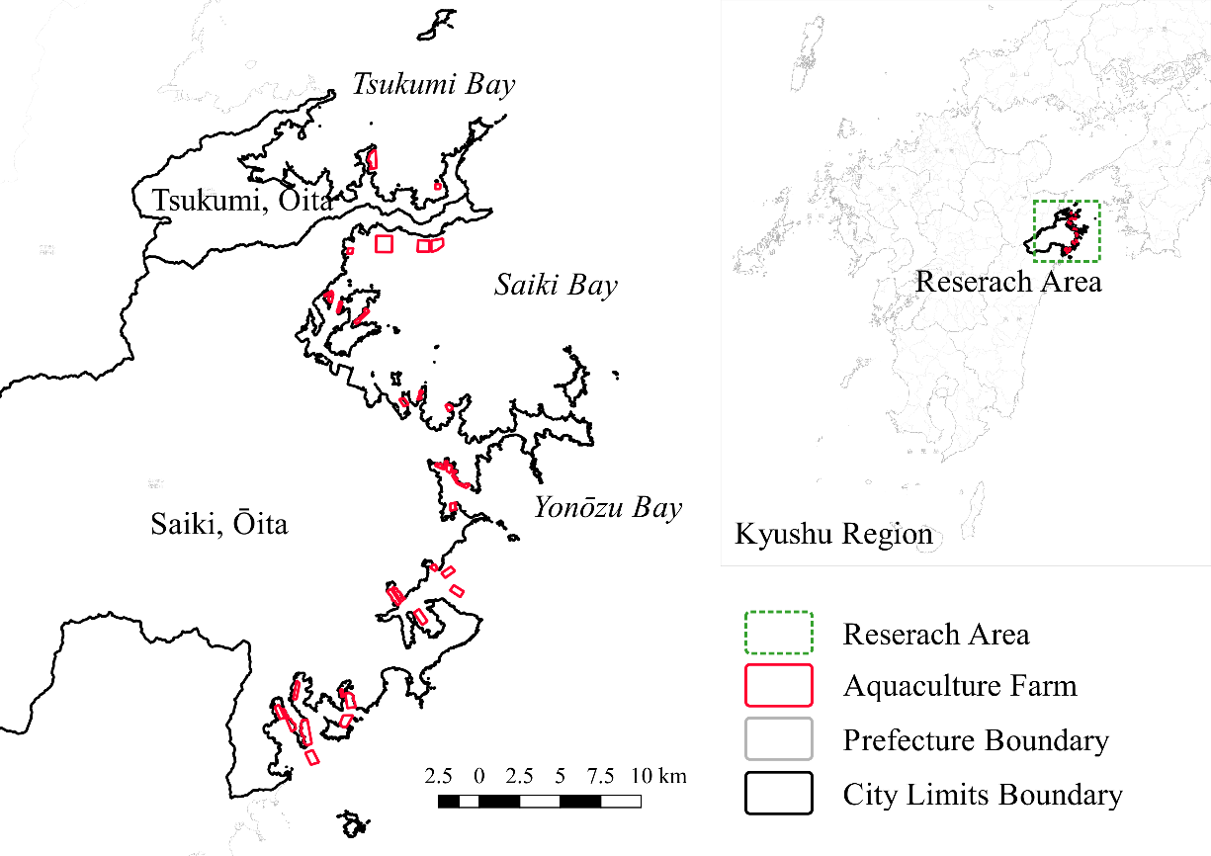

**Fig. 1 Research area and the aquaculture farms.**

The production calculated here includes two kinds of fish, yellow-tail and tuna, which accounting for about 91% of the marine fish production in Oita in 2017. The location, area of farm and type of fish are based on information on MDA Situational Indication Linkages(参考文献) and the Aquaculture Database（参考文献）. The number and area of cages are from satellite image recognition in 2017. The depth of the cage is 8m, is the field survey data. The water depth data is from JODC. (参考文献) Table 1 lists the values of other parameters.

２）卫星图像识别

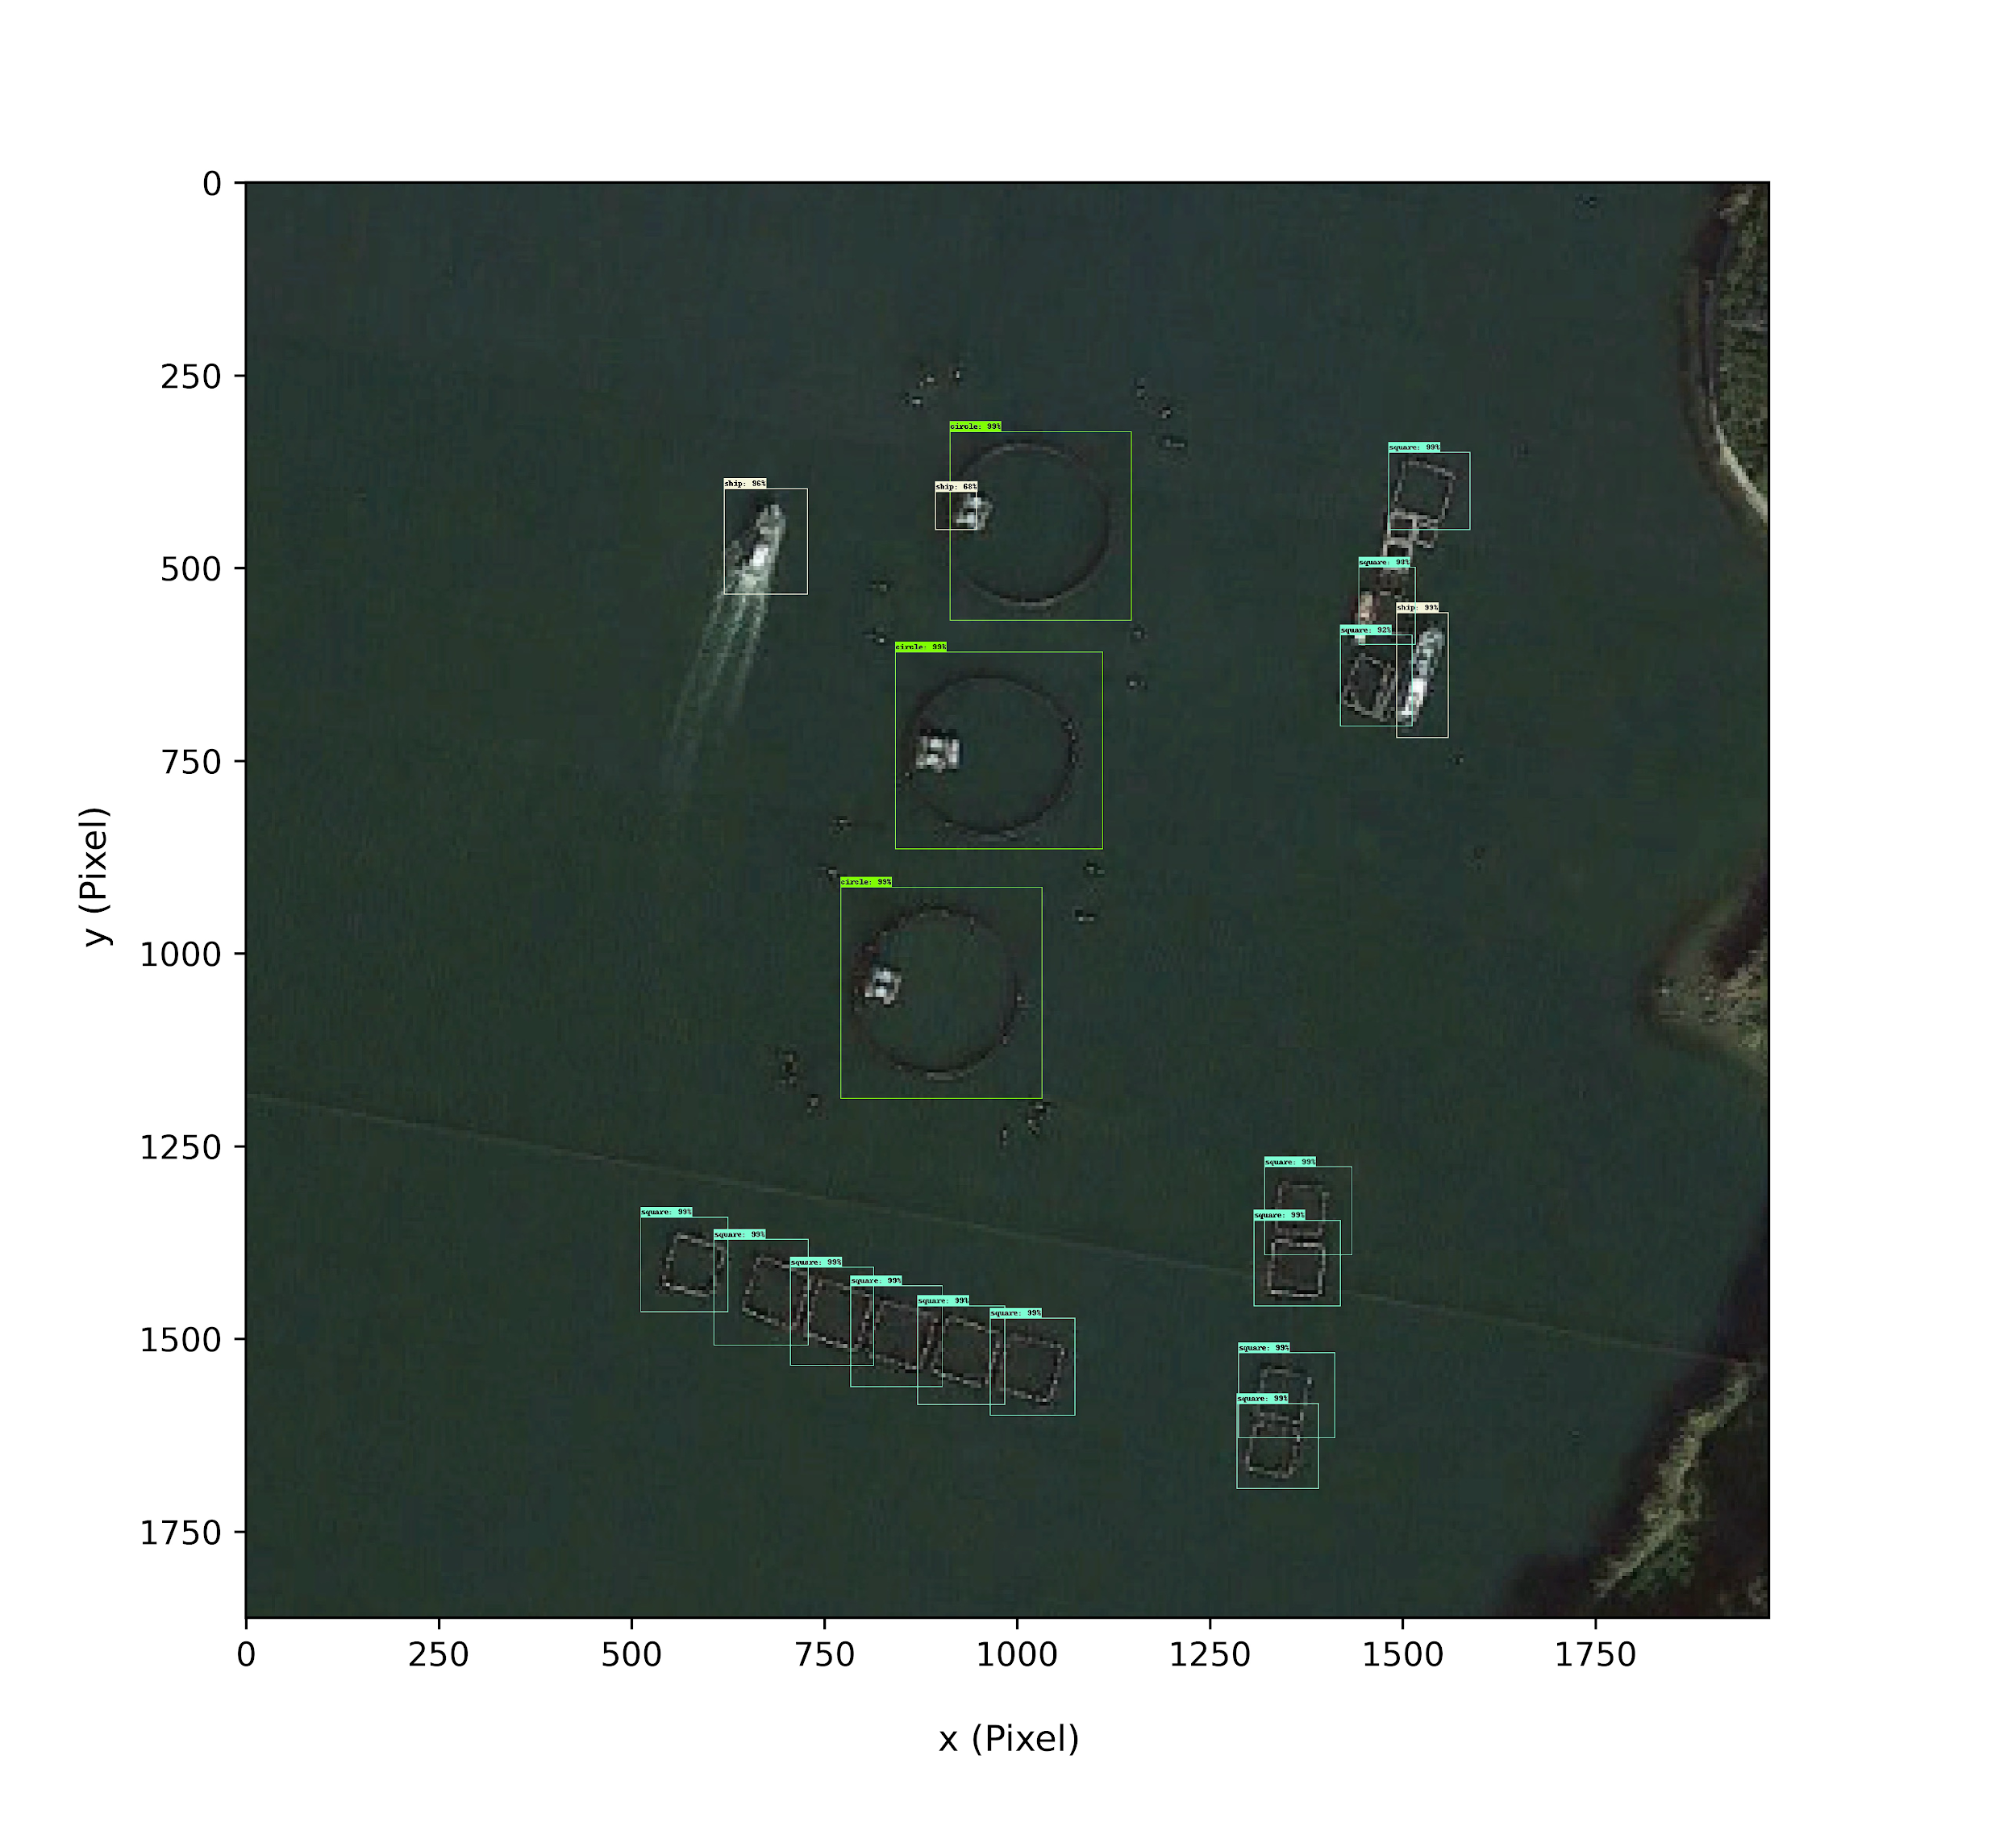

**Fig. 2 Object detection based on TensorFlow technology: round and square fishing cages.**

# RESULTS AND DISCUSSION

Compared with the Marine Aquaculture Production Statistics in 2017, the calculated value of yellow tail is 0.3% lower than the statistical value, and the calculated value of tuna is 3.68% higher than the statistical value. The possible causes of the deviation are the error in the calculation of the cage volume and the mean error in the stocking density.

养殖强度结果分析（分布图）

# FIGURES

Number figures in sequence they appear in text. Use the figure number when referring to a figure (Fig. 1) or figures (Figs. 2~3). Figures must have a caption consisting of an abbreviated number, like Fig. 1, and brief title should be placed below figure.

# TABLES

Number tables in sequence they appear in text. Use the table number when referring to a table (Table 1) or tables (Tables 2~3). Tables must have a caption with a brief title placed above table.

# EQUATIONS

Equations should be numbered in sequence they are displayed in text from Eq. 1 to the end of the paper including any appendices. Use the equation number when referring to equations (Eq. 1, Eqs. 5~7,). Enclose equation numbers in parentheses and flush right them.

# CONCLUSIONS

The evaluation index of aquaculture intensity established here is the first step to assess the aquaculture intensity of fish farm. Water current and water quality information, such as total nitrogen and total phosphorus, will be combined in the future, which will be used to estimate the optimal stocking density within the environmental capacity of the cultured sea area.The result can provide reference for making environmental standards of fish farms and stock density decision and ensure sustainable development of marine aquaculture.

# ACKNOWLEDGEMENT

# BIOGRAPHY

*Example---* So-Gi Kang is a research scientist at TTTT Institute in Daejeon, Korea. He has 10 years of experience within the area of marine environmental assessment. His main field of competence are physical and chemical properties of oils, oil spill behavior and weathering at sea and laboratory testing of oil spill chemicals.

# REFERENCES

[1] Donella, H.M., Dennis, L.M., Jorgen, R. and William, W.B., 1972, *The Limits to Growth*, Potomac Associates - Universe Books.

[2] Kitazawa, D., Zhou, J., Park, S., Zhang, J., Dong S., Li Q. and Yoshida, T., 2019, Study on numerical analysis of environmental capacity in aquaculture area. Japan Society of Fisheries Engineering Proceedings, 2019, 99-100. DOI: 10.18903/pamjsfe.2019.0_99. (in Japanese)

[3] Zhang, J., and Kitazawa, D., 2016, Assessing the bio-mitigation effect of integrated multi-trophic aquaculture on marine environment by a numerical approach. Marine pollution bulletin, 110(1), 484-492. DOI: 10.1016/j.marpolbul.2016.06.005.

[4] Ministry of Agriculture, Forestry and Fishieries (MAFF), “The Marine Aquaculture Production Statistics”. Minister's Secretariat Statistics Department Production Distribution Consumption Statistics Section of Ministry of Agriculture, Forestry and Fishieries. Accessed Aug. 2019. <http://www.maff.go.jp/j/tokei/kouhyou/kaimen_gyosei/>. (in Japanese)

[5] Ren, S., He, K., Girshick, R., & Sun, J., 2015, Faster R-CNN: Towards real-time object detection with region proposal networks. In Advances in neural information processing systems, 91-99. arXiv:1506.01497v3.

[6] Zhang, S., Wu, R., Xu, K., Wang, J., & Sun, W., 2019, R-CNN-Based Ship Detection from High Resolution Remote Sensing Imagery. Remote Sensing, 11(6), 631. DOI: 10.3390/rs11060631.

（作为指标，考虑水产养殖区域的排泄率与海域的海水交换率之间的比率，如果海水交换率远高于排泄率，则确定其是可持续的。 通过将每单位时间的排泄物量除以海域的密度和体积来获得排泄率。 海水交换率是通过将海域开口的垂直横截面积乘以平均流速和海域体积得到的。 使用长波近似公式从主要潮汐的波数，周期和振幅计算平均流速。）